May 2023

Network BSC

Address 0xbe39bd8ae3b369bd08d09ad799cd9e7a7eaa9fdb

Audited by © cyberscope

## Table of Contents

**Table of Contents 1**

**Review 2**

Audit Updates 2

Source Files 2

**Findings Breakdown 3**

**Analysis 4**

**Diagnostics 5**

IDI - Immutable Declaration Improvement 6

Description 6

Recommendation 6

L02 - State Variables could be Declared Constant 7

Description 7

Recommendation 7

L04 - Conformance to Solidity Naming Conventions 8

Description 8

Recommendation 8

L05 - Unused State Variable 10

Description 10

Recommendation 10

L14 - Uninitialized Variables in Local Scope 11

Description 11

Recommendation 11

L16 - Validate Variable Setters 12

Description 12

Recommendation 12

**Functions Analysis 13**

**Inheritance Graph 17**

**Flow Graph 18**

**Summary 19**

**Disclaimer 20**

**About Cyberscope 21**

## 

## Review

| **Contract Name** | Pepelon |
| --- | --- |
| **Compiler Version** | v0.8.19+commit.7dd6d404 |
| **Optimization** | 500 runs |
| **Explorer** | <https://bscscan.com/address/0xbe39bd8ae3b369bd08d09ad799cd9e7a7eaa9fdb> |
| **Address** | 0xbe39bd8ae3b369bd08d09ad799cd9e7a7eaa9fdb |
| **Network** | BSC |
| **Symbol** | PEPELON |
| **Decimals** | 9 |
| **Total Supply** | 420,690,000,000,000 |

### Audit Updates

| **Initial Audit** | 04 May 2023 |
| --- | --- |
| **Corrected Phase 2** | 06 May 2023 |

### Source Files

| **Filename** | SHA256 |
| --- | --- |

## Findings Breakdown

| Findings Breakdown | | ⬤ | Critical | 0 | | --- | --- | --- | | ⬤ | Medium | 0 | | ⬤ | Minor / Informative | 6 | |
| --- | --- | --- | --- | --- | --- | --- | --- | --- | --- | --- |

| **Severity** | | **Unresolved** | **Acknowledged** | **Resolved** | **Other** |
| --- | --- | --- | --- | --- | --- |
| ⬤ | Critical | 0 | 0 | 0 | 0 |
| ⬤ | Medium | 0 | 0 | 0 | 0 |
| ⬤ | Minor / Informative | 6 | 0 | 0 | 0 |

## Analysis

|  | ⬤ | Critical | ⬤ | Medium | ⬤ | Minor / Informative | ⬤ | Pass |
| --- | --- | --- | --- | --- | --- | --- | --- | --- |

| **Severity** | **Code** | **Description** | **Status** |
| --- | --- | --- | --- |
| ⬤ | ST | Stops Transactions | Passed |
| ⬤ | OCTD | Transfers Contract's Tokens | Passed |
| ⬤ | OTUT | Transfers User's Tokens | Passed |
| ⬤ | ELFM | Exceeds Fees Limit | Passed |
| ⬤ | ULTW | Transfers Liquidity to Team Wallet | Passed |
| ⬤ | MT | Mints Tokens | Passed |
| ⬤ | BT | Burns Tokens | Passed |
| ⬤ | BC | Blacklists Addresses | Passed |

## Diagnostics

|  |  |  | ⬤ | Critical | ⬤ | Medium | ⬤ | Minor / Informative |
| --- | --- | --- | --- | --- | --- | --- | --- | --- |

| **Severity** | **Code** | **Description** | **Status** |
| --- | --- | --- | --- |
| ⬤ | IDI | Immutable Declaration Improvement | Unresolved |
| ⬤ | L02 | State Variables could be Declared Constant | Unresolved |
| ⬤ | L04 | Conformance to Solidity Naming Conventions | Unresolved |
| ⬤ | L05 | Unused State Variable | Unresolved |
| ⬤ | L14 | Uninitialized Variables in Local Scope | Unresolved |
| ⬤ | L16 | Validate Variable Setters | Unresolved |

### 

### IDI - Immutable Declaration Improvement

| **Criticality** | Minor / Informative |
| --- | --- |
| **Location** | contracts/5-3-2023_PEPELON.sol#L131,145 |
| **Status** | Unresolved |

#### Description

The contract is using variables that initialize them only in the constructor. The other functions are not mutating the variables. These variables are not defined as immutable .

| dexRouter  lpPair |
| --- |

#### Recommendation

By declaring a variable as immutable, the Solidity compiler is able to make certain optimizations. This can reduce the amount of storage and computation required by the contract, and make it more gas-efficient.

### 

### L02 - State Variables could be Declared Constant

| **Criticality** | Minor / Informative |
| --- | --- |
| **Location** | contracts/5-3-2023_PEPELON.sol#L102,113 |
| **Status** | Unresolved |

#### Description

State variables can be declared as constant using the constant keyword. This means that the value of the state variable cannot be changed after it has been set. Additionally, the constant variables decrease gas consumption of the corresponding transaction.

| uint256 private timeSinceLastPair = 0  bool public taxesAreLocked |
| --- |

#### Recommendation

Constant state variables can be useful when the contract wants to ensure that the value of a state variable cannot be changed by any function in the contract. This can be useful for storing values that are important to the contract's behavior, such as the contract's address or the maximum number of times a certain function can be called. The team is advised to add the constant keyword to state variables that never change.

### 

### L04 - Conformance to Solidity Naming Conventions

| **Criticality** | Minor / Informative |
| --- | --- |
| **Location** | contracts/5-3-2023_PEPELON.sol#L33,107,108,109,110,111,119,271 |
| **Status** | Unresolved |

#### Description

The Solidity style guide is a set of guidelines for writing clean and consistent Solidity code. Adhering to a style guide can help improve the readability and maintainability of the Solidity code, making it easier for others to understand and work with.

The followings are a few key points from the Solidity style guide:

1. Use camelCase for function and variable names, with the first letter in lowercase (e.g., myVariable, updateCounter).
2. Use PascalCase for contract, struct, and enum names, with the first letter in uppercase (e.g., MyContract, UserStruct, ErrorEnum).
3. Use uppercase for constant variables and enums (e.g., MAX_VALUE, ERROR_CODE).
4. Use indentation to improve readability and structure.
5. Use spaces between operators and after commas.
6. Use comments to explain the purpose and behavior of the code.
7. Keep lines short (around 120 characters) to improve readability.

| function WETH() external pure returns (address);  uint256 constant private startingSupply = 420_690_000_000_000  string constant private _name = "Pepelon"  string constant private _symbol = "PEPELON"  uint8 constant private _decimals = 9  uint256 constant private _tTotal = startingSupply * 10**_decimals  bool public _hasLiqBeenAdded = false  bool _antiBlock  bool _antiSnipe |
| --- |

#### Recommendation

By following the Solidity naming convention guidelines, the codebase increased the readability, maintainability, and makes it easier to work with.  
Find more information on the Solidity documentation [https://docs.soliditylang.org/en/v0.8.17/style-guide.html#naming-convention](https://docs.soliditylang.org/en/v0.8.17/style-guide.html#naming-conventions).

### 

### L05 - Unused State Variable

| **Criticality** | Minor / Informative |
| --- | --- |
| **Location** | contracts/5-3-2023_PEPELON.sol#L102 |
| **Status** | Unresolved |

#### Description

An unused state variable is a state variable that is declared in the contract, but is never used in any of the contract's functions. This can happen if the state variable was originally intended to be used, but was later removed or never used.

Unused state variables can create clutter in the contract and make it more difficult to understand and maintain. They can also increase the size of the contract and the cost of deploying and interacting with it.

| uint256 private timeSinceLastPair = 0 |
| --- |

#### Recommendation

To avoid creating unused state variables, it's important to carefully consider the state variables that are needed for the contract's functionality, and to remove any that are no longer needed. This can help improve the clarity and efficiency of the contract.

### 

### L14 - Uninitialized Variables in Local Scope

| **Criticality** | Minor / Informative |
| --- | --- |
| **Location** | contracts/5-3-2023_PEPELON.sol#L365,366 |
| **Status** | Unresolved |

#### Description

Using an uninitialized local variable can lead to unpredictable behavior and potentially cause errors in the contract. It's important to always initialize local variables with appropriate values before using them.

| bool checked  bool check |
| --- |

#### Recommendation

By initializing local variables before using them, the contract ensures that the functions behave as expected and avoid potential issues.

### 

### L16 - Validate Variable Setters

| **Criticality** | Minor / Informative |
| --- | --- |
| **Location** | contracts/5-3-2023_PEPELON.sol#L195 |
| **Status** | Unresolved |

#### Description

The contract performs operations on variables that have been configured on user-supplied input. These variables are missing of proper check for the case where a value is zero. This can lead to problems when the contract is executed, as certain actions may not be properly handled when the value is zero.

| operator = newOperator |
| --- |

#### Recommendation

By adding the proper check, the contract will not allow the variables to be configured with zero value. This will ensure that the contract can handle all possible input values and avoid unexpected behavior or errors. Hence, it can help to prevent the contract from being exploited or operating unexpectedly.

## Functions Analysis

| **Contract** | **Type** | **Bases** |  |  |
| --- | --- | --- | --- | --- |
|  | **Function Name** | **Visibility** | **Mutability** | **Modifiers** |
|  |  |  |  |  |
| **IERC20** | Interface |  |  |  |
|  | totalSupply | External️ |  | -️ |
|  | decimals | External️ |  | -️ |
|  | symbol | External️ |  | -️ |
|  | name | External️ |  | -️ |
|  | getOwner | External️ |  | -️ |
|  | balanceOf | External️ |  | -️ |
|  | transfer | External️ | ✓ | -️ |
|  | allowance | External️ |  | -️ |
|  | approve | External️ | ✓ | -️ |
|  | transferFrom | External️ | ✓ | -️ |
|  |  |  |  |  |
| **IFactoryV2** | Interface |  |  |  |
|  | getPair | External️ |  | -️ |
|  | createPair | External️ | ✓ | -️ |
|  |  |  |  |  |
| **IV2Pair** | Interface |  |  |  |
|  | factory | External️ |  | -️ |
|  | getReserves | External️ |  | -️ |
|  | sync | External️ | ✓ | -️ |
|  |  |  |  |  |
| **IRouter01** | Interface |  |  |  |
|  | factory | External️ |  | -️ |
|  | WETH | External️ |  | -️ |
|  | addLiquidityETH | External️ | Payable | -️ |
|  | addLiquidity | External️ | ✓ | -️ |
|  | swapExactETHForTokens | External️ | Payable | -️ |
|  | getAmountsOut | External️ |  | -️ |
|  | getAmountsIn | External️ |  | -️ |
|  |  |  |  |  |
| **IRouter02** | Interface | IRouter01 |  |  |
|  | swapExactTokensForETHSupportingFeeOnTransferTokens | External️ | ✓ | -️ |
|  | swapExactETHForTokensSupportingFeeOnTransferTokens | External️ | Payable | -️ |
|  | swapExactTokensForTokensSupportingFeeOnTransferTokens | External️ | ✓ | -️ |
|  | swapExactTokensForTokens | External️ | ✓ | -️ |
|  |  |  |  |  |
| **Protections** | Interface |  |  |  |
|  | checkUser | External️ | ✓ | -️ |
|  | setLaunch | External️ | ✓ | -️ |
|  | setLpPair | External️ | ✓ | -️ |
|  | setProtections | External️ | ✓ | -️ |
|  | removeSniper | External️ | ✓ | -️ |
|  |  |  |  |  |
| **Pepelon** | Implementation | IERC20 |  |  |
|  |  | Public️ | Payable | -️ |
|  |  | External️ | Payable | -️ |
|  | transferOwner | External️ | ✓ | onlyOwner |
|  | renounceOwnership | External️ | ✓ | onlyOwner |
|  | setOperator | Public️ | ✓ | -️ |
|  | renounceOriginalDeployer | External️ | ✓ | -️ |
|  | totalSupply | External️ |  | -️ |
|  | decimals | External️ |  | -️ |
|  | symbol | External️ |  | -️ |
|  | name | External️ |  | -️ |
|  | getOwner | External️ |  | -️ |
|  | allowance | External️ |  | -️ |
|  | balanceOf | Public️ |  | -️ |
|  | transfer | Public️ | ✓ | -️ |
|  | approve | External️ | ✓ | -️ |
|  | _approve | Internal | ✓ |  |
|  | approveContractContingency | External️ | ✓ | onlyOwner |
|  | transferFrom | External️ | ✓ | -️ |
|  | setInitializer | External️ | ✓ | onlyOwner |
|  | isExcludedFromProtection | External️ |  | -️ |
|  | setExcludedFromProtection | External️ | ✓ | onlyOwner |
|  | getCirculatingSupply | Public️ |  | -️ |
|  | removeSniper | External️ | ✓ | onlyOwner |
|  | setProtectionSettings | External️ | ✓ | onlyOwner |
|  | excludePresaleAddresses | External️ | ✓ | onlyOwner |
|  | _hasLimits | Internal |  |  |
|  | _transfer | Internal | ✓ |  |
|  | _checkLiquidityAdd | Internal | ✓ |  |
|  | enableTrading | Public️ | ✓ | onlyOwner |
|  | sweepContingency | External️ | ✓ | onlyOwner |
|  | multiSendTokens | External️ | ✓ | onlyOwner |
|  | finalizeTransfer | Internal | ✓ |  |

## Inheritance Graph

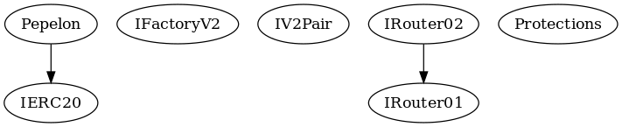

## Flow Graph

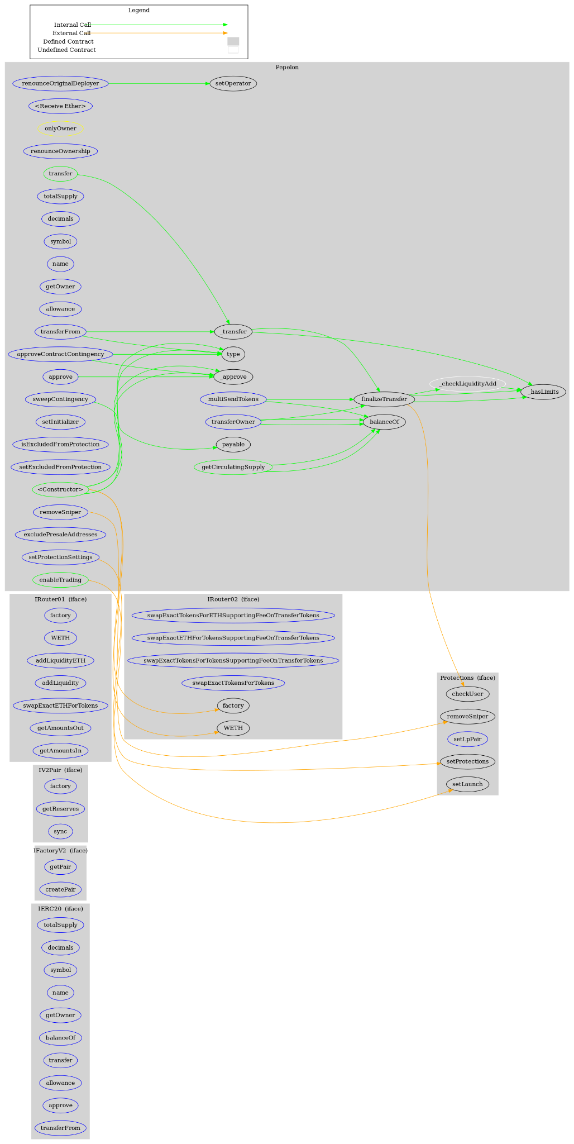

## Summary

Pepelon contract implements a token mechanism. This audit investigates security issues, business logic concerns and potential improvements. Pepelon is an interesting project that has a friendly and growing community. The Smart Contract analysis reported no compiler error or critical issues. The contract Owner can access some admin functions that can not be used in a malicious way to disturb the users’ transactions.

## Disclaimer

The information provided in this report does not constitute investment, financial or trading advice and you should not treat any of the document's content as such. This report may not be transmitted, disclosed, referred to or relied upon by any person for any purposes nor may copies be delivered to any other person other than the Company without Cyberscope’s prior written consent. This report is not nor should be considered an “endorsement” or “disapproval” of any particular project or team. This report is not nor should be regarded as an indication of the economics or value of any “product” or “asset” created by any team or project that contracts Cyberscope to perform a security assessment. This document does not provide any warranty or guarantee regarding the absolute bug-free nature of the technology analyzed, nor do they provide any indication of the technologies proprietors' business, business model or legal compliance. This report should not be used in any way to make decisions around investment or involvement with any particular project. This report represents an extensive assessment process intending to help our customers increase the quality of their code while reducing the high level of risk presented by cryptographic tokens and blockchain technology.

Blockchain technology and cryptographic assets present a high level of ongoing risk Cyberscope’s position is that each company and individual are responsible for their own due diligence and continuous security Cyberscope’s goal is to help reduce the attack vectors and the high level of variance associated with utilizing new and consistently changing technologies and in no way claims any guarantee of security or functionality of the technology we agree to analyze. The assessment services provided by Cyberscope are subject to dependencies and are under continuing development. You agree that your access and/or use including but not limited to any services reports and materials will be at your sole risk on an as-is where-is and as-available basis Cryptographic tokens are emergent technologies and carry with them high levels of technical risk and uncertainty. The assessment reports could include false positives false negatives and other unpredictable results. The services may access and depend upon multiple layers of third parties.

## About Cyberscope

Cyberscope is a blockchain cybersecurity company that was founded with the vision to make web3.0 a safer place for investors and developers. Since its launch, it has worked with thousands of projects and is estimated to have secured tens of millions of investors’ funds.

Cyberscope is one of the leading smart contract audit firms in the crypto space and has built a high-profile network of clients and partners.



**The Cyberscope team**

<https://www.cyberscope.io>