Jessica Carnes

February 22, 2021

Foundations of Programming: SQL

Assignment06

Views in SQL

# Introduction

This paper will discuss when to use a view in SQL and the similarities and differences between views, functions, and stored procedures.

# When to use a view in SQL

Views should be used in SQL as an abstraction layer. Best practice is for all tables to have a base view created which simply replicates the underlying table. All users and applications, including developers, should work off the base views.

Views can make querying the tables more accessible to users by saving complex select statements. This allows users without coding experience to access table data with a simple select statement. It also saves time so that if there is a specific data format a user needs to pull frequently, they can simply select the view. For example, the code in Figure 1 is complex and contains multiple joins.

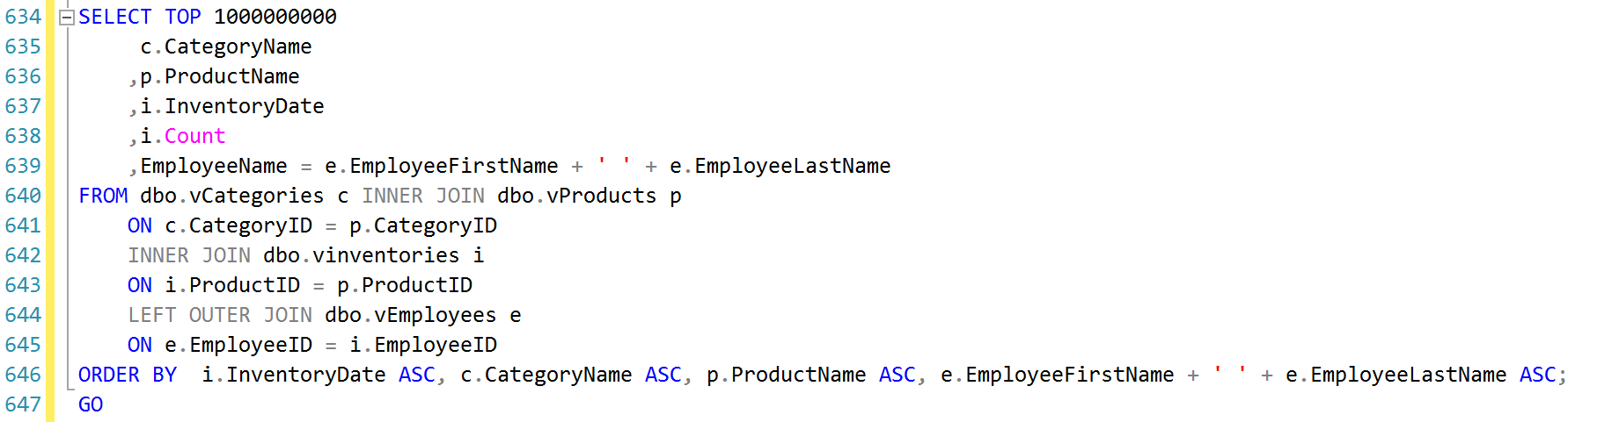  
Figure 1: Complex code containing multiple joins

If this code was saved in a view called vInventoriesByProductsByEmployees , the select statement to pull back the same information would be reduced to that shown in Figure 2, making it more accessible for non-technical users to run.

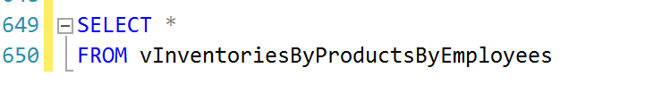  
Figure 2: The select statement when a view is created

Additionally, views can be used to restrict access to sensitive data in tables based on user group permissions. Two views of a table can be made, one including sensitive information and the other excluding that data. Access can then be granted to each view based on user group permissions.

# Views, Functions and Stored Procedures

Views, functions and stored procedures are all ways of storing code to be called later. Views and functions can only run select statements while stored procedures can contain code that makes changes to the database.

Views are saved select statements that can be thought of as virtual tables. The view stores a select statement which is then ran when view is called. Views are called in select statements in the same manner a table would be called.

Functions are similar to views in that they can only contain select statements. However, unlike views, functions can have built in parameters so that variables may be passed to the function as arguments. Functions can return data in either a table format or a single scalar value.

Similar to both views and functions, stored procedures can be created to return data, either tabular or scaler like functions, however they do not have to return anything. Unlike views and functions, stored procedures can make changes to the database. Stored procedures can be created with parameters like functions. Stored procedures are not called in a select statement like views and functions, instead stored procedures are executed. The code underlying a stored procedure can reference views or functions as well.

# Summary

Views should be used to create an abstraction layer in the database. Base views for all tables should be created and all users and applications should access the views instead of the tables. Views can also be used to restrict access to sensitive information through user groups. Views, functions, and stored procedures are all methods of storing code within SQL. Views return table data and can be thought of as virtual tables. Functions can return table or scalar data and can be written with parameters. Stored procedures can return either table data, scalar data, or not return anything at all. Unlike views and functions, stored procedures can make changes to the database.