Game Design Document

Fill up the following document

1. Write the title of your project.

League of Flourige

1. What is the goal of the game?

Shoot the unclean & sad gems and collect the clean & happy gems.

1. Write a brief story of your game.

Zelian lives in Planet Flourige. The secret box located at the middle of

Flourige has many clean and happy gems in it. These gems are slowly

turning unhappy and unclean, due to the amount of pollution in

Flourige. Zerian belongs to the Safeguarding League of Flourige. Help him

and his team to collect more clean and happy gems and destroy the

unclean and unhappy gems, to help the league save Flourige.

1. Which are the playing characters of this game?

* Playing characters are the ones who respond to the user based on the input from the user.
* Cars, monkeys, dinos, wizards, etc., are the playing characters in the game.

|  |  |  |
| --- | --- | --- |
| Number | Character Name | What can this character do? |
| 1 | Spacecraft | Shoot the unclean & sad gems, and collect the clean & happy gems. |
| 2 |  |  |
| 3 |  |  |
| 4 |  |  |
| 5 |  |  |
| 6 |  |  |
| 7 |  |  |
| 8 |  |  |

1. Which are the Non-Playing Characters of this game?

* Non-Playing characters are the ones that don't have an action or behavior when the user interacts with the game.
* Hurdles, stones, bananas, coins, etc., are non-playing characters in the game.

|  |  |  |
| --- | --- | --- |
| Number | Character Name | What can this character do? |
| 1 | Clean & Happy Gems | Score points for the player |
| 2 | Unclean & Unhappy Gems | Score points for the player if it gets shot or destroy the spacecraft |
| 3 |  |  |
| 4 |  |  |
| 5 |  |  |
| 6 |  |  |
| 7 |  |  |
| 8 |  |  |

Draw your imagination of this game. What does this game look like?

* Draw the game either on your computer or on paper.
* Add images of the game scenes to show each of the playing and non-playing characters at least once.

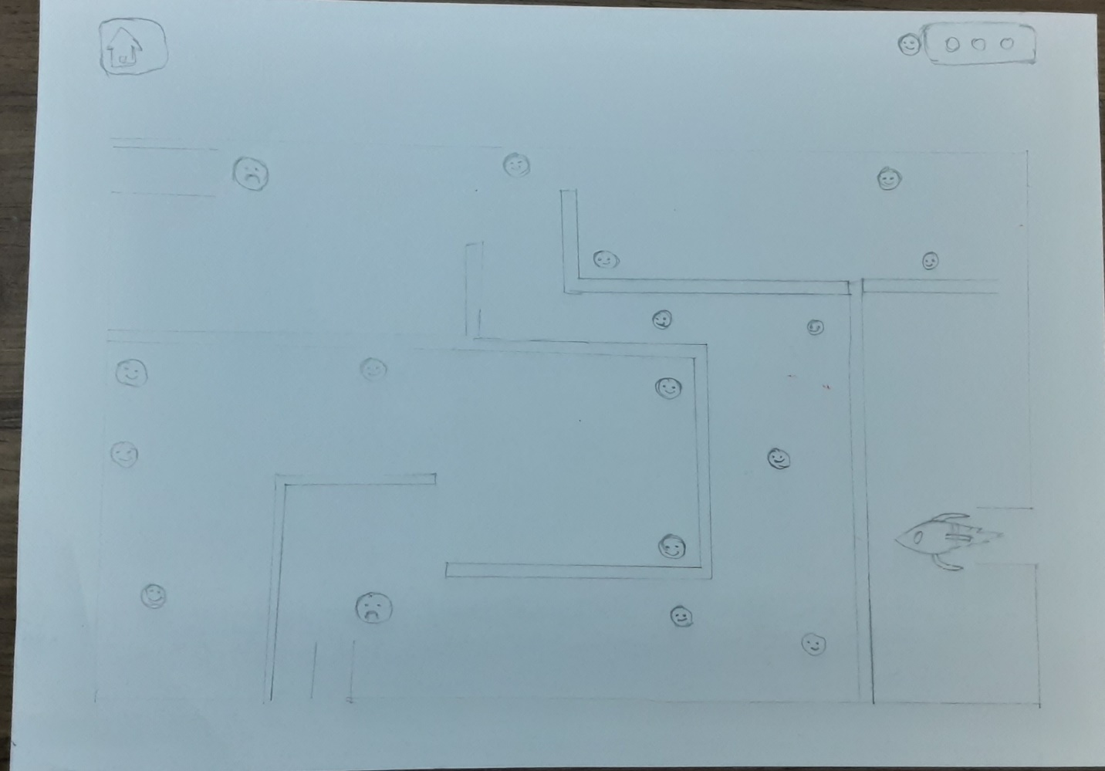

How do you plan to make your game engaging?

The players will receive rewards, if they have achieved a particular score.

There will be different levels for the player to play.

Images and Sound effects will be added.