Report

**Purpose**

The purpose of this project was to create an online ordering website that would allow customers to order their food without have to stop doing what they currently were doing. They could put in an order for a future time or for the soonest time possible. They were able to sign up for an account and then login to create their order. They are able to customize how they want the items made with the toppings and extras of their choice.

**Diagrams**

Sequence

Order decision

Customer

Login

Goes to webpage

Login

failed

order

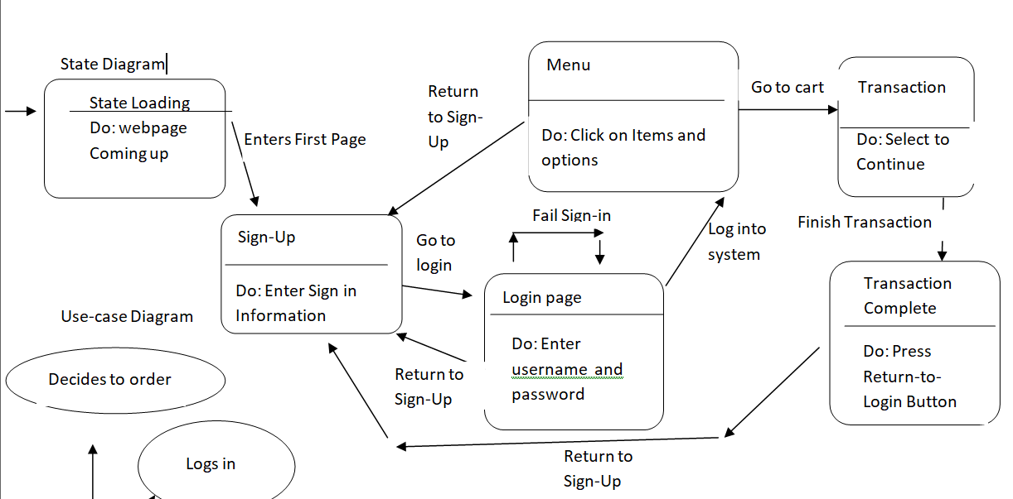

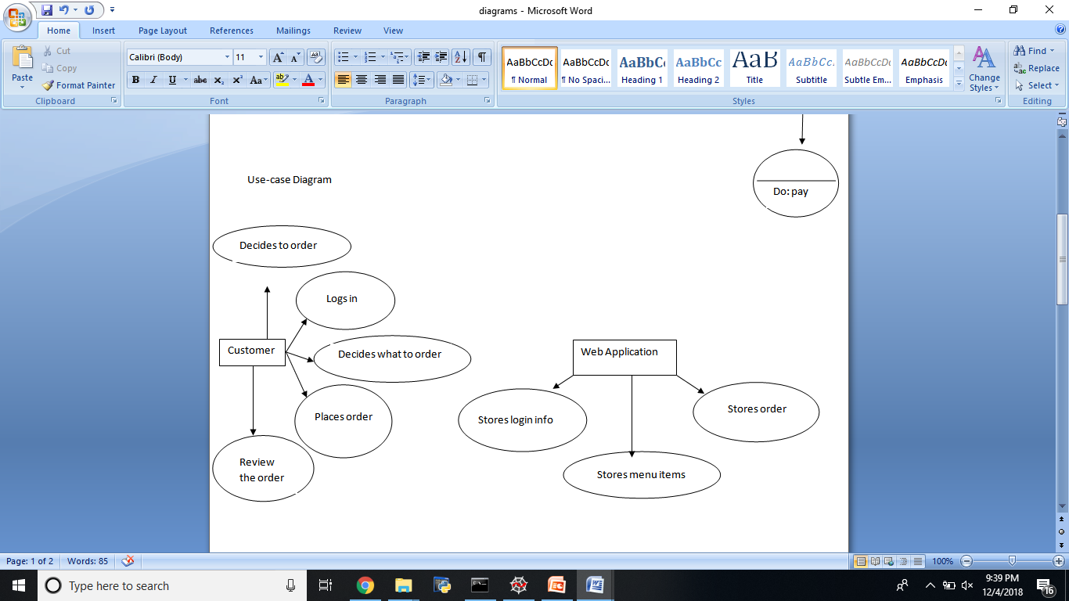

Activity

Customer pays

Customer enters time for order

Customer places their order

Customer sets up account

Customer goes to the webpage

Customer decides to place an order

**Weekly Status Reports**

Progress Report 1

What Has Been Done:

We laid out the very basic requirements for the software and have decided the roles of each team member: I am the database creator and manager; Tejash is the C# developer; and Mercedes will handle the HTML and CSS of the website. We also decided we would help each other in each of these areas if necessary. Mercedes has designed a menu example that we can look at and base our designs on, and I have designed a couple of ERDs (Entity Relationship Diagram) that we can base the design of the MySQL database on.

What Needs To Be Done:

Since we are in the design phase, we need to create some representation of the C# algorithms using a flowchart and some of the UML. Besides this, we will have to create the actual MySQL database based on one of the ERDs, create the HTML version of the menu, and implement the C# algorithms. Our team also needs to integrate the front-end, back-end, and HTML together once these different pieces are completed.

Obstacles:

There are no serious obstacles that we have so far. As we progress, we may eventually have to tackle some design or technical problem.

Progress Report 2

What Has Been Done:

Since the last report, my team has created a windows form prototype that was not connected to a database. After that, we created an ASP.NET project which included a sign-up page and menu; we connected the sign-up page to a MySQL database. After struggling with MySQL, we switched to Microsoft SQL database to simplify compatibility and data access in the website significantly. From here on, we rewrote the ASP.NET websites to match this. After transitioning smoothly to Microsoft SQL, we created a menu system that has a rudimentary shopping cart functionality that has the ability to add several items in a session of the food items that the user can choose.

What Needs To Be Done:

The menu shopping cart needs to be given the functionality to remove, add the total price together, and give the ability to customize. The payment and final transaction pages need to be completed which will communicate with the Microsoft SQL and store the order information. If time allows, we will try to also improve the user information.

Obstacles:

Time will be our biggest factor in attempting to finish the remaining parts of the programs. Besides this, another obstacle is our unfamiliarity with C# ASP.NET which may slow down progress. Fortunately, we are learning the language and structure of these projects, and this will help us potentially speed up progress.

**Software Requirements**

The project should allow a user to setup an account, log in to the webpage, place an order, choose what customization they would like, check out, give them a time frame on when their order will be done, and review their order.

The software behind those requirements are a database that stores the customer’s username and password once they create it to log in to their account. It is done through an interactive GUI menu that allows them to just click what they want to add or remove. The database also stores their phone number and credit card number for payment processes.

We used the IDE Visual Studios Community Edition to create the GUI and the Microsoft Database to manage our database. We used Microsoft Excel to track our progress through the project. GitHub was used as our version control tool. When we had to communicate with our team members we used Outlook for emails, sent text messages, or used Slack.