Jessica Battles INFM310 Week 4 Programming Assignment
Part A:
Lab 9-5: Reverse.java Screenshot
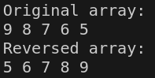

Lab 9-6: Cornwall.java
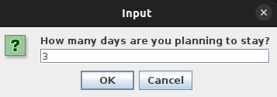

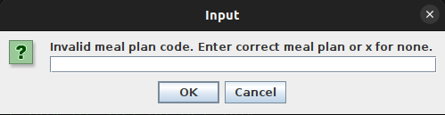
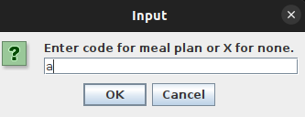
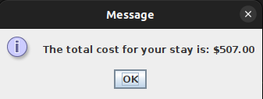

Lab 9-7: ChangeCase.java
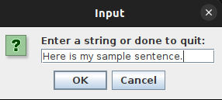

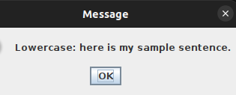
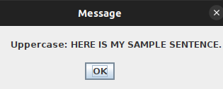

Part B:
Design a class named TermPaper that holds an author’s name, the subject of the paper, and an assigned letter grade. Include methods to set the values for each data field and display the values for each data field. You only need to create the class diagram to fulfill the requirement of this design.

TermPaper
-authorName: String
-paperSubject: String
-letterGrade: String
+setAuthorName(name: String): void
+setPaperSubject(subject: String): void
+setLetterGrade(grade: String): void
+getAuthorName() : String
+getPaperSubject() : String
+getLetterGrade() : String
+displayInfo(): void

