**Jessie George**

**Net ID: jg1114**

**Brain Inspired Computing**

**Homework 1**

**Part 2**

1. If an IF neuron is constantly fed a very low input current, it will fire even if the stimulus is not supposed to make the voltage cross the threshold, because each voltage boost is added to the sum of the previous voltage boosts until it fires. (i.e. the firing is inaccurate because the IF model doesn’t implement time-dependent memory.)

If an LIF neuron is constantly fed a very low input current, it will not fire unless the very low input current is greater than the minimum current required to spike the voltage. (i.e the firing is accurate because the LIF model implements time-dependent memory by adding a leak.)

1. If an IF neuron is constantly fed a very high input current, it will spike repeatedly in immediate succession.

If an LIF neuron is constantly fed a very high input current, it will spike repeatedly in immediate succession. (i.e this type of firing is often unrealistic, because the standard LIF model only keeps memory of the most recent spike and therefore doesn’t slow down the firing rate by increasing the inter-spike intervals during bursts.)

1. Limitations of an LIF neuron:
2. It only keeps memory of the most recent spike and therefore doesn’t slow down the firing rate by increasing the inter-spike intervals during bursts. (i.e no adaptation of neuron.)
3. The input current injected or the input from a presynaptic neuron is integrated linearly, independent of the state of the postsynaptic neuron, which could make firing rate faulty.
4. It cannot accurately represent post-inhibitory rebound spikes, conductance changes after a spike, and the effects of spatial structure on firing rate.

**Part 3**

**Question 1: LIF Model - Code is given in LIF.py**

Graphs are shown below:

The graphs that say “Membrane Potential Decay” plot change in membrane potential (dV) vs time.

The graphs that say “Spiking Behavior” plot membrane potential (V) vs time.

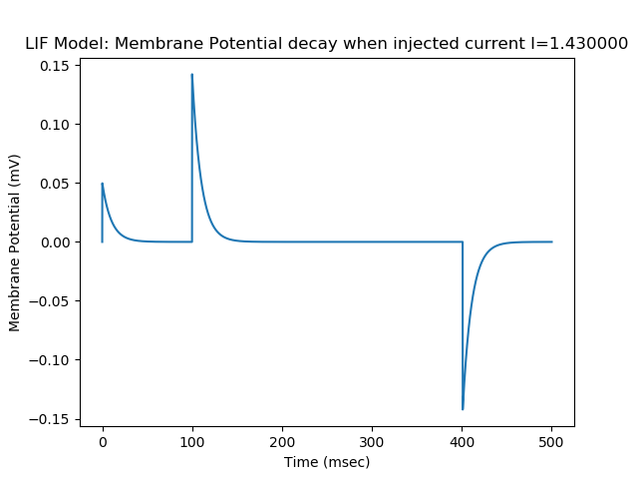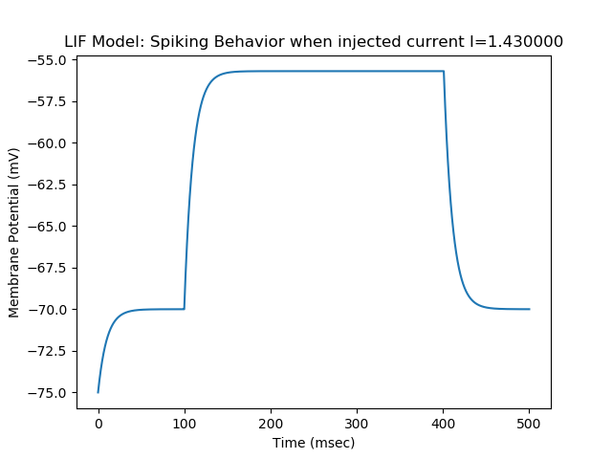

More LIF graphs on next page.

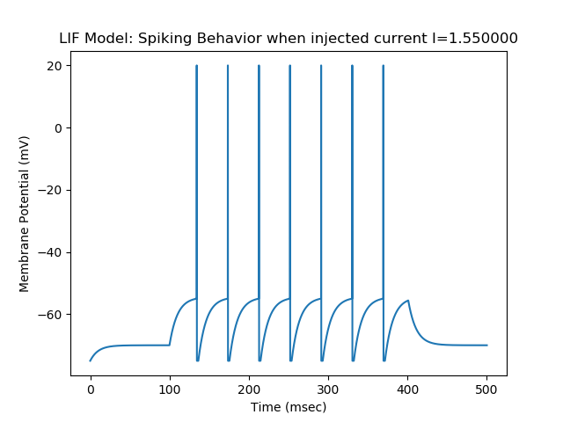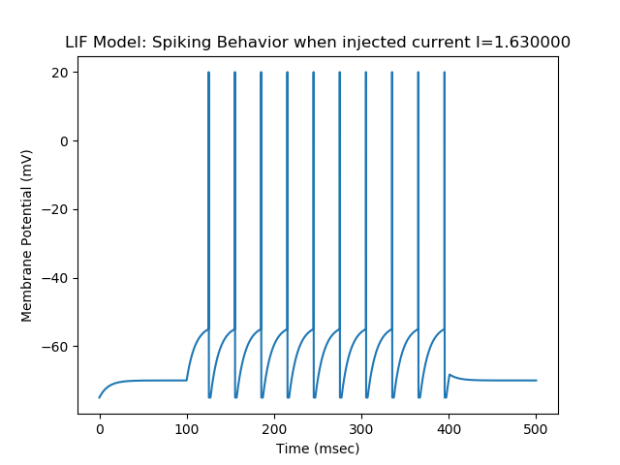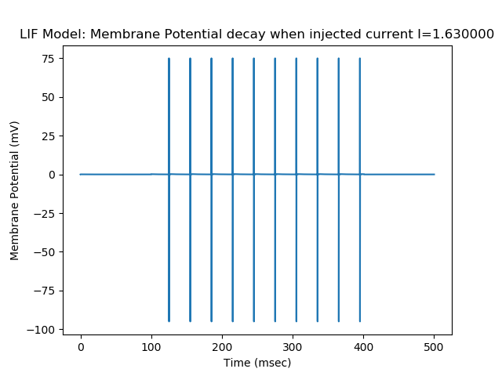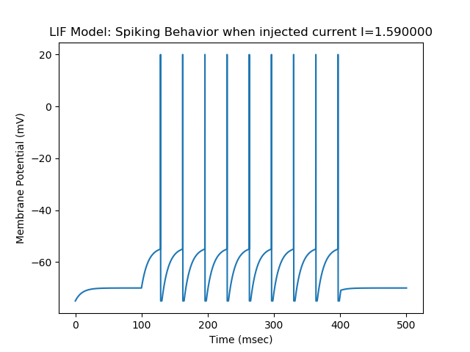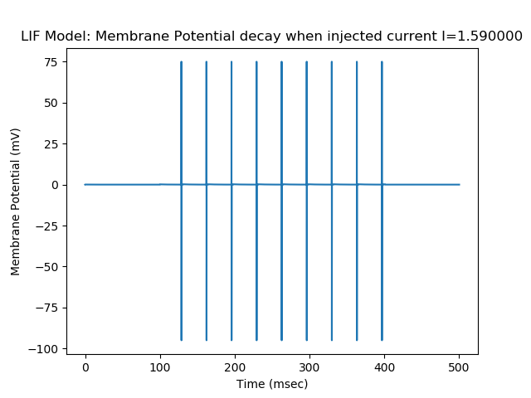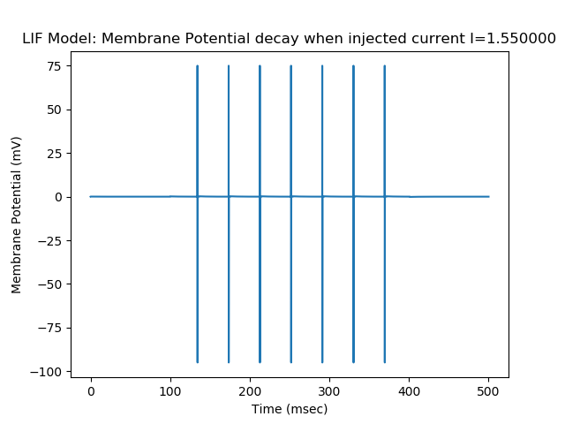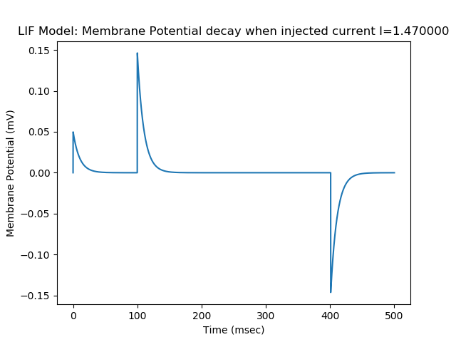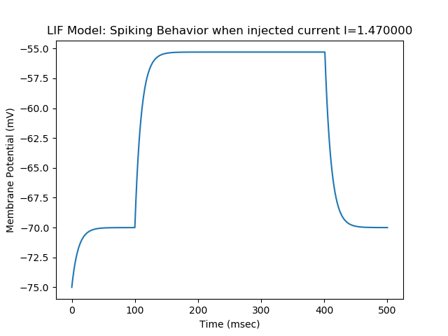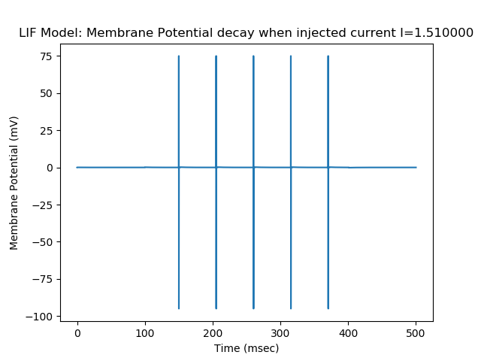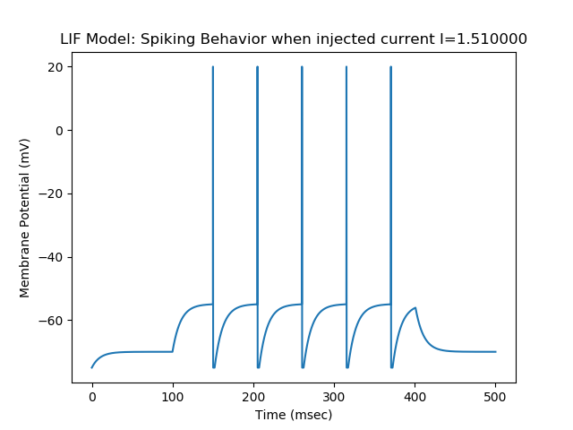

**Question 2: LIF Model: Plot firing rate**

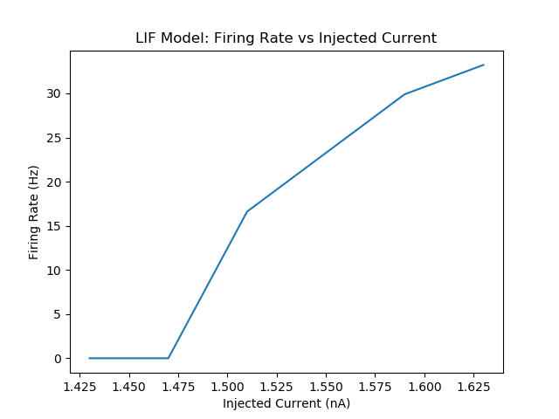

**Question 3: Firing rate**

The firing rate increases as you increase the input current because the equation for LIF is:

tau_m *(dV_m/dt) = -V_m(t) + (R_m * I(t)) so as I(t) increases, V will increase, which will lead to more number of spikes, which increases firing rate.

**Question 4: Izhikevich Model – code in IZK.py**

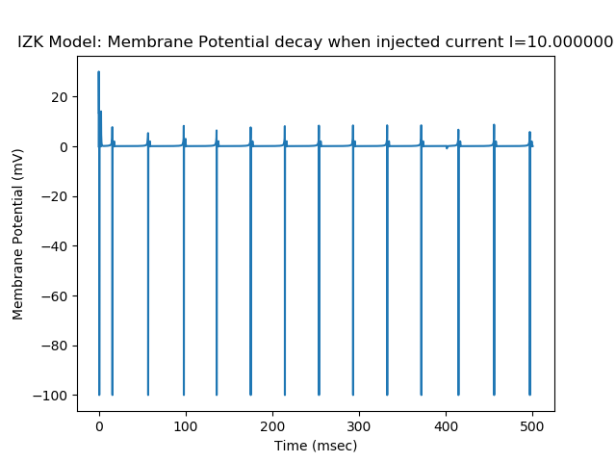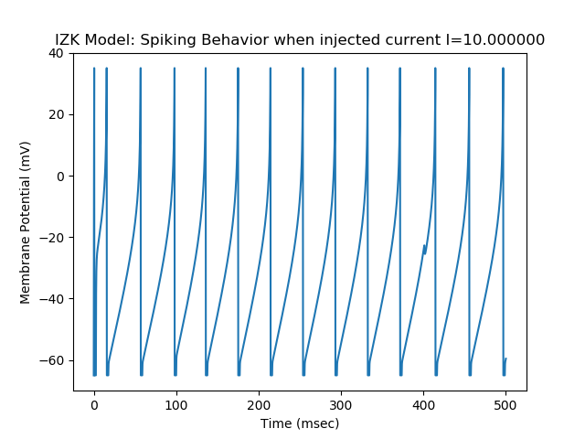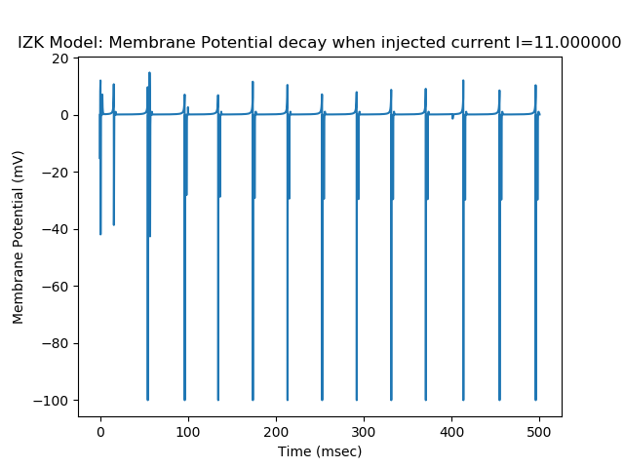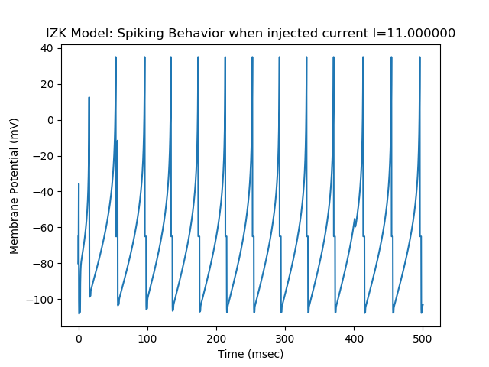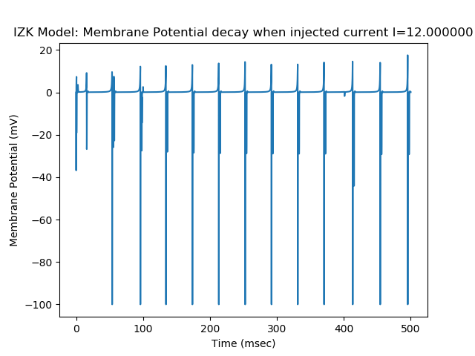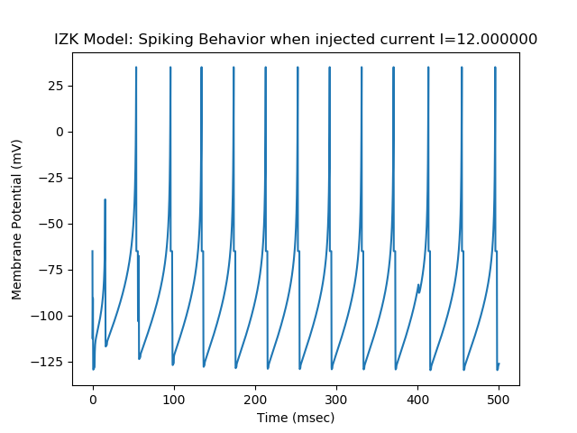

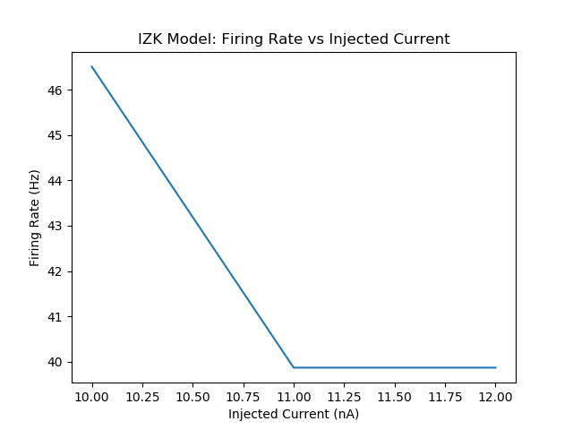

**Question 5: HH Model – code in HH.py**

