Jessie George

Homework 4

**DIARY**

im = imread('f.bmp');

size(im)

ans =

1156 890

figure

imshow(im)

title('Character f')

h = imhist(im);

figure

plot(h)

title('Intensity Histogram')

th = 200;

im2 = im;

im2(im >= th) = 0;

im2(im < th) = 1;

figure

imagesc(~im2)

colormap gray

title('Threshold=200')

level=triangle_th(h,256);

th=level*255

th =

239.0625

im2 = uint8(im < th);

figure

imagesc(im2)

colormap gray

title('Triangle Algorithm Threshold')

level = graythresh(im);

BW = imbinarize(im, level);

figure, imshow(BW), title('Graythresh')

th = 200;

im2 = im;

im2(im >= th) = 0;

im2(im < th) = 1;

im2 = medfilt2(im2); %removing salt and pepper noise

figure

imagesc(~im2)

colormap gray

title('im2')

L = bwlabel(im2);

BoundingBox

title('Connected Components')

diary off

**FIGURES**

Grayscale Image

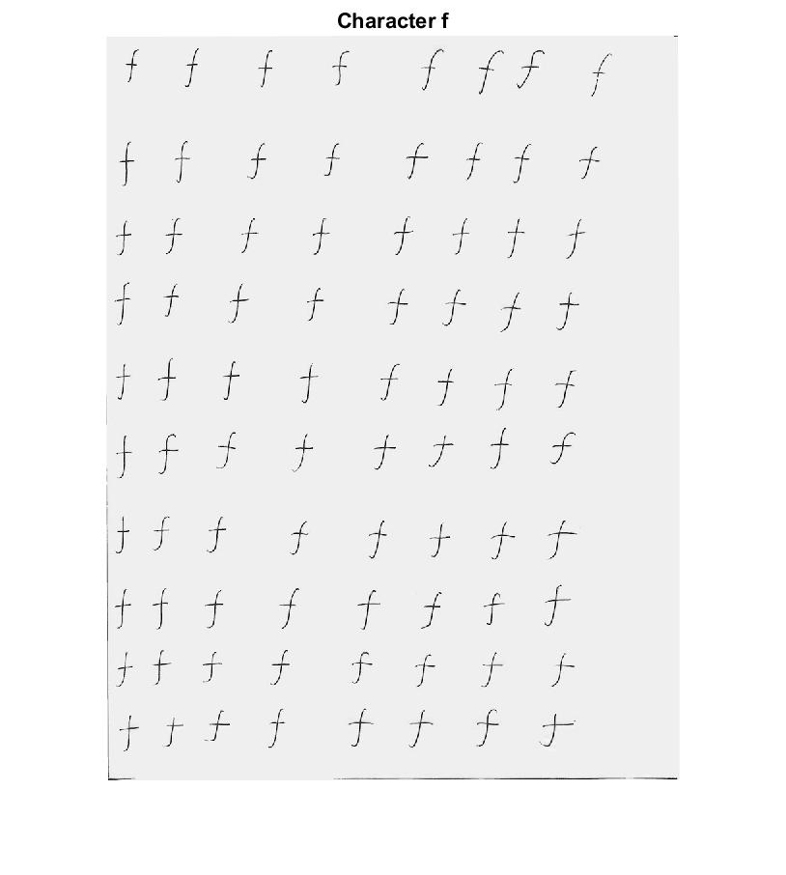

Intensity Histogram

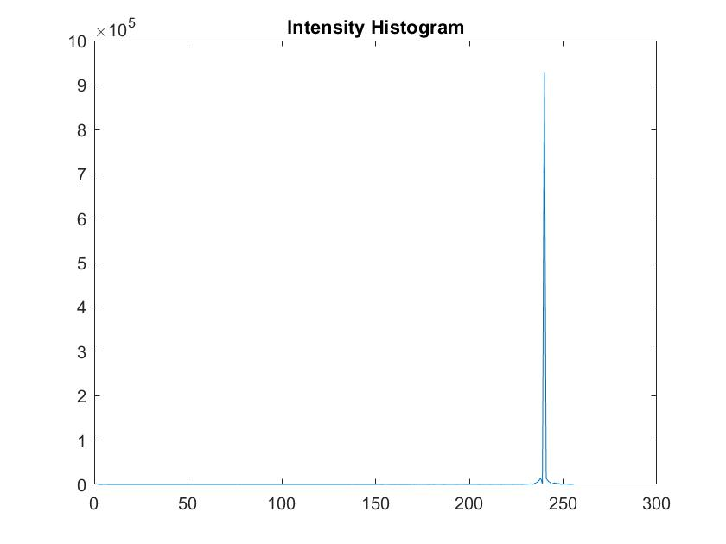

Trials of different thresholds

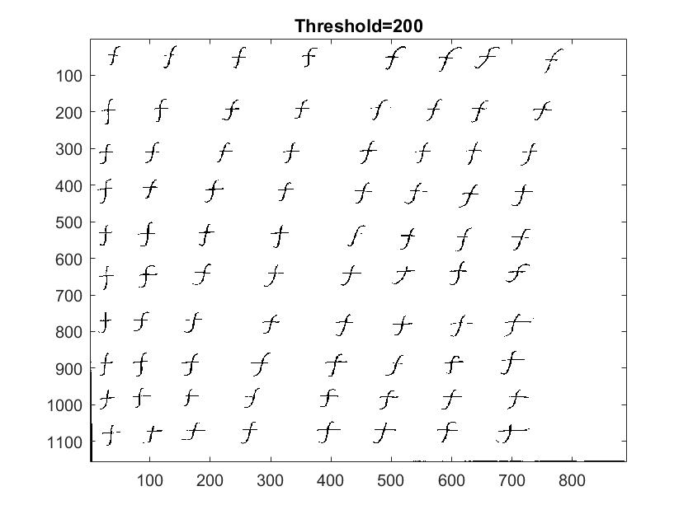

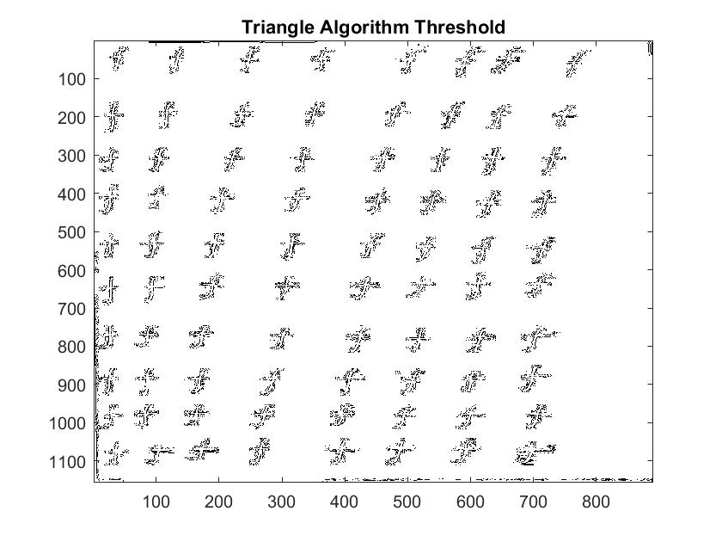

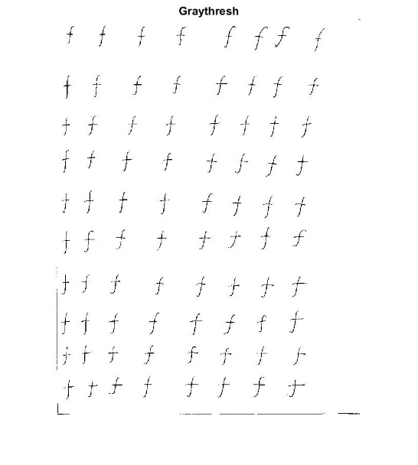

After trials, I decided to use threshold = 200 because it looked better than triangle threshold and graythresh.

Final Binary Image

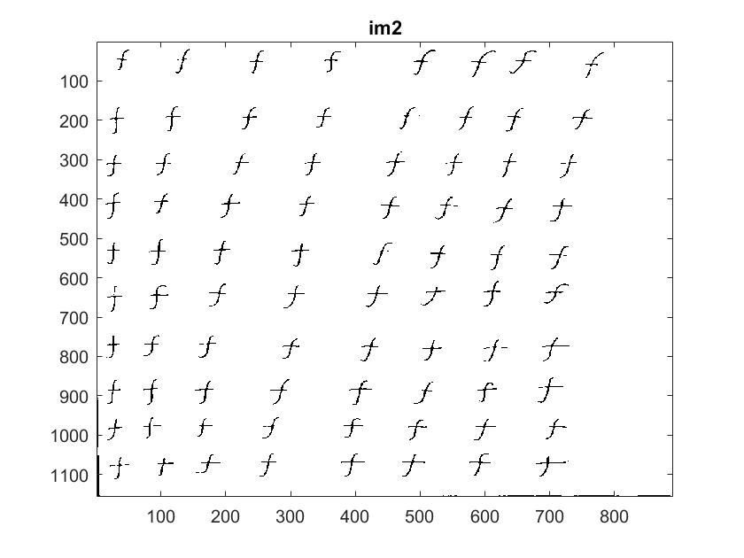

Connected Components

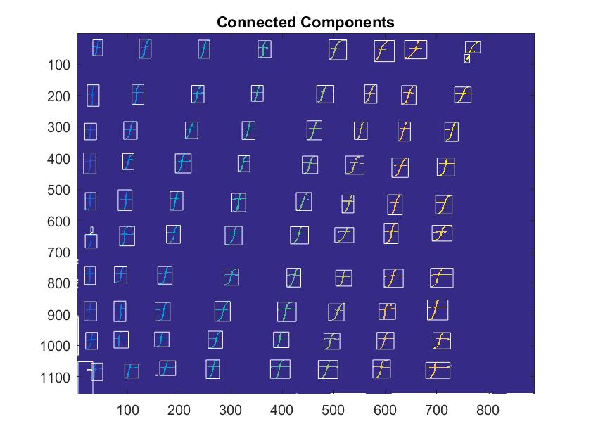

Distance Matrix for f individually

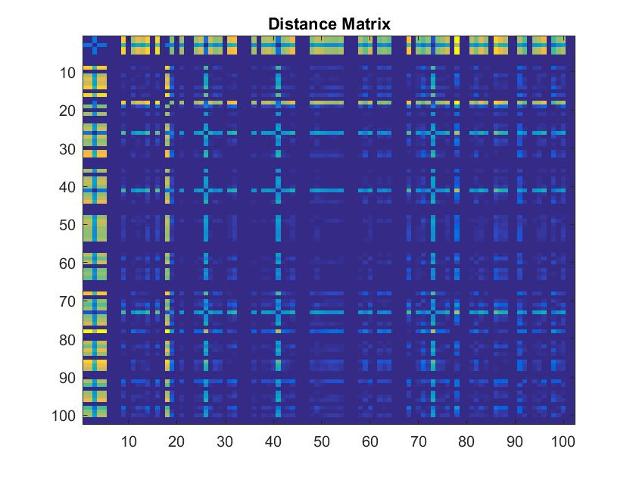

Distance Matrix for All Training Images

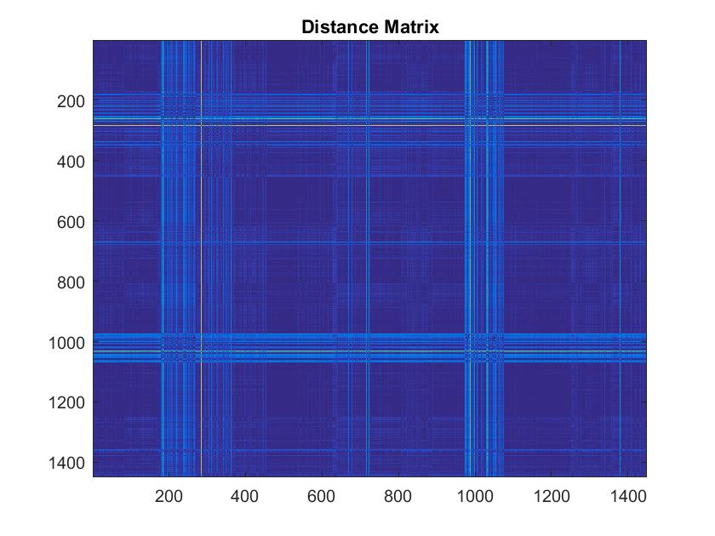

**RESULTS**

For all training images

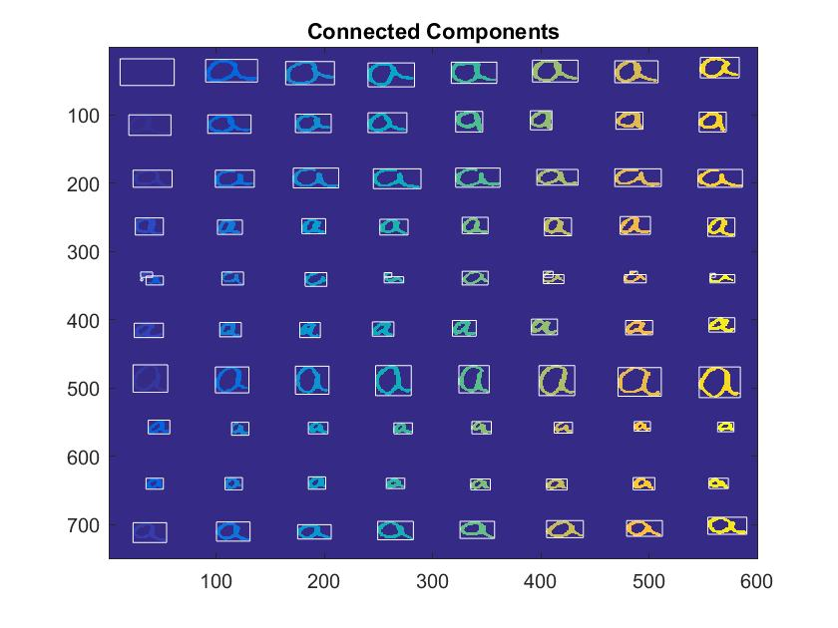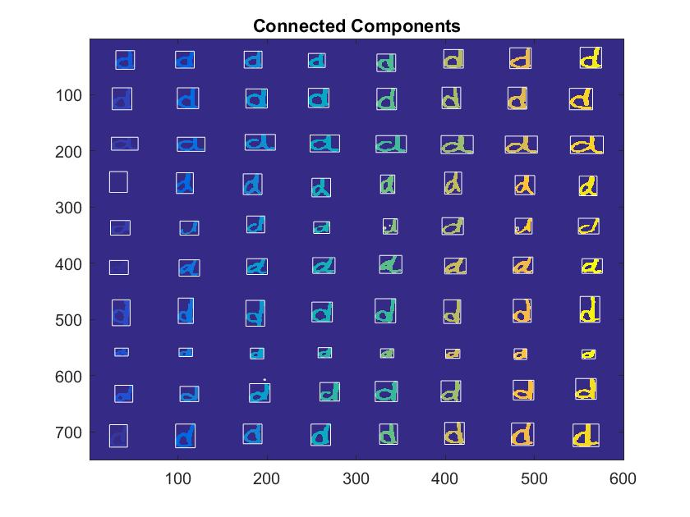

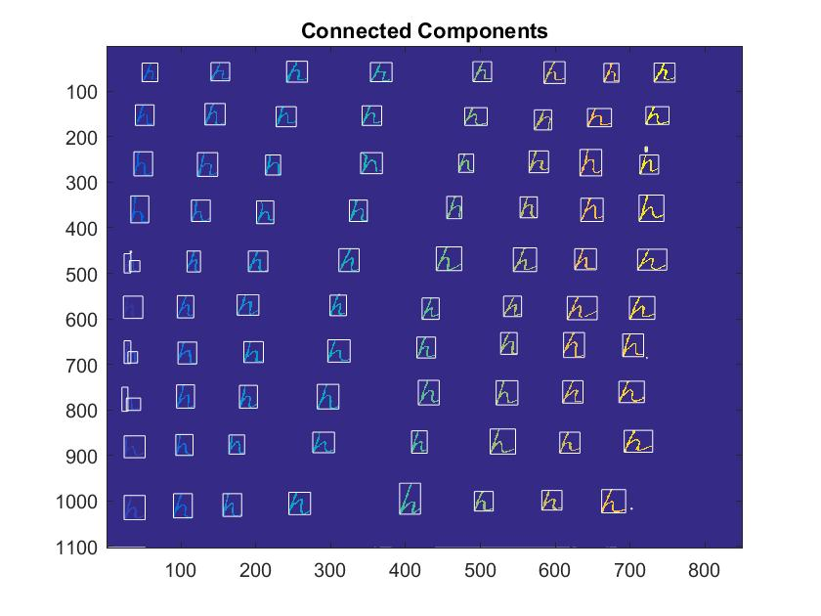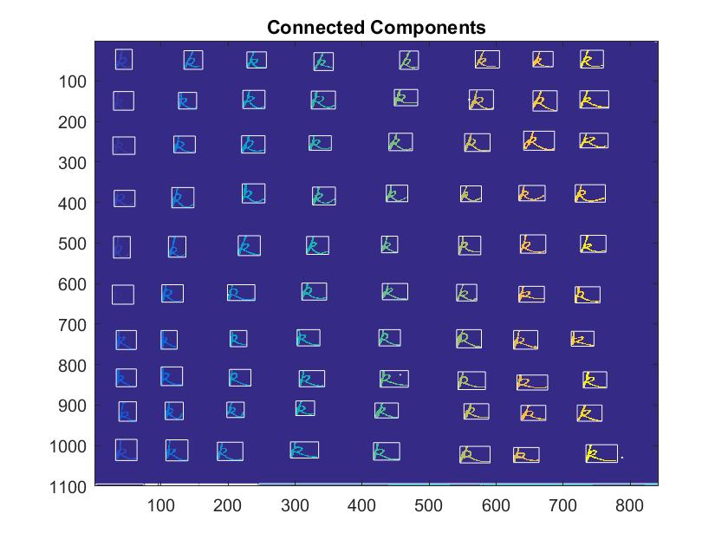 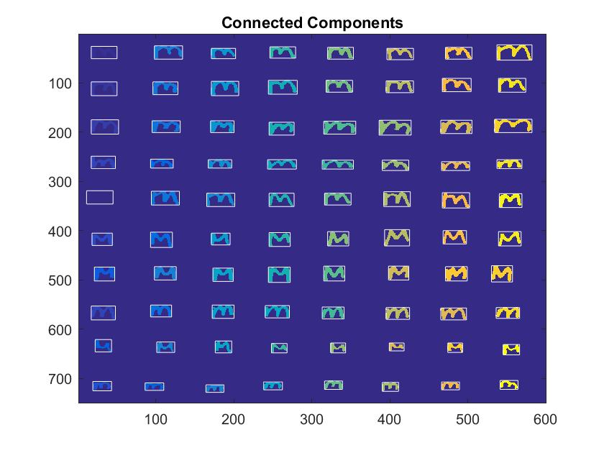

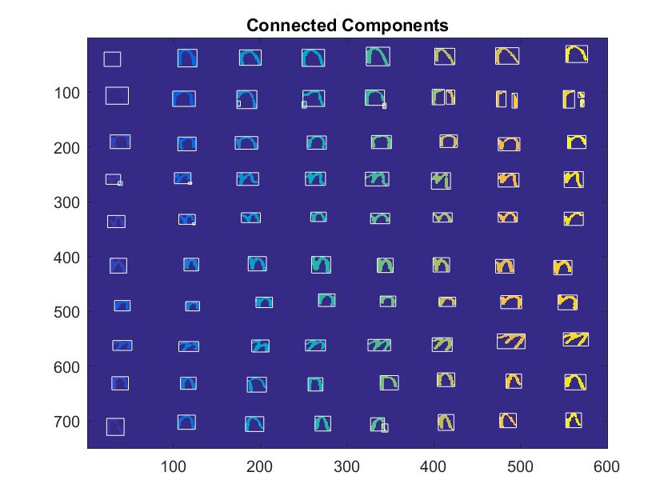 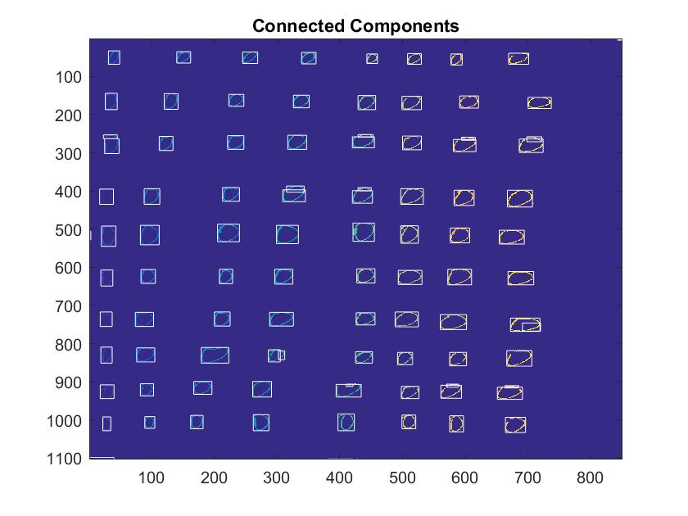

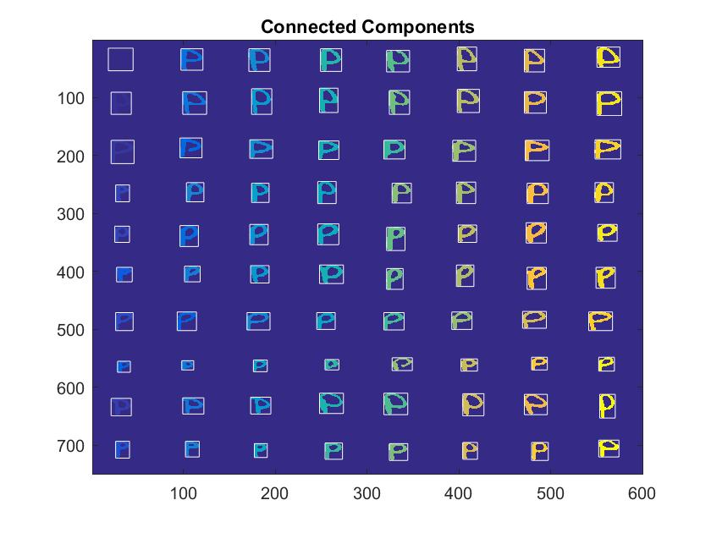 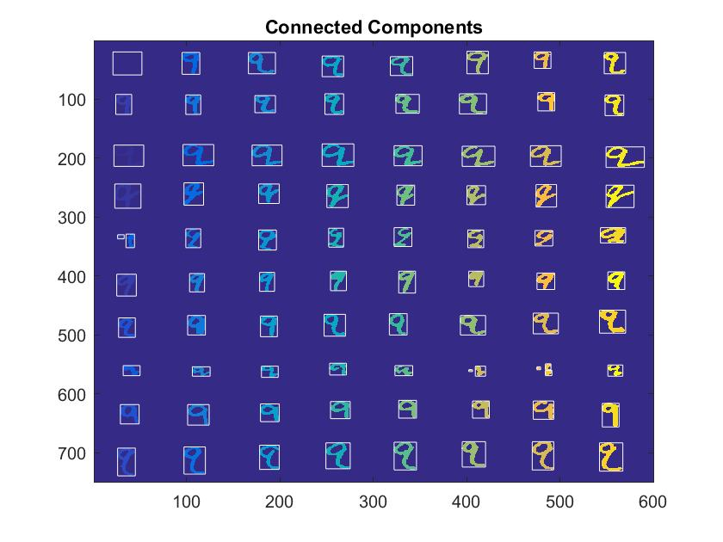

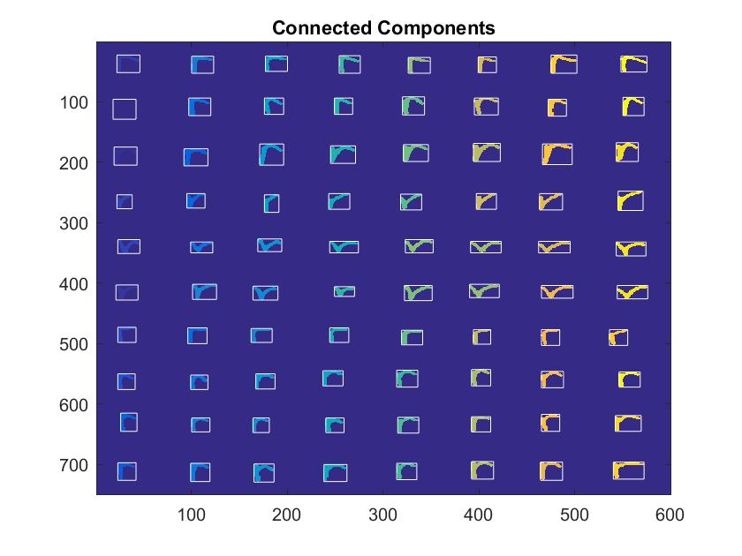 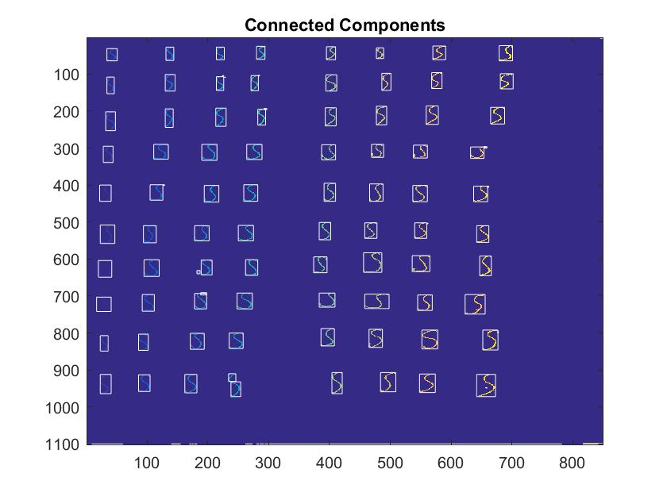

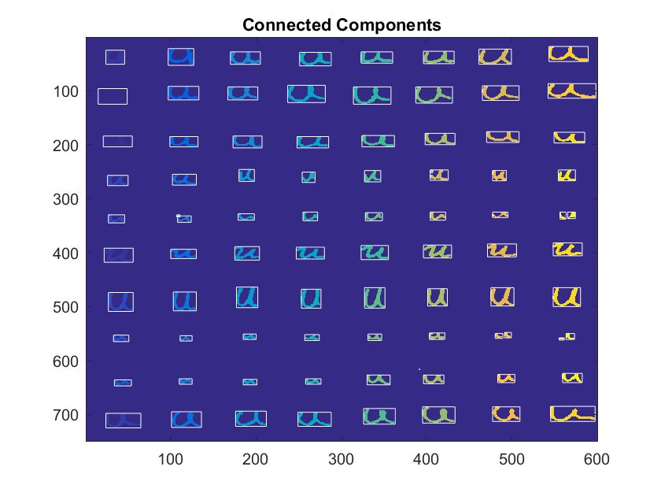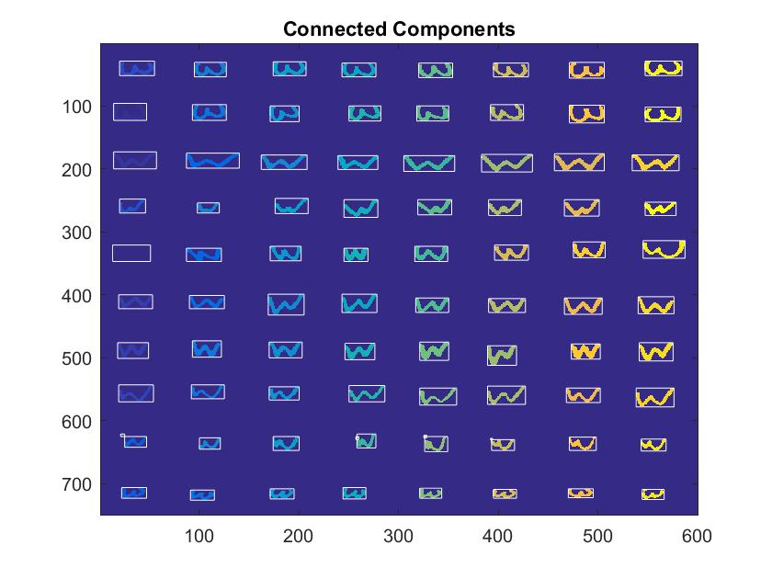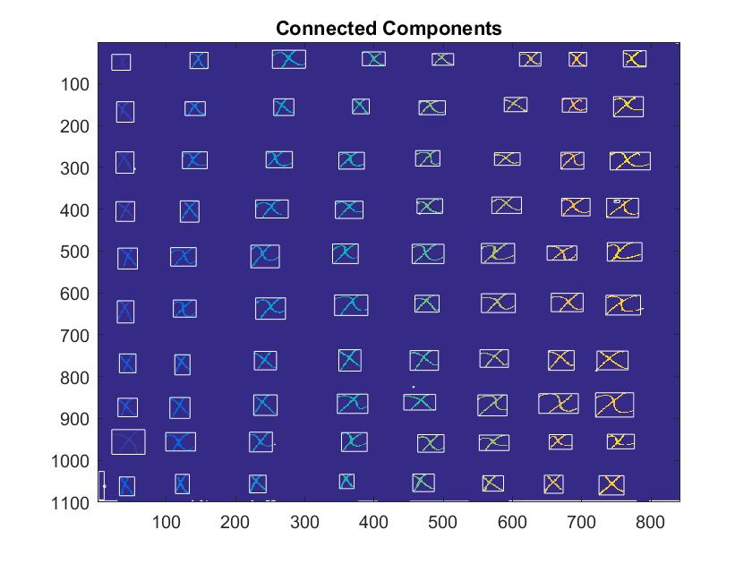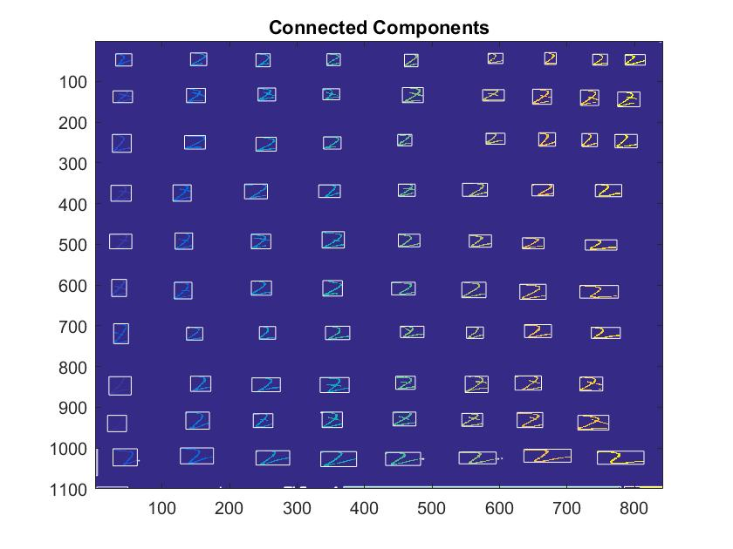

Recognition Phase

For test image 1

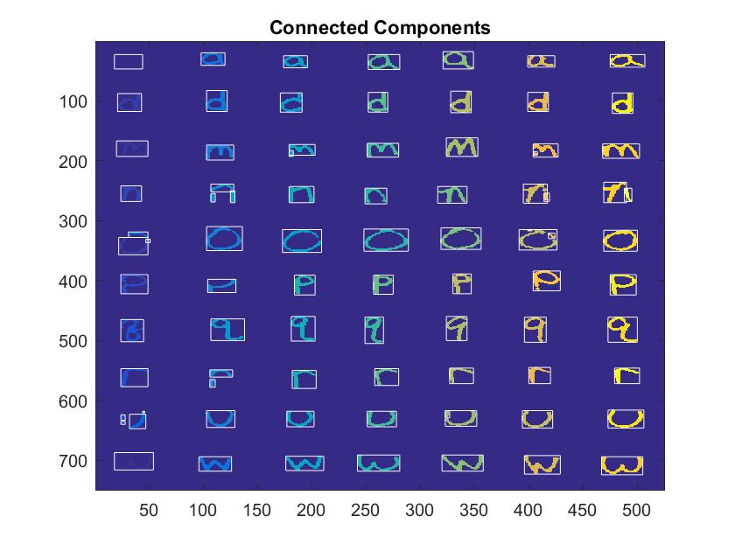

For test Image 2

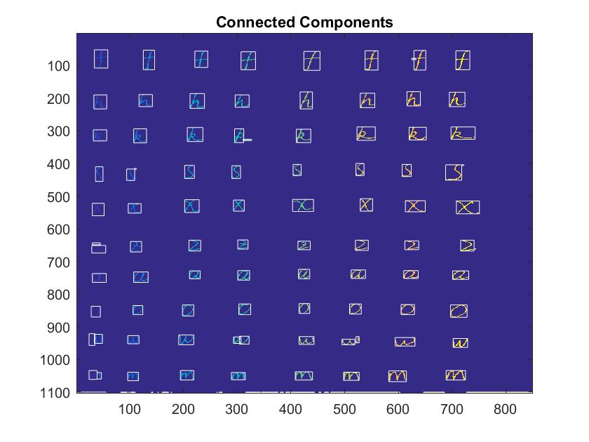

Recognition Rates and Other Values

I picked threshold = 200

Number of components for test1 = 85

Number of components for test2 = 109