Staff: Lyle Frank
Counsel to the Committee on Parks and Recreation

Patrick Mulvihill
Policy Analyst

Walter Pitts
Financial Analyst

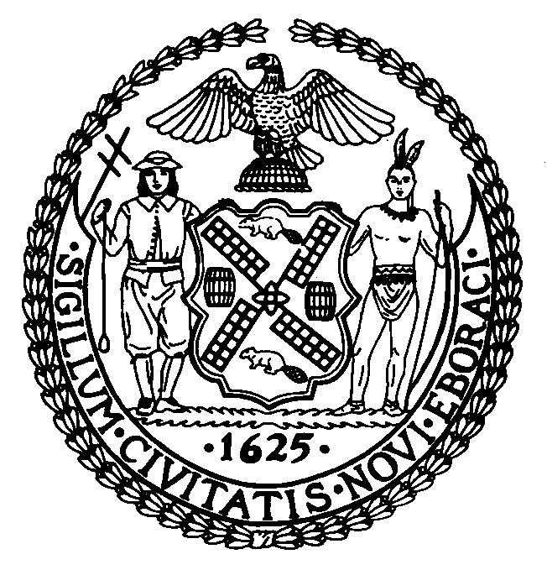

THE COUNCIL

BRIEFING PAPER OF THE INFRASTRUCTURE DIVISION
Robert Newman, Legislative Director

COMMITTEE ON PARKS AND RECREATION
Hon. Helen Diane Foster, Chairperson

April 1, 2009

“Street Co-naming April 1, 2009”

Proposed Int. No. 931-A By Council Members Arroyo, Comrie, DeBlasio, Gioia, Gonzalez, Ignizio, Jackson, Mealy, Palma, Reyna, Sanders, Jr., and Vacca

Title: A Local Law in relation to the naming of 18 thoroughfares and public places, Firefighter Peter A. Bielfeld Way, Borough of the Bronx, Citizens of Pozzallo Way, Borough of Brooklyn, Giorgio Perlasca Way, Borough of Brooklyn, Anthony Suraci Place, Borough of Queens, Jason Ruiz Way, Borough of Brooklyn, Lt Brendan D Pearson EMS Sta 23 Way, Borough of Staten Island, Thurgood Marshall Boulevard, Borough of Manhattan, Homer Young Kennedy Way, Borough of Manhattan, Lucille Bulger Place, Borough of Manhattan, Alexander Felix Place, Borough of Manhattan, Mother Gloria A. Boyce Way, Borough of Brooklyn, Franciscan Way, Borough of the Bronx, Reverend Dr. Jerry Mosby Way, Borough of the Bronx, Jose Sucuzhañay Place, Borough of Brooklyn, Joseph Albergo Way, Borough of Queens, Michael A. Clarke Avenue, Borough of Queens, Mother Teresa Way, Borough of the Bronx, Poor Freddie’s Avenue, Borough of Queens and the repeal of section 38 of local law number 28 for the year 2007 and the repeal of section 21 of local law number 64 for the year 2008.

Comment:
On April 1, 2009, the Committee on Parks and Recreation will hold a hearing to consider a bill co-naming eighteen (18) thoroughfares and public places. This is the second hearing on the bill. The Council acts upon the authority granted in subdivision (b) of section 25-102.1 of the New York City Administrative Code which states:

b. Unless the local law specifically provides otherwise, any local law
changing the name of a street, park, playground or portion thereof, or
any facility or structure, located and laid out on the city map, that
bears a name indicated on the city map shall not be construed to require
a change in such name as it is indicated on the city map; provided,
however, that in the case of a local law changing the name of a street
or portion thereof, the name added by such local law shall be posted on
a sign placed adjacent to or near a sign bearing the name of such street
or portion thereof indicated on the city map.

The following street name changes are not to be construed as a change in the City
Map, but as additional names to be posted near or adjacent to the street or location indicated on the City Map.

Section 1. Firefighter Peter A. Bielfeld Way
Introduced by Council Member Arroyo
Died September 11, 2001
Firefighter Peter A. Bielfeld was a member of Ladder 42, Engine 73 who was killed in the September 11th attacks.

Section 2. Citizens of Pozzallo Way
Introduced by Council Member DeBlasio
The Society of the Citizens of Pozzallo was founded in 1919. This organization has provided assistance to the poor and underprivileged by promoting the advancement of education and by contributing to other organized institutions of science and medical research.

Section 3. Giorgio Perlasca Way
Introduced by Council Member DeBlasio
January 31, 1910 – August 15, 1992
Giorgio Perlasca worked for Angel Sanz-Briz during WWII issuing protective passes to Budapest’s Jewish population. He was put in charge of the safe houses sheltering Jews from deportation and the Arrow Cross militia. He also worked with Raoul Wallenberg, Friedrich Born, from the International Red Cross, and Angelo Rotta, from the Vatican, in issuing protective passes. It is estimated that Giorgio Perlasca saved approximately 3,500 Hungarian Jews and was awarded honorary citizenship in Israel, the Medaglia d’ Oro al Valor Civile from Italy, the Star of Merit from Hungary and also laid the first stone of the Holocaust Museum in Washington. The location of the co-naming is in an area of Brooklyn having a large Jewish and Holocaust Survivor community.

Section 4. Anthony Suraci Place
Introduced by Council Member Gioia
Died in September, 2006
Anthony Suraci lived with his wife in Sunnyside, Queens, for over 60 years where he served as President of the Thompson Hill Civic Association, District Leader and held a number of annual charity events for needy families through the United Republicans of Western Queens.

Section 5. Jason Ruiz Way
Introduced by Council Member Gonzalez
January 11, 1978 – September 4, 2008
Jason Ruiz was an FDNY Emergency Medical Technician (EMT) whose brave actions included rescuing a woman who fell on the subway tracks at Marcy and Myrtle Avenues. He was awarded a medal for meritorious acts in 2006 and 2007.

Section 6. Lt Brendan D Pearson EMS Sta 23 Way
Introduced by Council Member Ignizio
Died April 23, 2005
Lt. Brendan Drew Pearson was an EMT for 25 years. Promoted to Lieutenant when the New York Health and Hospital Corporation merged with the Fire Department, he won five “Lieutenant of the Year Awards” and was one of the first EMT Lieutenants to staff the Rossville Firehouse.

Section 7. Thurgood Marshall Boulevard
Introduced by Council Member Jackson
July 2, 1908 – January 24, 1993
Thurgood Marshall was an American jurist and the first African-American to serve on the United States Supreme Court. He served for 24 years compiling a liberal record that included strong support for Constitutional protection of individual rights.

Section 8. Homer Young Kennedy Way
Introduced by Council Member Jackson
Died September 1, 2004
Homer Young Kennedy was a resident of New York City for 25 years and contributed to the Inwood community. He was responsible for locking and unlocking the Indian Road Playground and also contributed to the revival of Drums Along the Hudson, Uptown Arts Stroll, and became the Assistant Chair of the Parks and Cultural Affairs Committee for Community Board 12.

Section 9. Lucille Bulger Place
Introduced by Council Member Jackson
September 26, 1912 – October 6, 2007
Lucille Bulger was a neighborhood leader and the founder and long-time Executive Director of the Community League of the Heights. The organization was originally created to offer programs and services for the neighborhoods youth, but was later expanded to provide social services, affordable housing, health care, summer jobs and youth programs, as well as food for the hungry.

Section 10. Alexander Felix Place
Introduced by Council Member Jackson
January 8, 1976 – July 2, 2007
Alexander Felix was a long-time resident of Washington Heights and served as an Auxiliary Officer for the 30th Precinct from 1996 until 2004. In that time, he received Observer Police Officer for the Year in 1997 for his dedication and community service. In June 2004, he joined the Police Academy and served in the Tracer Unit in the 30th Precinct making over 100 arrests. In 2007, he was accepted into the elite Patrol of Manhattan’s North Grand Larceny Unit. He was killed by a drunk driver on the morning he was supposed to start with his new unit.

Section 11. Mother Gloria A. Boyce Way
Introduced by Council Member Mealy
Gloria A. Boyce served the central Brooklyn area for over forty years. She was a member of the Brownsville Community Council Board, the Community Progress Center, the Marcus Garvey Urban Renewal and founded the LaVaughn Moore Day Care Center, in East New York, as well as the Northeast Brooklyn Block Association.

Section 12. Franciscan Way
Introduced by Council Member Palma
This street co-naming will honor the contribution and service that the Friars and Sisters of the Franciscan Order have provided the Soundview and Classon Point communities for nine decades including both spiritual and educational support.

Section 13. Reverend Dr. Jerry Mosby Way
Introduced by Council Member Palma
December 11, 1947 – November 18, 2007
Reverend Dr. Jerry Mosby was the Pastor for the Fellowship Covenant Church in the Bronx and a very active member of the community. He also served as the Community Chaplain for the 43rd Precinct and was a retired Pastor for the Bronx Network Health and Hospital Corporation. He was also vital in organizing Hurricane Relief Drives in the community, most memorable being Katrina.

Section 14. Jose Sucuzhañay Place
Introduced by Council Member Reyna
Jose Sucuzhañay was the co-owner of Open Realty International, a real estate agency in Bushwick. He was a gentle, generous man and the father of two children who live with his parents in Azogues, Ecuador. He was the victim of a hate crime when he was walking home with his brother early one morning and three men began shouting anti-gay and anti-Hispanic slurs. When Jose threatened to call the police, he was severely beaten with a baseball bat and died a few days later.

Section 15. Joseph Albergo Way
Introduced by Council Member Sanders, Jr.
Joseph Albergo was one of the most active residents of Rosedale for half a century. He served as Treasurer for Community Board 13 and was involved in various projects throughout the community. In addition, he served as president of Community School Board 29 for many years. In addition, Joseph served on the Rosedale Ambulance Corps, the Rosedale Civic Association, the Rosedale Lions Club and the Rosedale Nutrition Club.

Section 16. Michael A. Clarke Avenue
Introduced by Council Member Sanders, Jr.
Michael A. Clarke was very active in his community and also in the First Presbyterian Church. He will be most remembered for his artistic talents involving his camera coverage at Ground Zero in 2001 and the crash of American Airlines Flight 587 in Belle Harbor.

Section 17. Mother Teresa Way
Introduce by Council Member Vacca
August 26, 1910 – September 5, 1997
Mother Teresa was one of the leading humanitarian figures of the 20th Century. She settled in India and spent over 45 years ministering to the poor, sick, orphaned and dying through the Missionaries of Charity, an organization she founded. She was awarded the Nobel Peace Prize in 1979 and in 2003. Her memory bears special significance within Albanian-American communities, such as along Pelham Parkway in the Bronx.

Section 18. Poor Freddie’s Avenue
Introduced by Council Member Comrie
Freddie Dill, Sr. was not only a role model for entrepreneurs, but also a valued and active member of his community. He has been honored by various community leaders, politicians and those who he had helped over the years. When he moved to Jamaica, Queens, he started working at a gas station where he met Clarence Shackelford who owned a landscaping business. Shackelford became very fond of Freddie and taught him the trade of landscaping. From that point on, Freddie became a successful business owner by running a towing service, a tire center, a take-out and catering establishment and finally, an auto center. Freddie Dill, Sr. was a kind and soft-spoken man whose aim was to up-lift the spirits of the people living in the community.

Section 19. The REPEAL of Section 38 of Local Law number 28 for the year 2007. This section repeals Section 38 of Local Law number 28 for the year 2007.

Section 20. The REPEAL of Section 21 of Local Law number 64 for the year 2008. This section repeals Section 21 of Local Law number 64 for the year 2008.

