Staff: Kris Sartori
Counsel to the Committee on Parks and Recreation

Patrick Mulvihill
Policy Analyst

Chima Obichere
Financial Analyst

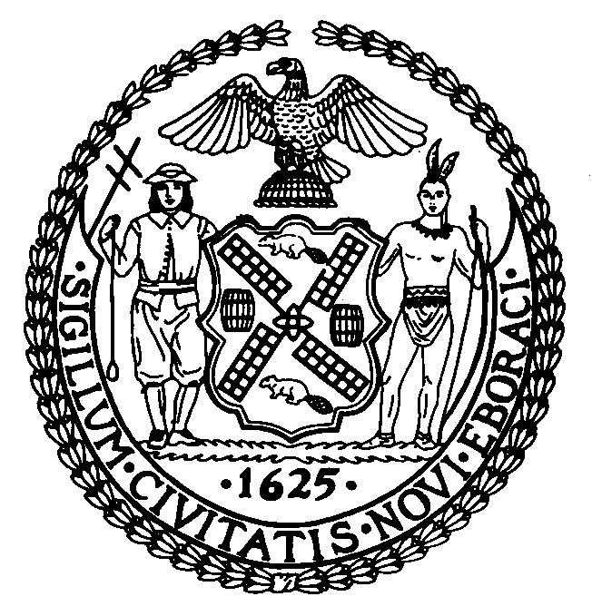

THE COUNCIL

BRIEFING PAPER OF THE INFRASTRUCTURE DIVISION
Robert Newman, Legislative Director

COMMITTEE ON PARKS AND RECREATION
Hon. Melissa Mark-Viverito, Chairperson

March 23, 2011

Int. No. 417 By Council Members Koppell, Foster and Van Bramer

Title: A Local Law in relation to renaming one thoroughfare in the Borough of the Bronx, Southern Boulevard, and to amend the official map of the city of New York accordingly and co-naming one thoroughfare Dr. Theodore Kazimiroff Boulevard in the Borough of the Bronx.

Proposed Int. No. 446-A By The Speaker (Council Member Quinn) Council Members Brewer, Cabrera, Fidler, Gentile, Koslowitz, Nelson, Sanders, Jr., Gennaro, Weprin and Koo (in conjunction with the Mayor)

Title: A Local Law in relation to the naming of Ed Koch Queensboro Bridge.

INTRODUCTION
The Committee on Parks and Recreation met on March 22, 2011 to consider Int. No. 417, A Local Law in relation to renaming one thoroughfare in the Borough of the Bronx, Southern Boulevard, and to amend the official map of the city of New York accordingly and co-naming one thoroughfare Dr. Theodore Kazimiroff Boulevard in the Borough of the Bronx and Proposed Int. No. 446-A, A Local Law in relation to the naming of the Ed Koch Queensboro Bridge. At this meeting, the Committee voted 7-0 in favor of Int. No 417 and 6-1 in favor of Proposed Int. No. 446-A.
BACKGROUND
Int. No. 417 permanently changes the name of Dr. Theodore Kazimiroff Boulevard Fordham Road to Allerton Avenue in the Borough of the Bronx, to Southern Boulevard and amends the New York City Map accordingly. The bill then co-names that portion of what would now be Southern Boulevard as Dr. Theodore Kazimiroff Boulevard.
On May 9, 1981, the northern portion of Southern Boulevard was renamed Dr. Theodore Kazimiroff Boulevard. Since then, the renaming has been confusing and problematic for communities and institutions adjacent to this roadway. Dr. Theodore Kazimiroff Boulevard and Southern Boulevard have never been recognized as one and the same, as some streets, such as, Avenue of the Americas, which is still recognized as Sixth Avenue. The confusion has led to missed postal deliveries, difficulties for the New York Police Department (NYPD) in taking accident reports and providing directions, as well as delays in fire response.
The United States Postal Service continues to recognize the Southern Boulevard designation. A number of letters and resolutions from the affected Community Boards, FDNY Battalion, local police precinct, cultural and educational institutions, civic associations and the community have urged that the name should be changed back to Southern Boulevard.
Dr. Theodore Kazimiroff Boulevard (Int. No. 417)
May 22, 1914 – March 19, 1980
Dr. Theodore Kazimiroff was born May 22, 1914, in the borough of the Bronx. He attended James Monroe High School and was graduated with honors from Manhattan College in 1936. He was an associate professor on the faculty of the New York University Dental College where he had received his DDS degree in 1940.
He founded the Bronx County Historical Society in 1955 and served as its first president. Dr. Kazimiroff was appointed official Bronx historian by then Borough President James J. Lyons. He organized the excavation of the Revolutionary War sites in Pelham Bay Park and he also was the leader in the drive to save the Valentine-Varian House which is now the Museum of Bronx History.
Dr. Kazimiroff was a consultant to the New York Botanical Garden, the Bronx Zoo, the Museum of Natural History and the Museum of American Indians and was a fellow of the New York Zoological Society. He was made president of the Kingsbridge Historical Society in 1974 and that same year received a Distinguished Service Award from the New York Botanical Garden.

Ed Koch Queensboro Bridge (Proposed Int. No. 446-A)
Proposed Int. No. 446-A would permanently change the name of the “Queensboro Bridge” to the “Ed Koch Queensboro Bridge,” and would amends the New York City Map accordingly.
Edward Irving Koch, the 105th Mayor of New York City, was born in the Bronx in 1924. During the Great Depression, his family moved to Newark, New Jersey and later moved to Ocean Parkway in Brooklyn. He interrupted his studies at City College, to serve in the United States Army during World War II and became a decorated combat infantryman who achieved the rank of Sergeant.
In 1948, he received his law degree from New York University Law School and became an active member of the Greenwich Village Independent Democrats. He was also a campaign volunteer for Democratic Party presidential candidate Adlai Stevenson in 1952 and 1956. In 1963, Koch ran successfully for district leader against Carmine DeSapio and was reelected in 1965. Koch was elected to the New York City Council in 1966.
In 1968, Koch was elected to the United States House of Representatives for the 17th Congressional District, a district that had not elected a Democrat to Congress since 1934 and was reelected four times. In Congress, he served on the Banking and Currency Committee and the Appropriations Committee and was a congressional observer on the Emergency Financial Control Board which was established to deal with the City’s fiscal crisis of 1975. In addition, he spoke out strongly against the Vietnam War and for civil rights and championed aid for family assistance programs, health care for the elderly and mass transit.
He successfully sought the Democratic nomination for mayor in 1977 and defeated Mario Cuomo, who ran as the Liberal Party candidate, State Senator Roy Goodman, who ran as the Republican Party candidate, and several other candidates in the general election, making Koch the City’s 105th mayor.
In his inaugural address, Mayor Koch sent New Yorkers a message of redemption by saying, "These have been hard times. We have been drawn across the knife-edge of poverty. We have been shaken by troubles that would have destroyed any other city. But we are not any other city. We are the city of New York and New York in adversity towers above any other city in the world."
As Mayor, Koch tackled the City’s fiscal problems and sought to restore the City's credit through a series of budget cutting measures. This enabled the City to re-enter the bond market and raise capital funds. The City's economy began to improve as did the mood of many New Yorkers. Through his leadership, the City's budget doubled to $26 billion, with $19 billion being spent on capital projects throughout the 1980's. As his mayoralty progressed, he became known for his ebullient personality and his trademark greeting, “How'm I doin’?”
Ed Koch’s mayoralty was also highlighted by the infrastructure improvements his administration made to the City, including those to the Queensboro Bridge. Through the creation of the Bridge Rehabilitation Project (BRPR), followed by the biannual inspections to monitor the deterioration of bridge components, it was determined that the Queensboro Bridge was in need of comprehensive renovation to ensure the safety of motorists and the physical integrity of the structure. Initial rehabilitation work, which included the reconstruction of two approach viaducts in Queens, the reconstruction of the South Upper Roadway, the replacement of the movable maintenance platforms under the main bridge, the installation of Variable Message Signs at the entrance to approach ramps in Queens, the rehabilitation of the main bridge lower truss chords, the renovation of the main bridge pier tops and the replacement of two outer roadway floorbeams and deck at the Manhattan anchor pier, was completed during the remaining years of the Koch Administration, from 1981 to 1989. In fact, work on rehabilitating and maintaining the Queensboro Bridge is still an ongoing project.
Regarding the success of his mayoralty, it was once said that “He brought the energy and the discipline that remain today and are the basis of the confidence that people have in the city.”
Koch, was re-elected Mayor twice, in 1981 and 1985. He then attempted to be the City’s first four-term mayor by seeking reelection in 1989, but lost the Democratic primary to his eventual successor, then-Manhattan Borough President David Dinkins.
Since leaving office, Ed Koch has continued to remain extremely active in public life through practicing law in the City, lecturing, writing newspaper columns, hosting radio shows, being a political commentator on television and even serving as a television judge on the popular show, "The People's Court." He has also authored several books including a children’s book and several novels. Some of his books include His Eminence And Hizzoner, All The Best, Citizen Koch, Ed Koch On Everything, Giuliani: Nasty Man, I’m Not Done Yet: Remaining Relevant, Buzz: How to Create It and Win with It, All the Best: Letters from a Feisty Mayor and The Koch Papers: My Fight Against Anti-Semitism. Most recently, Ed Koch started the organization New York Uprising, which, according to information on its website, seeks to enact government reform on the State level by promoting ethics reform, non-partisan redistricting and responsible budgeting.

Int. No. 417

By Council Member Koppell, Foster and Van Bramer

A Local Law

In relation to renaming one thoroughfare in the Borough of the Bronx, Southern Boulevard, and to amend the official map of the city of New York accordingly and co-naming one thoroughfare Dr. Theodore Kazimiroff Boulevard in the Borough of the Bronx.

Be it enacted by the Council as follows:

Section 1. The following street name, in the Borough of the Bronx, is hereby renamed as hereafter indicated.

New Name | Present Name | Limits
Southern Boulevard | Dr. Theodore Kazimiroff Boulevard | From Fordham Road to Allerton Avenue

§2. The following street name, in the Borough of the Bronx, is hereby designated as hereafter indicated.

New Name | Present Name | Limits
Dr. Theodore Kazimiroff Boulevard | Southern Boulevard | From Fordham Road to Allerton Avenue

§3. The official map of the city of New York shall be amended in accordance with

the provisions of section one of this local law only.

§4. This local law shall take effect immediately.

PM
LS # 1097
9/24/10

Proposed Int. No. 446-A
By The Speaker (Council Member Quinn) and Council Members Brewer, Cabrera, Fidler, Gentile, Koslowitz, Nelson, Sanders, Jr., Gennaro, Weprin and Koo (in conjunction with the Mayor)

A Local Law

In relation to the naming of the Ed Koch Queensboro Bridge.

Be it enacted by the Council as follows:

Section 1. The following bridge located in the Boroughs of Manhattan and Queens is hereby designated as hereafter indicated.

New Name | Present Name
Ed Koch Queensboro Bridge | Queensboro Bridge

§2. The official map of the city of New York shall be amended in accordance with the provisions of section one of this local law.

§3. This local law shall take effect immediately.

KS
2/22/11

See Columbia University “Notable New Yorkers” website, http://www.columbia.edu/cu/lweb/digital/collections/nny/koche/profile.html
See, http://www.nyc.gov/html/nyc100/html/classroom/hist_info/mayors.html#koch
Id.
Id.
Id.
Id.
See New York City Department of Transportation website, http://www.nyc.gov/html/dot/html/bridges/qbrehab.shtml#eight, viewed on February 18, 2011.
Id.
Id.
See Forum: Ed Koch’s Legacy, November 14, 2005, available at http://www.gothamgazette.com/article//20051114/202/1652#3.
See supra note 2.
Id.
Id; see also Columbia University “Notable New Yorkers” website, http://www.columbia.edu/cu/lweb/digital/collections/nny/koche/profile.html
See Huffington Post, http://www.huffingtonpost.com/ed-koch.
See New York Uprising Website, http://www.nyuprising.org.

