Staff: Fredy H. Kaplan, Counsel
Patrick Mulvihill, Policy Analyst
Chima Obichere, Financial Analyst

The Council of the City of New York

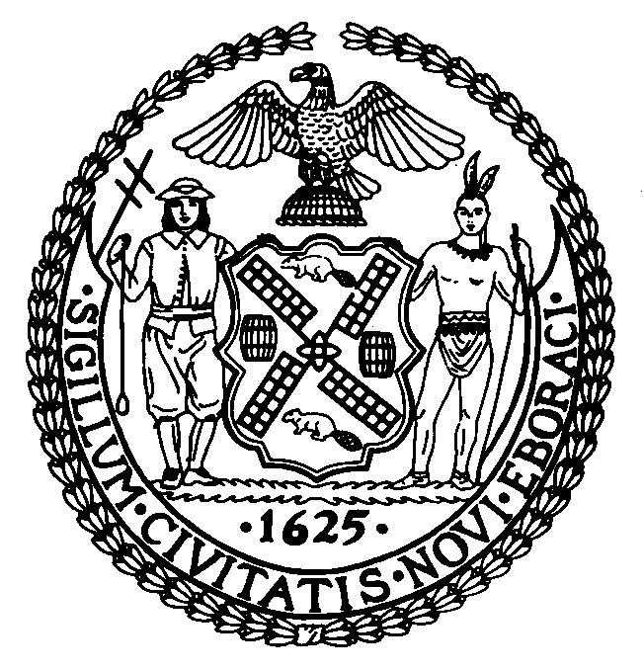

Briefing Paper of the Infrastructure Division
Robert Newman, Legislative Director

Committee on Parks and Recreation
Hon. Helen Diane Foster, Chair

June 15, 2006

“Street Renaming, June 15, 2006”

Int. No. 368-A By The Speaker (Council Member Quinn) and Council Members Gentile, Reyna, Monserrate and Dickens

Title: A local law in relation to the naming of five thoroughfares and
public places, Actors’ Equity Corner, Borough of Manhattan, Josephine Diana Blvd., Borough of Brooklyn, Rev. Msgr. Bryan J. Karvelis Way, Borough of Brooklyn and Sgt. Jose Gomez Place, Borough of Queens, Dr. Reverend Wyatt Tee Walker Square, Borough of Manhattan and the repeal of sections 3, 26 and 47 of local law number 13 for the year 2006.

On June 15, 2006, the Committee on Parks and Recreation will hold a hearing to

consider a bill renaming thoroughfares and public places.
Section 1. This section repeals section 3 of Local Law 13 of 2006 which enacted a co-naming of Rev. Bryan J. Karvelis Way. There was a typographical error which is corrected by section 6 of this bill.

Section 2. This section repeals section 26 of Local Law 13 of 2006 which enacted a co-naming of Josephine Diana Blvd. There was a sign location error which is corrected by section 5 of this bill.

Section 3. This section repeals section 47 of Local Law 13 of 2006 which enacted a co-naming of Actors Equity Corner. There was a typographical error which is corrected by section 4 of this bill.

Section 4. Actors’ Equity Corner

Introduced by The Speaker (Council Member Quinn)
The Actors’ Equity Association represents over 45,000 actors and stage manager in the United States. For 90 years, it has negotiated wages and working conditions providing a wide range of benefits including health and pension plans. It promotes and fosters the art of live theater as an essential part of our cultural life.

Section 5. Josephine Diana Blvd.

Introduced by Council Member Gentile
January 1954 – September 2, 2004
Josephine Diana migrated to the United States with her parents in 1955 and settled in Bensonhurst, Brooklyn. She married and had three children, all of whom attended Our Lady of Guadalupe School where Josephine was an active parent and volunteer all through her children’s education. Josephine really epitomized a community minded person by helping her neighbors at time of need and always assisting when something happened in her community.

Section 6. Rev. Msgr. Bryan J. Karvelis Way

Introduced by Council Member Reyna
Born in 1930 – October 18, 2005
Rev. Bryan J. Karvelis led the Parish of the Transfiguration and was a consummate pillar of the community who dedicated his life improving the neighborhood in a variety of ways. From his work in founding the Southside Mission to his help in opening Casa Betsaida, a residence for people in the community who are infected with the AIDS virus, Rev. Karvelis uplifted his parish by making sure residents had access to the services they needed. His effort and leadership strengthened the community.

Section 7. Sgt. Jose Gomez Place

Introduced by Council Member Monserrate
Died April 27, 2006
Sgt. Jose Gomez is a local hero. He gave his life for his country in Iraq on April 27, 2006, in a roadside bombing in Iraq. He was three months into his second tour of duty in Iraq with the 10th Calvary, 4th Brigade, 4th Infantry Division. According to Maj. Gen. Bill Grisoli, Sergeant Gomez moved his vehicle forward after an explosion to save and protect his fellow soldiers in the convoy. He received a purple heart and bronze star in honor of his heroic efforts. Sgt. Jose Gomez was born in the Dominican Republic and came to Corona, Queens at the age of three. His dream was to go to college and study mathematics to become an accountant.

Section 8. Dr. Reverend Wyatt Tee Walker Square

Introduced by Council Member Dickens
Born in 1929
Dr. Reverend Wyatt Tee Walker was born in 1929 in Brockton, Massachusetts and later earned his bachelor’s degree in 1950 from Virginia Union University in Richmond, Virginia. It was through his enrollment there that he met Dr. Martin Luther King Jr. and they attended the Crozer Theological Seminary together.
In 1960, Rev. Walker was appointed as the Executive Director of the Southern Christian Leadership Conference (SCLC). It was under the leadership of Walker that SCLC became a major national factor in the Civil Rights Movement. Rev. Walker is also responsible for $100 million in housing construction, as Chairman of the Consortium for Harlem Development. In addition to his pastoral duties, Rev. Walker was able to complete his doctoral dissertation, receiving his PhD. from Colgate Rochester Divinity School in 1975.
Dr. Reverend Wyatt Tee Walker was named one of the greatest African-American preachers in the nation, named by an Ebony Magazine poll in 1993. He is an author of twenty-one books, including Common Thieves and the Harvard Paper. Even today, the Canaan Baptist remains involved in the advocacy of senior citizens, housing and drug rehabilitation programs.

