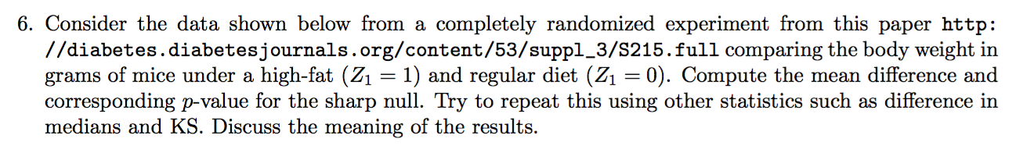

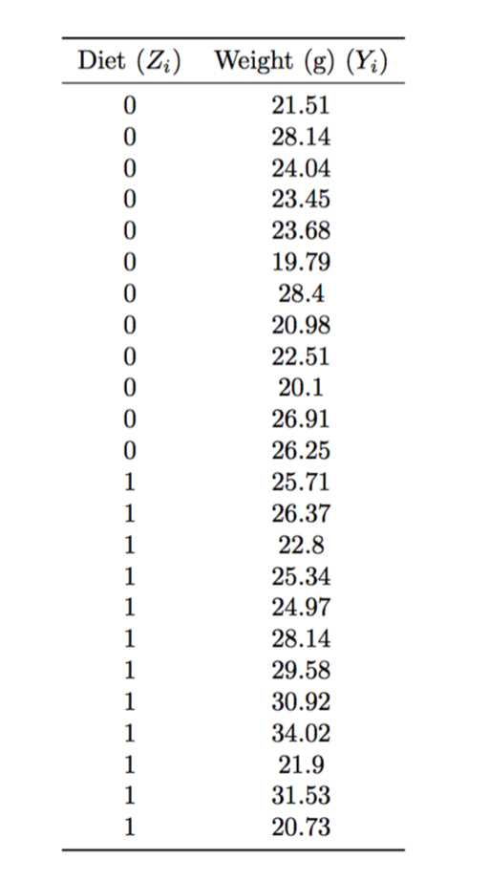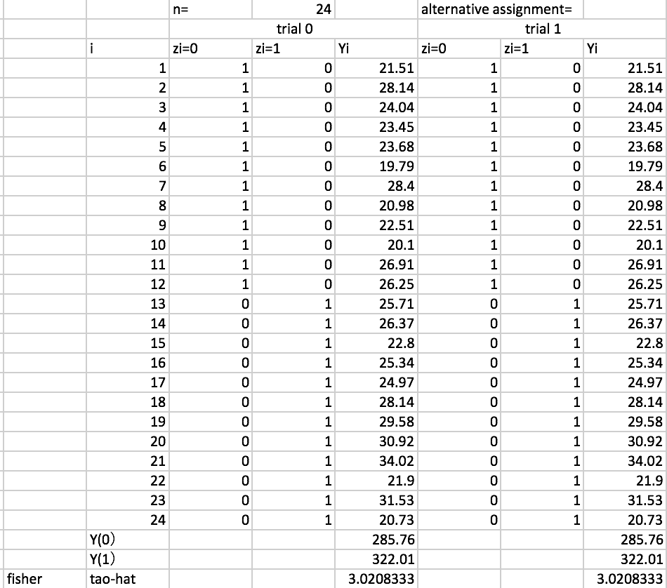

|  |
| --- |
| https://github.com/JessieJingxuGao/Causality-and-Learning-for-Intelligent-Decision-Making/blob/master/hw1-6-PermutationTest.ipynb |

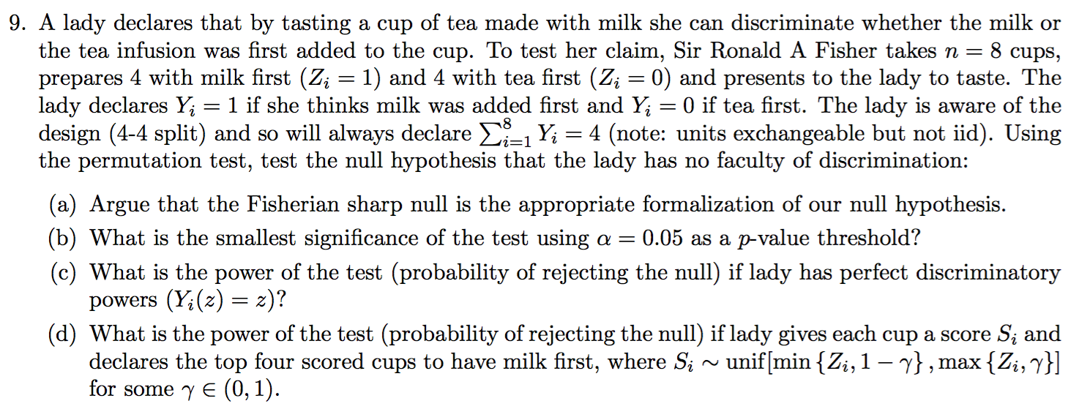

|  |
| --- |
| https://github.com/JessieJingxuGao/Causality-and-Learning-for-Intelligent-Decision-Making/blob/master/hw1-9-LadyTea.ipynb |