

**A Simulation Framework for Iterated Prisoner’s Dilemma Scenarios**

**By Jessica Boe**

**CSC-400 Dr. Antonios**

**Strategies**

**“Dumb”**

**“Intermediate”**

**“Advanced”**

**Cooperator Defector**

**Tit for Tat Adaptive Tit for Tat**

**Grudger Random Nydegger**

**Adaptive Pavlov**

**Revised Downing**

**Average Copier**

A player who always cooperates.

A player who always defects.

A player starts by cooperating and then mimics the previous action of the opponent.

A player who keeps track of how many times the opponent defects in order to employ a Tit for Tat strategy.

A player that starts by cooperating but will defect if at any point the opponent has defected.

A player who randomly chooses between cooperating and defecting with 0.5 probability of choosing either.

A player cooperates with the opponent’s cooperation ratio, starting with a random decision

The player uses a complex algorithm in order to decide what choice it should make, starting with Tit for Tat and then keeping track of opponent moves in order to decide what to do.

A player attempts to classify its opponent into cooperative, defective, random, or advanced strategies. It responds in a manner intended to achieve mutual cooperation or to defect against uncooperative opponents.

A player attempts to estimate the next move of the opponent by estimating the probability of cooperating given that they defected or cooperated on the previous round. These probabilities are continuously updated during play and the strategy attempts to maximize the long-term play.

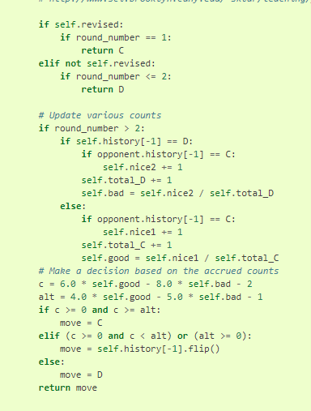

**ATFT - Adaptive Tit For Tat (Basic Model)**

if (opponent played C in the last cycle) then world = world + r*(1-world) else world = world + r*(0-world) If (world >= 0.5) play C, else play D

Attributes

**world :float [0.0, 1.0], set to 0.5**

continuous variable representing the world’s image 1.0 - total cooperation 0.0 - total defection other values - something in between of the above updated every round, starting value shouldn’t matter as long as it’s >= 0.5

**Nydegger**

The program begins with tit for tat for the first three moves, except that if it was the only one to cooperate on the first move and the only one to defect on the second move, it defects on the third move. After the third move, its choice is determined from the 3 preceding outcomes in the following manner.

*A*=16*a*1+4*a*2+*a*3A=16a1+4a2+a3

Where *ai*ai is dependent on the outcome of the previous *i*i th round. If both strategies defect, *ai*=3, if the opponent only defects: *ai*=2and finally if it is only this strategy that defects then *ai*=1.

*A*∈{1,6,7,17,22,23,26,29,30,31,33,38,39,45, 49,54,55,58,61}A∈{1,6,7,17,22,23,26,29,30,31,33,38,39,45,49,54,55,58,61}

Thus if all three preceding moves are mutual defection, A = 63 and the rule cooperates. This rule was designed for use in laboratory experiments as a stooge which had a memory and appeared to be trustworthy, potentially cooperative, but not gullible.

This strategy came 3rd in Axelrod’s original tournament.

*A*∈{1,6,7,17,22,23,26,29,30,31,33,38,39,45,49,54,55,58,61}

Thus if all three preceding moves are mutual defection, A = 63 and the rule cooperates. This rule was designed for use in laboratory experiments as a stooge which had a memory and appeared to be trustworthy, potentially cooperative, but not gullible. This strategy came 3rd in Axelrod’s original tournament.