Lab 5 Report

Name 盧家馨

Student ID 106598005

Date 2018/06/12

1. **Test Plan**
   1. **Summary**

This Lab aims to help students to learn the concepts of Load/Stress testing and to be familiar with a well-known open-source tool, called JMeter, for performance testing.

* 1. **Features to be tested**
     1. Login with Ramp-up
     2. Login without Ramp-up
     3. ISBN Search books
     4. ISBN Search books waiting all finished login
     5. Check in books / Check out books
     6. Check in books / Check out books waiting all finished login
  2. **Success criteria of completing the test**

All test script must be passed.

* 1. **Test environment and infrastructure**
* OS: macOS
* JMeter : v4.0
* Docker
  1. **Test approaches**

This lab use “user scenarios” and “workload” to design test case. For the Login scenarios, using 2, 4, 8, 16, 32, 64, 128, 256, 512 and 1024 people with ramp-up and without ramp-up. For ISBN Search books, using javascript to generate random ISBN with 2, 4, 8, 16, 32, 64, 128, 256, 512 and 1024 people, with waiting all finished login and without waiting all finished login. For Check in/out books, using javascript to generate random book code with 2, 4, 8, 16, 32, 64, 128 and 256 people, with waiting all finished login and without waiting all finished login.

* 1. Testing tasks

To implement the proposed strategy, the following activities are planned to perform.

|  |  |  |  |
| --- | --- | --- | --- |
| No. | Activity Name | Plan hours | Schedule Date |
| 1 | Study Jmeter | 4 | 2018/06/08 |
| 2 | Install and use docker for environment | 2 | 2018/06/09 |
| 3 | Design test cases for the features | 4 | 2018/06/09 |
| 4 | Implement test cases | 4 | 2018/06/10 |
| 5 | Perform test | 6 | 2018/06/11 |
| 6 | Complete Lab5 report | 3 | 2018/06/12 |

1. **Test Design**

|  |  |
| --- | --- |
| Scenario: Login | |
| Preconditions | Loading user data with account and password |
| Input actions | 1. User login into library system 2. User logout |
| Expected output | 1.Verify response status is “success” and authority is “2’  2.Verify text response is “success” |
| Design of workload | The number of users is 2  The number of users is 4  The number of users is 8  The number of users is 16  The number of users is 32  The number of users is 64  The number of users is 128  The number of users is 256  The number of users is 512  The number of users is 1024 |

|  |  |
| --- | --- |
| Scenario: Login with ramp-up | |
| Preconditions | Loading user data with account and password |
| Input actions | 1. User login into library system 2. User logout |
| Expected output | 1. Verify response status is “success” and authority is “2’ 2. Verify text response is “success” |
| Design of workload | The number of users is 2, and the ramp-up period is 1 sec.  The number of users is 4, and the ramp-up period is 1 sec.  The number of users is 8, and the ramp-up period is 1 sec.  The number of users is 16, and the ramp-up period is 1 sec.  The number of users is 32, and the ramp-up period is 1 sec  The number of users is 64, and the ramp-up period is 1 sec  The number of users is 128, and the ramp-up period is 1 sec  The number of users is 256, and the ramp-up period is 10 sec  The number of users is 512, and the ramp-up period is 20 sec  The number of users is 1024, and the ramp-up period is 40 sec |

|  |  |
| --- | --- |
| Scenario: ISBN search books | |
| Preconditions | Loading user data with account and password |
| Input actions | 1. User login into library system 2. Search book with ISBN 3. User logout |
| Expected output | 1. Verify response status is “success” and authority is “2’ 2. Verify response code is 200 3. Verify text response is “success” |
| Design of workload | The number of users is 2, and the ramp-up period is 1 sec.  The number of users is 4, and the ramp-up period is 1 sec.  The number of users is 8, and the ramp-up period is 1 sec.  The number of users is 16, and the ramp-up period is 1 sec.  The number of users is 32, and the ramp-up period is 1 sec  The number of users is 64, and the ramp-up period is 1 sec  The number of users is 128, and the ramp-up period is 1 sec  The number of users is 256, and the ramp-up period is 10 sec  The number of users is 512, and the ramp-up period is 20 sec  The number of users is 1024, and the ramp-up period is 40 sec |

|  |  |
| --- | --- |
| Scenario: ISBN search books waiting all finished login | |
| Preconditions | Loading user data with account and password |
| Input actions | 1. User login into library system 2. Wait for all the users finished login 3. Search book with ISBN 4. User logout |
| Expected output | 1. Verify response status is “success” and authority is “2’ 2. Verify response code is 200 3. Verify text response is “success” |
| Design of workload | The number of users is 2, and the ramp-up period is 1 sec.  The number of users is 4, and the ramp-up period is 1 sec.  The number of users is 8, and the ramp-up period is 1 sec.  The number of users is 16, and the ramp-up period is 1 sec.  The number of users is 32, and the ramp-up period is 1 sec  The number of users is 64, and the ramp-up period is 1 sec  The number of users is 128, and the ramp-up period is 1 sec  The number of users is 256, and the ramp-up period is 10 sec  The number of users is 512, and the ramp-up period is 20 sec  The number of users is 1024, and the ramp-up period is 40 sec |

|  |  |
| --- | --- |
| Scenario: Check in books / Check out books | |
| Preconditions | Loading user data with account and password |
| Input actions | 1. User login into library system 2. Enter account 3. Check in books with book code 4. Check out books with same book code 5. User logout |
| Expected output | 1. Verify response status is “success” and authority is “2’ 2. Verify text response is “success” |
| Design of workload | The number of users is 2, and the ramp-up period is 1 sec.  The number of users is 4, and the ramp-up period is 1 sec.  The number of users is 8, and the ramp-up period is 1 sec.  The number of users is 16, and the ramp-up period is 1 sec.  The number of users is 32, and the ramp-up period is 1 sec  The number of users is 64, and the ramp-up period is 10 sec  The number of users is 128, and the ramp-up period is 20 sec  The number of users is 256, and the ramp-up period is 40 sec |

|  |  |
| --- | --- |
| Scenario: Check in books / Check out books waiting all finished login | |
| Preconditions | Loading user data with account and password |
| Input actions | 1. User login into library system 2. Wait for all the users finished login 3. Enter account 4. Check in books with book code 5. Check out books with same book code 6. User logout |
| Expected output | 1. Verify response status is “success” and authority is “2’ 2. Verify text response is “success” |
| Design of workload | The number of users is 2, and the ramp-up period is 1 sec.  The number of users is 4, and the ramp-up period is 1 sec.  The number of users is 8, and the ramp-up period is 1 sec.  The number of users is 16, and the ramp-up period is 1 sec.  The number of users is 32, and the ramp-up period is 1 sec  The number of users is 64, and the ramp-up period is 10 sec  The number of users is 128, and the ramp-up period is 20 sec  The number of users is 256, and the ramp-up period is 40 sec |

1. **Test Implementation**

There are upload in the Lab5 folder in gitlab.

1. **Test Results**
   1. **Jmeter snapshot**

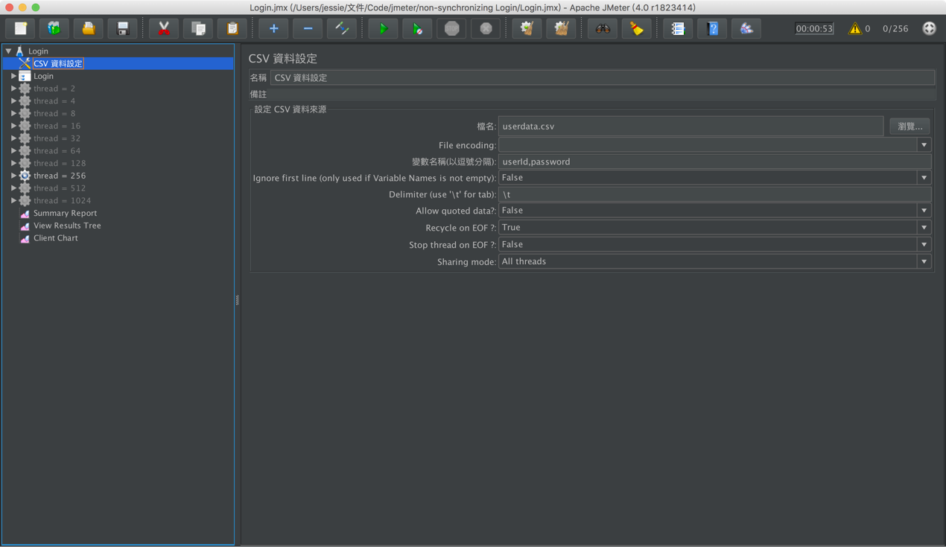

* 1. **Summary Report**
* Login with Ramp-up



* Login without Ramp-up



* ISBN Search books



* ISBN Search books waiting all finished login



* Check in books / Check out books

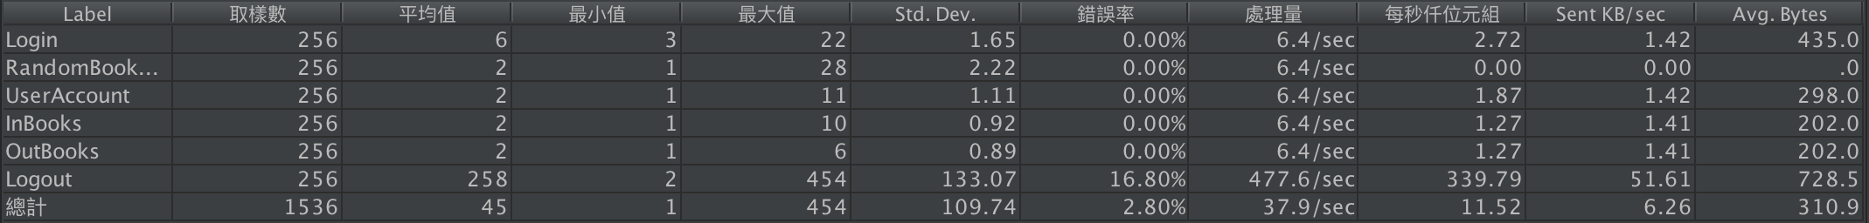

* Check in books / Check out books waiting all finished login

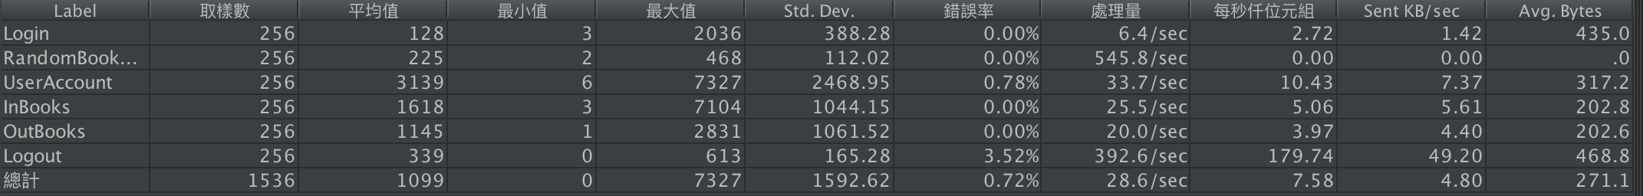

* 1. **Client Chart**
* Login with Ramp-up

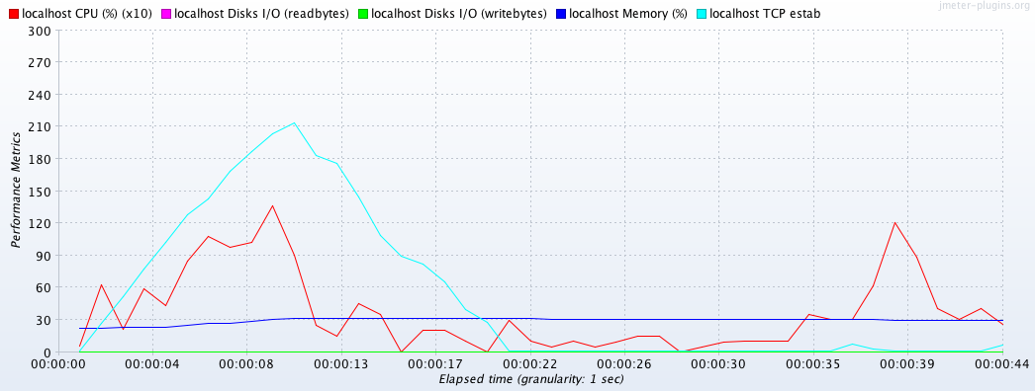

* Login without Ramp-up

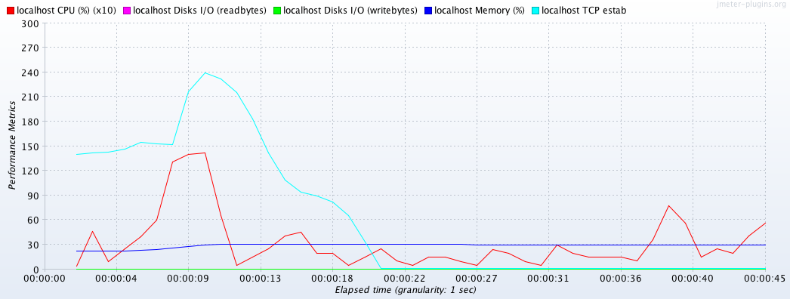

Compare: At the beginning, login with Ramp-up, the TCP estab gradually increase not like login without Ramp-up.

* ISBN Search books

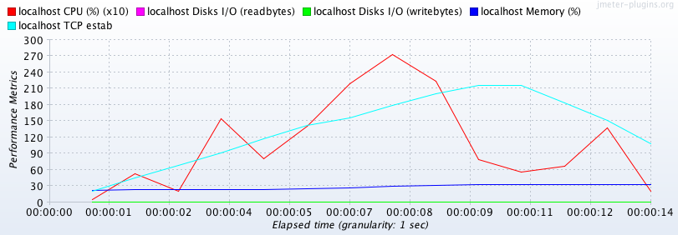

* ISBN Search books waiting all finished login

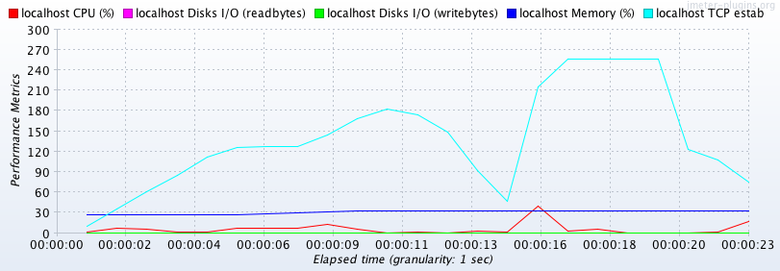

Compare: The CPU performance is much higher than with waiting all finished login.

* Check in books / Check out books

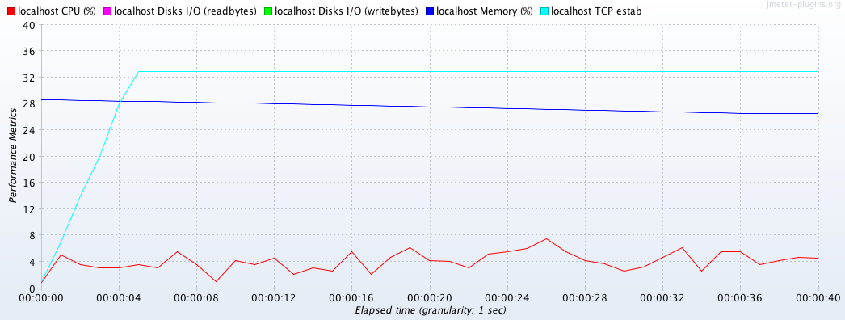

* Check in books / Check out books waiting all finished login

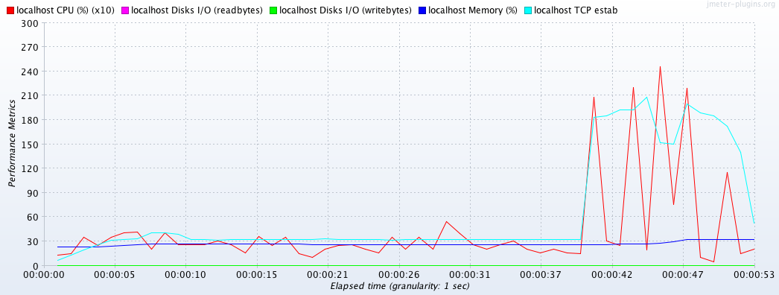

Compare: The CPU and estab dramatically increase with waiting all finished login.