

Complete Documentation: Pharmacy Search and Route Calculation

I. Backend - Route /get_pharmacies 2
I.1. Operation 2
I.2. Tips 3
II. Frontend - InsufficientStock Component 4
II.1. Workflow 4
II.2. Key Features 4
II.3. Distance Calculation 4
III. Backend - Route /get_direction 5
III.1. Objective 5
III.2. Operation 5
III.3. Common Errors 5
IV. Frontend - DirectionsMapPage Component 7
IV.1. Workflow 7
IV.2. Path Decoding 7
IV.3. Map Management 7
V. Code Snippet Examples 8
V.1. Backend - Haversine 8
V.2. Frontend - Cache 8
VI. Essential Tips 9
VI.1. Security 9
VI.2. Performance 9
VI.3. Mobile UX 9
VI.4. Keyboard Ergonomics 9
VII. Global Explanations 10
VII.1. Architecture 10
VII.2. Best Practices 10
VII.3. Alternatives 10
VII.4. Points of Attention 10

I. Backend - Route /get_pharmacies

Objective:
Find pharmacies near a geographic location.

I.1. Operation

1. Parameters

- lat (required): Latitude of the search point
- lon (required): Longitude of the search point
- radius (optional): Search radius in meters (default: 1000m)

2. Process

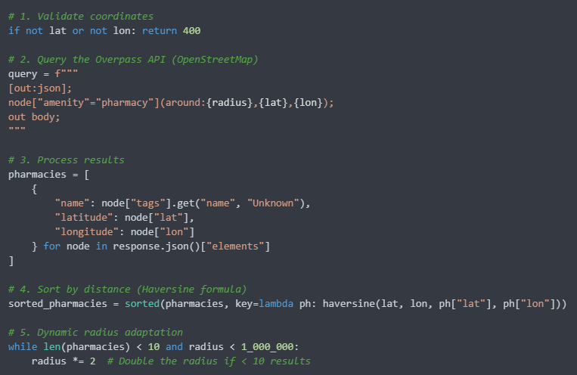

3. Responses

- 200 OK: List of pharmacies (max 10)
- 400 Bad Request: Missing coordinates
- 404 Not Found: No pharmacies found
- 500 Internal Error: Overpass API error

I.2. Tips

- Use a timeout (e.g., 10s) to avoid blocking
- Filter pharmacies without a name ("Unknown")
- The Haversine formula is optimized for short distances

II. Frontend - InsufficientStock Component

II.1. Workflow

1. Get user position via navigator.geolocation
2. Call /get_pharmacies with coordinates
3. Display results in an interactive modal

II.2. Key Features

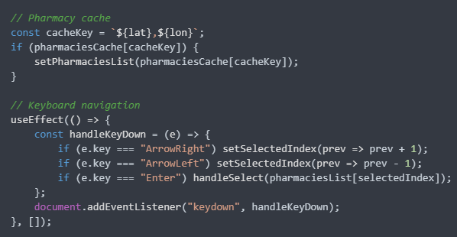

II.3. Distance Calculation

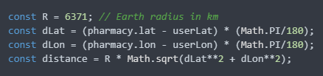

III. Backend - Route /get_direction

III.1. Objective

Calculate a route between two points via OpenRouteService.

III.2. Operation

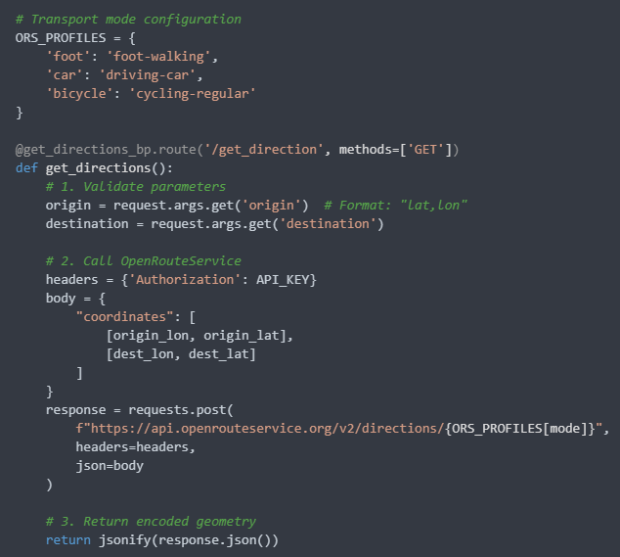

III.3. Common Errors

- 400: Invalid coordinates
- 500: Missing API key or ORS error

IV. Frontend - DirectionsMapPage Component

IV.1. Workflow

1. Get URL parameters

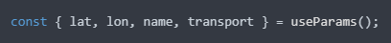

2. Call /get_direction with coordinates
3. Display the route on a Leaflet map

IV.2. Path Decoding

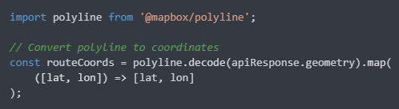

IV.3. Map Management

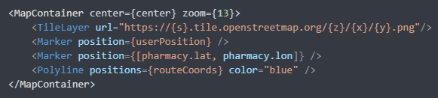

V. Code Snippet Examples

V.1. Backend - Haversine

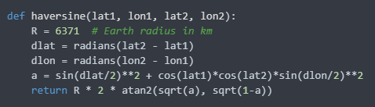

V.2. Frontend - Cache

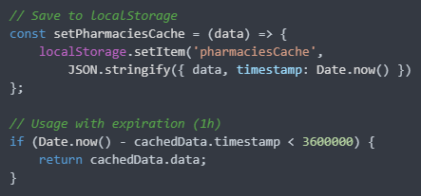

VI. Essential Tips

VI.1. Security

- Validate ALL user inputs
- Store API keys in environment variables
- Use HTTPS in production

VI.2. Performance

- Limit results to 10 pharmacies
- Client-side caching (localStorage)
- Request timeouts (e.g., 5s)

VI.3. Mobile UX

- Responsive design
- Large clickable areas
- Visual feedback during loading

VI.4. Keyboard Ergonomics

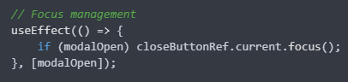

VII. Global Explanations

VII.1. Architecture

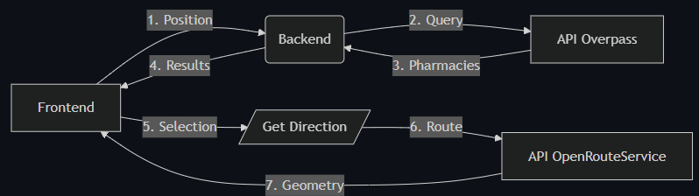

VII.2. Best Practices

- Decoupling: Independent Frontend/Backend
- Stateless: No server-side sessions
- Modular: Reusable components
- Documentation: Swagger for APIs

VII.3. Alternatives

- Replace Overpass with Google Places API
- Use Mapbox instead of OpenRouteService
- Implement a Redis cache server-side

VII.4. Points of Attention

- Overpass limitations (request frequency)
- Cost of premium APIs (OpenRouteService)
- Geolocation permissions (browser)

