

Complete Documentation: QR Code Generation and Reading

I. I. Backend - Route /generate_prescription_qr 2
I.1. Operation 2
I.2. Security 2
II. Backend - Route /generate_direction_qr 3
II.1. Objective 3
II.2. Operation 3
II.3. Data Structure 3
III. Backend - Route /read_prescription_qr 4
III.1. Objective 4
III.2. Operation 4
III.3. Robust Detection 4
IV. Frontend - StepOrdonnance Component 5
IV.1. Workflow 5
IV.2. QR Code Handling 5
IV.3. Keyboard Navigation 6
V. Frontend - MapQrCodePage Component 7
V.1. Direction QR Generation 7
V.2. QR Code Display 7
VI. QR Code Scripts 8
VI.1. Generation (qrCodeGen.py) 8
VI.2. Reading (qrCodeLect.py) 8
VII. Code Snippet Examples 10
VII.1. Backend - Encryption 10
VII.2. Frontend - State Management 10
VIII. Essential Tips 11
VIII.1. Security 11
VIII.2. Performance 11
VIII.3. Mobile UX 11
VIII.4. Robustness 11
IX. Global Explanations 12
IX.1. Architecture 12
IX.2. Best Practices 12
IX.3. Alternatives 12
IX.4. Points of Attention 12

I. I. Backend - Route /generate_prescription_qr

Objective: Generates an encrypted QR code containing medical prescription information.

I.1. Operation

1. Parameters

- doctor (required): Object containing doctor information
- patient (required): Object containing patient information
- date (required): Prescription date (String)
- content (required): Prescription content (Array)

2. Process

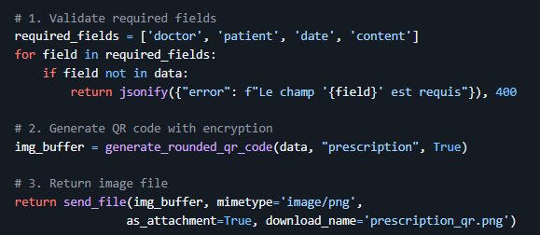

3. Réponses

- 200 OK: Generated QR code image file
- 400 Bad Request: Missing required fields
- 500 Internal Error: Generation error

I.2. Security

- AES-ECB encryption of data
- zlib compression to reduce size
- Encryption key stored in .env
- QR code with rounded modules and custom color

II. Backend - Route /generate_direction_qr

II.1. Objective

Generates a QR code containing pharmacy direction information.

II.2. Operation

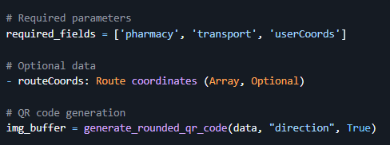

II.3. Data Structure

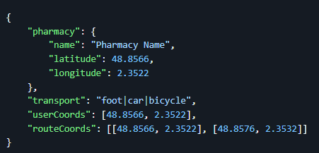

III. Backend - Route /read_prescription_qr

III.1. Objective

Reads and decrypts a QR Code containing prescription information.

III.2. Operation

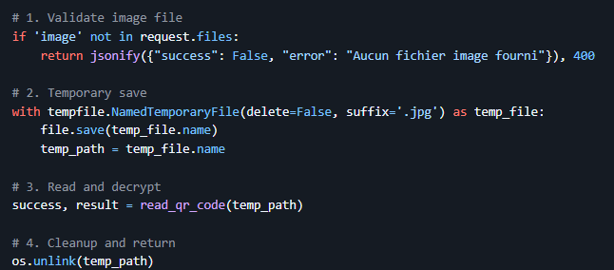

III.3. Robust Detection

- Multi-scale detection (0.5x to 3.0x)
- Aggressive image enhancement (CLAHE, adaptive thresholding, etc.)
- Automatic perspective correction
- Image rotation (0°, 90°, 180°, 270°)
- Support for tilted or deformed QR codes

IV. Frontend - StepOrdonnance Component

IV.1. Workflow

- Select scan type (QR or classic prescription)
- Open camera via ModalCamera
- Capture and process image
- API call based on scan type

IV.2. QR Code Handling

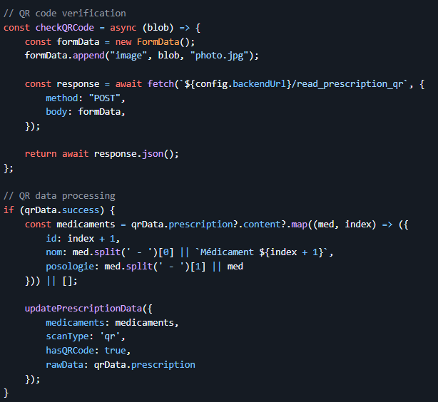

IV.3. Keyboard Navigation

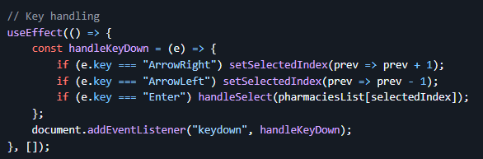

V. Frontend - MapQrCodePage Component

V.1. Direction QR Generation

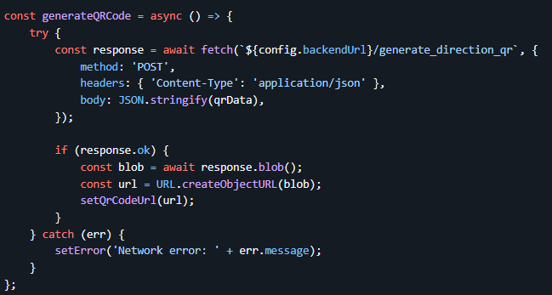

V.2. QR Code Display

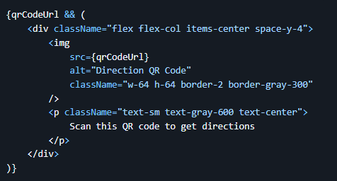

VI. QR Code Scripts

VI.1. Generation (qrCodeGen.py)

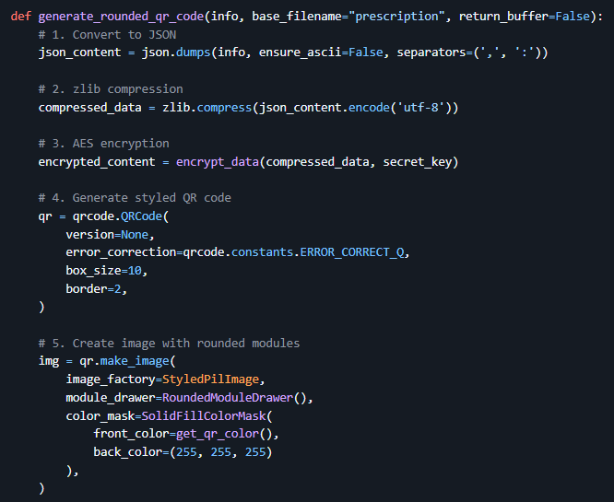

VI.2. Reading (qrCodeLect.py)

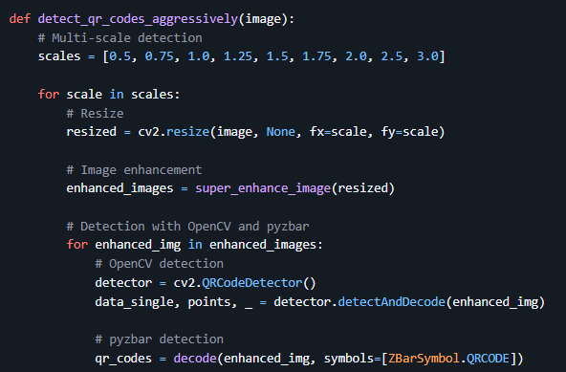

VII. Code Snippet Examples

VII.1. Backend - Encryption

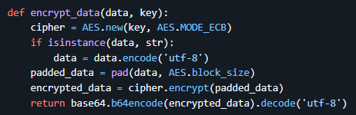

VII.2. Frontend - State Management

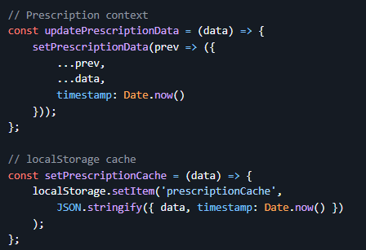

VIII. Essential Tips

VIII.1. Security

- 32-byte minimum encryption key
- Secure key storage in .env
- Strict input data validation
- Automatic temporary file cleanup

VIII.2. Performance

- zlib compression to reduce QR code size
- Multi-scale detection for improved recognition
- Client-side cache for frequent data
- Request timeouts (e.g., 10s)

VIII.3. Mobile UX

- Touch-optimized interface
- Visual feedback during processing
- User-friendly error handling
- Support for deformed or tilted QR codes

VIII.4. Robustness

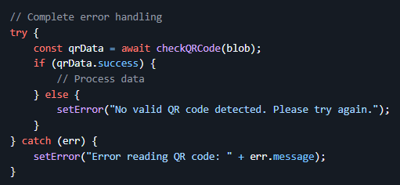

IX. Global Explanations

IX.1. Architecture

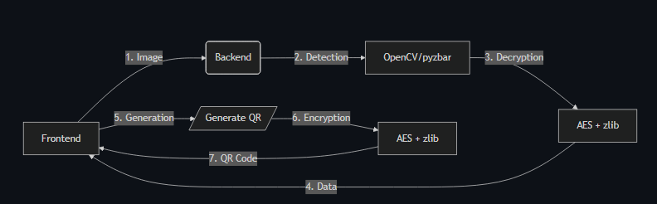

IX.2. Best Practices

- Decoupling: Independent Front/Back
- Security: Systematic encryption
- Robustness: Multi-technique detection
- Performance: Compression and cache

IX.3. Alternatives

- Replace AES with RSA for security
- Use Google Vision API for detection
- Implement Redis cache server-side
- Add digital signature

IX.4. Points of Attention

- QR code size limitations (2953 characters max)
- Encryption/decryption cost
- Camera permissions (browser)
- Image quality for detection

