Practicum Final Exam – Odd Semester Year 2021/2022
Subject |  |  | ISYS6169001 – Database Systems |  |  | 
Class | : | B201 / B301 / BC01 |  | Start Date | : 21 January 2022
Lecturer | : | D4625 – Trisna Febriana, S.Kom., M.M.S.I  D5197 – Nadila Setiabudiarto, S.E., M. Kom. |  | Start Time | : 15:20
Lecturer | : |  |  | End Date | : 21 January 2022
Lecturer | : |  |  | End Time | : 17:20

PERATURAN UJIAN:
Exam Regulations:
- Mahasiswa tidak diperbolehkan berdiskusi dan/atau bekerja sama dengan peserta ujian lainnya
Student is not allowed to discuss and/or work together with other exam participants
- Mahasiswa tidak diperbolehkan untuk membuka dan menyalin dari BUKU atau CATATAN, VIDEO dari pengajar (recording kelas, VBL, Youtube, dsb) dan REFERENSI lainnya
Student isn't allowed to open and copy from any resources such as notes, videos (class recording, VBL, Youtube, etc) and other references
- Mahasiswa tidak diperbolehkan membuka dan menyalin jawaban dari internet (google, stackoverflow, dsb)
Student isn't allowed to open and copy answer from the internet (google, stackoverflow, etc)
- Asisten BERHAK memberi nilai 0 (NOL) bagi peserta ujian yang melakukan segala bentuk kecurangan
Assistant is able to give 0 (ZERO) score for exam participant who does any cheating actions
- Kumpulkan jawaban tepat pada waktunya, apabila terlambat mengumpulkan maka jawaban tidak akan dikoreksi dan nilai mahasiswa adalah 0
Submit the answer on time, if not, then the answer will not be checked, and the students will receive 0 (ZERO)
- Bila Anda tidak membaca peraturan ini, maka Anda dianggap telah membaca dan menyetujuinya
If you have missed to read these regulations, so you are considered to have read and agreed on it

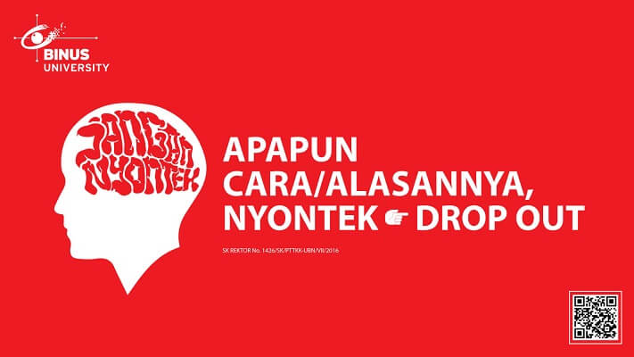

SOFTWARE YANG DIGUNAKAN:
Software will be used:
- SQL Server Developer 2019
- SQL Server Management Studio 18.9.1

FILE YANG DIKUMPULKAN:
File must be collected:
- [Last 6 digit of Student Id].SQL query answer

PERHATIAN!
Attention!
- Bagi yang mengerjakan tidak sesuai dengan soal, maka akan diberikan nilai NOL (0)
For those who do not work in accordance with the exam case will be marked as ZERO (0)
- Bagi yang mengerjakan tidak sesuai dengan software dan versi yang telah ditetapkan, maka akan tetap dikoreksi dengan software dan versi yang telah ditetapkan
For those who do not work in accordance with the software and specific version will be corrected by the predefined software and version
- Kompres semua jawaban yang akan diunggah. Pastikan format pengumpulan nama file dan ekstensi sesuai dengan format berikut: [NIM]-[NAMA].zip
Compress all file that will be uploaded. Make sure the format for collecting file name and extension according to the following format: [NIM]-[NAME].zip

Tabel Relasional
Relational Table

LEE’s Shikdang

LEE’s Shikdang is a famous BBQ Restaurant in Indonesia. LEE’s Shikdang provides transaction for every customer who wants to buy BBQ food and will be handled by a staff. The customer can buy more than one food in a transaction. Below is a picture of Entity Relationship Diagram (ERD) from LEE’s Shikdang:

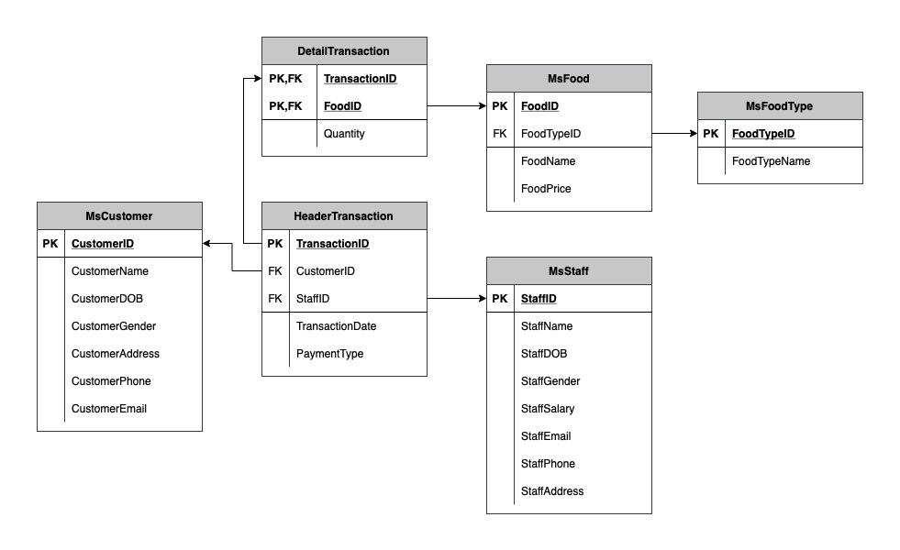

*Note:
Before taking the exam, please open the create+insert.sql file (attached with the case folder) then executes it on SSMS.

Soal
Case

- Display CustomerID, CustomerName, and CustomerGender for every customer whose length of name less than 15 characters.
(LEN).
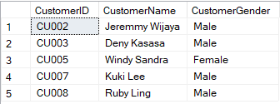

- Display StaffID, StaffName, and TransactionDate for every transaction that occurs in December.
(JOIN, DATENAME, MONTH)
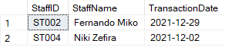

- Display StaffID, StaffName, and Total Transaction (obtained from total transaction of each staff and adding ‘ Transaction’ in the end of it) for every staff whose name has three words.
(CAST, COUNT, JOIN, LIKE, GROUB BY)
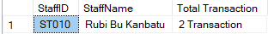

- Display StaffID (obtained by replacing 'ST00' with 'Staff '), StaffName (obtained from StaffName and start with 'Mr. '), AverageFoodPrice (obtained from average of food price), and TotalTransaction (obtained from total transactions) for every transaction handled by staff whose gender is male and FoodTypeID is 'FT004'. Then, combine with StaffID (obtained by replacing 'ST00' with 'Staff '), StaffName (obtained from StaffName and start with 'Ms. '), AverageFoodPrice (obtained from average of food price), and TotalTransaction (obtained from total transactions) for every transaction handled by staff whose gender is female and FoodTypeID is 'FT002'.
(STUFF, CAST, AVG, COUNT, GROUP BY, UNION)
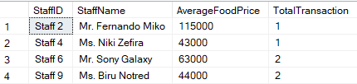

- Display TransactionID, FoodName, and PaymentType (obtained by payment type and adding the year of transaction date) for every transaction that FoodTypeName is 'Pork' or 'Premium Beef' and PaymentType is 'OVO' or 'Gopay'.
(CAST, YEAR, IN)
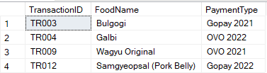

- Display Customer ID (obtained by replacing ‘CU’ with ‘Customer ’), Handle by (obtained by replacing ‘ST00’ into ‘Staff ’), FoodPrice (obtained by adding ‘Rp. ’ in front of food price), FoodName, and Quantity for every transaction where the food price is the highest of all food price and quantity is greater than 2.
(REPLACE, STUFF, CONCAT, MAX, alias subquery)
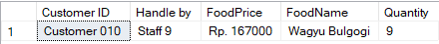

- Create a view name ‘ViewTransactionInEvenDay’ to display CustomerID, FoodID, TransactionDate, PaymentType, and Quantity (obtained from quantity each transaction transaction and adding ‘ Items’ in the end of it) for every transaction that occurs in even day.
(CREATE VIEW, CAST, DAY)
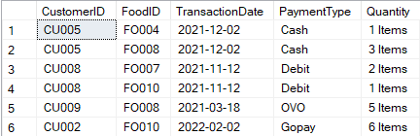

- Create a view name ‘ViewTransaction’ to display StaffEmail, TransactionDate, and Total Food Sold (obtained from summing of quantity food) for every transaction that handle by staff whose email contains ‘@yahoo’ and total food sold more than 1.
(CREATE VIEW, SUM, LIKE, GROUP BY, HAVING)
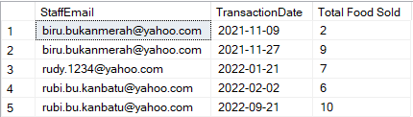

- Add 'StaffPosition' as a new column on MsStaff table with varchar data type and the length is 25. After that, add a constraint that StaffPosition must be 'Manager' or ‘Cashier’ or ‘Waiter’.
(ALTER TABLE, ADD, ADD CONSTRAINT, LIKE)
Before alter:
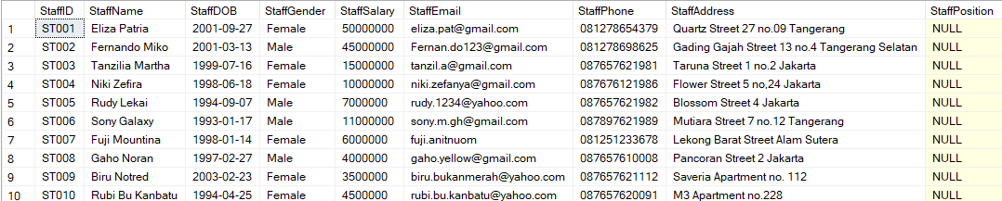
After alter:

- Delete data from MsCustomer table for every transaction that quantity greater than 2 and transactions occur in February.
(DELETE, DATENAME, MONTH, LIKE)
Before delete: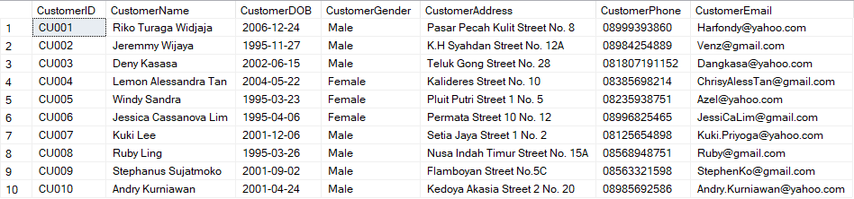

After delete:
