HRIS ( Human Resource Information System) for Local Government: A Municipal Employee Data Management Tool

In Partial Fulfillment of the Requirements for the Degree of
Bachelor of Science in Information Systems

by

Jutine A. Capili
Mark Justine Cruz
Ken V. Del Barrio
Chino G. Dela Cruz
Adrian L. Evangelista

September 2025

APPROVAL SHEET

This thesis entitled “HRIS ( Human Resource Information System) for Local Government: A Municipal Employee Data Management Tool” prepared and submitted by Jutine Capili, Mark Justine Cruz, Ken V. Del Barrio, Chino G. Dela Cruz and Adrian L. Evangelista in partial fulfillment of the requirements for the DEGREE of Bachelor of Science in Information Systems is hereby accepted and recommended for Oral Examination.

MR. REYNALDO SANTOS
Adviser

JUSTINE A. CAPILI MARK JUSTINE CRUZ
Member Member

KEN V. DEL BARRIO CHINO G. DELA CRUZ
Member Member

ADRIAN L. EVAGELISTA
Member

ACCEPTED as partial fulfillment of the requirements for the strand/degree <SHS Strand or Baccalaureate Degree>

MR. REYNALDO SANTOS
Research Instructor

_______________________________________________________________

APPROVED by the tribunal at the Oral Examination with the grade of _________.

<NAME IN UPPER CASE & BOLD> <NAME IN UPPER CASE & BOLD>
Member Member

<NAME IN UPPER CASE & BOLD>
Chairman

ACKNOWLEDGEMENT

The researchers would like to express their utmost gratitude to Almighty God for the wisdom, knowledge, and perseverance granted to them in the completion of this capstone project.

Special thanks and deepest appreciation are extended to Mr. Reynaldo Santos, their research adviser, for his invaluable guidance, encouragement, and expertise throughout the duration of the study. The researchers are also grateful to the panel of examiners for their constructive comments and suggestions that greatly improved the quality of this project.

Sincere acknowledgment is also given to Victoria M. Sison, MAEd., OIC-Office of the College President/Vice President for Academic Affairs, for her support and approval of this study.

Finally, heartfelt thanks to their families and friends for their unwavering love, understanding, and motivation. Their prayers and encouragement served as inspiration for the researchers to finish this work successfully.

EXECUTIVE SUMMARY

TABLE OF CONTENTS

Title Page
Title Page …………… ……………………………………………………….…... i
Approval Sheet ………………………………………..……………..…………... ii
Acknowledgment………………………………………..…....…………………... iii
Executive Summary …………………………..……………..…………………... iv
Table of Contents………………..………..……………..……………………….. v
List of Tables …………………………….…………..………..………………….. v
List of Figures ……………………………………..……..……………………….. v
List of Graphs ……………...…………..……………..…………….…………….. v

Chapter 1: Introduction
Project Context ……………………..……………..……………………….. 1
Purpose and Description ……………………………...………………….. 2
Statement of the Problem ………………………..……………………….. 3
Scope and Limitations ……………………………..…..………………….. 4
Definition of Terms ………………………………...……………..……….. 5
Chapter 2: Review of Related Studies and Technical Background
Related Studies ………………………………...………..…….………….. 6
Technical Background of the Project ………………………...………….. 7
Technical Background of the System ……..………………...………….. 8
Chapter 3: Research Method
Design and Development ………………………………...………..…….. 9
Research Design ………………………….…...………………..…….. 10
Theoretical and Conceptual Framework …………………………….. 11
Target Clientele ………………………………...………………..…….. 12
Research Instruments…………………..……...……………..……….. 13
Data Gathering Procedure ………………………………...………….. 14
Development Process, Testing, and
Implementation of the System……………………………………….... 15
Ethical Consideration ………………………..…..…………………….. 16
Chapter 4: Results of the Study
Existing (if applicable) ……………………………..…………………….. 17
Proposed………………………………...……………….……..………….. 18
Summary of Findings ………………………………...……………….. 19
Interpretation of the Results ………………………………....……….. 20
Comparison with Previous System (if applicable) ………………….. 21
Implications of the Findings ……………………………….....……….. 22
Chapter 5: Conclusions
References ………………………………...………………..……………..…….. 23
Appendices …………..…………...………………………….………………….. 24
- System Source Code/Program Developed
(Photo documentation)……………………………………………….. 25
- User’s Manual ………..……………...……………………………….. 26
- Certificate of Implementation ………………….…………………….. 27
- End User System Evaluation…………………...…………..……….. 28
- Documented Undertakings ……………………....………………….. 29
- Curriculum Vitae……...……………....……………………………….. 30

Chapter 1
Introduction
Local Government Units (LGUs) play a vital role in ensuring efficient public service delivery. One of the fundamental administrative responsibilities of LGUs is the proper monitoring of employee attendance and the accurate preparation of salary-related documents. Attendance records serve as the primary basis for payroll computation, employee accountability, and workforce management.
Despite advancements in information technology, many municipal offices continue to use manual attendance logbooks and paper-based time records. These traditional methods are vulnerable to human error, proxy attendance, and delays in record consolidation. As a result, payroll preparation becomes time-consuming and prone to inaccuracies, which may affect employee trust and organizational efficiency.
The integration of information systems in government operations has been recognized as an effective approach to improving accuracy, transparency, and efficiency. In particular, the use of QR code technology combined with geolocation validation provides a practical and cost-effective solution for attendance monitoring without the need for expensive biometric devices.
This study focuses on the development of a QR Code–Based Attendance and Payslip Viewing System intended for use within the Municipal Hall. The system ensures that attendance is recorded only when employees are physically present within the defined proximity of the municipal premises, and that attendance data is accurately reflected in employee payslips.

Project Context
Attendance monitoring is one of the most essential administrative functions in Local Government Units (LGUs) because it directly affects employee accountability and salary computation. However, many municipalities still rely on manual attendance logbooks and paper-based time records. These traditional methods are prone to errors, proxy signing, unreadable entries, and delays in attendance consolidation.
In most cases, payroll personnel manually compute salaries based on attendance summaries, which increases the risk of miscalculation and delays in releasing payslips. These issues often lead to employee dissatisfaction and reduced administrative efficiency.
With the increasing demand for transparency and efficiency in government offices, there is a need for a computerized attendance system that can accurately record employee presence and automatically reflect attendance data in salary computation. The use of QR code technology combined with geolocation proximity validation provides a practical solution that ensures employees are physically present at the workplace during attendance recording.
This study proposes the development of a QR Code–Based Attendance and Payslip Viewing System for the Municipal Government. The system focuses on recording attendance within the proximity of the Municipal Hall and generating payslips based on recorded attendance and salary grade.

Purpose and Description
The primary purpose of this study is to design and develop a QR Code–Based Attendance and Payslip Viewing System for Local Government Units. Specifically, the system aims to:
- Record employee attendance through QR code scanning
- Validate attendance using geolocation proximity within the Municipal Hall
- Maintain accurate attendance logs with date and time stamps
- Automatically compute salary based on attendance and salary grade
- Generate and allow viewing of employee payslips
- Reduce errors and delays in attendance recording and payroll preparation
The proposed system serves as a payroll support tool and does not replace the official accounting system of the municipality.

Statement of the Problem
Many Local Government Units still rely on manual attendance recording and payroll preparation, which are time-consuming and prone to error. The absence of a centralized and location-validated attendance system results in inaccurate attendance records, delayed salary computation, and limited transparency in payslip generation.
This study seeks to answer the following questions:
- What problems are encountered in the current manual attendance and payroll preparation process of the municipality?
- How accurate and efficient is the existing manual attendance recording system?
- How can a QR code–based attendance system with geolocation proximity improve attendance accuracy and accountability?
- How can the integration of attendance records into payslip generation improve payroll efficiency and transparency?

Scope and Limitations
Scope
The scope of this study focuses on the design and development of a QR Code–Based Attendance and Payslip Viewing System for the Municipal Government. The system includes the following functions:
- QR code–based attendance scanning
- Geolocation proximity validation limited to the Municipal Hall
- Attendance log management
- Salary grade–based payroll computation support
- Payslip generation and viewing
- Role-based access for administrators and employees

Limitations
- The system does not function as a full payroll or accounting system
- Attendance validation depends on mobile device GPS accuracy and internet connectivity
- The system reduces but does not entirely eliminate possible misuse of attendance recording
- The system is limited to use within the Municipal Hall premises

Definition of Terms
QR Code – A two-dimensional barcode used to trigger attendance recording in the system.
Geolocation Proximity – The validation of a user’s physical location within a defined radius of the Municipal Hall.
Attendance System – A computerized system used to record employee time-in and time-out.
Payslip – A document showing an employee’s salary details based on attendance and salary grade.
Salary Grade – A standardized salary classification used in government institutions.
Local Government Unit (LGU) – A political subdivision responsible for local governance and administration.

Chapter 2
Review of Related Studies and Technical Background
This section presents five local and five foreign studies relevant to the development of the Human Resource Information System (HRIS). The reviewed literature covers studies published from August 2019 to 2025, focusing on livelihood programs, beneficiary profiling, information systems, and digital monitoring tools.

Related Studies
Local Literature
Design and Development of a QR Code–Based Attendance Monitoring System for Government Offices
R. M. Santos & L. P. Dela Cruz (2023) – Philippine Journal of Information Technology
This study focused on the development of a QR code–based attendance system for a local government office in the Philippines. The findings revealed that the system significantly reduced proxy attendance and improved accuracy compared to manual logbooks. The study supports the use of QR code technology as an effective attendance trigger in government institutions.
Web-Based Attendance Monitoring System for Municipal Employees
J. A. Ramos (2022) – Asia Pacific Journal of Multidisciplinary Research
The research evaluated a web-based attendance system used by municipal employees. Results showed improved efficiency in attendance tracking and faster report generation. The study emphasized the importance of centralized databases in ensuring reliable attendance records.
Employee Attendance Monitoring and Payroll Support System for LGUs
M. L. Hernandez & P. C. Uy (2021) – International Journal of Advanced Computer Studies
This study examined the integration of attendance monitoring with payroll support in local government units. The system improved payroll accuracy and minimized disputes related to salary computation. The findings highlight the importance of linking attendance data directly to payroll processes.
Implementation of Location-Based Attendance Systems in Public Institutions
S. R. Mendoza (2024) – Journal of Public Sector Innovation
The study explored the use of geolocation technology for attendance validation in public offices. Results indicated that location-based validation enhanced accountability and ensured employee presence within designated work areas.
Digital Attendance Systems and Administrative Efficiency in Philippine LGUs
E. T. Navarro (2025) – Journal of Governance and Information Systems
This research analyzed the impact of digital attendance systems on administrative efficiency in LGUs. The study concluded that automated attendance systems significantly reduced processing time and improved data reliability.

Foreign Literature
QR Code–Based Attendance Systems in Organizational Management
A. Kumar & S. Verma (2022) – International Journal of Computer Applications
This study examined the effectiveness of QR code–based attendance systems in organizational settings. The results showed improved attendance accuracy and reduced administrative workload compared to traditional methods.
Geolocation-Based Employee Attendance Monitoring Systems
L. Zhang & H. Chen (2021) – Journal of Information Systems Engineering
The research focused on the use of geolocation technology to validate employee attendance. Findings revealed that proximity-based validation significantly minimized attendance fraud and improved monitoring efficiency.
Web-Based Payroll and Attendance Integration Systems
M. Johnson & R. Smith (2020) – Journal of Digital Business Systems
This study emphasized the benefits of integrating attendance systems with payroll modules. The system reduced payroll errors and enhanced transparency in salary computation.
Information Systems for Public Sector Workforce Management
D. Brown (2023) – Government Information Quarterly
The study highlighted how information systems improve workforce monitoring and accountability in public sector organizations. It emphasized system usability and data security as critical success factors.
Mobile-Based Attendance Systems Using Location Validation
S. Patel et al. (2024) – IEEE Access
This research demonstrated that mobile attendance systems with location validation improved reliability and user acceptance, particularly in government and institutional environments.

Chapter 3
Research Method
This chapter discusses the research methodology used in the design, development, testing, and evaluation of the QR Code–Based Attendance and Payslip Viewing System for the Local Government Unit (LGU). It presents the research design, theoretical and conceptual framework, target clientele, research instruments, data gathering procedures, system development process, and ethical considerations observed throughout the study.

Design and Development
The study adopted a system-oriented design and development approach focused on building a functional and user-centered Human Resource Information System (HRIS) module for attendance monitoring and payslip viewing. The system was designed to address the limitations of the existing manual attendance process by introducing QR code scanning and geolocation-based validation to ensure accurate employee attendance recording.
The development process followed three major phases: (1) Analysis and Design, which involved requirements elicitation, system architecture planning, and database design; (2) Development and Implementation, which included frontend and backend coding, module integration, and security implementation; and (3) Testing and Deployment, which involved unit testing, integration testing, user acceptance testing, and user training prior to pilot deployment.

Research Design
The study employed a Developmental Research Design. This design is appropriate for studies that focus on the creation, improvement, and evaluation of a system or technological product. In this research, the developmental design guided the systematic development of the HRIS, ensuring that the system was aligned with the operational needs of the LGU and evaluated based on actual user experience and system performance.
Theoretical and Conceptual Framework

Theoretical Foundation
The theoretical foundation of the study was based on the Information System
Success Model by DeLone and McLean (2003). This model identifies System Quality, Information Quality, and Service Quality as primary factors influencing system success. This theory guided the researchers in designing a reliable and user-centered system that meets the operational needs of the HRIS Program.
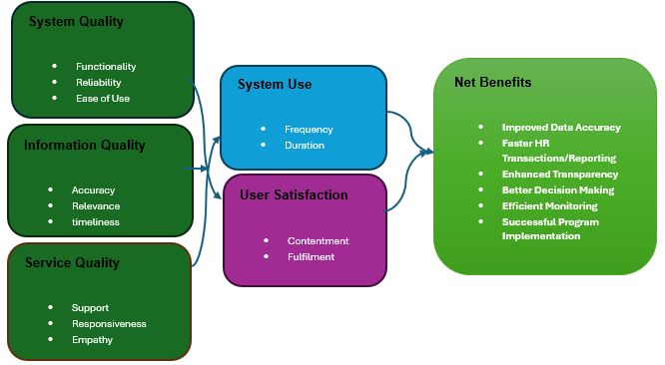

Conceptual Framework
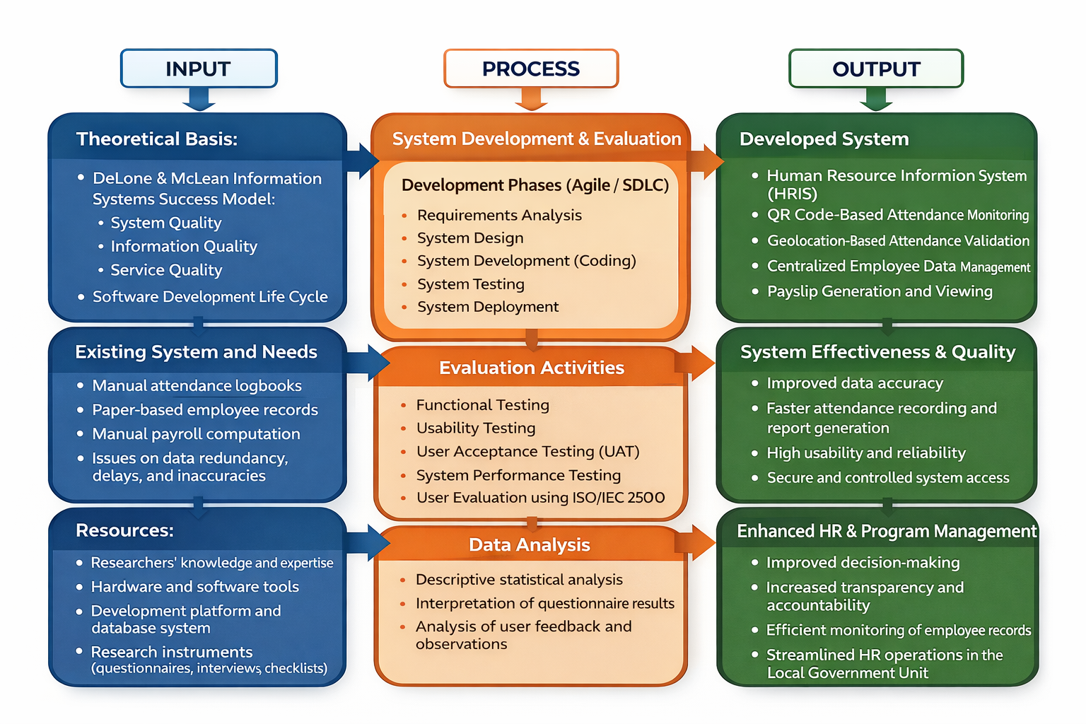
Target Clientele
The target clientele of the study included personnel from the Local Government Unit who are directly involved in attendance monitoring and payroll support activities. These include:
- Municipal Government Employees – end users who record their attendance and view their payslips through the system.
- Human Resource Management Office (HRMO) Staff – primary system users responsible for managing employee records, attendance logs, and payroll-related data.
- Department Heads and Supervisors – users who monitor attendance records and verify employee compliance.
- Municipal Administrators – decision-makers who utilize consolidated attendance data for workforce management.

Research Instruments
Three research instruments were used in this study. First, a User Evaluation Questionnaire based on the ISO/IEC 25010 Software Quality Model was administered to assess the system’s functionality, efficiency, usability, reliability, and security using a five-point Likert scale. Second, informal interviews were conducted with HRMO staff to gather qualitative feedback on system usability and workflow integration. Third, system testing tools and test cases were used to evaluate system performance, accuracy, and error handling.

Data Gathering Procedure
Data collection was conducted in several stages. Permission to conduct the study was secured from the LGU administration and HRMO. The researchers observed the existing attendance and payroll preparation processes to identify workflow gaps and inefficiencies. A working prototype of the system was then deployed in a controlled environment. Participants were asked to perform predefined tasks such as QR code attendance scanning, viewing attendance logs, and accessing payslips. User feedback was collected through questionnaires and interviews, while system logs were analyzed to assess performance and reliability.

Development Process, Testing, and Implementation of the System
The system development followed an Agile-based Software Development Life Cycle (SDLC). Requirements were gathered iteratively through consultation with HR personnel. The system was developed using Python for backend logic, HTML and CSS for frontend design, and PostgreSQL for database management.
Testing included functional testing to verify system features, usability testing to assess ease of use, and User Acceptance Testing (UAT) to confirm that the system met the operational needs of the LGU. After successful testing, the system was deployed for pilot use, and user orientation was conducted.

Ethical Consideration
Ethical standards were strictly observed throughout the study. Informed consent was obtained from all participants. Employee data privacy and confidentiality were protected through role-based access control and secure authentication mechanisms. All collected data were used solely for academic purposes, and participants were allowed to withdraw from the study at any time without penalty.

Ethical Consideration
The development and implementation of the HRIS ( Human Resource Information System) for Local Government: A Municipal Employee Data Management Tool followed strict ethical standards to safeguard the rights, privacy, and welfare of all stakeholders. The system manages sensitive information, including employee profiles, contact details, and employment and payroll records. Access levels were assigned based on user roles (Administrator, HR Personnel, Department Heads, and Employee) to ensure that only authorized users can view or modify critical information.

Chapter 4
Results of the Study
This chapter presents the evaluation results of the existing Human Resource Information System (HRIS) and the proposed Municipal Employee Data Management Tool for Local Government, based on the ISO/IEC 25010 software quality criteria.
Existing
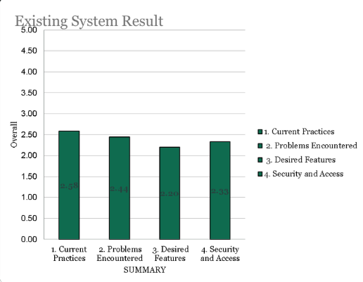
The existing system obtained a mean score of 2.58 for current practices, 2.44 for problems encountered, 2.20 for desired features, and 2.33 for security and access, indicating that while the current HRIS supports basic operational needs, it still experiences notable issues, lacks advanced and user-desired functionalities, and requires improvement in system security and access control for effective municipal employee data management.
Proposed
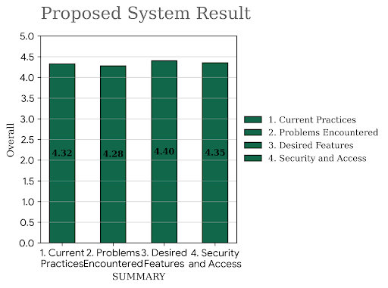
The proposed system obtained a mean score of 4.32 for current practices, 4.28 for problems encountered, 4.40 for desired features, and 4.35 for security and access, indicating that the proposed HRIS significantly improves operational efficiency, effectively addresses previously identified issues, provides comprehensive and user-centered features, and ensures stronger security and controlled access to municipal employee records.

Summary of Findings
1. The existing manual system demonstrated low efficiency and weak data organization, as evidenced by the baseline mean scores (ranging from 2.20 to 2.58), which highlighted significant delays in record retrieval and data management.
2. The proposed system achieved very high acceptability ratings across all criteria, with mean scores consistently exceeding 4.28, indicating that the software architecture aligns perfectly with municipal requirements.
3.Automation significantly improved monitoring, accuracy, and data security. The shift to a digital HRIS provides a centralized database that minimizes human error and ensures the integrity of sensitive employee information.
4.Users expressed high satisfaction with the usability and reliability of the system. The high score in "Desired Features" (4.40) confirms that the HRIS is user-centered, accessible, and provides the necessary tools for modern human resource management.

Interpretation of the Results
The results indicate that the proposed system successfully addressed the major problems identified in the existing process. The noticeable improvement in evaluation scores rising from a previous average of approximately 2.39 to an impressive 4.34 confirms that the use of an automated information system enhances efficiency, reliability, and service delivery. These findings support the importance of digital solutions in managing municipal employee records and streamlining HR operations.

Comparison with Previous System

Implications of the Findings

The findings of this study imply that the implementation of the proposed Human Resource Information System (HRIS) can greatly improve transparency, accountability, and efficiency in municipal employee management. The system supports informed decision-making by providing accurate and timely data, replacing the inconsistencies of manual record-keeping. Furthermore, it contributes to the modernization of local government HR management and promotes sustainable, long-term monitoring of personnel growth and institutional records.

Chapter 5
Conclusions and Recommendations
This chapter presents the conclusions drawn from the findings of the study and the corresponding recommendations based on the results of the system evaluation.
Conclusions
Based on the results of the study, the following conclusions were drawn:
1. The development of the Municipal Employee Data Management Tool demonstrated that an HRIS is an effective solution for improving the management of employee records in the local government unit. The system successfully addressed common issues such as data redundancy, manual record-keeping, and delayed retrieval of employee information.
2. The results showed that System Quality, Information Quality, and Service Quality significantly influenced both System Use and User Satisfaction, consistent with the DeLone and McLean Information Systems Success Model (2003). Users found the system easy to use, reliable, and functional for daily HR operations.
3. The proposed system achieved very high acceptability ratings in terms of functionality, usability, reliability, efficiency, and security based on ISO/IEC 25010 standards.
4. User satisfaction was positively affected by the system’s responsiveness, data reliability, and support features, indicating that the HRIS effectively met the operational needs of the municipality.
5. The implementation of the HRIS resulted in positive net benefits, including enhanced transparency, improved monitoring of employee records, streamlined HR processes, and better service delivery within the local government unit.

Recommendations
Based on the conclusions of the study, the following recommendations are proposed:
- System Implementation and Adoption
Local government units are encouraged to adopt the proposed HRIS to improve employee data management, reduce manual processing, and enhance efficiency in HR-related operations.
- User Training and Capacity Building
Regular training programs should be conducted for HR staff and system users to ensure proper utilization of the HRIS features and to maximize system effectiveness.
- System Maintenance and Technical Support
Continuous system maintenance and reliable technical support should be ensured to address system issues promptly and to maintain optimal performance and data security.
- Data Security and Privacy Enhancement
Future implementations should strengthen security measures such as role-based access control, data encryption, and regular backups to protect sensitive employee information.
- System Enhancement and Expansion
The HRIS may be enhanced by integrating additional modules such as performance evaluation, leave management, and payroll processing to further support HR functions.

References
DeLone, W. H., & McLean, E. R. (2003). The DeLone and McLean model of information systems success: A ten-year update. Journal of Management Information Systems, 19(4), 9–30. https://www.tandfonline.com/doi/abs/10.1080/07421222.2003.11045748

Davis, F. D. (1989). Perceived usefulness, perceived ease of use, and user acceptance of information technology. MIS Quarterly, 13(3), 319–340. https://misq.umn.edu/misq/article-abstract/13/3/319/191/Perceived-Usefulness-Perceived-Ease-of-Use-and?redirectedFrom=fulltext

Kavanagh, M. J., Thite, M., & Johnson, R. D. (2020). Human resource information systems: Basics, applications, and future directions (4th ed.). Sage Publications.

Ngai, E. W. T., & Wat, F. K. T. (2006). Human resource information systems: A review and empirical analysis. Personnel Review, 35(3), 297–314.
https://www.emerald.com/pr/article-abstract/35/3/297/323013/Human-resource-information-systems-a-review-and?redirectedFrom=fulltext
Ball, K. S. (2001). The use of human resource information systems: A survey. Personnel Review, 30(6), 677–693. https://www.emerald.com/pr/article-abstract/30/6/677/322851/The-use-of-human-resource-information-systems-a?redirectedFrom=fulltext

