Assignment2_Group9_DataBase

A locally running hosted database, XAMPP + MYSQL = local sandbox

# Section1- Relational Database Description

## Schema information

*DEFAULT CHARACTER SET utf8mb4*

*DEFAULT COLLATE utf8mb4_unicode_ci;*

To comply with XAMPP MySql version requirements, **MariaDB 10.x** (e.g. 10.4 / 10.5), set as above.

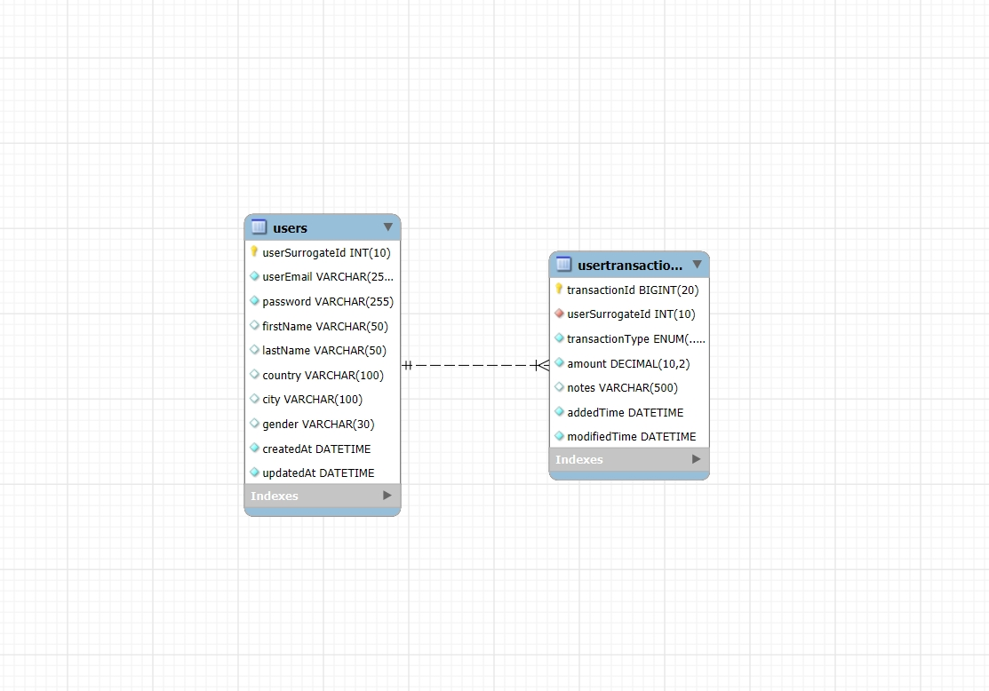

## Table1 – User information

**Fields**

|  |  |  |
| --- | --- | --- |
| **Field** | **DataType** | **Notes** |
| userSurrogateId | INT | auto generated, primary key |
| userEmail | VARCHAR(255) NOT NULL |  |
| password | VARCHAR(255) NOT NULL | No complexity check for the ease of use. |
| firstName | VARCHAR(50) |  |
| lastName | VARCHAR(50) |  |
| country | VARCHAR(100) |  |
| city | VARCHAR(100) |  |
| gender | VARCHAR(30) |  |
| createdAt | DATETIME NOT NULL DEFAULT CURRENT_TIMESTAMP | User creation time, auto generated |
| updatedAt | DATETIME NOT NULL DEFAULT CURRENT_TIMESTAMP  ON UPDATE CURRENT_TIMESTAMP | User creation time, auto generated |

**Constraint:**

1. *UNIQUE KEY uq_users_email (userEmail) uniqueness, which is used as login credentials.*

Used to check userEmail

1. CONSTRAINT chk_password_minlen

CHECK (CHAR_LENGTH(passwordPlain) >= 8 constraint for password.

Used to check password simple length

## Table 2 – User financial tracker

|  |  |  |
| --- | --- | --- |
| **Field** | **DataType** | **Notes** |
| trackSurrogateId | BIGINT |  |
| userSurrogateId | INT | Foreign key |
| transactionType | ENUM('INCOME','SPENDING') |  |
| amount | DECIMAL(10,2) |  |
| notes | VARCHAR(500) |  |
| addedTime | DATETIME NOT NULL DEFAULT CURRENT_TIMESTAMP |  |
| modifiedTime | DATETIME NOT NULL DEFAULT CURRENT_TIMESTAMP  ON UPDATE CURRENT_TIMESTAMP |  |

**Constraint:**

1. CONSTRAINT fk_ut_users

FOREIGN KEY (userSurrogateId)

REFERENCES Users(userSurrogateId)

ON DELETE CASCADE

ON UPDATE CASCADECONSTRAINT chk_password_minlen

CHECK (CHAR_LENGTH(passwordPlain) >= 8)

1. CONSTRAINT chk_transaction_type

CHECK (transactionType IN ('INCOME','SPENDING'))

# How to clone my locally built SQL database

## Copy mysql dump file to your local instance.

mysql -u root -p < visualBudget_schema.sql