Arduino Uniform Stock Kiosk Complete Build and Transfer Manual
Grade 12 STEM Implementation Handout and Account Transfer Specification
School Uniform Stock Availability Prototype

System focus School uniform stock availability checking
Core controller Arduino Uno
Communication bridge ESP32
User interface HTML CSS and JavaScript kiosk

System concept hardware and software setup and implementation reference

How to Use This Guide
This document is a practical reference for planning, building, testing, and presenting the prototype. It is written for Grade 12 students who may be using web development and board-to-board communication for the first time. Each technical term is explained in simple language before it is used in a detailed procedure.
Read Sections 1 to 4 to understand the purpose and limits of the project. Use Sections 5 to 16 while assembling the electronics and communication link. Use Sections 17 to 30 while creating the interface and programs. Complete Sections 31 to 34 before the capstone defense.
Prototype status. The diagrams, sample quantities, commands, pin assignments, and programs are starting points. Confirm the final wiring and record actual test results from the assembled kiosk before claiming that the system works.

Recommended Learning Order
Step | Read | What the student should understand
1 | Sections 1 to 4 | The purpose, users, scope, and limitations of the kiosk.
2 | Sections 5 to 8 | The role of each hardware and software component.
3 | Sections 9 to 16 | How a request moves through the system and how the boards are wired.
4 | Sections 17 to 30 | How to build the screens, commands, storage, and programs.
5 | Sections 31 to 37 | How to test, troubleshoot, demonstrate, and explain the prototype.

Key Terms for Beginners
Term | Simple meaning
Kiosk | A computer station designed for one focused task. In this project, the task is checking uniform stock.
Stock | The number of uniform pieces currently recorded for one item and size.
Prototype | A working model used to prove the idea. It is not yet a full school production system.
Interface | The screens, labels, and buttons that a person sees and uses.
Web server | A program that receives browser requests and sends information back. The ESP32 performs this role.
Serial communication | A method of sending short messages between the ESP32 and Arduino Uno through TX and RX wires.
EEPROM | Small Arduino memory that keeps saved values even after the power is removed.
GPIO pin | A board connection that can read a signal or control a component such as an LED.

Contents
Section | Topic
1 | Project Overview
2 | Project Objectives
3 | Scope of the System
4 | Project Limitations
5 | Complete Hardware Requirements
6 | Role of the Arduino Uno
7 | Role of the ESP32
8 | Software Requirements
9 | Complete System Architecture
10 | How the System Works
11 | Stock Classification Logic
12 | Sample School Uniform Inventory
13 | Data Storage
14 | Serial Communication
15 | Important Voltage Safety
16 | Hardware Wiring
17 | Kiosk User Interface
18 | Admin Interface
19 | Admin Communication Command
20 | Assistance Button
21 | LED Indicator Panel
22 | Proposed Physical Kiosk Design
23 | Complete User Flowchart
24 | Admin Flowchart
25 | Example Arduino Program Structure
26 | Example ESP32 Program Structure
27 | HTML Structure
28 | CSS Design
29 | JavaScript Function
30 | Sample Inventory Data Structure
31 | Functional Testing
32 | Possible Problems and Troubleshooting
33 | Development Order
34 | Demonstration Scenario
35 | Questions the Panel May Ask
36 | Future Improvements
37 | Final Recommended System

Section 1 Project Overview
The proposed system is a self-service kiosk for checking school uniform stock. Stock means the recorded number of pieces available for a specific item and size. A student first chooses Formal Uniform, School T-Shirt, or PE Uniform. Formal Uniform requires a Male or Female choice before the garment is selected. School T-Shirt and PE Uniform are unisex, so the kiosk skips the gender question. The student then chooses a size and receives the stored quantity and one of three statuses: Available, Low Stock, or Out of Stock.
A matching LED provides a physical indication beside the screen. Green represents Available, yellow represents Low Stock, and red represents Out of Stock. A physical button also allows the student to request local assistance.
The kiosk may be placed near the uniform office, cashier area, student services office, or another supervised location. It addresses a practical concern: a student may wait in line only to learn that the required item is unavailable. The kiosk provides the recorded quantity before the student proceeds to the uniform office.
The Arduino Uno performs the stock and hardware processing. It reads stock values, classifies availability, controls the LEDs and buzzer, and monitors the assistance button. The ESP32 provides the network and webpage connection. It receives requests from the browser and forwards them to the Arduino Uno through serial communication.
The system is a prototype, which means it is a working model used to demonstrate the concept. It is suitable for a Grade 12 capstone because the group can clearly show the relationship between the webpage, communication board, main controller, stored data, and physical components.
Main focus. This prototype checks stock availability. It does not sell uniforms, accept payment, reserve items, dispense products, or automatically change stock after a student checks an item.

Section 2 Project Objectives

General Objective
To develop an Arduino-based interactive kiosk prototype that allows students to check the quantity and availability status of school uniforms while providing physical status indicators and a simple administrator method for maintaining stock values.

Specific Objectives
- Develop a touchscreen-friendly kiosk interface using HTML, CSS, and JavaScript.
- Allow students to choose a category and size, with Male or Female required only for Formal Uniform.
- Retrieve and display the current stock quantity for the selected item and size.
- Classify stock as Available, Low Stock, or Out of Stock using clear prototype rules.
- Control green, yellow, and red LEDs so the physical indicator matches the displayed status.
- Provide a physical assistance button that activates a local buzzer and displays an assistance message.
- Allow an authorized administrator to view and manually update stock quantities through a simple PIN-protected screen.
- Store prototype stock values so they can be restored after the Arduino restarts.
- Demonstrate reliable communication among the kiosk browser, ESP32, Arduino Uno, and connected hardware.

Section 3 Scope of the System
The scope states exactly what the prototype is expected to do. The functions below form the required system. Additional features should be considered only after the group has completed and tested these requirements.

Student Functions
- Open the kiosk home screen.
- Choose Formal Uniform, School T-Shirt, or PE Uniform.
- For Formal Uniform, choose Male or Female and then the matching garment.
- For School T-Shirt or PE Uniform, skip gender because the design is unisex.
- Select a size.
- Send an availability request.
- View the stored stock quantity and availability status.
- See the corresponding LED turn on.
- Request local assistance.
- Check another item or return to the home screen.

Administrator Functions
- Open the administrator login screen and enter a prototype PIN.
- Select a category and size; use Male or Female only when the category is Formal Uniform.
- Enter a non-negative replacement quantity.
- Send the update to the Arduino Uno and save it to EEPROM.
- Receive a confirmation showing the item, size, and new quantity.

Hardware Functions
Hardware | Required behavior
Green LED | Turns on for Available when stock is 4 or more.
Yellow LED | Turns on for Low Stock when stock is 1 to 3.
Red LED | Turns on for Out of Stock when stock is 0.
Buzzer | Sounds briefly for confirmation or assistance. It must not remain on continuously.
Assistance button | Sends a local assistance event when pressed.

Section 4 Project Limitations
The prototype does not include actual purchasing, online ordering, payment processing, GCash, credit or debit cards, reservations, automatic inventory deduction, RFID tracking, automatic dispensing, student accounts, facial recognition, an AI chatbot, SMS notifications, or cloud-based enterprise inventory management.
An authorized administrator manually maintains the stock information. The kiosk reports the number stored in the Arduino; it does not independently confirm the quantity physically present in the uniform office. Staff must count or verify the actual items and enter the correct number.
Checking does not subtract stock. If School T-Shirt Medium contains 12 pieces, a student check must still leave the value at 12. Only an administrator SET command changes the stored quantity.
The PIN is suitable only for a supervised prototype. A real deployment would require stronger authentication, protected network access, audit records, backup procedures, and integration with the school's official inventory process.

Section 5 Complete Hardware Requirements
Component | Quantity | Purpose | Important Notes
Arduino Uno R3 | 1 | Runs stock logic and controls local hardware. | Main controller; use an original or compatible board.
ESP32 DevKit | 1 | Hosts or connects the kiosk webpage and bridges requests to Arduino. | Uses 3.3 V GPIO; do not feed 5 V into its pins.
Laptop mini PC or computer | 1 | Displays the kiosk webpage. | A laptop is acceptable for the prototype.
Touchscreen monitor | Optional 1 | Provides direct touch input. | A mouse may be used during early testing.
Green LED | 1 | Shows Available status. | Use with a current-limiting resistor.
Yellow LED | 1 | Shows Low Stock status. | Use with a current-limiting resistor.
Red LED | 1 | Shows Out of Stock status. | Use with a current-limiting resistor.
220 ohm resistors | 3 | Limit current through the three LEDs. | One resistor per LED.
Active buzzer | 1 | Produces a simple notification tone. | Check its voltage and current rating.
Push button | 1 | Lets a student request assistance. | Use Arduino INPUT_PULLUP wiring.
2N2222 transistor | 1 if needed | Lets Arduino switch a buzzer that needs more current. | Use when buzzer current is above safe GPIO current.
1 kilohm resistor | 1 | Limits current into the transistor base. | Used with the transistor driver.
Breadboard | 1 | Holds prototype wiring without soldering. | Use labeled rails and tidy wire routes.
Jumper wires | As needed | Connect boards, LEDs, button, and buzzer. | Use male to male or male to female as required.
USB cables | 2 | Power and program the Arduino and ESP32. | Use data-capable cables, not charge-only cables.
Logic-level converter | Optional 1 | Safely translates Uno 5 V TX to ESP32 3.3 V RX. | Recommended for a reliable serial link.
Kiosk enclosure | 1 | Holds the display and protects electronics. | Provide ventilation and service access.

Power note. Do not power a laptop, monitor, or high-current buzzer from an Arduino pin. Use the proper rated power source for each device and connect grounds only as required by the communication design.

Section 6 Role of the Arduino Uno
The Arduino Uno serves as the main hardware controller. In simple terms, it receives a question from the ESP32, finds the requested stock quantity, decides the correct availability status, activates the matching LED, and sends the answer back.
For example, the command GET|T_SHIRT|M asks for the quantity of a Medium School T-Shirt. The Arduino reads the stored value, applies the stock rule, and returns a response such as STOCK|12|AVAILABLE.
- Store or access the 36 prototype stock values for six stock item rows and six sizes.
- Process GET commands for stock checks and SET commands for administrator updates.
- Classify the quantity as Available, Low Stock, or Out of Stock.
- Ensure only one stock-status LED is active after a check.
- Control the buzzer and read the physical assistance button.
- Load saved values from EEPROM at startup and update EEPROM only when a value changes.
- Exchange newline-terminated text commands with the ESP32.
The Arduino performs essential processing and is not included only for appearance. If the Arduino is disconnected or its program is stopped, the stock request and physical indicators should no longer work. This test demonstrates the Arduino's central role in the prototype.

Section 7 Role of the ESP32
The ESP32 serves as the communication bridge between the webpage and the Arduino Uno. A bridge connects two parts that cannot communicate directly in the same way. The browser uses web requests, while the Arduino uses short serial messages. The ESP32 translates between these two forms of communication.
The ESP32 may create a local Wi-Fi access point or join a school-approved network. It receives browser requests, converts them into serial commands, waits for the Arduino response, and returns the result to JavaScript.
Device | Main responsibility
Arduino Uno | Hardware controller and stock logic
ESP32 | Communication bridge and web server
Computer or touchscreen | Graphical user interface used by the student or administrator

Using both boards makes each responsibility easy to explain. The ESP32 is better suited to Wi-Fi and web requests, while the Arduino Uno gives the project a clear physical-computing controller for stock rules, LEDs, buzzer, and button.

Section 8 Software Requirements
Software | Purpose
Arduino IDE | Writes, compiles, and uploads programs to the Arduino Uno and ESP32.
HTML | Defines the text, buttons, forms, and sections shown on the kiosk screen.
CSS | Controls sizes, spacing, colors, and touchscreen-friendly layout.
JavaScript | Changes screens, stores selections, sends requests, and displays results.
Chrome or Edge | Opens the local kiosk webpage in full-screen or kiosk mode.
ESP32 WebServer library | Creates routes such as /check, /update, /status, and /assist.
Arduino EEPROM library | Saves small stock values so the Uno can restore them after power loss.

React, Node.js, Firebase, MySQL, Supabase, and similar platforms are not required for this basic prototype. Plain HTML, CSS, JavaScript, the ESP32 WebServer library, and Arduino EEPROM are sufficient. Additional technology should be considered only after the core system works reliably.

Section 9 Complete System Architecture
System architecture is the organized arrangement of the system's parts and their responsibilities. Figure 1 shows the complete path from the student's selection to the physical output.
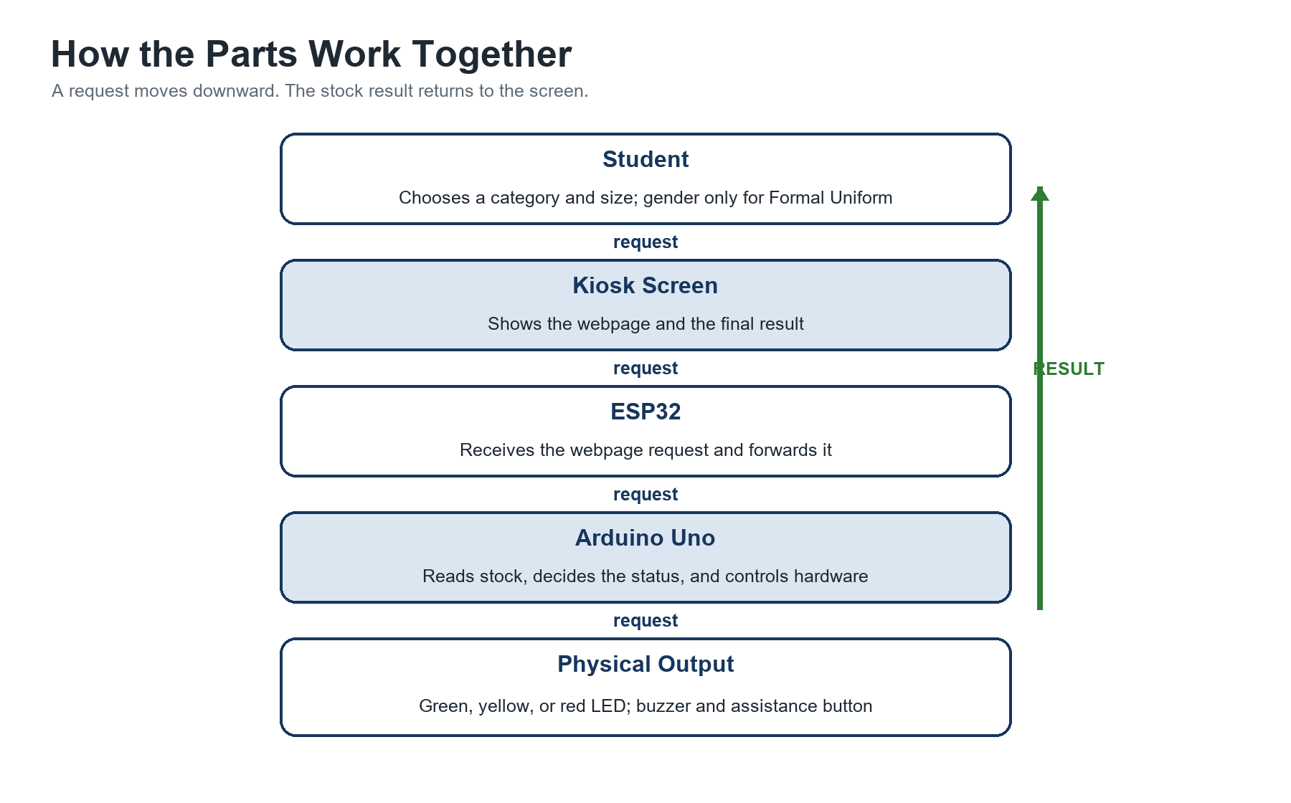
Figure 1 Overall system architecture
Stage | What happens
Student | Chooses an item, selects a size, reads the result, or requests assistance.
Touchscreen or computer | Displays the browser and sends touch or mouse input.
HTML CSS JavaScript | Presents screens, validates choices, and calls ESP32 routes.
ESP32 Web Server | Receives HTTP requests and translates them into serial messages.
UART serial communication | Carries short text commands between the two boards.
Arduino Uno | Looks up stock, applies rules, saves updates, and controls hardware.
Indicators and controls | Show the result and provide local assistance input.

A request moves from the screen toward the Arduino. The result then moves back to the screen. For example, JavaScript asks the ESP32 to check a Medium School T-Shirt. The ESP32 sends GET|T_SHIRT|M to the Arduino. The Arduino replies STOCK|12|AVAILABLE, and the ESP32 returns that information to the browser.

Section 10 How the System Works
Figure 2 follows one stock check from beginning to end. The vertical lines represent the four participants. Each horizontal arrow shows a message or action moving from one participant to another.
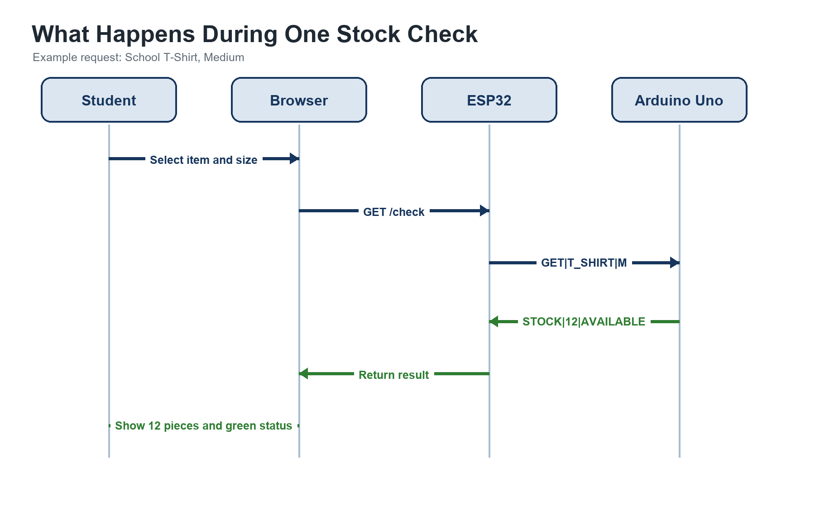
Figure 2 Message sequence for one stock check
1. The student approaches the kiosk and sees the home screen.
2. The student presses Check Availability.
3. The interface displays three categories: Formal Uniform, School T-Shirt, and PE Uniform.
4. If Formal Uniform is selected, the student chooses Male or Female and then chooses the matching garment: Male Polo, Male Pants, Female Blouse, or Female Skirt.
5. If School T-Shirt or PE Uniform is selected, the system skips the gender question because that item is unisex.
6. The interface displays the supported sizes. The student selects a size and reviews the confirmation screen.
7. The student presses Check Availability.
8. JavaScript sends an HTTP request to the ESP32, such as /check?item=T_SHIRT&size=M.
9. The ESP32 validates the parameters and sends GET|T_SHIRT|M followed by a newline to the Arduino Uno.
10. The Arduino searches its stock array for the matching item and size.
11. The Arduino determines whether the quantity is Available, Low Stock, or Out of Stock.
12. The Arduino turns off all status LEDs and then turns on only the correct LED.
13. The Arduino sends a response such as STOCK|12|AVAILABLE to the ESP32.
14. The ESP32 returns a small response to the browser.
15. JavaScript displays the quantity, status, guidance, and Check Another and Home buttons.
16. The student checks another item or returns to the home screen.
If the Arduino does not respond within the ESP32 timeout, the browser should show a clear error such as Hardware controller not responding. It must not invent a stock value.

Section 11 Stock Classification Logic
Classification logic is the rule that converts a number into a clear status. The Arduino compares the stored quantity with the three ranges shown below.
Stored quantity | Status | LED
4 or more | AVAILABLE | Green
1 to 3 | LOW STOCK | Yellow
0 | OUT OF STOCK | Red

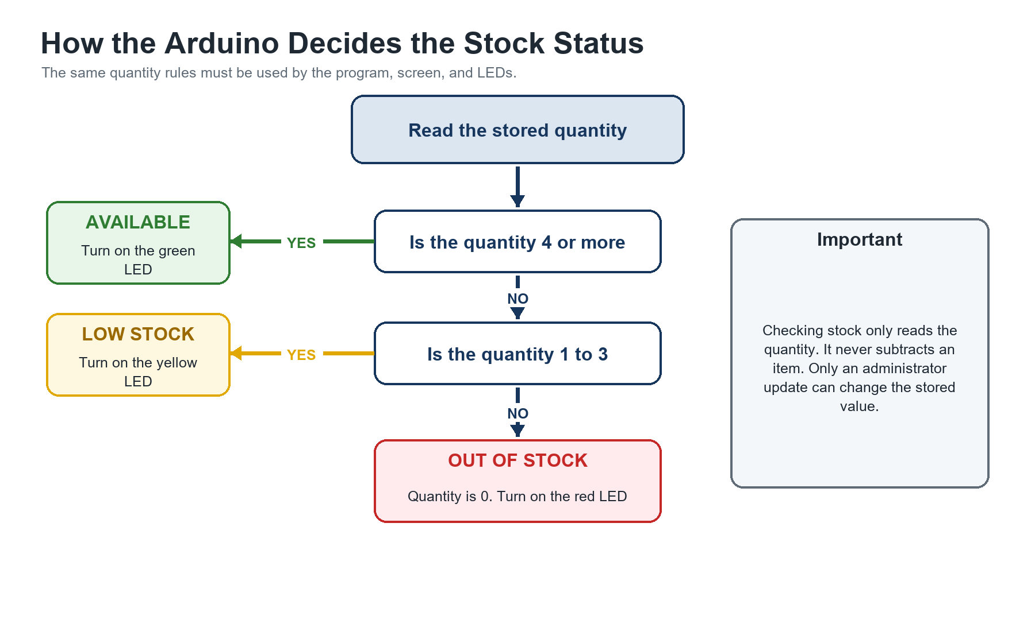
Figure 3 Stock classification decision
Availability pseudocode
IF stock >= 4
status = AVAILABLE
ELSE IF stock >= 1
status = LOW STOCK
ELSE
status = OUT OF STOCK
END IF

These thresholds are prototype rules. The school may later change them based on actual demand and restocking practice. The same thresholds must be used by the Arduino, interface labels, tests, and defense explanation.

Section 12 Sample School Uniform Inventory
Sample data only. Replace these quantities with approved demonstration values or verified school inventory. Do not present this table as the school's actual stock record.
Uniform | XS | S | M | L | XL | XXL
Male Polo | 12 | 8 | 5 | 3 | 2 | 0
Female Blouse | 9 | 7 | 6 | 4 | 1 | 0
Male Pants | 6 | 5 | 4 | 3 | 2 | 1
Female Skirt | 8 | 7 | 5 | 4 | 2 | 0
School T-Shirt | 10 | 15 | 12 | 8 | 4 | 2
PE Uniform | 7 | 9 | 6 | 3 | 1 | 0

Selection rule: Male Polo and Male Pants belong to the Male formal-uniform path. Female Blouse and Female Skirt belong to the Female formal-uniform path. School T-Shirt and PE Uniform are unisex and must not ask for gender.
The table intentionally includes Available, Low Stock, and Out of Stock examples. This makes it useful for testing all three LED and result states.

Section 13 Data Storage
EEPROM is a small memory area that keeps data after power is removed. The Arduino Uno uses it to remember stock values after a restart. Each storage location has an address, which works like a numbered space where one value can be placed.
Six stock item rows multiplied by six sizes produces 36 stock values. If each demonstration quantity is limited to 0 through 255, one byte can store each value. Address 0 may represent Male Polo XS, address 1 Male Polo S, and so on. Gender is only a screen-selection rule for the four formal items; it does not create another EEPROM dimension. A formula such as itemIndex multiplied by 6 plus sizeIndex gives the address.
Conceptual EEPROM mapping
address = (itemIndex * 6) + sizeIndex
quantity = EEPROM.read(address)

IF newQuantity is different from quantity
EEPROM.update(address, newQuantity)
END IF

EEPROM write limit. EEPROM can be written only a limited number of times. Use EEPROM.update and save only when an administrator confirms a changed value. Do not rewrite all values during every loop cycle.
A first-run marker can tell the program whether valid values already exist. If the marker is missing, the Arduino writes the sample defaults once. On later starts, it reads the saved quantities instead of replacing them.

Section 14 Serial Communication
Serial communication sends characters one after another between the ESP32 and Arduino Uno. UART is the communication method used for this wired link. TX means transmit or send, while RX means receive. The TX pin of one board connects to the RX pin of the other board.
Both programs must use the same baud rate, such as 9600 or 115200. The baud rate is the agreed communication speed. Each command ends with a newline character so the receiving board knows that the complete message has arrived.
Direction | Example | Meaning
ESP32 to Arduino | GET|T_SHIRT|M | Request the Medium School T-Shirt quantity.
Arduino to ESP32 | STOCK|12|AVAILABLE | Return quantity 12 with Available status.
ESP32 to Arduino | GET|MALE_POLO|XL | Request the Extra Large Male Polo quantity.
Arduino to ESP32 | STOCK|2|LOW | Return quantity 2 with Low Stock status.
ESP32 to Arduino | GET|MALE_POLO|XXL | Request the Double Extra Large Male Polo quantity.
Arduino to ESP32 | STOCK|0|OUT | Return quantity 0 with Out of Stock status.

The vertical bar separates fields. In GET|T_SHIRT|M, GET is the action, T_SHIRT is the item code, and M is the size code. Gender is not sent as a separate serial field because the formal item codes already identify the correct garment, while T_SHIRT and PE_UNIFORM are unisex. The programs must use exactly the same item and size codes. Unknown or incomplete commands should return an error such as ERROR|BAD_REQUEST.

Section 15 Important Voltage Safety
Arduino Uno digital pins normally use 5 V logic. ESP32 GPIO pins use approximately 3.3 V logic and are not designed to receive 5 V. A direct connection from an Arduino TX pin to an ESP32 RX pin can damage the ESP32.
Do not connect a 5 V Uno TX output directly to an ESP32 GPIO. Use a proper bidirectional logic-level converter or a correctly calculated resistor voltage divider on the Uno-to-ESP32 signal. Ask a teacher or electronics adviser to verify the circuit before power is applied.
The ESP32 TX output is 3.3 V. It is usually read as HIGH by the Arduino Uno, but the final circuit should still be checked. The Arduino and ESP32 must share a common GND for the serial voltage levels to have the same reference.
Connect TX to the other device's RX, not TX to TX. Keep the serial wires short during breadboard testing. Disconnect power before changing wiring.

Section 16 Hardware Wiring
Build and test one connection at a time. Figure 4 provides an overview, while the table gives the exact suggested pins. Disconnect power before adding or moving a wire.
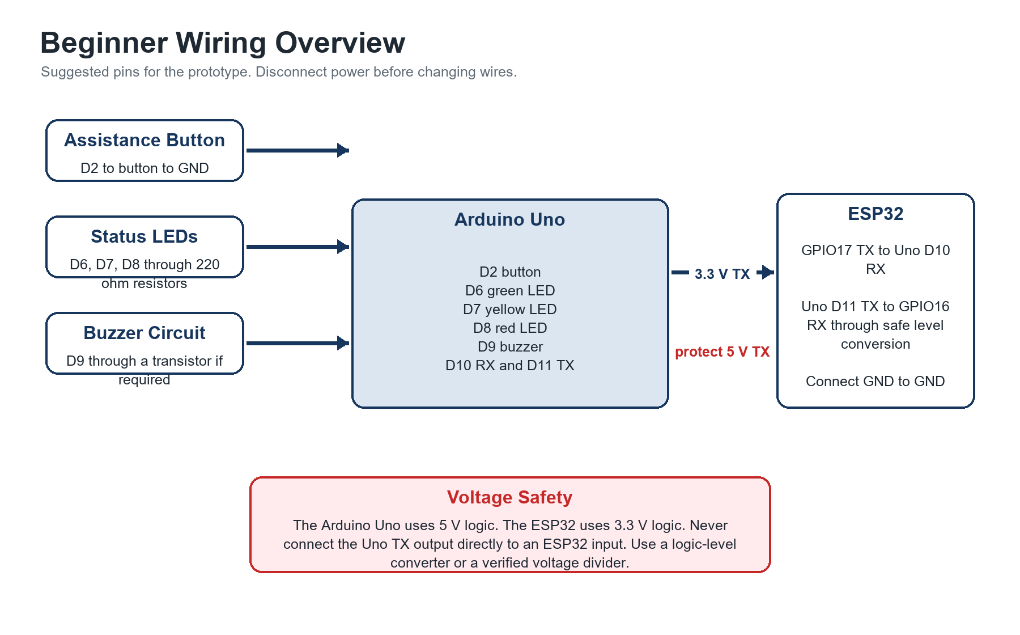
Figure 4 Beginner wiring overview
Function | Suggested connection
Green LED | Arduino D6 -> 220 ohm resistor -> green LED anode; LED cathode -> GND
Yellow LED | Arduino D7 -> 220 ohm resistor -> yellow LED anode; LED cathode -> GND
Red LED | Arduino D8 -> 220 ohm resistor -> red LED anode; LED cathode -> GND
Buzzer | Arduino D9 -> 1 kilohm resistor -> transistor base; transistor switches buzzer as rated
Assistance button | Arduino D2 -> push button -> GND; configure D2 as INPUT_PULLUP
ESP32 TX2 | ESP32 GPIO17 TX -> Arduino D10 SoftwareSerial RX
Arduino serial TX | Arduino D11 SoftwareSerial TX -> level shifter or divider -> ESP32 GPIO16 RX2
Common reference | Arduino GND -> ESP32 GND

With INPUT_PULLUP, the Arduino enables an internal resistor. The button does not need a separate pull-up resistor in the basic circuit. Button not pressed reads HIGH. Button pressed connects the pin to ground and reads LOW.
The suggested D10 and D11 pins use SoftwareSerial so the Uno USB serial port remains available for programming and debugging. If different pins are used, update the wiring diagram and both programs.

Transistor Buzzer Connection
- Connect Arduino D9 through a 1 kilohm resistor to the transistor base.
- Connect the transistor emitter to GND.
- Connect the buzzer negative terminal to the transistor collector.
- Connect the buzzer positive terminal to its rated supply voltage.
- Connect the supply ground to Arduino GND.
- For an inductive sounder, add the protection component recommended by its datasheet or adviser.

Section 17 Kiosk User Interface
The user interface is the part of the system that students see and touch. It should use large buttons, short instructions, strong contrast, and consistent Home and Back controls. Each screen should ask the student to make only one main decision.
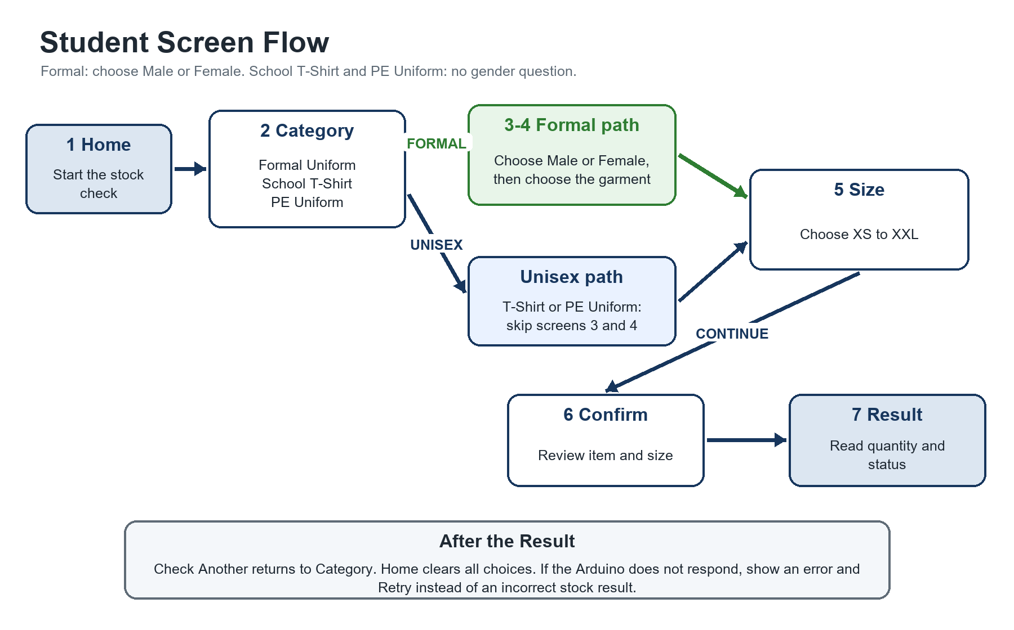
Figure 5 Student screen flow
Screen | Required content
Screen 1 Home | Title: School Uniform Availability Kiosk. Buttons: Check Availability, Request Assistance, Uniform Information.
Screen 2 Category | Buttons: Formal Uniform, School T-Shirt, PE Uniform, and Back.
Screen 3 Gender | Show only after Formal Uniform. Buttons: Male, Female, and Back. Never show this screen for School T-Shirt or PE Uniform.
Screen 4 Garment | Formal only. Male: Male Polo or Male Pants. Female: Female Blouse or Female Skirt. Unisex categories skip this screen because the category already identifies the item.
Screen 5 Size | Buttons: XS, S, M, L, XL, XXL, and Back. Show the selected item above the choices.
Screen 6 Confirmation | Show Selected Item and Selected Size. Show gender only when the chosen item is a formal uniform. Buttons: Check Availability and Back.
Screen 7 Result | Show a large status, item, size, quantity, guidance, and buttons for Check Another and Home.

Result Wording
Status | Example screen message
AVAILABLE | School T-Shirt | Medium | 12 Pieces Available | Please proceed to the Uniform Office for purchasing.
LOW STOCK | Only 2 pieces remaining. Please verify availability with the Uniform Office.
OUT OF STOCK | This size is currently unavailable. Please check another size or ask school personnel.

Do not use green, yellow, or red as the only way to communicate status. Always display the status word and quantity because color can be misunderstood and the physical LED may not be visible from every angle.

Section 18 Admin Interface
The administrator interface is separate from the student screens because it can change stored quantities. It begins with a prototype PIN field and Login button. After a correct PIN, the Inventory Management screen follows the same selection rule as the student side: Formal Uniform asks for Male or Female and then the garment, while School T-Shirt and PE Uniform skip gender. The screen then shows the selected item, size, current stock, new quantity, Update Stock button, and Logout button.
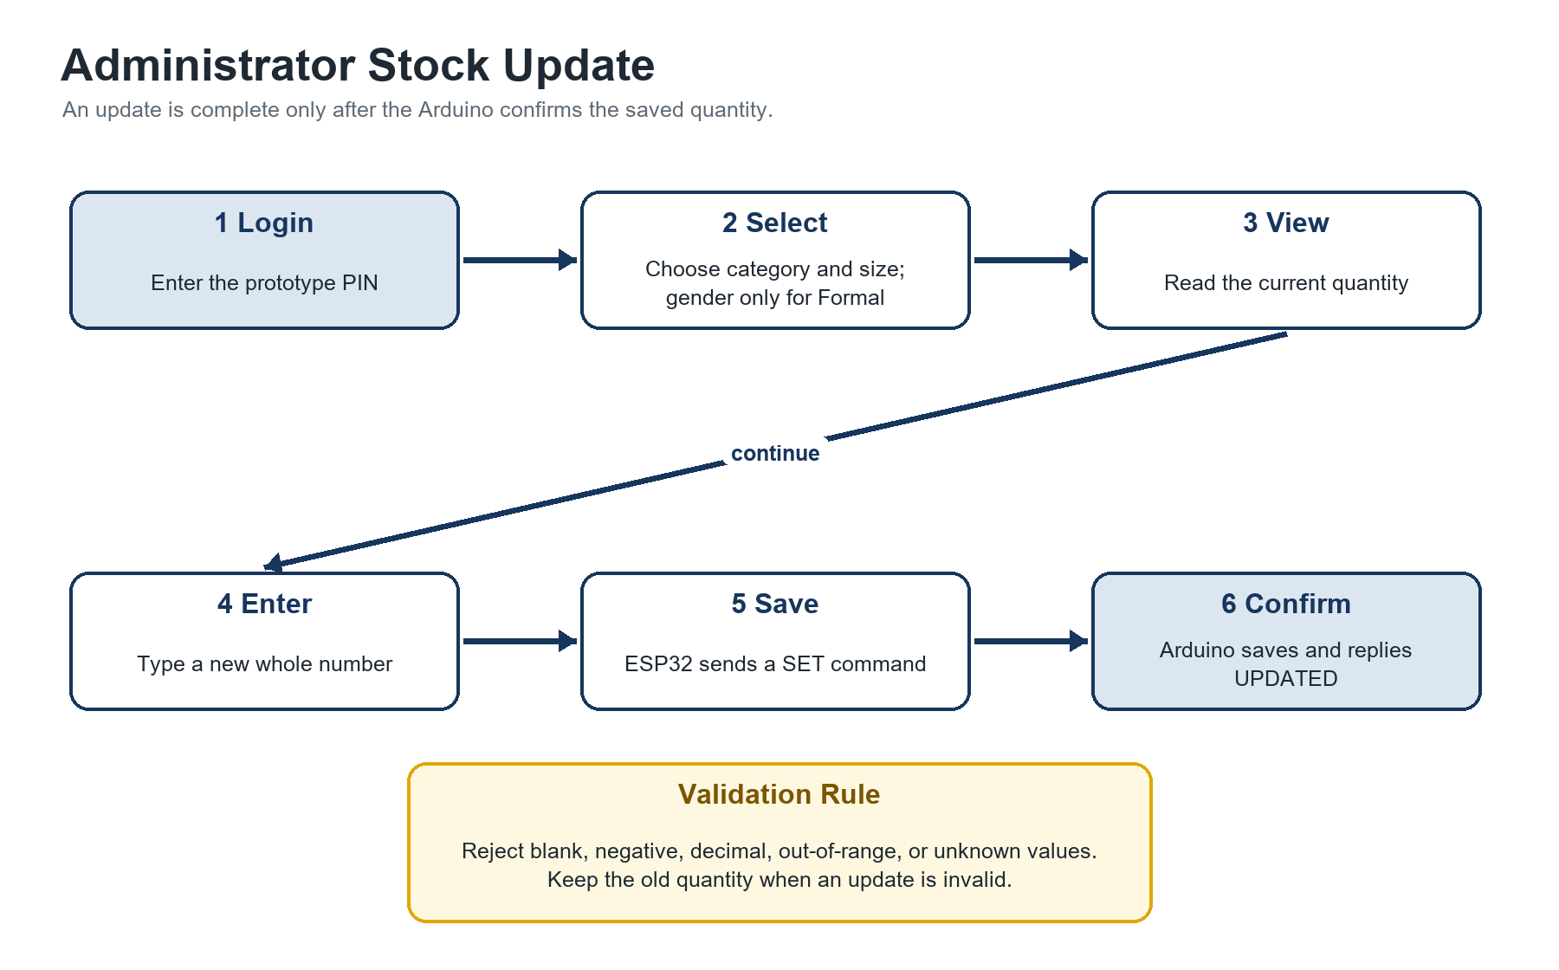
Figure 6 Administrator stock update process
1. The administrator chooses a category and size. Formal Uniform requires Male or Female and a garment; School T-Shirt and PE Uniform do not ask for gender.
2. JavaScript requests the current value through the normal check route.
3. The Arduino returns the existing quantity.
4. The administrator enters a whole number of zero or greater.
5. The ESP32 sends a SET command to the Arduino.
6. The Arduino validates the command, changes the array value, and saves only that address to EEPROM.
7. The Arduino returns an UPDATED response, and the interface displays a confirmation.
Validate every update. Reject blank input, negative numbers, decimals, values above the selected storage limit, unknown items, and unknown sizes. Do not display success until the Arduino confirms the saved value.
For a classroom prototype, the PIN may be stored in the ESP32 program. Explain during the defense that this is not secure enough for actual school deployment because code and network traffic may be inspected.

Section 19 Admin Communication Command
Example administrator update
SET|T_SHIRT|M|15
UPDATED|T_SHIRT|M|15

SET tells the Arduino to replace a value. T_SHIRT identifies the unisex School T-Shirt, M identifies the size, and 15 is the new quantity. The response confirms that Medium School T-Shirt stock is now 15. A later GET request should return STOCK|15|AVAILABLE.
If the request is invalid, the Arduino should keep the old value and return a message such as ERROR|BAD_QUANTITY or ERROR|UNKNOWN_ITEM. This prevents a failed update from appearing successful.

Section 20 Assistance Button
1. The student presses the physical assistance button.
2. The Arduino detects a change from HIGH to LOW.
3. The Arduino sounds the buzzer for a short, controlled period.
4. The Arduino sends ASSIST|REQUESTED to the ESP32.
5. The ESP32 makes the event available to the webpage through /status or /assist.
6. The kiosk displays Assistance Requested. Please wait for school personnel.
The program should debounce the button so one press creates only one event. A delay of about 30 to 50 milliseconds or a non-blocking time check can filter electrical bouncing.
Local notification only. The prototype buzzer and screen message do not automatically contact a person through SMS, email, or the internet. School personnel must be near enough to hear or see the request.

Section 21 LED Indicator Panel
Suggested label beside or below the screen
STOCK STATUS
GREEN Available
YELLOW Low Stock
RED Out of Stock

Mount the LEDs where students and panel members can see them. Label each color with its meaning. After a check, the Arduino should first switch all three LEDs off and then switch on the one that matches the result. When the user returns home, the program may turn all status LEDs off so an old result is not mistaken for the current one.

Section 22 Proposed Physical Kiosk Design
A simple enclosure may be built from plywood, acrylic, PVC board, or another safe prototype material. Place the touchscreen or monitor near eye level. Put the three labeled LEDs and the assistance button below or beside the screen. Keep the buzzer behind a small opening so it can be heard without being touched.
- Mount the Arduino Uno and ESP32 inside the enclosure on non-conductive standoffs.
- Separate loose wires from moving parts and screen brackets.
- Provide ventilation openings for the computer and power components.
- Keep USB and power connectors accessible for programming and maintenance.
- Use strain relief so a cable cannot pull directly on a circuit board.
- Cover exposed conductors and avoid sharp edges.
- Add labels for Green Available, Yellow Low Stock, Red Out of Stock, and Request Assistance.
For the defense, a laptop on a stable stand with a small electronics panel is acceptable if a full enclosure is not yet safe or complete. The important requirement is a working and clearly explained system, not an expensive cabinet.

Section 23 Complete Student Process
Figure 5 gives the visual summary. The complete student process is written below in short stages so that each part can be tested separately.
1. Start: The student opens the Home screen and selects Check Availability.
2. Choose: The student selects a category. Formal Uniform requires Male or Female and then a garment; School T-Shirt and PE Uniform skip gender. The student selects a size and confirms the choice.
3. Request: The browser sends the selected item and size to the ESP32.
4. Forward: The ESP32 sends a GET command to the Arduino Uno through serial communication.
5. Decide: The Arduino reads the stored quantity and classifies it as Available, Low Stock, or Out of Stock.
6. Respond: The Arduino sends the quantity and status to the ESP32, which returns them to the browser.
7. Display: The result screen shows the quantity, status words, and matching LED indication.
8. Continue: Check Another returns to category selection. Home clears the choices and returns to the first screen.
Error rule: If a timeout or invalid response occurs, show an error screen with Retry and Home. Never display Available, Low Stock, or Out of Stock unless a valid Arduino response was received.

Section 24 Complete Administrator Process
Figure 6 gives the visual summary. The administrator process below separates validation, saving, and confirmation so the group can explain exactly when a value changes.
1. Login: The administrator enters the prototype PIN. An incorrect PIN returns to the login screen with an error message.
2. Select: The administrator chooses a category and size. Formal Uniform also requires Male or Female and the matching garment; School T-Shirt and PE Uniform skip gender.
3. View: The interface requests and displays the current saved quantity.
4. Enter: The administrator types a new whole-number quantity within the allowed range.
5. Validate: The webpage rejects blank, negative, decimal, out-of-range, or unknown values before sending an update.
6. Send: The ESP32 sends a SET command only after the input passes validation.
7. Save: The Arduino validates the command again, changes the correct array value, and saves that one address to EEPROM.
8. Confirm: The interface shows success only after the Arduino replies UPDATED. Invalid requests keep the previous quantity.

Section 25 Example Arduino Program Structure
The Arduino Uno program should use a simple and organized structure. A function is a named group of instructions that performs one task. Separate functions for item lookup, size lookup, stock classification, LED control, command processing, and button monitoring make the program easier to test and explain.
The sample below shows the main structure and important responsibilities. It is an implementation reference rather than a complete production program. The group must add the missing helper functions, first-run EEPROM initialization, and final error handling.
Simplified Arduino Uno program structure
#include <EEPROM.h>
#include <SoftwareSerial.h>

const byte GREEN_LED = 6;
const byte YELLOW_LED = 7;
const byte RED_LED = 8;
const byte BUZZER = 9;
const byte ASSIST_BUTTON = 2;

SoftwareSerial espSerial(10, 11); // RX, TX

const byte ITEM_COUNT = 6;
const byte SIZE_COUNT = 6;
byte stock[ITEM_COUNT][SIZE_COUNT];

const char* itemCodes[ITEM_COUNT] = {
"MALE_POLO", "FEMALE_BLOUSE", "MALE_PANTS",
"FEMALE_SKIRT", "T_SHIRT", "PE_UNIFORM"
};
const char* sizeCodes[SIZE_COUNT] = {"XS", "S", "M", "L", "XL", "XXL"};

void setup() {
pinMode(GREEN_LED, OUTPUT);
pinMode(YELLOW_LED, OUTPUT);
pinMode(RED_LED, OUTPUT);
pinMode(BUZZER, OUTPUT);
pinMode(ASSIST_BUTTON, INPUT_PULLUP);

Serial.begin(9600); // USB debugging
espSerial.begin(9600); // link to ESP32
loadInventory();
setStatusLeds(-1);
}

void loop() {
if (espSerial.available()) {
String command = espSerial.readStringUntil('\n');
command.trim();
processCommand(command);
}
monitorAssistanceButton();
}

void processCommand(String command) {
if (command.startsWith("GET|")) {
processGet(command);
} else if (command.startsWith("SET|")) {
processSet(command);
} else {
espSerial.println("ERROR|BAD_REQUEST");
}
}

String statusFor(byte quantity) {
if (quantity >= 4) return "AVAILABLE";
if (quantity >= 1) return "LOW";
return "OUT";
}

void setStatusLeds(int quantity) {
digitalWrite(GREEN_LED, LOW);
digitalWrite(YELLOW_LED, LOW);
digitalWrite(RED_LED, LOW);
if (quantity < 0) return;
if (quantity >= 4) digitalWrite(GREEN_LED, HIGH);
else if (quantity >= 1) digitalWrite(YELLOW_LED, HIGH);
else digitalWrite(RED_LED, HIGH);
}

void processGet(String command) {
String item = field(command, 1);
String size = field(command, 2);
int itemIndex = findCode(itemCodes, ITEM_COUNT, item);
int sizeIndex = findCode(sizeCodes, SIZE_COUNT, size);
if (itemIndex < 0 || sizeIndex < 0) {
espSerial.println("ERROR|UNKNOWN_ITEM_OR_SIZE");
return;
}
byte quantity = stock[itemIndex][sizeIndex];
setStatusLeds(quantity);
espSerial.println("STOCK|" + String(quantity) + "|" + statusFor(quantity));
}

void processSet(String command) {
String item = field(command, 1);
String size = field(command, 2);
String valueText = field(command, 3);
int itemIndex = findCode(itemCodes, ITEM_COUNT, item);
int sizeIndex = findCode(sizeCodes, SIZE_COUNT, size);
int value = valueText.toInt();
if (itemIndex < 0 || sizeIndex < 0 || value < 0 || value > 255) {
espSerial.println("ERROR|BAD_UPDATE");
return;
}
stock[itemIndex][sizeIndex] = (byte)value;
int address = itemIndex * SIZE_COUNT + sizeIndex;
EEPROM.update(address, (byte)value);
espSerial.println("UPDATED|" + item + "|" + size + "|" + String(value));
}

void monitorAssistanceButton() {
static bool wasPressed = false;
bool pressed = digitalRead(ASSIST_BUTTON) == LOW;
if (pressed && !wasPressed) {
digitalWrite(BUZZER, HIGH);
delay(150);
digitalWrite(BUZZER, LOW);
espSerial.println("ASSIST|REQUESTED");
}
wasPressed = pressed;
delay(20);
}

void loadInventory() {
for (byte item = 0; item < ITEM_COUNT; item++) {
for (byte size = 0; size < SIZE_COUNT; size++) {
stock[item][size] = EEPROM.read(item * SIZE_COUNT + size);
}
}
}

// Implement field() to return text between | separators.
// Implement findCode() to return a matching array index or -1.

Before using the code, add a safe first-run initialization routine. A new Uno EEPROM may contain 255, which would appear as a large stock value. Use a marker byte outside the 36 stock addresses. If the marker is absent, write the sample data once and then write the marker.

Section 26 Example ESP32 Program Structure
The ESP32 program connects the browser to the Arduino Uno. For a demonstration that does not depend on school Wi-Fi, the ESP32 can create a local access point. An access point is a small Wi-Fi network created by the ESP32. The kiosk computer joins that network and opens the ESP32 address in a browser.
Simplified ESP32 program structure
#include <WiFi.h>
#include <WebServer.h>

WebServer server(80);
HardwareSerial unoSerial(2);

String askUno(String command) {
while (unoSerial.available()) unoSerial.read();
unoSerial.println(command);
unsigned long start = millis();
while (millis() - start < 1500) {
if (unoSerial.available()) {
String reply = unoSerial.readStringUntil('\n');
reply.trim();
return reply;
}
}
return "ERROR|TIMEOUT";
}

void handleCheck() {
if (!server.hasArg("item") || !server.hasArg("size")) {
server.send(400, "text/plain", "ERROR|MISSING_PARAMETER");
return;
}
String command = "GET|" + server.arg("item") + "|" + server.arg("size");
server.send(200, "text/plain", askUno(command));
}

void handleUpdate() {
if (!server.hasArg("item") || !server.hasArg("size") || !server.hasArg("qty")) {
server.send(400, "text/plain", "ERROR|MISSING_PARAMETER");
return;
}
String command = "SET|" + server.arg("item") + "|" +
server.arg("size") + "|" + server.arg("qty");
server.send(200, "text/plain", askUno(command));
}

void setup() {
WiFi.softAP("Uniform-Kiosk", "school123");
unoSerial.begin(9600, SERIAL_8N1, 16, 17); // RX2, TX2

server.on("/", []() { server.send(200, "text/html", kioskHtml); });
server.on("/check", handleCheck);
server.on("/update", handleUpdate);
server.on("/status", handleStatus);
server.on("/assist", handleAssist);
server.begin();
}

void loop() {
server.handleClient();
readUnsolicitedArduinoEvents();
}

The request /check?item=T_SHIRT&size=M becomes GET|T_SHIRT|M. The /update route should require a valid administrator session or prototype token before it sends a SET command. The sample route is simplified and must not be described as secure.
A basic implementation may store the HTML in a program string on the ESP32. A later version may use the ESP32 file system, but that is optional. Keep the first version small enough to debug.

Section 27 HTML Structure
HTML defines the content and structure of the kiosk webpage. It creates the headings, buttons, labels, forms, and screen sections. The project may use one HTML page containing several sections. JavaScript displays only the section needed at that point in the process.
One-page screen structure
<main id="kiosk">
<section id="home" class="screen active">...</section>
<section id="category-screen" class="screen">...</section>
<section id="gender-screen" class="screen">...</section>
<section id="garment-screen" class="screen">...</section>
<section id="size-screen" class="screen">...</section>
<section id="confirm-screen" class="screen">...</section>
<section id="result-screen" class="screen">...</section>
<section id="admin-login" class="screen">...</section>
<section id="admin-panel" class="screen">...</section>
</main>

Each button should have a meaningful label and a predictable click action. Avoid links or controls that lead to unfinished screens. Add a short loading message while waiting for the Arduino response so the student does not press the button repeatedly.

Section 28 CSS Design
CSS controls the visual presentation of the kiosk, including colors, text size, spacing, button dimensions, and screen arrangement. Use strong contrast, readable text, sufficient spacing, and consistent button shapes. A button height of approximately 60 to 80 pixels is a suitable starting point for a touchscreen, but the group must test the final size on the actual display.
Simple touchscreen-friendly CSS
body {
margin: 0;
font-family: Arial, sans-serif;
background: #f4f6f8;
color: #1f2933;
}

.screen {
display: none;
max-width: 900px;
margin: 0 auto;
padding: 32px;
}

.screen.active { display: block; }

button {
min-height: 68px;
min-width: 180px;
margin: 10px;
padding: 12px 20px;
font-size: 22px;
border-radius: 8px;
}

button:focus { outline: 4px solid #17365d; }

Use status text as well as color. Test the interface from the normal viewing distance. Do not claim formal accessibility compliance unless the interface has been evaluated against a recognized standard.

Section 29 JavaScript Function
JavaScript provides the webpage behavior. It remembers the selected category, optional formal-uniform gender, final item code, and size. It changes the visible screen, sends requests to the ESP32, reads the response, and updates the displayed result. The program must ask for gender only when Formal Uniform is selected and must prevent a stock check until a final item code and size exist.
Example availability request
let selectedCategory = "";
let selectedGender = "";
let selectedItem = "";
let selectedSize = "";

function chooseCategory(category) {
selectedCategory = category;
selectedGender = "";
selectedItem = "";
if (category === "FORMAL") showScreen("gender-screen");
if (category === "T_SHIRT") {
selectedItem = "T_SHIRT";
showScreen("size-screen");
}
if (category === "PE_UNIFORM") {
selectedItem = "PE_UNIFORM";
showScreen("size-screen");
}
}

function chooseFormalGender(gender) {
selectedGender = gender;
showFormalGarments(gender === "MALE"
? ["MALE_POLO", "MALE_PANTS"]
: ["FEMALE_BLOUSE", "FEMALE_SKIRT"]);
showScreen("garment-screen");
}

async function checkAvailability() {
if (!selectedItem || !selectedSize) return;
showScreen("loading-screen");
try {
const url = `/check?item=${encodeURIComponent(selectedItem)}` +
`&size=${encodeURIComponent(selectedSize)}`;
const response = await fetch(url);
const reply = await response.text();
if (!response.ok || reply.startsWith("ERROR|")) throw new Error(reply);
const [type, quantity, status] = reply.split("|");
if (type !== "STOCK") throw new Error("Unexpected response");
displayResult(Number(quantity), status);
showScreen("result-screen");
} catch (error) {
displayError("The hardware controller did not return a valid result.");
showScreen("error-screen");
}
}

The script should also reset old selections when Home is pressed, display current choices on the confirmation screen, validate administrator quantities, and poll or request assistance status if the Arduino sends an assistance event.

Section 30 Sample Inventory Data Structure
The prototype does not require a separate database server. Its data structure is a 6 by 6 stock table stored in Arduino memory and EEPROM. The six rows represent stock items, the six columns represent sizes, and each item-size pair corresponds to one EEPROM address. Male or Female is a user-interface rule for Formal Uniform, not a separate database field or storage dimension.
Conceptual record structure
School T-Shirt
XS = 10 S = 15 M = 12 L = 8 XL = 4 XXL = 2

Male Polo
XS = 12 S = 8 M = 5 L = 3 XL = 2 XXL = 0

EEPROM address = (item index * 6) + size index

Item index | Uniform | EEPROM addresses
0 | Male Polo | 0 to 5
1 | Female Blouse | 6 to 11
2 | Male Pants | 12 to 17
3 | Female Skirt | 18 to 23
4 | School T-Shirt (Unisex) | 24 to 29
5 | PE Uniform (Unisex) | 30 to 35

Within each six-address block, XS is offset 0, S is 1, M is 2, L is 3, XL is 4, and XXL is 5. Keep this order unchanged in the code and documentation.

Section 31 Functional Testing
Run each test on the assembled prototype. Write the observed result in Actual Result and mark Pass only when the display, serial response, and hardware behavior match the expected result. A blank row means the test has not yet been performed.
Test | Feature | Input | Expected Result | Actual Result | Status
T01 | Available stock check | School T-Shirt M with stock 12 | Display 12 and Available; green LED on
T02 | Low stock check | Male Polo XL with stock 2 | Display 2 and Low Stock; yellow LED on
T03 | Out of stock check | Male Polo XXL with stock 0 | Display 0 and Out of Stock; red LED on
T04 | No automatic deduction | Check School T-Shirt M twice | Both checks display 12
T05 | Assistance button | Press physical button once | Short buzzer sound and assistance message
T06 | Admin update | Change School T-Shirt M from 12 to 15 | Confirmation received; next check displays 15
T06A | Formal gender path | Choose Formal Uniform, then Male | Only Male Polo and Male Pants are shown
T06B | Unisex path | Choose School T-Shirt or PE Uniform | No gender question is shown
T07 | Power recovery | Restart Uno after saved update | Updated value remains available
T08 | Invalid quantity | Enter -1 or blank | Update rejected; old value unchanged
T09 | Invalid item code | Send GET|UNKNOWN|M | Error response; no false stock result
T10 | Arduino disconnected | Check item with Uno link removed | Timeout or controller error shown
T11 | LED exclusivity | Run all three stock states | Only the matching LED is on after each check
T12 | Navigation | Check item then press Home | Home opens and old selection is cleared

Also record the date, tester, program versions, and wiring version in the group test log. If a test fails, note the cause and repeat the test after the correction.

Section 32 Possible Problems and Troubleshooting
Problem | Possible cause | Simple solution
ESP32 will not connect | Wrong network name or password; weak signal; wrong mode | Recheck credentials or use ESP32 access-point mode; view Serial Monitor messages.
Arduino receives no commands | TX and RX not crossed; wrong baud rate; loose wire | Connect TX to RX, match baud rates, inspect newline handling, and test with Serial Monitor.
Wrong stock value | Item index or EEPROM address mismatch | Print item and size indices; verify the 6 by 6 mapping; reinitialize test data safely.
LED always on | Pin logic error or LED connected incorrectly | Turn all LEDs off before setting one; check polarity and pin numbers.
Button always pressed | INPUT_PULLUP wiring wrong or pin shorted to GND | Confirm one side goes to D2 and the other to GND; inspect the breadboard rows.
ESP32 resets | Unstable power supply, short circuit, or excessive current | Use a stable rated supply; inspect wiring; do not power heavy loads from GPIO.
Webpage cannot connect | Computer is on another network or wrong ESP32 IP | Connect to the kiosk network and open the IP printed by the ESP32.
Serial text is garbled | Baud rates differ or shared ground is missing | Use the same baud rate and connect common GND.
TX and RX wiring fails | TX connected to TX or RX connected to RX | Cross the signals: ESP32 TX to Uno RX and Uno TX to ESP32 RX through safe level conversion.
Missing common ground | Boards have different voltage references | Connect Arduino GND and ESP32 GND.
5 V reaches ESP32 GPIO | Uno TX connected directly | Disconnect power immediately and add a level converter or verified divider.
EEPROM value is 255 or corrupted | Memory not initialized or invalid data stored | Use a first-run marker and range checks; restore known sample values.
Update says success but value is old | ESP32 confirms before Arduino reply | Show success only after receiving UPDATED from the Arduino.
One button creates many alerts | Mechanical button bounce | Add debounce logic and trigger only on the HIGH-to-LOW transition.

Safety first. Remove power before moving wires. If a board becomes hot, smells unusual, or repeatedly resets, disconnect it and ask a teacher or electronics adviser to inspect the circuit.

Section 33 Development Order
Phase | Build step | Completion check
1 | Arduino LEDs and button | Blink each LED separately, read the button, and sound the buzzer safely.
2 | Arduino stock arrays | Store the 36 sample values and print selected quantities to Serial Monitor.
3 | Arduino GET command | Parse a GET command and return the correct quantity and status.
4 | Arduino SET command | Validate and change one value in RAM before adding EEPROM.
5 | ESP32 serial connection | Send fixed commands between boards and confirm clean replies.
6 | ESP32 web server | Open a basic page and test /check from a browser.
7 | HTML interface | Build all student screens with working navigation using sample results.
8 | JavaScript integration | Connect the interface to /check and handle errors and loading states.
9 | Admin interface | Add PIN screen, current stock lookup, validation, and /update.
10 | EEPROM storage | Save changed values and verify them after a power restart.
11 | Physical kiosk enclosure | Mount only after the electronics and software work on the bench.
12 | Testing | Complete the test table, correct failures, and rehearse the demonstration.

Do not skip phases. Make each phase work by itself before adding the next. When several new parts are added at once, it becomes difficult to identify the cause of a failure.

Section 34 Demonstration Scenario
1. A student selects School T-Shirt and Medium. The kiosk does not ask for gender because the item is unisex.
2. The screen displays 12 pieces available.
3. The green LED turns on.
4. An administrator opens the admin screen and changes the value to 2.
5. The Arduino confirms the update and stores it.
6. The student checks the same item again.
7. The screen displays Low Stock with 2 pieces.
8. The yellow LED turns on and the green LED turns off.
9. The administrator changes the value to 0.
10. The student checks the same item again.
11. The screen displays Out of Stock.
12. The red LED turns on and the other LEDs turn off.
13. The student presses the physical assistance button.
14. The buzzer sounds and the assistance message appears.
This sequence proves that the browser sends a request, the ESP32 forwards it, the Arduino applies the rule, the hardware output changes, the admin update changes the saved quantity, and the physical button can create an event.

Section 35 Questions the Panel May Ask
Question | Suggested answer
Why did you use Arduino Uno? | The Uno stores or accesses prototype stock values, processes GET and SET commands, applies the stock rule, controls the LEDs and buzzer, and reads the assistance button.
Why did you also use ESP32? | The ESP32 provides Wi-Fi and a web server. It connects the browser interface to the Arduino through serial communication.
Why did you not use ESP32 only? | The project is designed to demonstrate an Arduino-based hardware controller. Separating the Uno hardware logic from the ESP32 communication role also makes the architecture easy to explain.
Why is stock manually updated? | This is a limited prototype without a link to the school's official inventory or sales process. Authorized staff enter a verified quantity.
Does checking stock decrease inventory? | No. A check is read-only. Stock changes only after an authorized SET update.
Why is there no purchasing feature? | The project's problem is availability checking. Purchasing would add transaction, receipt, security, and policy requirements outside the prototype scope.
Why is there no payment system? | Payment handling would require financial security, account controls, audit processes, and approval. It is unnecessary for proving the stock-checking concept.
Where is the inventory stored? | The working values are in the Arduino stock array, and saved quantities are kept in EEPROM for restart recovery.
What happens if the kiosk loses power? | EEPROM keeps the last saved quantities. The Arduino loads them when it starts again. Unsaved changes would not be preserved.
How do you determine Low Stock? | A quantity from 1 to 3 is Low Stock. Four or more is Available, and zero is Out of Stock.
What is the purpose of the LEDs? | They provide a visible physical output that matches the status calculated by the Arduino.
What makes the kiosk interactive? | The user chooses an item and size, the system processes the request, hardware responds, and the screen changes based on the returned result.
Is it ready for actual school deployment? | No. It is a prototype. Deployment would require verified inventory integration, stronger security, reliability testing, maintenance procedures, and school approval.

Section 36 Future Improvements
Possible future developments include a central database, cloud synchronization, barcode scanning, RFID inventory tracking, connection to the school's official inventory, automatic stock deduction after an approved transaction, support for multiple kiosks, staff notifications, purchasing integration, and a mobile application.
Future developments only. These functions are not part of the current prototype and should not be shown as completed features. Add them only after the required stock-checking system has been tested and after the school approves the added data and security responsibilities.

Section 37 Final Recommended System
Recommended prototype architecture
TOUCHSCREEN OR COMPUTER
|
v
HTML + CSS + JAVASCRIPT
|
v
ESP32 WEB SERVER
|
v
SERIAL COMMUNICATION
|
v
ARDUINO UNO
|
v
STOCK LOGIC + EEPROM
|
v
GREEN LED + YELLOW LED + RED LED
+
BUZZER
+
ASSISTANCE BUTTON

Student Capabilities
- Choose Formal Uniform, School T-Shirt, or PE Uniform.
- Choose Male or Female only for Formal Uniform, then choose the matching garment.
- Skip gender for the unisex School T-Shirt and PE Uniform.
- Select a size.
- Check stock quantity and status.
- See the matching LED.
- Request local assistance.

Administrator Capabilities
- Log in using a prototype PIN.
- View the current stored quantity.
- Update and save a stock quantity.

Functions Not Included
- Buying or online ordering.
- Payments or financial accounts.
- Reservations.
- Automatic actual inventory transactions.
- Automatic dispensing or enterprise inventory management.
The recommended design keeps the capstone focused and demonstrable. The computer provides the interface, the ESP32 carries web requests, and the Arduino Uno remains responsible for the stock rule and physical hardware. A successful prototype should return correct quantities, activate the correct LED, save authorized updates, detect the assistance button, and show clear errors when communication fails.

Prototype Completion Checklist
[ ] All six stock item rows and six sizes can be selected.
[ ] Formal Uniform requires Male or Female before the garment is selected.
[ ] School T-Shirt and PE Uniform are unisex and never ask for gender.
[ ] All 36 stock values return the expected quantity.
[ ] Available, Low Stock, and Out of Stock use the same thresholds everywhere.
[ ] Only the correct status LED turns on.
[ ] Checking an item never reduces stock.
[ ] Admin updates are validated, confirmed by Arduino, and retained after restart.
[ ] The assistance button creates one buzzer event and one message per press.
[ ] The Uno-to-ESP32 voltage level is protected and both devices share ground.
[ ] Timeouts and invalid commands show errors instead of false results.
[ ] The completed test table contains actual results and dates.
[ ] The group can explain each device's role and demonstrate the full data path.

Part Two Builder Transfer Specification
This part is the implementation contract for another account, AI builder, programmer, or group member. It records the decisions that must remain consistent across the interface, ESP32 program, Arduino program, wiring, tests, and capstone defense.

Transfer Package Purpose
Use the Word manual for complete explanations and the companion Master Builder Brief for direct copy and paste into another account. The receiving builder should confirm the fixed decisions before generating code or changing the design.

Fixed System Decisions
- No external or cloud database is used. The Arduino stores 36 working quantities in a 6 by 6 array and preserves confirmed quantities in EEPROM.
- The Arduino Uno owns stock values, stock classification, EEPROM storage, LED control, assistance button reading, and buzzer control.
- The ESP32 serves the interface and bridges browser requests to the Arduino through serial communication.
- Student checks are read only. Only a validated administrator update may replace a quantity.
- Formal Uniform requires Male or Female. School T-Shirt and PE Uniform are unisex and skip gender.
- Available is 4 or more, Low Stock is 1 to 3, and Out of Stock is 0.
- The prototype excludes purchases, payments, reservations, automatic deductions, barcode, RFID, official inventory integration, and production security.

Implementation Responsibility Matrix
Part | Required responsibility
HTML | Create the screens, controls, forms, headings, and labels.
CSS | Provide readable, consistent, and touchscreen friendly presentation.
JavaScript | Control navigation, selections, requests, loading, validation, results, and errors.
ESP32 | Run the local web server, validate requests, translate HTTP to serial, and enforce timeouts.
Arduino Uno | Own the inventory, apply status rules, save EEPROM values, and control physical devices.
Administrator | Verify physical stock and enter accurate replacement quantities.

Inventory and EEPROM Contract
The item order, size order, and EEPROM formula must remain unchanged unless every related program, test, and document is updated together.
Index | Item code | Display name | EEPROM addresses
0 | MALE_POLO | Male Polo | 0 to 5
1 | FEMALE_BLOUSE | Female Blouse | 6 to 11
2 | MALE_PANTS | Male Pants | 12 to 17
3 | FEMALE_SKIRT | Female Skirt | 18 to 23
4 | T_SHIRT | School T-Shirt (Unisex) | 24 to 29
5 | PE_UNIFORM | PE Uniform (Unisex) | 30 to 35

Size order: XS, S, M, L, XL, XXL. Size indexes are 0 through 5. EEPROM address equals item index times 6 plus size index.

Gender and Unisex Selection Contract
Category | Required choice | Final stock item
Formal Uniform | Male | Male Polo or Male Pants
Formal Uniform | Female | Female Blouse or Female Skirt
School T-Shirt | No gender | School T-Shirt (Unisex)
PE Uniform | No gender | PE Uniform (Unisex)

Gender controls only the Formal Uniform screen path. It is not another stored field or EEPROM dimension. The final item code and size are sufficient for stock lookup.

Communication Contract
GET|T_SHIRT|M
STOCK|12|AVAILABLE
SET|T_SHIRT|M|15
UPDATED|T_SHIRT|M|15
ASSIST|REQUESTED
ERROR|BAD_REQUEST
ERROR|UNKNOWN_ITEM
ERROR|UNKNOWN_SIZE
ERROR|BAD_QUANTITY
ERROR|TIMEOUT
Every command ends with a newline. The ESP32 must wait for an Arduino reply and must not display a successful update until UPDATED is received.

Recommended Web Contract
Route | Role | Required behavior
GET / | Open kiosk | Return the student and administrator interface.
GET /check | Read stock | Validate item and size, send GET, and return a verified result.
POST /update | Replace stock | Require the prototype login, validate input, send SET, and wait for UPDATED.
GET /status | Read local event | Return assistance or controller state if this route is implemented.

Hardware Safety Contract
Function | Suggested pin | Condition
Assistance button | D2 | Use INPUT_PULLUP and connect the button to ground.
Green LED | D6 | Use a suitable current limiting resistor.
Yellow LED | D7 | Use a suitable current limiting resistor.
Red LED | D8 | Use a suitable current limiting resistor.
Buzzer | D9 | Use a transistor driver if current requires it.
Serial RX | D10 | Receive the ESP32 3.3 volt TX signal.
Serial TX | D11 | Protect ESP32 RX from the Uno 5 volt output.

Voltage safety. The Uno uses 5 volt logic and the ESP32 uses 3.3 volt logic. Use verified level conversion or a verified voltage divider from Uno TX to ESP32 RX, connect common ground, and remove power before rewiring.

Required Build Order
1. Test the three LEDs, assistance button, and buzzer on the Arduino.
2. Create the 6 by 6 stock array and verify all 36 positions through Serial Monitor.
3. Implement GET and the exact stock thresholds.
4. Implement SET validation in working memory before adding EEPROM.
5. Add safe first run EEPROM initialization, loading, and single address updates.
6. Establish ESP32 to Arduino serial communication using fixed test messages.
7. Create the ESP32 web server and verify the check route from a browser.
8. Build the student interface and connect it to real responses.
9. Add the administrator login, current quantity lookup, validation, and confirmed update flow.
10. Add button debounce, buzzer timing, and the local assistance message.
11. Complete every functional test and record actual results and corrections.
12. Build the enclosure only after the electronics and software work reliably on the bench.

Builder Acceptance Checklist
- All six stock item rows and all six sizes are selectable.
- Formal Uniform requires Male or Female and shows only the matching garments.
- School T-Shirt and PE Uniform are unisex and do not ask for gender.
- All 36 stock values can be checked.
- The exact Available, Low Stock, and Out of Stock thresholds are used everywhere.
- A student check never decreases a quantity.
- Only one status LED is on after a valid result.
- Administrator updates are validated twice, confirmed by Arduino, and retained after restart.
- Invalid updates keep the previous value.
- Disconnected hardware produces an error instead of a false result.
- One button press produces one buzzer event and one assistance message.
- The serial voltage level is protected and both boards share ground.
- Actual tests, dates, versions, results, and corrections are recorded.

Instructions for Another Account
Copy the complete Master Builder Brief into the other account before requesting code. Ask the receiving builder to repeat the fixed design, conditional gender rule, item order, size order, status thresholds, communication messages, and excluded features before it begins. Require complete Arduino code, ESP32 code, web files, wiring instructions, setup steps, and a test sheet as separate outputs.

Change Control
Do not change the storage method, pin assignments, item order, size order, thresholds, serial commands, or feature scope silently. If the group approves a change, update the Arduino program, ESP32 program, webpage, wiring diagram, tests, manual, and defense explanation together.

Final Transfer Checklist
- Transfer this complete Word manual and the Master Builder Brief.
- Confirm that no external database will be added to the current prototype.
- Confirm the exact 6 by 6 inventory mapping and conditional gender rule before generating code.
- Confirm the exact serial commands and status thresholds.
- Replace sample quantities only with verified values.
- Record actual hardware tests before claiming completion.
- Record every approved design change and keep all deliverables consistent.

