**Digitalization of Cemetery Transaction Management and Mapping System for**

**Green Haven Memorial Park**

________________________

A Thesis Presented to the Faculty of Computer Science

ACLC College of Santa Maria Bulacan

________________________

In Partial Fulfillment of the Requirements for the

Degree of Bachelor of Science in Computer Science

________________________

**Submitted by:**Eugine Jester Jose

Mhark Joseph Legaspi

Paul John Raymundo

**Submitted to:**

Mr. Rohmer Roi A. Bujawe

**Chapter I**

**THE PROBLEM AND ITS SETTING**

**Introduction**

            What is digitalization? It is the process of transferring from manual operations into a streamlined and data-driven system using modern technology. Based on Horváth and Szerb (2018), digitalized management practice enhances business performance. Digitalization has improved efficiency, accuracy, and decision-making by replacing outdated processes with innovative solutions. However, Green Haven Memorial Park has yet to embrace this practice. Its cemetery transaction management still relies on traditional operations that consume time and are prone to errors.

The lack of a tailored system interface has made it difficult for the owner to track and verify transactions. Using physical transaction records is not disaster-proof and must be digitalized to enable recoverability. Lastly, the frequent conflicts between reservations are a critical problem at Green Haven Memorial Park. Solutions are detailed below to address the issue in cemetery management.

This project aims to address concerns about payment tracking and verification, the insecurity of data, and frequent conflicts regarding reservations. The first solution will be the process optimization of payment tracking and verification by replacing Excel-based processing with a web-based system interface for a better transaction view. The second solution will be securing data for disaster-proofing by providing backups within the system. The third will be the development of a digital map of the cemetery to display all necessary information at a glance. This project also seeks to provide innovative solutions to the field of cemetery management.

After the completion of the project, the objectives will contribute to the efficiency and accuracy of the management process at Green Haven Memorial Park. A group of pages for payments and transactions will streamline tracking and verification by providing a comprehensive user interface and fast navigation. The digital map of the cemetery will reduce the frequency of reservation conflicts using color-coded information to assess the plots. Ultimately, this project aims to serve as a model for the digital transformation of cemetery management, providing insights and strategies in other contexts.

**Theoretical Framework**

This study employed three theoretical frameworks (one main framework and two supporting frameworks) to guide the development and implementation of the proposed system. These frameworks – Technology Acceptance Model (TAM), Socio-Technical Systems Theory (STS), Data Security and Disaster Recovery Framework were used to ensure that the proposed system is user-friendly, integrative with the existing system, and secured.

Technology Acceptance Model (TAM) (Davis, 1989)

The Technology Acceptance Model (TAM) is often used in the field that explores the acceptance of a new technology. Created by Fred Davis in 1986, the framework addresses the absence of a theoretical model for measuring the acceptance of a technology. The framework will help the researchers make the system likable and usable for its intended purpose. By applying TAM, the study will measure how users perceive the new digital system, ensuring it is valuable and user-friendly.

*Socio-Technical Systems Theory (STS) (1960)*

Proposed by Emery and Trist in 1960, it focuses on how people and technology interact within an organization. STS discusses the importance of delivering a functional system that accounts for user experience to improve the implementation of the new system. By implementing STS, the recently developed digital system will integrate smoothly with the existing system in Green Haven Memorial Park.

Lastly, the National Institute of Standards and Technology Cybersecurity Framework 2.0 (NIST CSF). Made from the collaboration of the NIST and various industries. This framework ensures that digital transaction records are secure, disaster-proof, and backed up for system recovery.

**Conceptual Framework**

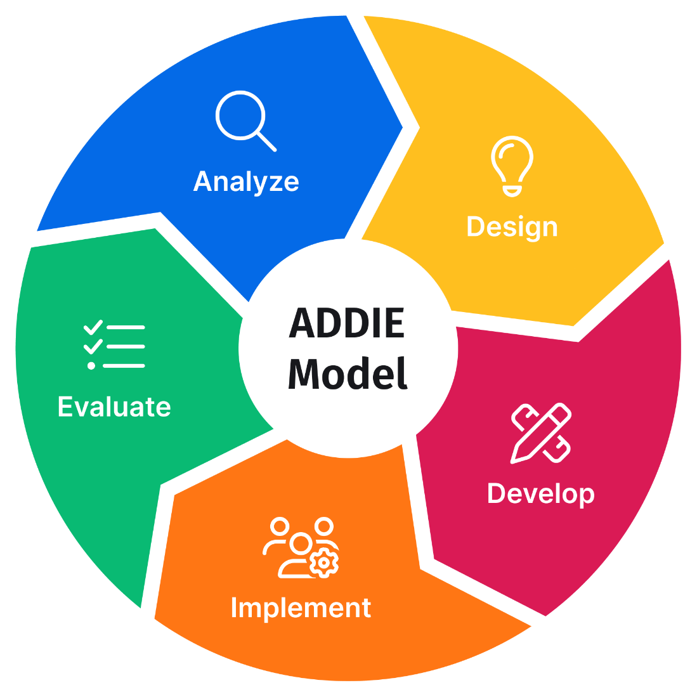

**Figure 1. Paradigm of the Study**

This study used the ADDIE model, a framework for instructional design that stands for Analysis, Design, Development, Implementation, and Evaluation (Clark, 2015). The model was initially for systematic instructional development. It is highly adaptable for software development and ensures structured progress across all phases.

The Analysis phase involves identifying the system requirements. It includes reducing reservation conflicts, optimizing transaction processes, and providing a digital cemetery map. Detailed beneficiary information is collected, and the current procedures are analyzed.

The Design phase creates a blueprint of the system; it comprises a digital map layout, transaction workflows, and dashboard interface. It ensures that user needs and system objectives are aligned.

During the Development phase, the system will depend on professional and user feedback. In this phase, the project uses Agile principles to ensure the system responds to opinions and the continuous involvement of the beneficiary.

The system deployment and testing in the real world at Green Haven Memorial Park would represent the Implementation phase. This operation ensures that the system meets requirements both for operational and user levels.

Finally, the Evaluation phase analyzes the system functionality toward the defined objectives-reservation conflict reductions, transactional transactions, and a digital map. The system will be adjusted using user and professional feedback.

The ADDIE model ensures the proper system deployment and launching, and maintaining flexibility to address stakeholders' needs effectively.

**Statement of the Problem**

Green Haven Memorial Park encounters management issues with frequent conflicts between reservations, unoptimized transaction processing, data vulnerability, and the overall operational efficiency caused by the Excel-based management system. This study will explore the following problems to address the issues:

1. How can a digital cemetery map prevent reservation conflicts and improve the accuracy of reservation management?
2. What features should the system include to ensure effective, secure, and user-friendly transaction management?
3. How can data backup and disaster recovery be implemented to protect and restore critical records in an unpredicted event?

**Assumptions of the Study**

The study will operate according to certain assumptions to have a proper foundation for the research. These assumptions will guide the project to ensure it is feasible and valid. The assumptions are the following:

1. The system users will provide honest and accurate feedback during the testing and evaluation.
2. The hardware and software required for the system development will function appropriately without significant technical failures.
3. The beneficiary will provide the exact structures of their records in their existing management system.
4. System evaluation will be about user satisfaction, performance, and ability to address the identified problems.

**Scope and Limitation of the Study**

This project aims to develop a digitalized cemetery transaction management with a mapping system specifically for Green Haven Memorial Park. This research involves:

1. Designing and implementing a system to manage transactions and provide a digital cemetery map.
2. Preventing reservation conflicts by implementing a two-dimensional digital map of the cemetery.
3. Developing a comprehensive user interface to streamline transaction processing.
4. Integrate data backup and recovery for more secure data.
5. Collecting user feedback to evaluate the system to ensure user satisfaction and proper performance.
6. Installing a kiosk to give directions to a resting place for visitors.

The research limitations are the following:

1. This research is only limited to Green Haven Memorial Park.
2. The project will only focus on digitalizing transaction management and mapping.
3. The mapping system will only provide a two-dimensional representation of the cemetery.
4. The kiosk machine will not have a touchscreen capability, only a mouse and keyboard.
5. Potential infrastructure limitations, such as internet connectivity, can affect the full deployment of the system.

**Significance of the Study**

This study will develop a digitalized cemetery transaction management and mapping system for Green Haven Memorial Park. The results of this project will contribute to the following:

**Green Haven Memorial Park Management.** The system will prevent reservation conflicts, streamline transaction processing, and secure data in the event of a disaster.

**Visitors and Families.** By implementing a kiosk machine, visitors and families can easily navigate to the resting place of their loved ones.

**Future Researchers.** The results of this study can contribute additional knowledge to future researchers about transaction management and Geographical Information Systems (GIS).

**The Cemetery Industry.** The digitalization of Green Haven Memorial Park can be an example of how it solves critical pain points in managing a cemetery.

**Definition of Terms**

To assist the reader in comprehending this study, the following terms are defined:

**Data Backup and Recovery.** The practice of creating copies of vital data to protect against data loss caused by technical failures, natural disasters, and other unforeseen events.Data recovery ensures that data can be re-established when a loss or corruption occurs.

**Digitalized Cemetery Transaction Management and Mapping System.** This refers to the digital tools and software systems to manage cemetery transactions effectively, including reservations, payments, and record-keeping.

**Geographical Information System.** A system used to display geographical data, like a cemetery map.

**Infrastructure Limitations.** Restrictions related to physical and technical problems, such as internet connectivity, hardware compatibility, or power failures, could affect the full deployment of the system.

**Kiosk Machine.** It is a self-service machine that provides information. In this study, a kiosk machine will give directions to a burial place.

**Reservation Conflicts.** A situation where two or more parties attempt to reserve a cemetery plot simultaneously can lead to confusion and disputes.

**Two-Dimensional Map.** A map that only has length and width. It does not have any depth like in three-dimensional maps.

**Transaction Processing.** It refers to transaction managing and recording, such as reservations, payments, and other related actions within the cemetery management system.

**User Interface (UI).** The point of interaction between a user and a system. It includes visual elements, buttons, and other layouts to make the system intuitive and navigable.

**Chapter II**

**REVIEW OF RELATED LITERATURE AND STUDIES**

This chapter will review related literature and studies for digitalizing cemetery transaction management and mapping system in Green Haven Memorial Park. The materials to explore include digital transaction systems, mapping technologies, user interface and experience design, and standard data security measures. By investigating these works, the study will directly address the best practices and research gaps and create a framework to propose a solution to enhance efficiency and user experience.

The selected literature is the following:

*Benefits of Digitalization (Parviainen, et. al, 2017)*

According to Parviainen, Tihinen, Kääriäinen, and Teppola (2017), digitalization is one of the key trends that will change society and business. Moreover, digitalization benefits are automation and process optimization, which can improve productivity and profitability by reducing costs, speeding up production, and preventing errors. Digitalization will increase efficiency by 15% to 20% and revenue by more than 20%, as expected (Parida, Sjödin, & Reim, 2019).

*Challenges of Digitalization (Kutnjak and Pihir, 2019)*

While digitalization offers significant benefits, it also presents various challenges. Kutnjak and Pihir (2019) highlighted the lack of comprehensive literature addressing digitalization barriers. Existing studies identify twelve key barriers, including missing skills, technological disruption, and high implementation costs (Tripathi & Gupta, 2019). Strategic alignment, data reliability, and integration within value chains also pose difficulties.

Moreover, societal and conceptual barriers such as resistance to change, inadequate system design, and unclear economic benefits can hinder successful implementation. Addressing these challenges for a cemetery management system involves ensuring user adoption, minimizing disruptions during transitions, and securing reliable data backups.

*Applications of Digital Mapping Systems (Goodchild and Li, 2012)*

Ubiquitous industries use digital mapping systems, most for navigation, resource management, and location-based services. As for cemeteries, digital mapping enables better management of plots by organized reservations, reducing the likelihood of conflicts and altering the tending of visitors for the better. Goodchild and Li (2012) provide an argument in support of the use of GIS as the tools that facilitate the active and accurate building of maps that demonstrate the spatial relationships of users to the systems and each other.

But digital mapping's advantage goes beyond simply being a visualization tool. It provides the capability for plotting management efficiency, as it offers real-time information about occupancy, which encourages manual allocation of spaces in plots. In the case of Green Haven Memorial Park, a two-dimensional mapping system that is simple and easy to use while addressing managerial requirements is needed.

**Chapter III**

**RESEARCH METHODOLOGY**

This section outlines the approach and methods for the computerized management and spatial information system. It details the research method, description of respondents, research instrument, data-gathering procedure, and statistical treatment of data employed in the study. The selected methodologies will maximize the trustworthiness, comprehensiveness, and success in achieving the set targets. The chapter also outlines ethical considerations and acknowledges the study limitations as part of pursuing a clear framework for the research objectives.

**Method of Research**

The research methods and techniques constitute the blueprint for accomplishing the expected benefits. The investigators applied the hybrid Waterfall-Agile method as the primary methodology of the project for digitalizing cemetery transaction management and mapping at Green Haven Memorial Park. This combination gives the development process orderliness and some allowance for change to meet the objectives set and other changes that are deemed necessary.

The Waterfall approach gives the system a linear structure that follows defined and distinct stages: requirements definition, coding, testing, and maintenance. Such stage-by-stage processes are best for projects that have clear goals and objectives.

Agile methodology has been added to the developmental process to increase flexibility and enable user input into the system. It implies a build-and-evaluate approach that allows the team to use the inputs that occur as the requirements develop and change over the project course.

This hybrid approach ensures that every build, deployment, and testing can allow for user-based modifications. The integrated approach assists organized data collection to obtain and provide accurate and reliable data during the project phase.

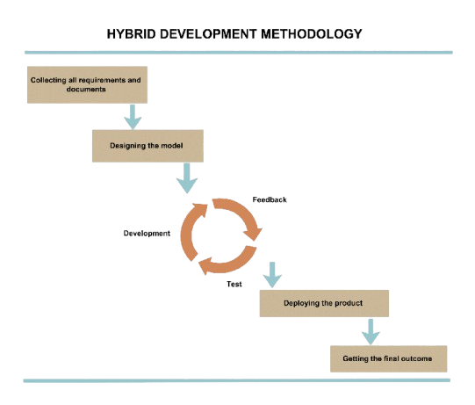

**Figure 2. The Waterfall-Agile Hybrid Model**

The hybrid methodology diagram outlines the sequential and iterative processes used in this study:

**Gathering all requirements and documents.** Comprehensive requirements and relevant documentation are needed to define the system's objectives, such as reducing reservation conflicts and digitalizing cemetery transactions. Ultimately, it will have an explicit foundation for development.

**Designing the model.** This phase will provide a system blueprint with workflow, map layout, and key functionalities. It is a linear phase in a structured Waterfall approach.

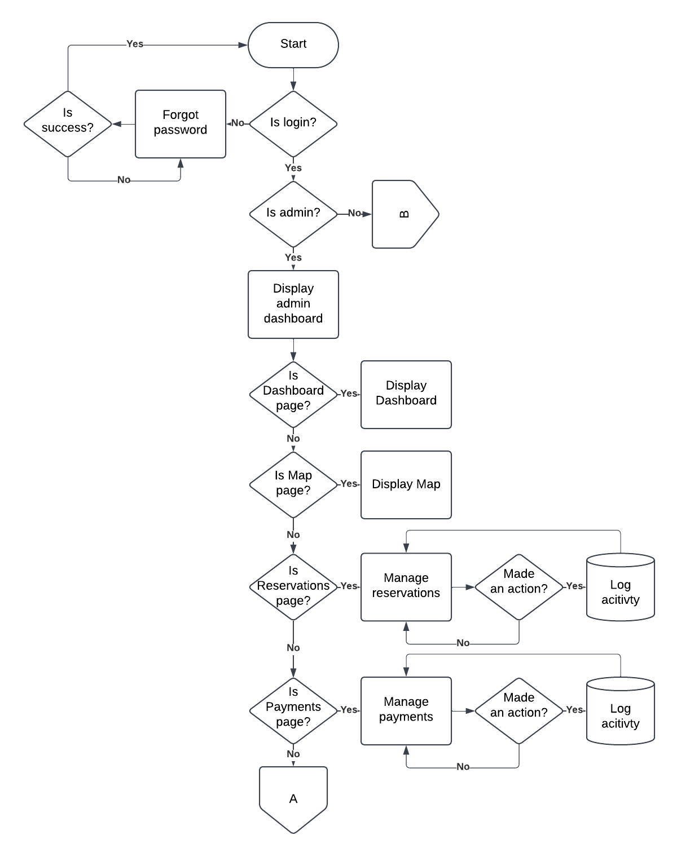

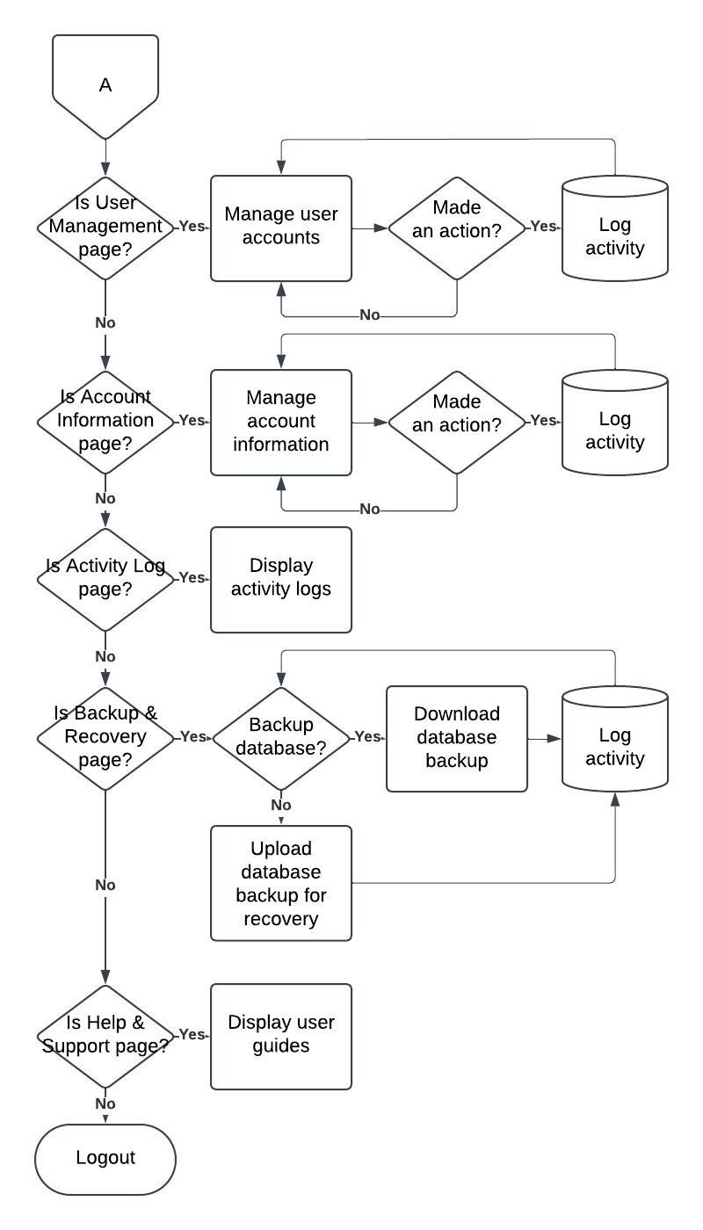

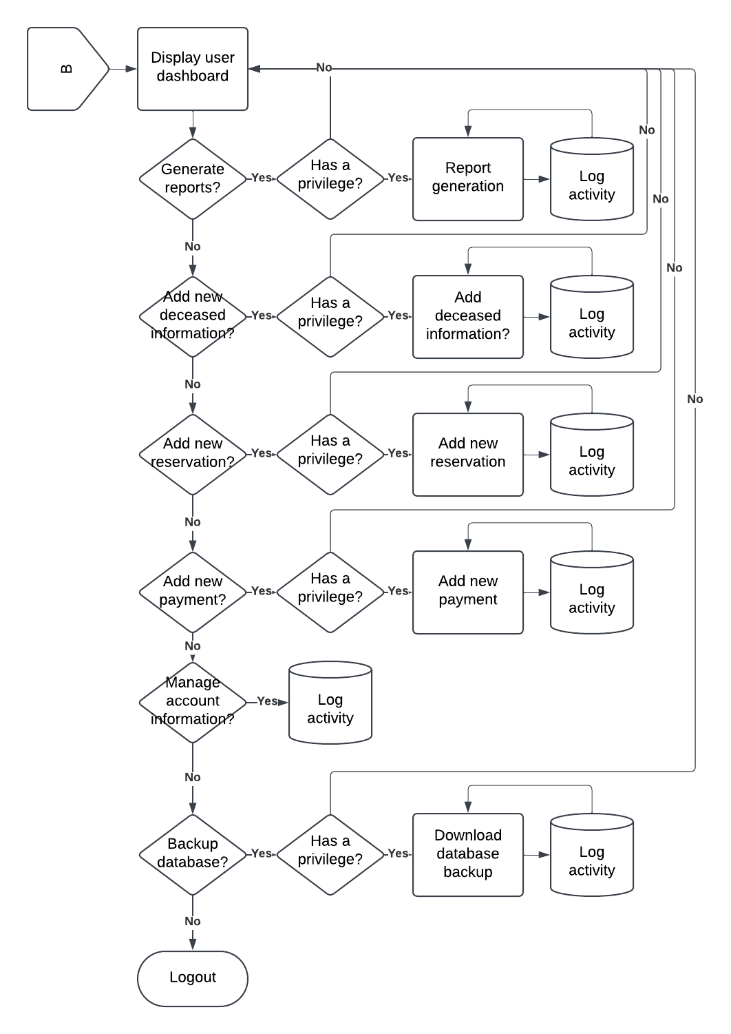

**Figure 3.** **Program Flowchart of the Proposed Study**

**(Agile methodology starts here) Development.** It is a phase of step-by-step developing components. It is an open window for adding new insights and user input.

**Feedback.** The stakeholders and the end-users review how the system under development has gone. It is an iteration process where emerging system meets their needs.

**Test.** Thorough testing enables checking functionalities and solving problems early. Agile ensures adaptability and responsiveness to the suggested improvements.

**(Agile methodology ends here) Deployment of the product.** Upon Passing the development and test stages, the system is now ready for real-world operations.

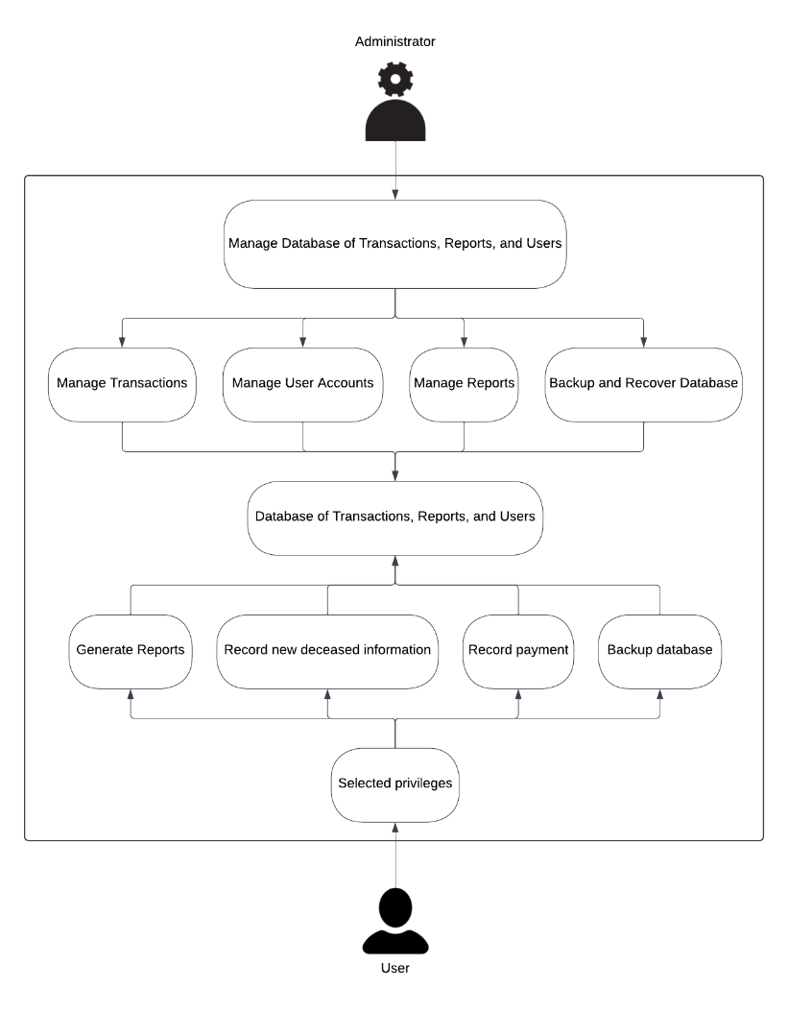

**Figure 4. Use Case Diagram of the Proposed Study**

**Getting the outcome.** To achieve the outcome, ensure that the system aligns with the project's objectives and stakeholder expectations.

This diagram shows how the Waterfall model provides an overall structure but ensures flexibility and collaboration with the stakeholders during development leading to a robust and user-centered system.

**Description of Respondents**

The only respondent interviewed for this study was Ms. Vanessa Gumatay-Abalona, the owner of Green Haven Memorial Park, who provided invaluable insights current cemetery management practices, challenges, and transaction management. And the potential benefits of digital mapping systems. Ms. Gumatay-Abalona's information is a tool for determining the scope and direction of this research. It offers an accurate perspective on the needs of the cemetery.

**Research Instrument**

The main research instrument in this study was a semi-structured interview with Ms. Vanessa Gumatay-Abalona, the owner of Green Haven Memorial Park. The interview acquired qualitative data on existing transaction management practices, challenges, and potential benefits of implementing a digital mapping and transaction management system.

The interview allowed open-ended questions to probe deeper and investigate specific concerns related to the development and implementation of the system. Framed questions were around circumstances with cemetery operations, difficulties with manual processes, benefits of digitalization, and user requirements for the proposed system.

The responses to the interview were analyzed qualitatively by the researchers to identify themes, which included the automation requirement, process optimization, and the incorporation of mapping technology. At the same time, the respondent's feedback helped provide direction in designing the system to fulfill the practical demands of cemetery management.

Due to the semi-structured interview, there is a potential to explore unforeseen issues, yet the potential to cover all areas remained on track.

**Data-Gathering Procedure**

Data gathering for this study was basically through a semi-structured interview with Ms. Vanessa Gumatay-Abalona, owner of Green Haven Memorial Park. The interview was conducted personally, following all ethical guidelines: informed consent and similar. The questions were about the current practice in handling cemetery transactions and the challenges and benefits of implementing a digital system for mapping and handling transactions.

The researchers recorded the interview after getting permission from Ms. Gumatay-Abalona; the data gathered was transcribed for analysis. Its semi-structured format provided flexibility during the process, enabling the researcher to look into interesting or unexpected answers while ensuring there was no omission of critical areas of inquiry. Significant areas of focus included difficulties in managing transactions with traditional manual processes, features desirable in a proposed digital system, such as automation capabilities, mapping capabilities, and other features that guarantee data security.

The investigators conducted a qualitative analysis of responses to identify recurring themes such as the need for efficiency and better data management and the desire for integrated systems. This information facilitated the development of the digital system to ensure that it would best meet the needs of Green Haven Memorial Park management.

**Statistical Treatment of Data**

To implement the Digitalization of Cemetery Transaction Management and Mapping System for Green Haven Memorial Park, the proponent used some instruments to improve the quality of software. The following Software Quality Factors were used

as follows:

**Functionality** is a set of attributes that bear on the capability to provide functions which meet stated and implied needs when the software is used.

**Reliability** is a set of attributes that bear on the capability to maintain a specified level of performance.

**Usability** is a set of attributes that bear on the capability to be understood, learned, and used.

**Efficiency** is a set of attributes that bear on the capability to provide appropriate performance relative to the number of resources used.

**Maintainability** is a set of attributes that bear on the capability to modified for 56 purposes of making corrections, improvements, or adaption.

**Portability** is a set of attributes that bear on the capability to be adapted for different specified environments without applying actions or means other than those provided for this purpose in the product.

The system was evaluated against functionality, reliability, usability, efficiency, maintainability and portability. The developed system’s acceptability was measured using the Likert Scale and the ranking were as follows: Highly Acceptable if the computed average was 4.5 to 5, Very Acceptable if the computed average was 3.5 to 4.49, Acceptable if the computed average was 2.5 to 3.49, Moderately Acceptable if the computed average was 1.5 to 2.49, and Unacceptable if the computed average was 1 to 1.49.

|  |  |
| --- | --- |
| **Mean Score** | **Interpretation of Mean** |
| 1.00 – 1.49 | Unacceptable (U) |
| 1.50 – 2.49 | Moderately Acceptable (MA) |
| 2.50 – 3.49 | Acceptable (A) |
| 3.50 – 4.49 | Very Acceptable (VA) |
| 4.50 – 5.00 | Highly Acceptable (HA) |

**Table 1. Interpretation of Acceptability**

**CHAPTER IV**

**PRESENTATION, ANALYSIS AND INTERPRETATION OF DATA**

This chapter discusses the assessment of the manual existing system as well as the analysis of the respondents to the developed system. There are tables below showing the acceptability of the developed system in terms of Functionality, Reliability, Usability, Efficiency, Maintainability, and Portability.

Table 1 shows the assessment of end-user and I.T. Experts to the proposed Digitalization of Cemetery Transaction Management and Mapping System for Green Haven Memorial Park; and it is being shown on the table that in terms of Functionality “Suitability or the software has suitable but appropriate set of functions in accordance to its system objectives” received the highest average of 4.5 for end-users with a qualitative interpretation of Highly acceptable and 4.2 with a qualitative interpretation of Very acceptable for I.T Experts collecting a computed average of 4.35 with a qualitative interpretation of Very acceptable.

“Accuracy or the software provides accurate results” received the lowest average of 4.1 for end-users with a qualitative interpretation of Very acceptable and 4.2 with a qualitative interpretation of Very acceptable for I.T Experts collecting a computed average of 4.15 with a qualitative interpretation of Very acceptable.

“Compliance or the system defines the net of needs or information” received an average of 4.3 for end-users with a qualitative interpretation of Very acceptable and 4.4 with a qualitative interpretation of Very acceptable for I.T Experts collecting a computed average of 4.35 with a qualitative interpretation of Very acceptable.

In terms of Functionality, the end-user received an overall average of 4.3 with a qualitative interpretation of Very acceptable; while the proponents and IT experts received an overall average of 4.26 with a qualitative interpretation of Very acceptable. The overall computed average is 4.28 with a qualitative interpretation of Very acceptable. This finding is being supported by Parviainen, Tihinen, Kääriäinen, and Teppola (2017), which emphasizes the digital transformation is an important trend affecting society and business. In addition to this, benefits of digitalization are automation, optimization, and process betterment, which may lead to an improvement in efficiency and profitability through a cost reduction, increase in speed of production, and a reduction in errors.

**Table 1**

**Assessment of end-user and I.T. Digitalization of Cemetery Transaction Management and Mapping System for Green Haven Memorial Park**

|  |  |  |  |  |  |  |  |  |  |  |  |  |  |
| --- | --- | --- | --- | --- | --- | --- | --- | --- | --- | --- | --- | --- | --- |
|  | | Functionality | | End-Users | | | I. T. Experts | | | Over-all | | | |
|  | |  | | Avg. | Q.I | | Avg. | | Q.I | Avg. | | Q.I | |
| 1 | | Suitability or the software has suitable but appropriate set of functions in accordance to its system objectives | | 4.5 | HA | | 4.2 | | VA | 4.35 | | VA | |
| 2 | | Accuracy or the system can provide an accurate result. | | 4.1 | VA | | 4.2 | | VA | 4.15 | | VA | |
| 3 | Compliance or the system Defines the set of needs or information. | 4.3 | | | VA | | 4.4 | VA | | 4.35 | VA |
|  | Over-All | 4.3 | | | VA | | 4.26 | VA | | 4.28 | VA |

Legend: 4.50 to 5.00 (Highly Acceptable–HA); 3.50 to 4.49 (Very Acceptable-VA);

2.50 to 3.49 (Acceptable-A); 1.50 to 2.49 (Moderately Acceptable-MA); 1 to 1.49 (Unacceptable-U)

Table 2 shows the assessment of end-user and I.T. Experts to the proposed Digitalization of Cemetery Transaction Management and Mapping System for Green Haven Memorial Park; and it is being shown on the table that in terms of Reliability “Recoverability or the system can record saved form” received the highest average of 4.6 with a qualitative interpretation of Highly acceptable for end-users and 4.2 with a qualitative interpretation of very acceptable for I.T. Experts collecting a computed average of 4.4 with a qualitative interpretation of very acceptable.

“Fault tolerance or the system can still perform when internet is not available” received the lowest average of 3.9 with a qualitative interpretation of very acceptable for end-users and 4.2 with a qualitative interpretation of very acceptable for I.T. Experts collecting a computed average of 4.05 with a qualitative interpretation of very acceptable.

In terms of Reliability, the end-users an overall average of 4.25 with a qualitative interpretation of very acceptable; while the I.T. Experts received an overall average of

4.2 with a qualitative interpretation of very acceptable. The overall computed average is

4.22 with a qualitative interpretation of very acceptable. This study is being supported by Data-Driven Decision Making (DDDM) (Provost and Fawcett, 2013), which highlights the importance of analytics and quantifiable data to guide business and system choices. The integration of data analytics in the suggested system enables precise evaluations, organized adherence, and appropriateness based on user requirements. The elevated ratings indicate that data-informed insights were employed to enhance the system's performance, guaranteeing efficiency, accuracy, and ongoing enhancement rooted in practical feedback.

**Table 2**

**Assessment of end-user and I.T. Digitalization of Cemetery Transaction Management and Mapping System for Green Haven Memorial Park**

|  |  |  |  |  |  |  |  |
| --- | --- | --- | --- | --- | --- | --- | --- |
|  | Reliability | End-users | | I.T. Experts | | Over-all | |
|  |  | Avg. | Q.I. | Avg. | Q.I. | Avg. | Q.I. |
| 1 | Fault tolerance or the system can still perform after power lost. | 3.9 | VA | 4.2 | VA | 4.05 | VA |
| 2 | Recoverability on the system can record saved form. | 4.6 | HA | 4.2 | VA | 4.4 | VA |
|  | Over-All | 4.25 | VA | 4.2 | VA | 4.22 | VA |

Legend: 4.50 to 5.00 (Highly Acceptable–HA); 3.50 to 4.49 (Very Acceptable-VA); 2.50

to 3.49 (Acceptable-A); 1.50 to 2.49 (Moderately Acceptable-MA); 1 to 1.49 (Unacceptable-U)

Table 3 shows the assessment of end-user and I.T. Expert to the proposed Digitalization of Cemetery Transaction Management and Mapping System for Green Haven Memorial Park; and it is being shown on the table that in terms of Usability “Operability or the system is easy to operate ” received the highest average of 4.8 with a qualitative interpretation of Highly acceptable for end- users and 4.4 with a qualitative interpretation of Very acceptable for I.T. experts collecting a computed average of 4.6 with a qualitative interpretation of Highly acceptable.

“Understandability or the system is user friendly and Learn ability or the system is easy to understand” both acquired the lowest average of 4.7 with a qualitative interpretation of Highly acceptable for end-users and 4.4 with a qualitative interpretation of very acceptable for I.T. experts collecting a computed average of 4.55 with a qualitative interpretation of Highly acceptable.

In terms of Usability, the end-users an acquired an overall average of 4.73 with a qualitative interpretation of very acceptable; while the I.T. Experts received an overall average of 4.4 with a qualitative interpretation of very acceptable. The overall computed average is 4.56 with a qualitative interpretation of very acceptable.

**Table 3**

**Assessment of end-user and I.T. experts to the proposed Digitalization of Cemetery Transaction Management and Mapping System for Green Haven Memorial Park**

|  |  |  |  |  |  |  |  |
| --- | --- | --- | --- | --- | --- | --- | --- |
|  | Usability | End-Users | | I.T. Experts | | Over-all | |
|  |  | Avg. | Q.I. | Avg. | Q.I. | Avg. | Q.I. |
| 1 | Understandability or the system is user friendly. | 4.7 | HA | 4.4 | VA | 4.55 | HA |
| 2 | Learn ability or the system is easy to understand. | 4.7 | HA | 4.4 | VA | 4.55 | HA |
| 3 | Operability or the system is easy to operate. | 4.8 | HA | 4.4 | VA | 4.6 | HA |
|  | Over-all | 4.73 | HA | 4.4 | VA | 4.56 | HA |

Legend: 4.50 to 5.00 (Highly Acceptable–HA); 3.50 to 4.49 (Very Acceptable-VA); 2.50

to 3.49 (Acceptable-A); 1.50 to 2.49 (Moderately Acceptable-MA); 1 to 1.49 (Unacceptable-U)

Table 4 reveals the assessment of end-users and I.T. Experts to the proposed Digitalization of Cemetery Transaction Management and Mapping System for Green Haven Memorial Park, and it is being shown on the table that in terms of Efficiency “Time behavior or the system has acceptable response and processing time” received the highest average of 4.40 with a qualitative interpretation of very acceptable for end-users and 4.20 with a qualitative interpretation of very acceptable for I.T. experts collecting a computed average of 4.15 with a qualitative interpretation of very acceptable.

“Resource Behavior or the system uses enough computing resources for all its function” acquired the lowest average of 4.20 with a qualitative interpretation of very acceptable for end-users and 4.10 with a qualitative interpretation of very acceptable for I.T. experts collecting a computed average of 4.15 with a qualitative interpretation of very acceptable.

Overall, in terms of Efficiency, the end-users received an overall average of 4.30 with a qualitative interpretation of very acceptable; while the I.T. Experts received an overall average of 4.00 with a qualitative interpretation of very acceptable. The overall computed average is 4.15 or very acceptable.

**Table 4**

**Assessment of end-user and I.T. experts to the proposed Digitalization of Cemetery Transaction Management and Mapping System for Green Haven Memorial Park**

|  |  |  |  |  |  |  |  |
| --- | --- | --- | --- | --- | --- | --- | --- |
|  | Efficiency | End-users |  | I.T. Experts | | Over-all |  |
|  |  | Avg. | Q.I. | Avg. | Q.I. | Avg. | Q.I. |
| 1 | Time behavior or the system has a quick response. | 4.40 | VA | 3.90 | VA | 4.15 | VA |
|  | Over-All | 4.30 | VA | 4.00 | VA | 4.15 | VA |

Legend: 4.50 to 5.00 (Highly Acceptable–HA); 3.50 to 4.49 (Very Acceptable-VA); 2.50

to 3.49 (Acceptable-A); 1.50 to 2.49 (Moderately Acceptable-MA); 1 to 1.49 (Unacceptable-U)

**Table 5** shows the assessment of evaluation of end-users and I.T. Experts to the proposed Digitalization of Cemetery Transaction Management and Mapping System for Green Haven Memorial Park; The table shows that “Resource Behavior or the system consistently uses enough computing resources for all its functions” received the highest average of 4.8 with a qualitative interpretation of Highly Acceptable for end-users and 4.4 with a qualitative interpretation of Very Acceptable for IT experts, collecting a computed average of 4.6 with a qualitative interpretation of Highly Acceptable.

“Testability or the system is easy to validate after modifications” received the 2nd highest average, with an end-user rating of 4.4 Very Acceptable and an IT expert rating of 4.8 Highly Acceptable, resulting in a computed average of 4.6, which is still interpreted as Highly Acceptable.

“Stability or the system is stable when modified” received a lowest of 4.4, with a qualitative interpretation of Very Acceptable for end-users and 4.2 with a qualitative interpretation of Very Acceptable for IT experts, collecting a computed average of 4.3 with a qualitative interpretation of Very Acceptable.

“Changeability or the system is relatively easy to modify or remove faults” received an average of 4.8, with a qualitative interpretation of Highly Acceptable for end-users and 4.0 with a qualitative interpretation of Very Acceptable for IT experts, collecting a computed average of 4.4 with a qualitative interpretation of Very Acceptable.

Overall, in terms of Maintainability, the end-users provided an overall average of 4.6 with a qualitative interpretation of Highly Acceptable, while the IT experts gave an overall average of 4.35 with a qualitative interpretation of Very Acceptable. The overall computed average is 4.47, which is interpreted as Very Acceptable.

**Table 5**

**Assessment of end-user and I.T. experts to the proposed Digitalization of Cemetery Transaction Management and Mapping System for Green Haven Memorial Park**

|  |  |  |  |  |  |  |  |
| --- | --- | --- | --- | --- | --- | --- | --- |
|  | Portability | End-users | | I.T. Experts | | Over-all | |
|  |  | Avg. | Q.I. | Avg. | Q.I. | Avg. | Q.I. |
| 1. | Resource behavior or the system can consume a lot of storage. | 4.8 | HA | 4.4 | VA | 4.6 | HA |
| 2.  3.  4. | Changeability or the system can be easily modified by the user.  Stability or the system is stable when it is used.  Testability or the system can be easily tested | 4.8  4.4  4.4 | HA  VA  VA | 4.0  4.2  4.8 | VA  VA  HA | 4.4  4.3  4.6 | VA  VA  HA |
|  | Over-all | 4.6 | HA | 4.35 | VA | 4.47 | VA |

Legend: 4.50 to 5.00 (Highly Acceptable–HA); 3.50 to 4.49 (Very Acceptable-VA); 2.50

to 3.49 (Acceptable-A); 1.50 to 2.49 (Moderately Acceptable-MA); 1 to 1.49 (Unacceptable-U)

Table 6 shows the assessments of I.T. Experts to the proposed Digitalization of Cemetery Transaction Management and Mapping System for Green Haven Memorial Park; The table shows that “Accessibility or the system can be easily Access any web browser” received the highest average of 4.45, which has a qualitative interpretation of very acceptable.

On the other hand, “Adoptability or the system can be adapted to any environment that does not need changes” received the lowest average of 4.3, with a qualitative interpretation of Very acceptable. The overall average is 4.40, which is also interpreted as very acceptable.

**Table 6**

**Assessment of I.T. experts to the proposed Digitalization of Cemetery Transaction Management and Mapping System for Green Haven Memorial Park**

|  |  |  |  |  |  |  |  |
| --- | --- | --- | --- | --- | --- | --- | --- |
|  | Portability | End-users | | I.T. Experts | | Over-all | |
|  |  | Avg. | Q.I. | Avg. | Q.I. | Avg. | Q.I. |
| 1. | Adoptability or the system can be adapted to any environment that does not need changes. | 4.2 | VA | 4.4 | VA | 4.3 | VA |
| 2. | Accessibility or the system can be easily Access any web browser. | 4.3 | VA | 4.6 | HA | 4.45 | VA |
|  | Over-all | 4.25 | VA | 4.5 | HA | 4.40 | VA |

0

to 3.49 (Acceptable-A); 1.50 to 2.49 (Moderately Acceptable-MA); 1 to 1.49 (Unacceptable-U)

Table 7 reveals the summary table of the assessment of end-users and I.T. Experts to the proposed Web-Based Ticketing & Monitoring System in terms of Functionality, Reliability, Usability, Efficiency and Portability. It shows that “Efficiency” received the highest average of 4.73 which is Highly acceptable for end-users; while “Efficiency and Portability” received the highest average of 4.5 which is Highly acceptable for I.T. Experts.

Furthermore, “Portability and Reliability” received the lowest weighted mean of 4.25 which is Very acceptable respectively for end-users; and on the other hand, “Reliability” received the lowest average of 4.2 which is Very acceptable for the I.T. Experts.

Overall, the end-users received an overall average of 4.47 which is Very acceptable; and for the I.T. Experts the overall average is 4.36 which are Very acceptable. In totality, the overall average for both respondents are 4.41 with a qualitative interpretation of very acceptable.

**Table 7**

**Summary table of the assessment of end-users and I.T. experts to the proposed Digitalization of Cemetery Transaction Management and Mapping System for Green Haven Memorial Park in terms of Functionality, Usability, Efficiency and Portability.**

|  |  |  |  |  |  |  |  |
| --- | --- | --- | --- | --- | --- | --- | --- |
|  | Degree of  Evaluation | End-users | | I.T. Experts | | Over-all | |
| Avg. | Q.I. | Avg. | Q.I. | Avg. | Q.I. |
| 1. | Functionality | 4.3 | VA | 4.26 | VA | 4.28 | VA |
| 2. | Reliability | 4.25 | VA | 4.2 | VA | 4.22 | VA |
| 3. | Usability | 4.73 | HA | 4.4 | VA | 4.56 | HA |
| 4.  5. | Efficiency  Maintainability | 4.7  4.6 | HA  HA | 4.5  4.35 | HA  VA | 4.6  4.47 | HA  VA |
| 6. | Portability | 4.25 | VA | 4.5 | VA | 4.37 | VA |
|  | Over-all | 4.47 | VA | 4.36 | VA | 4.41 | VA |

Legend: 4.50 to 5.00 (Highly Acceptable–HA); 3.50 to 4.49 (Very Acceptable-VA); 2.50

to 3.49 (Acceptable-A); 1.50 to 2.49 (Moderately Acceptable-MA); 1 to 1.49 (Unacceptable-U)

**CHAPTER V**

**SUMMARY, CONCLUSIONS, AND RECOMMENDATIONS**

This chapter presents the summary of the findings on the study, conclusions drawn from the findings and recommendations offered based on the study.

**Summary of Findings**

In terms of Functionality, the end-user received an overall average of 4.12 with a qualitative interpretation of very acceptable; while the proponents and IT experts received an overall average of 4.03 with a qualitative interpretation of very acceptable. The overall computed average is 4.08 with a qualitative interpretation of very acceptable. In terms of Reliability, the end-users an overall average of 3.75 with a qualitative interpretation of very acceptable; while the I.T. Experts received an overall average of

3.83 with a qualitative interpretation of very acceptable. The overall computed average is

4.03 with a qualitative interpretation of very acceptable. In terms of Usability, the end- users an acquired an overall average of 4.47 with a qualitative interpretation of very acceptable; while the I.T. Experts received an overall average of 4.30 with a qualitative interpretation of very acceptable. The overall computed average is 4.39 with a qualitative interpretation of very acceptable.

Overall in terms of Efficiency, the end-users received an overall average of 4.30 with a qualitative interpretation of very acceptable; while the I.T. Experts received an overall average of 4.00 with a qualitative interpretation of very acceptable. The overall computed average is 4.15 or very acceptable. In terms of Portability, the end-users

received an overall average of 4.55 with a qualitative interpretation of highly acceptable; while the I.T. Experts received an overall average of 4.25 with a qualitative interpretation of very acceptable. The overall computed average is 4.40 with a qualitative interpretation of very acceptable. On the other hand, “Changeability or the system can be easily modified by the user” and “Testability or the system can be easily tested” both received the lowest average of 4.40 which is very acceptable. The overall average is 4.13 with a qualitative interpretation of very acceptable.

Overall the end-users received an overall average of 4.32 which is very acceptable; and for the I.T. Experts the overall average is 4.10 which are very acceptable. In totality, the overall average for both respondents is 4.21 with a qualitative interpretation of very acceptable.

**Conclusions**

1. Based on the findings that “Recoverability or the system can record saved form” under Recoverability evidently bring an effect to all respondents concerned. It is detailed on proposed Web-Based Ticketing & Monitoring System that it is hard to retrieve data in case of memory malfunction and maintain data unless there is a back-up data from a computer or support from the data manager. Reliable satisfaction is difficult when support system from the management or computer managing system is weak. Recoverability is developing the services and support towards the users of the system to attain satisfaction.
2. Respondents find Fault tolerance as a critical aspect for Reliability. Network speed and connection has always been a problem in any computer system; and considering the

importance of data transfer to the database, the respondents had assessed difficulty that could be encountered in the retrieval of requested report and related data.

1. End-users and IT experts found problems with regards to Resource behavior. The consistency resources or memory space of the Web-Based Ticketing & Monitoring System was sighted a problem in selected users that they have assessed possible delays in the transmission of data that may affect the fixing time of all concerned person most especially among the administrator and system engineers.
2. Portability in terms of adoptability was assessed to be a potential challenge among the users of the system as it may require further feasibility and wide scope utilization before it becomes accepted for further utilization. On the other hand, End-users and IT experts find maintainability specifically changeability and stability as challenges as a result of the changing demands when it comes to report management and monitoring.
3. The findings showed that there is significant difference in the assessment of the respondents to the proposed Web-Based Ticketing & Monitoring System due to different computer platform.

**Recommendations**

* + The system needs to have with a Back-up data plan constantly to avoid potential data lost as well as to avoid delays especially to those who need immediate action. It need organize installation, antivirus, and spyware scans for which is necessary for the system to be protected at all time.
  + Recovery options may also be implied and consider like storing data to the data manager and to maintain a copy of each transaction in the Web-Based Ticketing & Monitoring System.
  + Wiring management installation may also be applied for an accurate use of the.
  + Increase PC performance Web-Based Ticketing & Monitoring System and speed will help the system to perform its task and to provide quick output in any given time.
  + Network connection must be reliable and may also recommended to upgrade in much higher speed for more accurate and reliable connectivity for smooth operation for the future use of all the user of the system.

**APPENDIX A**

**SOFTWARE EVALUATION FORM**

Dear Respondent,

This survey will serve as an instrument to assess the level of acceptability of the developed system. Your cooperation by completing this form will make an important contribution in gathering a reliable and accurate data needed in the evaluation of the developed system.

Rest assured that the information you give would be treated with utmost confidentiality as necessary.

Proponents: Noted by:

Eugine Jester S. Jose Mr. Rohmer Roi A. Bujawe (Adviser)

Mhark Joseph Legaspi

Paul John Raymundo

**DIGITALIZED CEMETERY TRANSACTION MANAGEMENT**

**AND MAPPING SYSTEM FOR GREEN HAVEN MEMORIAL PARK**

Each rating is quantified by the following:

|  |  |
| --- | --- |
| **Numerical Rating** | **Equivalent** |
| 5 | Highly Acceptable |
| 4 | Very Acceptable |
| 3 | Acceptable |
| 2 | Moderately Acceptable |
| 1 | Unacceptable |

**Instruction:** Please evaluate the developed system by using the given scale and placing a

|  |  |  |  |  |  |  |  |
| --- | --- | --- | --- | --- | --- | --- | --- |
| **Characteristics** | **Sub-characteristics** | **Descriptions** | **HA 5** | **VA 4** | **A 3** | **MA 2** | **UA 1** |
| Functionality | Suitability | The software has suitable but appropriate set of functions in  accordance to its system objectives. |  |  |  |  |  |
| Accuracy | The software provides accurate results. |  |  |  |  |  |
| Compliance | The software addresses the defined set of needs. |  |  |  |  |  |

|  |  |  |  |  |  |  |  |
| --- | --- | --- | --- | --- | --- | --- | --- |
| **Characteristics** | **Sub-characteristics** | **Descriptions** | **HA 5** | **VA 4** | **A 3** | **MA 2** | **UA 1** |
| Reliability | Fault tolerance | It has ability to maintain a specified level of performance in case of software faults or of infringement of its specified interface. |  |  |  |  |  |
| Recoverability | It has the capability to re-establish its level of performance and recover the data directly affected in case of a failure and on the time and effort needed for it. |  |  |  |  |  |
| Usability | Understandability | It is easy for the users to recognize its logical concept and applicability. |  |  |  |  |  |
| Learnability | It is easy for the users to learn its application. |  |  |  |  |  |
| Operability | The software is easy to operate. |  |  |  |  |  |
| Efficiency | Time behavior | It has acceptable response and processing time and throughput  rates. |  |  |  |  |  |
| Maintainabilit y | Resource behavior | It consistently uses enough  computing resources (memory space) for all its functions. |  |  |  |  |  |
| Changeability | It is relatively easy to modify the software or remove faults. |  |  |  |  |  |
| Stability | It is deemed stable when modified. |  |  |  |  |  |
| Testability | It is easy to validate any  modification made. |  |  |  |  |  |
| Portability | Adaptability | It could adapt to different specified environments without applying other actions or means that those provided for this purpose for the software considered. |  |  |  |  |  |
| Accessibility | It is accessible at any browser. |  |  |  |  |  |

Instruction: *Please fill up all fields with * as required, optional otherwise.*

|  |  |  |  |  |
| --- | --- | --- | --- | --- |
| Respondent’s Name: | |  | | |
| * Type of Respondent: | | End User (Users / Administrator)  IT Expert (Software Developer / Programmer/ IT Specialist) Others : | | |
| Please confirm your responses by signing. Thank you very much for your time and insights. | | | | |
| * Signature: |  | | * Date: |  |

**APPENDIX B**

Dear Respondent,

This survey will serve as an instrument to evaluate the existing system of Green Haven Memorial Park. Your cooperation by answering the question on this form will make an important contribution in gathering a reliable and accurate data needed to design and develop a new system.

Rest assured that the information you give would be treated with utmost confidentiality as necessary.

**QUESTIONNAIRE FORM**

**“Digitalized Cemetery Transaction Management and Mapping System**

**for Green Haven Memorial Park”**

|  |
| --- |
| 1. What are the problems you encountered in having manual management of your current system? |
| 2. Why do you think those problems occur? |
| 3. What solution can you suggest solving these problems? |
| 4. Do you think a digitalized cemetery transaction management and mapping system will help solving the problems you mentioned? |
| 5. What do you suggest enhancing the digitalized cemetery transaction management and mapping system? |
| 6. Do you think having an interactive map helps you identify the status of the lots? |
| 7. Is the process of reservation being smooth enough for you? |

Instruction: *Please fill up all fields with * as required, optional otherwise.*

|  |  |  |  |  |
| --- | --- | --- | --- | --- |
| Respondent’s Name: | |  | | |
| * Type of Respondent: | | End User (Users / Administrator)  IT Expert (Software Developer / Programmer/ IT Specialist)  Others: | | |
| Course: | |  | Year/Year Graduated: |  |
| Please confirm your responses by signing. Thank you very much for your time and  insights. | | | | |
| * Signature: |  | | * Date: |  |