**EXPERIMENT NO. 6**

**SEMICONDUCTOR DIODE CHARACTERISTICS AND TESTING**

**OBJECTIVES:**

1. To test a semiconductor diode using a VOM.
2. To examine the effects of forward and reverse bias on diode current.
3. To prove that a diode is a non-linear device.

**PROCEDURE:**

1. **Diode Testing**
2. Choose from the multi sim five types of diodes.
3. Using the Ohmmeter of the VOM, test each diode.

|  |  |  |  |
| --- | --- | --- | --- |
| **Diodes** | **Forward Voltage** | **Reverse Voltage** | **Silicon or Germanium** |
| SB520 | 0.119117 VDC | OPEN | GERMANIUM |
| RGP30K | 0.381690 VDC | OPEN | GERMANIUM |
| RGF1G | 0.446683 VDC | OPEN | SILICON |
| MURS220T3 | 0.484598 VDC | OPEN | SILICON |
| MBR6035PF | 0.084509 VDC | OPEN | GERMANIUM |

**Table 1 Forward and Reverse Resistances**

1. Take screen shots per procedure.
2. **Forward Characteristics Curve**
3. Set-up circuit no. 1 as shown using multisim.
4. The voltages across it are set in turn to the values in Table 2. The associated current values are measured and entered in Table 2.
5. For each setting and measurement, take a screenshot. Include in the submission.
6. Graph the forward characteristic curve.

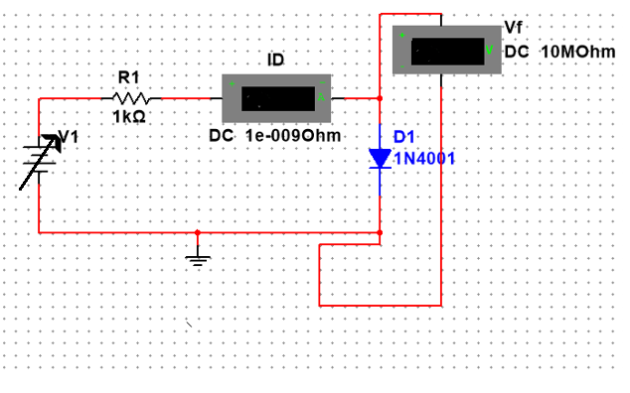

|  |
| --- |
| CIRCUIT NO. 1 |

|  |  |  |  |
| --- | --- | --- | --- |
| T**able 2. Diode Forward Bias Condition** | | |  |
|  |  | **PN DIODE UNDER FORWARD BIAS** |  |
| **Steps** | **Supply Voltage** | **Voltage Drop across Diode (V)** | **Diode Current(mA)** |
| 1 | 0 | 0.4z | -0.352y |
| 2 | 0.1 | 0.018 | 0.082m |
| 3 | 0.2 | 0.031 | 0.169m |
| 4 | 0.3 | 0.041 | 0.259m |
| 5 | 0.4 | 0.05 | 0.35m |
| 6 | 0.5 | 0.057 | 0.443m |
| 7 | 0.6 | 0.063 | 0.537m |
| 8 | 0.7 | 0.068 | 0.632m |
| 9 | 0.8 | 0.073 | 0.727m |
| 10 | 0.9 | 0.078 | 0.822m |
| 11 | 1 | 0.081 | 0.919m |
| 12 | 1.2 | 0.088 | 1.112m |
| 13 | 1.5 | 0.097 | 1.403m |
| 14 | 2 | 0.108 | 1.892m |
| 15 | 3 | 0.125 | 2.875m |

1. **Diode Reverse Characteristics**
2. Using multisim, connect circuit no. 3.
3. Vary the values of V1 with reference to table 3. Measure the current across the diode. Fill-in the values of table 2. Solve the corresponding values of RD.
4. For each value of V1, take a screenshot and include in the submission of the experiment.
5. Graph the reverse characteristic curve

**Table 3. Diode Reverse Characteristics**

|  |  |  |
| --- | --- | --- |
| **V1(V)** | **I(mA)** | **RD(Ohms)=V1/I** |
| **0** | **-4.724pA** | **0** |
| **5** | **0.003289mA** | **1520.22 Ohms** |
| **10** | **0.006579mA** | **1519.99 Ohms** |
| **15** | **0.009868mA** | **1520.06 Ohms** |
| **20** | **0.0014041mA** | **14243.99 Ohms** |
| **25** | **0.0018972mA** | **13177.31 Ohms** |
| **30** | **0.0023938mA** | **12532.38 Ohms** |
| **35** | **0.0028916mA** | **12104.03 Ohms** |

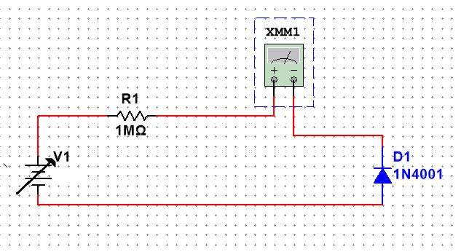

**Circuit no. 2**

**GRAPHS**

**OBSERVATION**

**CONCLUSION**