Dog Breed Image Classification

Apon, Johndale F.   
3JJosé Rizal University, Mandaluyong  
Johndaleapon16@gmail.com

Cardinez, John Christopher.   
3JJosé Rizal University, Mandaluyong  
Johnchristopher.cardinez@my.jru.edu

Costinar, Jesther   
3JJosé Rizal University, Mandaluyong  
Jesther.costinar@my.jru.edu

*Abstract*— Image classification is becoming increasingly significant in the digital world, with uses that extend far beyond human facial recognition. Image classification, particularly fine-grained image identification, has a wide range of applications, from social media to marketing to national security. The topic of this article was dog breed classification. The classification of dog breeds is a difficult task for a deep convolutional neural network. A group of sample images of a dog breed is used to classify and learn the breed's characteristics. With image processing, the images are turned to a single dimension label. The images of dogs are used to determine the percentage of components that present in dogs for breed classification.

Keywords—Image classification, deep convolutional, neural network, breed classification.

# **Background of the study**

[1]The focus of this research is to employ neural networks to identify or classify dog breeds. Thousands of individuals can identify the breed of their pet using image recognition, and it can predict the breed type of the dog using many trained sample photographs of different breeds of dogs.

Different types of pet dogs will bring different problems. When buying a dog in an internet store or from a shelter, for example, people are occasionally duped because they know the dog has a breed, but when it grows up, it turns out to be a typical dog.

[2] Deep learning provides the ability to train algorithms (models) that can tackle the problems of data classification and prediction based on deriving (learning) knowledge from raw data. Convolutional Neural Networks (CNNs) provides one commonly used approach for image classification and detection. Many owners find the companionship of their dog so rewarding that they want to breed their dog, to continue the bloodline and/or to keep a puppy.

[3]Dog breed identification is essential for many reasons, particularly for understanding individual breeds’ conditions, health concerns, interaction behavior, and natural instinct. The goal of this research is to identify dog breeds from images. There is low inter-breed variation and a high intra-breed diversity; in other words, there aren't many different breeds. Variances in size, shape, and color between breeds, as well as quite big differences within breeds. Dogs are, in reality, the world's most morphologically and genetically varied animals. The technical variances of pictures used in the dataset, which exhibit dogs of the same breed in a variety of lighting and situations, add to the difficulty of recognizing breeds due to diversity.

# **Research problem**

This research contains of dogs’ breed classification. To be able to know your dogs breed especially to the puppy. This image classification is a part of deep convolutional neural network (CNNs). Convolutional neural network is one of the best used to image classification, recognition, and other system that requires classifications.

[4]Object recognition is an important problem with a wide range of applications. It is also a challenging problem, especially for animal categorization as the differences among breeds can be subtle

[5]Object recognition is an important problem with a wide range of applications. It is also a challenging problem, especially for animal categorization as the differences among breeds can be subtle. It has a sample pictures of a dog and their breed to train and to test those breeds of each dogs to be able to perform the categorization of each breed. Some of the dogs’ breed are not recognized with their physical appearance especially when the dog was new born/puppy. Puppies/new born dogs has a possibility to become a pure breed or not.

Puppies/new born dogs usually doesn’t maintain their looks when their grow up. Some adoptee cannot tell whether their puppy is a pure breed or not when they start to adopt a new puppy.

# **SIGNIFICANCE OF THE RESEARCH**

The research of Dog Breed Image Classification will help

many people and organizations like animal pound or animal shelter to easily recognize the dog breed because other people can’t figure out what type of pet they have because in the present time many animals are mixed with other races. All of the different breeds and mixed breeds have their own distinct characteristics that appeal to different types of people.

**Organization –** The study will have a big impact to the animal pound or animal shelter because the system helps them to determine the breed of dogs especially puppies in order to supply appropriate treatments and training. Also, it helps the animal shelter to easily categorize each breed to their designated shelter because dogs usually get assigned to their shelter base on the dog breed or base on the way they look. The problem that is other people can’t figure out what type or what breed of the dog and it’s hard for them to the dog in their shelter.

**Pet owner –** On the part of pet owner, this will help them on what breed of dog should they get especially when choosing puppies because puppies usually doesn’t maintain their looks when their grow up.

**Groomer -** Recognizing different dog breeds or mixed breeds right away when meeting new clients goes a long way toward building a positive client-groomer relationship and retaining professionalism. It also aids the groomer in completing each task quickly while maintaining good quality work.

**IV. DATA AND METHODOLOGY**

This chapter contains explains various methodologies that were used in gathering data and analysis which relevant to the research. The methodologies includes such as source of data, data set and instrumentation and data collection.

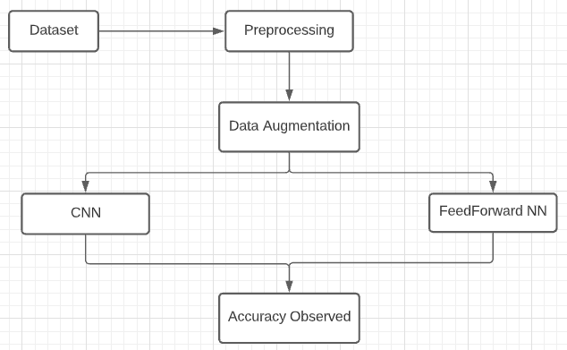

Fig. 1. Basic structure of proposed model

**Pre-Processing**

[6] Before building the model, dataset is also preprocessed. With the help of preprocessing, we are able to get all the information in the dataset. It helped us to know the quality of data and on the other hand, it also helped to prevent data from redundancy. Preprocessing data set also provides an enhancement in both of our models which also plays an important role in our study.

**Data Augmentation**

[6] The data analysis technique is applied which is used to increase the amount of data by adding an average of modified copies of already existing dataset or by newly originated data set. Mainly the purpose of data augmentation is to remove over fitting and increasing the dataset for the training set.

**Convolutional Neural Network (CNN)**

A convolutional neural network (CNN) is a type of artificial neural network that is specifically designed to process pixel data in image recognition and processing. CNNs are image processing, artificial intelligence (AI) systems that employ deep learning to do both generative and descriptive tasks, often including machine vision, which includes image and video recognition, as well as recommender systems and natural language processing. A CNN employs a technology similar to a multilayer perceptron that is optimized for low processing requirements. An input layer, an output layer, and a hidden layer with several convolutional layers, pooling layers, fully connected layers, and normalizing layers make up a CNN's layers. The removal of constraints and improvements in image processing efficiency result in a system that is significantly more effective and easier to train for image processing and natural language processing.

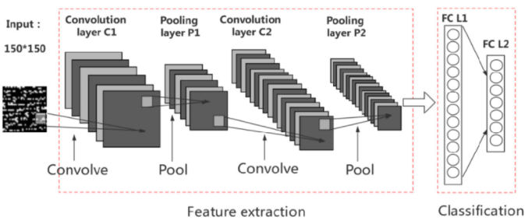

Fig. 2. Structure for CNN

**Feed forward Neural Network**

A Feed Forward Neural Network is a type of artificial neural network in which nodes are connected in a circular pattern. Because input is only processed in one direction, the feed forward model is the simplest form of neural network. Regardless of how many hidden nodes the data passes through, it always goes in one direction and never backwards. In its most basic form, a Feed Forward Neural Network is a single layer perceptron. The weighted input values are then summed together to form a total. If the sum of the values is more than a predetermined threshold, which is normally set at zero, the output value is usually 1, and if the sum is less than the threshold, the output value is usually -1.

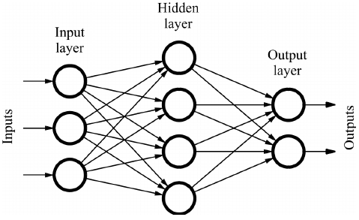 Fig. 3. Structure of feed forward neural network

**Source of Data**

In processing the data, we researchers used different kinds of data – the observations, publish sources, websites and data sets to collect accurate data.

**Published Sources**

Published sources may be written or electronic, depending on the situation. They could be paid or unpaid, depending on the decision of the writer and the publishing house.

**Websites**

Information posted on websites is often unregulated, and as a result, it might not be as reliable as information obtained from other outlets. Some controlled websites, on the other hand, only share authentic data and could be trusted by developers. The majority if these websites are either government or private entities that collect data for a fee.

**Data Set**

Dataset use for the classification model has 3(three) categories, Labrador, shihtzu and Chihuahua data sets which has the types of dog breeds around the world. This datasets contains images, number of categories and number of data per breed (categories). Detailing of this data set contains:

* Number of images: 338
* Number of categories: 3
* Labrador: 114
* Shihtzu: 120
* Chihuahua: 104

[6]This data set is very good as it holds mainly every type of image of dogs which provides a high level of accuracy for training the data set and it also consist of 3 categories which is Labrador, Chihuahua and shihtzu allowing us to make it fully prepared dataset for our model. While working in this dataset we came across any if the different aspects of dogs which we have seen or not.

**V. Results**

Throughout the training of both models, it was discovered that both models were successfully trained, and ensures the accuracy of each individual training.

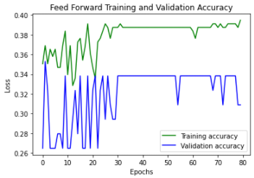

Fig. 4. Feed Forward Training and Validation Accuracy.

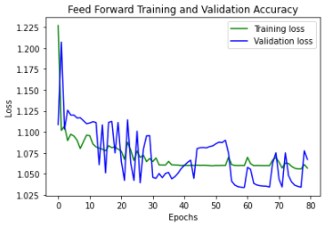

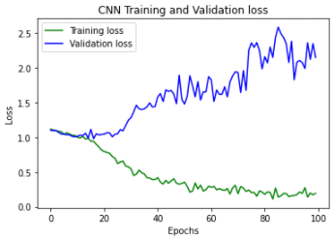

Fig. 6. CNN Training and Validation accuracy.

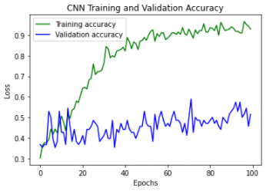

Fig. 7. CNN Training and Validation Loss.

From fig.4 and fig. 5 it shows the learning performance or accuracy of both model which is the Convolutional Neural Network (CNN) and Feed Forward Neural Network. Both fig 4. And fig. 5 shows relationship between accuracy value and number of epochs which contains train accuracy and validation accuracy with the maximum accuracy of 39.48% with epochs equals to 80. While in CNN model fig 6. And fig 7, shows relationship between accuracy value and number of epochs which contains train accuracy and validation accuracy with the maximum accuracy of 91% with epochs equals to 100.

Fig. 5. Feed Forward Training and Validation Loss.

**VI. Discussion**

The paper provides comparison between Convolutional Neural Network (CNN) and Feed Forward Neural Network (FNN). Because the two models were compared, all of the same parameters were used, such as the same number of epochs and group sizes, and the training data set was likewise the same. It has been discovered that FNN has an accuracy of 39.48%, while CNN has an accuracy of 91%, which is significantly less than the CNN model. Since the epoch provided to both the model were same and the classes were also same. Overall a productive comparison has been made between both the models.

After the completion of this study, we came across many of the positive results;

1. As compared between both of the models Convolutional Neural Network (CNN) has much higher accuracy than the Feed Forward Neural Network.

2. Train loss as compared is also less in CNN than FNN.

Contributions:

Cardinez – Background, data, results, references, system

Apon – Introduction, data, methodology, discussions, system

Costinar – Significance, data, results, refereces, system

# VII. **References**

|  |  |
| --- | --- |
| [1] | A. K. A. K. Bickey Kumar shah, "IEEEXplore," 18 January 2021. [Online]. Available: https://ieeexplore.ieee.org/document/9315871?fbclid=IwAR0XS3wEffeiw2dTuNTUXjehSNn_Hm5YNF7PBGfh_VDGh1bMSq-T3kvNwnE. |
| [2] | F. W. W. C. Richard O. Sinnott, "A Mobile Application for Dog Breed Detection and Recognition Based on Deep Learning," 10 January 2018. [Online]. Available: https://ieeexplore.ieee.org/abstract/document/8606639. |
| [3] | W. K. S. K. K. T. Punyanuch Borwarnginn, "SpringerLink," 04 June 2020. [Online]. Available: https://link.springer.com/article/10.1007/s11633-020-1261-0#citeas. |
| [4] | V. L. S. S. C. K. Xiaolong Wang, "IEEEXplore," 27-30 October 2014. [Online]. Available: https://ieeexplore.ieee.org/abstract/document/7026060. |
| [5] | V. L. S. S. C. K. Xiaolong Wang, "IEEEXplore," 29 January 2015. [Online]. Available: https://ieeexplore.ieee.org/abstract/document/7026060/authors#authors. |
| [6] | A. Varshney, A. K. Signh, S. s. Chauhan and A. Katiyar, "Dog Breed Classification Using Deep Learning," June 2021. [Online]. Available: https://www.researchgate.net/publication/353693466_Dog_Breed_Classification_Using_Deep_Learning. |
| [7] | P. K. K. C. Massinee Chanvichitkul, "IEEEXplore," 21 January 2008. [Online]. Available: https://ieeexplore.ieee.org/document/4433495. |
| [8] | C. S. Z. V. A. Z. Zalán Ráduly, "IEEEXplore," 08 September 2018. [Online]. Available: https://ieeexplore.ieee.org/abstract/document/8524715. |
| [9] | O. R. A. E.-R. A. F. A. E.-S. Basma Abd El-Rahiem. Muhammad Atta Othman Ahmed, "SpringerLink," 17 March 2019. [Online]. Available: https://link.springer.com/chapter/10.1007/978-3-030-14118-9_3. |