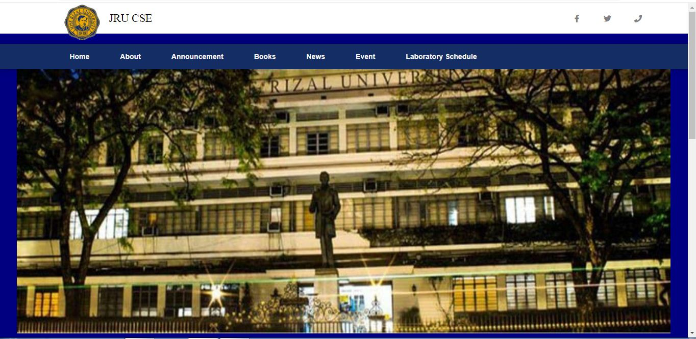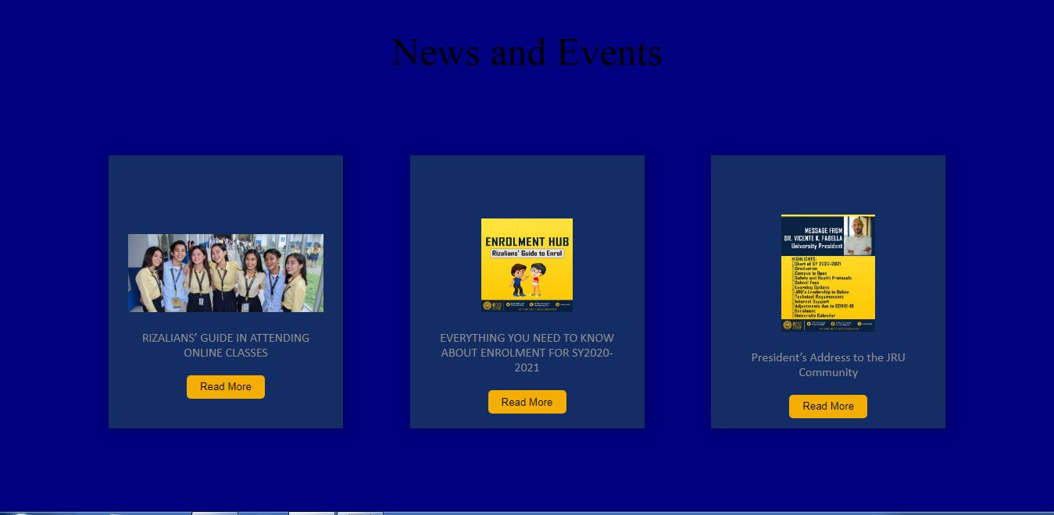

Explanation:

In this part the user see the news of JRU CSE once they click read more the location is redirect to the news page of JRU