All Final Models

Group4

July 22, 2016

### Data Prep

##### Seasonally adjusted unemployment

unem = econ.sa$unem_rate_sa

##### Differencing

Everyone seems to agree that 2 differences gets us stationarity... since we specify differencing in the arima model parameters, it feels like we should not be differencing the data beforehand.

unem1 = diff(unem)  
unem2 = diff(unem, differences = 2)

##### Differencing plots

par(mfrow = c(1, 2))  
plot.ts(unem1, main = "First difference")  
plot.ts(unem2, main = "Second difference")

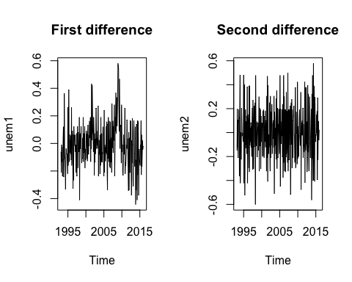

##### ADF of differenced data

adf.test(unem1)

##   
## Augmented Dickey-Fuller Test  
##   
## data: unem1  
## Dickey-Fuller = -3.618, Lag order = 6, p-value = 0.03183  
## alternative hypothesis: stationary

adf.test(unem2)

## Warning in adf.test(unem2): p-value smaller than printed p-value

##   
## Augmented Dickey-Fuller Test  
##   
## data: unem2  
## Dickey-Fuller = -9.3595, Lag order = 6, p-value = 0.01  
## alternative hypothesis: stationary

##### ACF/PACF Plots

par(mfrow = c(2,2))  
Acf(unem1); Pacf(unem1)  
Acf(unem2); Pacf(unem2)

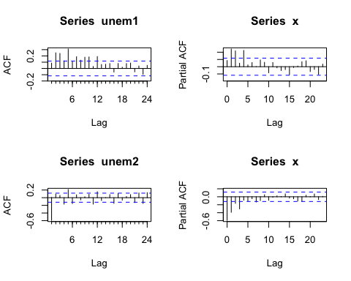

#### ACF/PACF Model Suggestions

##### First Difference

##### -----------------------------

##### Suggested: MA(4)

##### 

##### Second Difference

##### -----------------------------

##### Suggested: ARMA(1,3)

##### Seasonally Adjusted Models

mdl.4 = sarima(econ.sa$unem_rate_sa, p = 0, d = 2, q = 1, P = 1, D = 0, Q = 0, S = 12)

## initial value -1.458952   
## iter 2 value -1.751503  
## iter 3 value -1.800806  
## iter 4 value -1.810417  
## iter 5 value -1.812306  
## iter 6 value -1.813791  
## iter 7 value -1.813876  
## iter 8 value -1.813888  
## iter 8 value -1.813888  
## iter 8 value -1.813888  
## final value -1.813888   
## converged  
## initial value -1.807693   
## iter 2 value -1.807718  
## iter 3 value -1.807721  
## iter 3 value -1.807721  
## iter 3 value -1.807721  
## final value -1.807721   
## converged

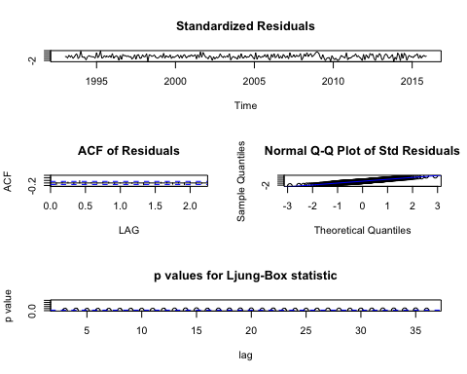

mdl.5 = sarima(econ.sa$unem_rate_sa, p = 1, d = 2, q = 1)

## initial value -1.454782   
## iter 2 value -1.756280  
## iter 3 value -1.798959  
## iter 4 value -1.806922  
## iter 5 value -1.812862  
## iter 6 value -1.814496  
## iter 7 value -1.815632  
## iter 8 value -1.815971  
## iter 9 value -1.815979  
## iter 10 value -1.815979  
## iter 10 value -1.815979  
## iter 10 value -1.815979  
## final value -1.815979   
## converged  
## initial value -1.817240   
## iter 2 value -1.817260  
## iter 3 value -1.817288  
## iter 4 value -1.817288  
## iter 4 value -1.817288  
## iter 4 value -1.817288  
## final value -1.817288   
## converged

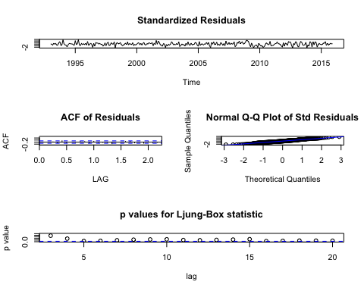

##### Seaonally Adjusted Models with Regressors

mdl.6 = sarima(econ.sa$unem_rate_sa, p = 0, d = 2, q = 1, P = 1, D = 0, Q = 0, S = 12, xreg = econ[, 2:6])

## initial value -1.464530   
## iter 2 value -1.467477  
## iter 3 value -1.498127  
## iter 4 value -1.709013  
## iter 5 value -1.790947  
## iter 6 value -1.817659  
## iter 7 value -1.818268  
## iter 8 value -1.819283  
## iter 9 value -1.819363  
## iter 10 value -1.819429  
## iter 11 value -1.819433  
## iter 12 value -1.819434  
## iter 13 value -1.819434  
## iter 14 value -1.819434  
## iter 14 value -1.819434  
## iter 14 value -1.819434  
## final value -1.819434   
## converged  
## initial value -1.810256   
## iter 2 value -1.810714  
## iter 3 value -1.810791  
## iter 4 value -1.810934  
## iter 5 value -1.810966  
## iter 6 value -1.810979  
## iter 7 value -1.810992  
## iter 8 value -1.810995  
## iter 9 value -1.811001  
## iter 10 value -1.811001  
## iter 10 value -1.811001  
## iter 10 value -1.811001  
## final value -1.811001   
## converged

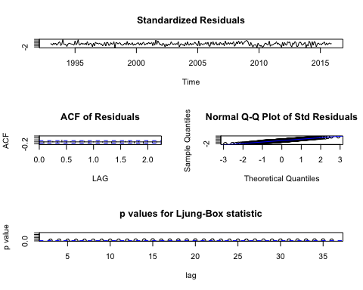

mdl.7 = sarima(econ.sa$unem_rate_sa, p = 1, d = 2, q = 1, xreg = econ[, 2:7])

## initial value -1.464512   
## iter 2 value -1.701745  
## iter 3 value -1.728679  
## iter 4 value -1.731572  
## iter 5 value -1.739068  
## iter 6 value -1.774854  
## iter 7 value -1.821381  
## iter 8 value -1.822716  
## iter 9 value -1.822830  
## iter 10 value -1.822919  
## iter 11 value -1.822935  
## iter 12 value -1.822948  
## iter 13 value -1.822950  
## iter 14 value -1.822951  
## iter 15 value -1.822951  
## iter 15 value -1.822951  
## iter 15 value -1.822951  
## final value -1.822951   
## converged  
## initial value -1.824116   
## iter 2 value -1.824125  
## iter 3 value -1.824127  
## iter 4 value -1.824143  
## iter 5 value -1.824162  
## iter 6 value -1.824165  
## iter 7 value -1.824180  
## iter 8 value -1.824181  
## iter 9 value -1.824182  
## iter 9 value -1.824182  
## iter 9 value -1.824182  
## final value -1.824182   
## converged

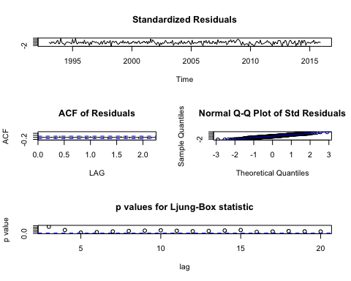

##### Comparison of various models

compare = data.frame(  
 Data = c("Unem.sa", "Unem.sa", "Unem.sa", "Unem.sa"),  
 Model = c("Mdl.4", "Mdl.5", "Mdl.6", "Mdl.7"),  
 Order = c("0,2,1", "1,2,1", "0,2,1", "1,2,1"),  
 Seasonal.Order = c("1,0,0", NA, "1,0,0", NA),  
 Xregs = c("N", "N", "Y", "Y"),  
 AIC = c(mdl.4$AIC, mdl.5$AIC, mdl.6$AIC, mdl.7$AIC),  
 BIC = c(mdl.4$BIC, mdl.5$BIC, mdl.6$BIC, mdl.7$BIC)  
)  
  
kable(compare)

|  |  |  |  |  |  |  |
| --- | --- | --- | --- | --- | --- | --- |
| Data | Model | Order | Seasonal.Order | Xregs | AIC | BIC |
| Unem.sa | Mdl.4 | 0,2,1 | 1,0,0 | N | -2.606460 | -3.580226 |
| Unem.sa | Mdl.5 | 1,2,1 | NA | N | -2.625197 | -3.598962 |
| Unem.sa | Mdl.6 | 0,2,1 | 1,0,0 | Y | -2.576905 | -3.485083 |
| Unem.sa | Mdl.7 | 1,2,1 | NA | Y | -2.595392 | -3.490453 |

xtable(compare)

## % latex table generated in R 3.2.4 by xtable 1.8-2 package  
## % Fri Jul 22 20:14:21 2016  
## \begin{table}[ht]  
## \centering  
## \begin{tabular}{rlllllrr}  
## \hline  
## & Data & Model & Order & Seasonal.Order & Xregs & AIC & BIC \\   
## \hline  
## 1 & Unem.sa & Mdl.4 & 0,2,1 & 1,0,0 & N & -2.61 & -3.58 \\   
## 2 & Unem.sa & Mdl.5 & 1,2,1 & & N & -2.63 & -3.60 \\   
## 3 & Unem.sa & Mdl.6 & 0,2,1 & 1,0,0 & Y & -2.58 & -3.49 \\   
## 4 & Unem.sa & Mdl.7 & 1,2,1 & & Y & -2.60 & -3.49 \\   
## \hline  
## \end{tabular}  
## \end{table}