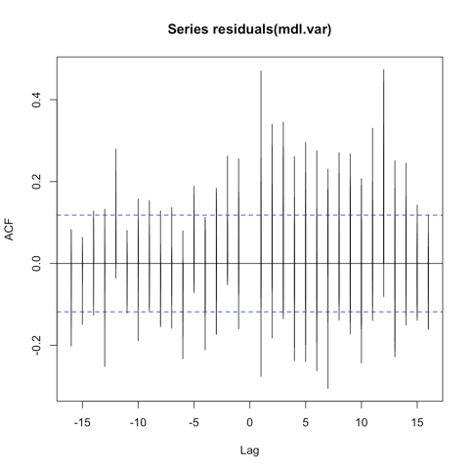Var

Group4

July 22, 2016

##### Fit a VAR on non stationary data

mdl.var = VAR(y = econ.sa[, 1:6], type = "both", p = 1, lag.max = 1)  
#acf(residuals(mdl.var))  
#plot(predict(mdl.var, n.ahead = 50))

##### 

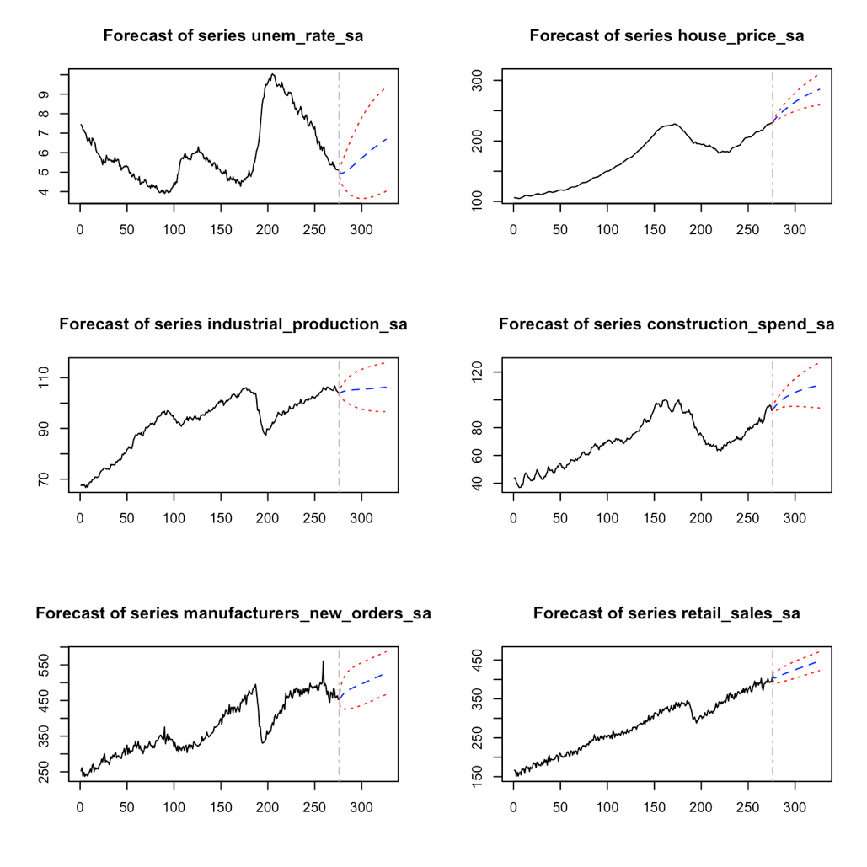

##### Detrend the data

econ.detrend = econ.sa  
  
econ.detrend$unem_rate_sa = with(econ.detrend, unem_rate_sa - fitted(lm(unem_rate_sa ~ time(unem_rate_sa))))  
econ.detrend$industrial_production_sa = with(econ.detrend, industrial_production_sa - fitted(lm(unem_rate_sa ~ time(industrial_production_sa))))  
econ.detrend$manufacturers_new_orders_sa = with(econ.detrend, manufacturers_new_orders_sa - fitted(lm(manufacturers_new_orders_sa ~ time(manufacturers_new_orders_sa))))  
econ.detrend$house_price_sa = with(econ.detrend, house_price_sa - fitted(lm(house_price_sa ~ time(house_price_sa))))  
econ.detrend$construction_spend_sa = with(econ.detrend, construction_spend_sa - fitted(lm(construction_spend_sa ~ time(construction_spend_sa))))  
econ.detrend$retail_sales_sa = with(econ.detrend, retail_sales_sa - fitted(lm(retail_sales_sa ~ time(retail_sales_sa))))  
plot.ts(econ.detrend)

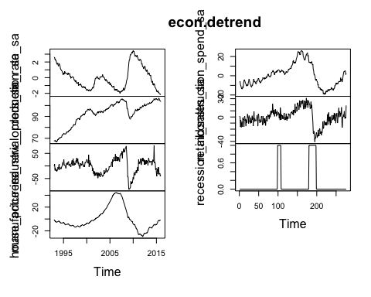

##### Fit a VAR on non stationary, but detrended data

mdl.var = VAR(y = econ.detrend[, 1:6], type = "none", p = 1, lag.max = 1)  
#acf(residuals(mdl.var))  
#plot(predict(mdl.var, n.ahead = 50))

