Texas A&M University
August 2015 Diagnostic Exam Study Group
Discussion of Previous Exams

This document is for reviewing and discussing the results of previous diagnostic exams, which are stored on the eCampus page. Try to keep discussion for each exam on separate pages for simplicity’s sake. I’ve just put a few here; add more as needed. Thanks!

Try to keep your questions/contributions to the discussion clear by signing your “posts” (perhaps with color-coding), and indenting your responses beneath the appropriate post.

This doc is only for discussing previous diagnostic exams; the other Google doc is for housing study notes for potentially relevant course material.

Grading format (told from Aug 2014 Diag. survivor) = graded in A/B/C/D per problem and overall a Pass/Fail grade. In case you flunk one out of four problems, it would technically still be fine to pass. - Monica Huynh 6/10/2015

NOTE: Since Categorical Data Analysis is now an elective, there doesn’t seem to be much point in reviewing 2013 or earlier qual exams, which tend to be a lot heavier on categorical data. -Sean

I think it might be good to also use this document for any problem from a pre 2013 test which is worth discussing. -Sen Zhang 08/02/2015

Jan 2012 started. Also, a table of contents might be helpful at this point, if anyone is inspired to create one. - Chris Shannon 8/11/15

Jan 2013 exam started further down. --Sean W. 8/12/15

As of 12:05 PM ET 8/19/15 I have access to the exam area in WebAssign. If you don’t have access, you should let Kim Ritchie know ASAP. --Sean W. 8/19/15
Jan. 2015 Exam Discussion

Part 1 (started by Sean Wisnieski)
from STAT 642 Handout 9 pg 24 and 25 Monica Huynh 7/7/15
1. I completed the table as follows:

SOURCE | DF | MS | EMS
Thickness | 2 | 0.0263
Type | 2 | 319.1202
Thickness*Type | 4 | 0.1152
Machine(Type) | 6 | 1.4935
Thickness*Machine(Type) | 12 | 0.0878
Error | 27 | 0.0445

2. Let be the lth observation within the ijkth treatment combination, be the fixed effect of the ith thickness, be the fixed effect of the jth machine type, be the random effect of the kth machine within the jth machine type, and be an error which is iid N(0,) and independent of . Then, our model is
.

additional model assumptions: Greg L 7/15/15
distribution properties: (642 HO9, pg 5)
are idd N(0,)
are idd N(0,)
are idd N(0,)
Monica 7/22/15

(Kuehl top of 239: “The interaction effects are assumed random when one of the factors involved is a random effect.”)

3. This is equivalent to testing a thickness-by-type interaction. If there is no true interaction, then this is equivalent to testing , in which case . Then, we can test the null using
with df = {4,12}, which is clearly p > .05. We therefore fail to reject and conclude that the mean uniformity of the windings produced by the three types of Machines are consistent across the three thicknesses. (This feels wrong, just from looking at the table. Can someone verify that I did this step correctly? --Sean)
This looks right to me, Sean, I also made the graph below of the mean uniformity of the windings vs machine type for the three different thicknesses - the lines look parallel to me so I would conclude no interaction just looking at the graph - Greg L
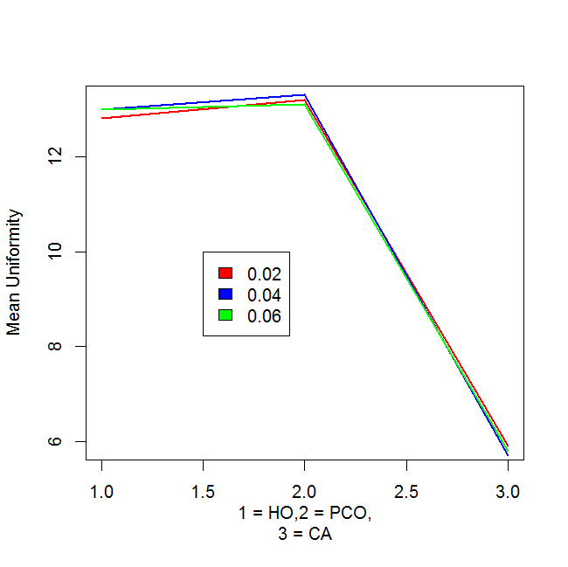

4. If there is no effect due to machine type, then = 0, in which case . Then, we can test the null using with df = {2,6}, which is clearly p < .001. We therefore reject = 0 and conclude that there is a significant effect of machine type.

5. a) = 0.0445
0.0878 = 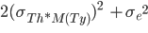 ⇒ 0.0878 = 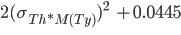 ⇒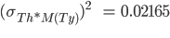
1.4935 = ⇒ = 0.234
= 0.0445 + + 0.234 = 0.30015

/ {} = 0.148
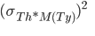/ {} =0.072
/ {} =0.78

( Chris Shannon See Kuehl 247 for an example of estimating the variance components and their percentages.)

b) Recall that our model is .

Then, .

Hence, (recalling that fixed effects are discarded because the variance of a constant is 0)
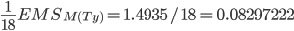, the square root of which is .

c) Again recalling our model above:
and
.

Then, - and
(once again discarding fixed effects)
-]
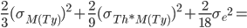

the square root of which is .

d) Again recalling our model above:
and
.

Then, . Remembering as always to discard fixed effects from the variance (since the contribution of a constant to the variance is 0), then
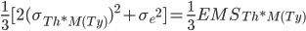. Then, .

SEAN 7/29/15:
SAS code for future reference:
data jan2015q1;
input type $ mach $ thick $ y;
cards;
HO 1 .02 12.30
HO 1 .02 12.59
HO 2 .02 13.46
HO 2 .02 14.00
HO 3 .02 12.35
HO 3 .02 12.06
HO 1 .04 13.16
HO 1 .04 13.00
HO 2 .04 13.29
HO 2 .04 13.62
HO 3 .04 12.50
HO 3 .04 12.39
HO 1 .06 12.87
HO 1 .06 12.92
HO 2 .06 13.46
HO 2 .06 13.82
HO 3 .06 12.73
HO 3 .06 12.15
PCO 4 .02 13.01
PCO 4 .02 12.63
PCO 5 .02 13.46
PCO 5 .02 13.92
PCO 6 .02 13.15
PCO 6 .02 13.20
PCO 4 .04 12.74
PCO 4 .04 12.68
PCO 5 .04 13.84
PCO 5 .04 13.75
PCO 6 .04 13.46
PCO 6 .04 13.57
PCO 4 .06 12.47
PCO 4 .06 12.15
PCO 5 .06 13.62
PCO 5 .06 13.28
PCO 6 .06 13.36
PCO 6 .06 13.42
CA 7 .02 5.47
CA 7 .02 5.96
CA 8 .02 5.75
CA 8 .02 5.68
CA 9 .02 6.24
CA 9 .02 6.15
CA 7 .04 5.73
CA 7 .04 5.64
CA 8 .04 5.60
CA 8 .04 5.65
CA 9 .04 5.92
CA 9 .04 5.64
CA 7 .06 5.01
CA 7 .06 5.62
CA 8 .06 5.80
CA 8 .06 5.71
CA 9 .06 6.19
CA 9 .06 6.23
;
run;

proc glm data=jan2015q1;
class thick type mach;
model y = thick|type|mach(type);
random mach(type);
run;

Part 2 (started by Sean Wisnieski)
from STAT 641 - Monica Huynh 7/7/15
1. 95% CI:

2. I estimated n = 266 at least, using 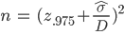 to generate an initial estimate of n = 264, then refined to 266 when it was apparent that such an interval was too small to generate t-based intervals of width under 4. Nevertheless, n = 265 generates an interval of approximately (but barely over) 4 days’ width.
I’m getting n= 66 using equation on Handout 11 page 26. The plus sign in your formula is throwing me off or my math is off :) - Monica 7/18/15
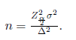
(This looks more correct; I have no idea where I got that original formula from! Nevertheless the principle of getting an initial estimate using the formula, then trying it out to make sure the width of the intervals don’t exceed , should be followed). --Sean W.
I think the discrepancy may be due to the interpretation of the delta in the formula on pg 26 of HO 11. The formula is used to calculate the number of units needed to insure that the estimate of the parameter is within Δ units of the true value of θ with 100(1 − α)% confidence. In that case, I think Δ is 2 instead of 4, which gives a value of n = 264. Greg L 7/20/15
(Oh, yes, it should definitely be 2 -- the intervals extend on both sides of the mean, after all. --Sean 7/21/15)
Thanks for the clarification. Monica 7/21/15

3. The survival times are extremely nonnormal, as witnessed by both the Shapiro-Wilk p-value (p < .001 despite the small sample size) and the very nonnormal quantile reference plot, which implies a fairly skewed distribution. This is to be expected: survival times are usually gamma-distributed.

4. (If I understand the notes right): We can draw 10,000 bootstrap samples with replacement from the data and calculate the mean for each, then order the resulting set of means from smallest to largest. We can then pull the 250th and 9750th means in the ordered set (corresponding to the 2.5th and 97.5 percentile), supply those means into the pivot, and solve for mu to derive t-values.

(Demonstrative R code follows; note the percentiles this produces DO NOT match what the exam gives in the following question, although is kinda close; that’s probably fine.

x = c(0.2,0.8,1.4,2.0,2.3,2.6,3.5,3.6,4.8,5.0,5.3,5.4,5.6,6.7,8.0,8.8,13.1,
15.4,16.1,18.9,26.1,32.4,38.7,42.3,68.7)

n = length(x)
thest = mean(x)

B = 9999
thestS = numeric(B)
thestS = rep(0,times =B)
for (i in 1:B)
thestS[i] = mean(sample(x,replace=T))
RS= sort(thestS-thest)
LRS = RS[250]
URS = RS[9750]
thL = thest-URS
thU = thest-LRS

lcl.t = sqrt(n)*(thL - thest)/sd(x)
ucl.t = sqrt(n)*(thU - thest)/sd(x)
lcl.t
ucl.t
Your Rcode shows that the standard deviation is calculated from the original data - sd(x). Should it be the standard deviation of the 250 and 9750th bootstrap sample? Monica 7/18/15

Sean 7/20/15: Yeah, Monica, that makes more sense, and gets t-values much closer to the ones given in the exam output. Revised code below, for reference’s sake:

x = c(0.2,0.8,1.4,2.0,2.3,2.6,3.5,3.6,4.8,5.0,5.3,5.4,5.6,6.7,8.0,8.8,13.1,
15.4,16.1,18.9,26.1,32.4,38.7,42.3,68.7)

n = length(x)
thest = mean(x)

B = 9999
mm = NULL
T = NULL
i = NULL
for (i in 1:B) {
mm = sample(x,replace=TRUE)
T[i] = (sqrt(n)*(mean(mm) - thest))/sd(mm)
}
T = sort(T)
LT = T[250]
UT = T[9750]
c(LT,UT)

Greg L 7/20/15: was wondering if here we should do the parametric bootstrap since the question states that the distribution is a gamma? In that case, we would use the original data to get the mle estimates for the parameters, then generate 10k samples of n=25 random values from a gamma with those parameters. I gave that a try (the data is actually not a great fit to a gamma) and got t0.025 = - 3.02 and t0.975 = 1.46.
Sean W. 7/20/15: That seems reasonable, since it’s the only way to incorporate the mentioning of the gamma distribution. But like you say, the data’s not a great fit and using bootstrap method yields t-values closer to what are indicated in the exam. Anyone else have thoughts? Maybe either way would work.

Should we calculate the test statistics t= , instead of mean from the bootstraped sample? The questions is asking about the percentile of the distribution of t, not the distribution of mean. I think we should construct a distribution of the test statistics: t instead of the mean. Jingjing 8/6/2015
Yes; that’s what my revised code (in dark red above) does. --Sean W. 8/11/15

5. I just used and solved for , getting (7.075, 25.9125).

I am getting different answer for this one. -3.75*16.55/ 1.75*16.55/ , and the interval that I got is (1.0875,19.3). I double checked the calculation. Jingjing 8/6/2015
Let’s walk through my steps and see where we diverge. Starting with , we multiply all sides by 16.55 to get , then divide both sides by 5 to get , then subtract 13.5 (x-bar) from both sides to get . Then we just divide both sides by -1 and flip the signs around to get the limits I got above: (7.7075, 25.9125). --Sean W. 8/11/15
The result Jingjing has comes from using the typical Wald Interval: . - I don’t feel this method works, and I have the same results as Sean. D.Bartkowiak 8/12/15
I agree with Sean as well. The quantiles are for the distribution of the t statistic shown so it should be used to get the CI for the mean. -Oscar P 8/12/15

6. Huynh 7/18/15 - Sign Test Handout 12

Null hypothesis: u~ u₀~
Alternative hypothesis: u~ u₀~
p = P[X_{i} >0] = P[Y_{i} > u₀~] < 0.5

X_{i} = Y_{i} - u₀~
S₊ = # of positive X_{i} = 19

Reject null hypothesis if S+ B_{n,1- Suge}
B_{n,1-} = qbinom(,n,0.5) =qbinom(0.05,25,0.5) =8

19 greater than 8 so can not reject null hypothesis that the new treatment has increased the survival time in comparison to the previous treatment

Sean W. 7/20/15: I think it should be qbinom(1-a,n,0.5), which would give 17 rather than 8 (still fail to reject null).
I think if you use qbinom(1-a,n,0.5) which is H1 on page 36, you would actually reject the null and accept the alternative hypothesis u~ u₀~. I used the setup for H2 on page 36. Monica 7/21/2015

pvalue= P[B(n,0,5) S₊ ] = pbinom(S₊ ,n,0.5) = pbinom(19,25,0.5) = 0.9979613

According to HO12, page 53
H0: u~ u~>3.
reject region: Y > qbinom(.95, n=25, p0=0.5)= 17, Y=17 does not greater than 17 so fail to rejec
t H0. State that the new treatment has not increased the survival time compared to previous treatment.
p-value = p[Y >=17]=1-p[Y < 16]=1-pbinom(16,25,0.5)= 0.05388 → fail to reject H0.

[It looks like this discussion has moved on, but after reviewing the discussion above and checking back with HO12, it looks like we are supposed to reject HO. I get:

S₊ = 19 and qbinom(1-0.05, 25, 0.5) = 17, with the decision-rule to reject H₀ if S₊ >= 18. Here’s a snip from the handout for setup H1 - and it does look like we need to use setup H1 because the question is asking us if the survival time has increased. Hence the null hypothesis should be u <= u₀:

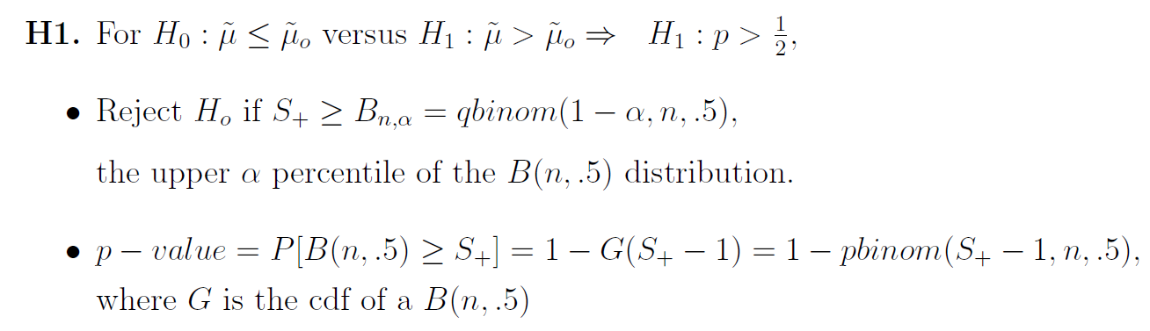
Just to clarify my use of qbinom(1-0.05,25,0.5) = 17:

1-pbinom(17-1,25,0.5) = 0.054
1-pbinom(18-1,25,0.5) = 0.022

As per the example on page 43 in HO12, we should use 18 if (using >=, or 17 if using >) as our critical value because of the binomial dist being discrete:

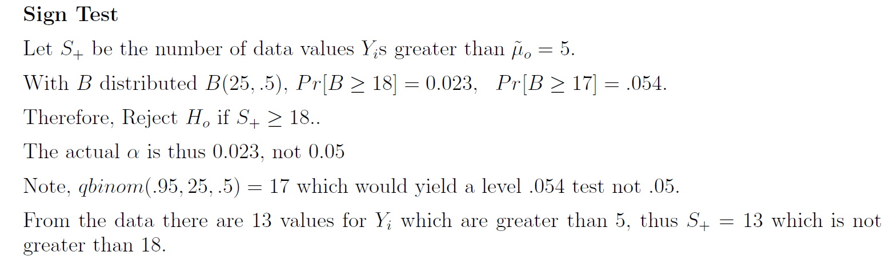

- Chris Shannon 8/15/15]

Part 3 (started by Sean Wisnieski, 7/17/15)

- I believe this question is just asking for the expressions
  - -D.Bartkowiak (7/20/15)
(These should be X-bar rather than just x, right? --Sean W., 7/30/15)
(I do not believe so as you would arrive at a single value if you used the mean value of the predictor -D.Bartkowiak, 8/7/15)

2.
a. is the mean response for subjects receiving treatment level when x is held
constant at 0.
b. is the difference between the mean response for subjects receiving treatment level and those receiving treatment level when x is held constant at 0.
c. is the difference between the mean response for subjects receiving treatment level and those receiving treatment level when x is held constant at 0.
d. is the average increase in the response for each one-unit increase in x, assuming the subject is receiving treatment level .
e. is the difference in the average increase in the response (for subjects receiving treatment level , compared to those receiving treatment level ) for each one-unit increase in x.
f. is the difference in the average increase in the response (for subjects receiving treatment level , compared to those receiving treatment level ) for each one-unit increase in x.

3. The slopes are equal iff the interaction between the treatment level and covariates is nonsignificant, i.e., if the treatment effects do not depend on the value of the covariate. Therefore, a useful test of the equality of the slopes is

4.

(It would seem part 4 of this exam was cut off of this copy -- I posted in the discussion board asking about it, since the cover page says there are four problems, but have not yet received a response. --Sean W., 7/20/15)

Aug. 2014 Exam Discussion

Part A (started by Sean Wisnieski, 7/21/15) (Chris Shannon - Stephanie Lowe and I disagree with the nested factor. Number 4 and 5 are correct.)
1. This looks like an RCBD with a split-plot treatment assignment. Containers are both the block and the whole-plot EU; one-quarter portions are the split-plot EU.

2. 4 x 4 x 3 factorial treatment structure, with container nested within sweetener and crossed with blending time. (alternative below)

3. Sweetener [S] - Fixed.
Container(Sweetener) [C(S)] - Random.
Blending Time [B] - Fixed.

4. Ice cream container is the (whole-plot) EU; one-quarter portion is the MU (and split-plot EU).

5. RV - texture score.
Covariates - none.
Subsampling - none.
Repeated Measures - none.

6.

SOURCE | DF | EMS
S | 3
C(S) | 8
B | 3
S*B | 9
C(S)*B = Error | 24

7.

Alternative answer to Part A 1 - 7 (Chris Shannon on 7/26/15)
Not sure I agree with this -- separate containers are assigned to each sweetener (i.e., it’s not just the same three containers), so isn’t it nested? --Sean 7/27/15
According to O Kuehl on page 243 (Ch 7.3), the levels of one factor will contain different levels of another. “In certain types of studies the levels of one factor, B, will not be identical across all levels of another factor, A. Each level of factor A will contain different levels of factor B. The levels of B are said to be nested within the levels of A.” But that doesn’t seem to be the case here, as the container itself is not regarded as a factor. Instead, the split plot seems closer to what is being asked here.

The motivation for the split plot design is when one factor “requires more experimental material for its evaluation than a second factor in factorial experiments.” (O Kuehl, Ch 14 page 469) And he gives some examples, which include applying different treatments to subplots within a whole plot and, for example, temperature control chambers with different temperatures in each one applying other treatments within each chamber.

He says, “If one factor, such as temperature, humidity, or photoperiod, requires environmental control chambers, then each level of that factor requires a separate chamber. A second treatment factor such as culture media for plants and even a third treatment factor can be included within each of the chambers, thereby achieving an economical use of the chambers to study more than one factor at a time. The chambers represent whole plots, and the subplots are units to which the second factor levels are applied inside each chamber.” (O Kuehl, page 471) -- Chris Shannon 7/27/15 @ 18:15 CST

(Hmmm. I didn’t cross check it again with your design, but it looks like we get the same degrees freedom and same E(MS) using either design. I wonder if either answer would be accepted? - Chris Shannon 7/27/15 @ 18:20 CST)
looking at the example on 642 Handout 2 page 2, the levels of containers only have meaning if we know which sweetener the containers are selected from so wouldn’t it be nested? Monica 8/9/15

When I did this problem before checking the study guide, I arrived at the same design as Chris. I just don’t see how the containers are being used as a factor. I was thinking that the 12 initial containers were supposed to be homogenous with respect to each other. In any case, we are not told of any difference between the containers assigned to each sweetener that would indicate levels to be concerned with. (I was thinking that any initial variation in the containers should be handled by an error term and not by factors) -Oscar P. 8/9/15

Looking back over the notes, I came upon the example on HO 12, pg. 15 about the CRD split-plot design. I believe that the containers in this problem are comparable to the classrooms in the example in the HO. -Oscar P. 8/10/15 Thanks! -Monica 8/10

- Completely randomized split plot design. (See O Kuehl ch. 14, page 480, table 14.7 first table.)
- 4 X 4 factorial treatment.
- Fixed: Sweetener (S), Blending time (B); Random: Container (whole plot)
- Experimental units: Containers; Measurement Units: portion of container.
- Response variable: texture score; Covariates: none; Subsampling: None; Repeated measures: None
6)

Source Variation | df | E(MS)
Sweetener (S) | 3
Error(1) | 8
Blend time (B) | 3
SxB | 9
Error(2) | 24
Total | 47

7)

is the general mean.
is the fixed effect of the ith level of sweetener.
is the random container effect with mean 0 and variance .
is the fixed effect of the jth level of blending time.
is the interaction effect of sweetener and blending time.
is the random experimental error with mean 0 and variance .

Necessary conditions:
- and are independent, normally distributed with constant variance.

Part B (started by Sean Wisnieski, 7/20/15)
- M 2)Q 3)N 4)E 5)P Sen Zhang, 08/02/2015

I got the same answers for all but #2. Why use Hsu’s procedure here when trying to determine which pairs of means are different across the levels of F1? I was guessing Tukey’s, but am not that confident in my answer either. The nested factor was confusing me. G Long 8/3/2015

I chose N for #2, Tukey’s applied to levels of F1 averaged over levels of other factors. I think the issue is that interaction effects between fixed level factors are not significant. Gabrielle G 8/3/15

I agree with both of you. N is the right answer. Thanks.
Sen 08/04/2015

In 4, would you average over values if the 3-way interaction and all the 2-way interactions were significant? -D.Bartkowiak, 8/7/15.

I chose S for #3 because the researcher “wants to determine if there are pairwise differences in the levels of F1”, which I interpret as the presence of simple effects. Since the F-test for F1 is not significant, there cannot be any pairwise differences. Along with D. Bartkowiak, I also chose D for #4 because of the presence of significant interactions. Since the “mean defective rate” is given as u_ijk, and since there are interactions, you would produce a number of trend plots with those interactions against F1. - Chris Shannon 8/8/15.

I agree with Chris on #3 being S since it was already determined that there were no main effects for F1. However, for #4 I thought it would be E. My reasoning was that the operators were random meaning you can automatically average over them even if an interaction is present. You are then left with the two other factors which interact leaving you with having to do the comparison separately for the levels of F2.
-Oscar P. 8/9/15

I agree with Oscar’s analysis for #4 and now believe E to be correct - Chris Shannon 8/9/15.

Problem II.

1.

2. RSS = 0.23471, MSE = 0.0782366667, therefore = 0.2797082.
3. is found in the diagonal of , which gives and .
I think the parameter variances you found here are using standard deviation instead of variance fromj #2. If I multiply by .278 I get your results, but if I multiply by .078 I get .086 and .01 respectively.
Gabrielle Griffin, 7/22/15
Yes, good catch -- thanks! Corrected in code below as well. --Sean 7/27/15

I am not sure if this has already been addressed here, but we are looking for 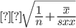and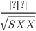 so you need to take the square root of the variances found above- Oscar P. 8/12/2015

4. When x = 3, we estimate a mean response of . Then, the 95% CI is 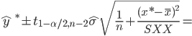
(1.11191, 1.90809). Therefore we can say with 95% confidence that the mean response at x = 3 falls somewhere between 1.11191 and 1.90809.
Do y’all think we are expected to have the correct percentile of t? The only tables given with this exam were binomial probabilities. -Kate Mullan, 8/16

I would expect that they would provide us with a t-table unless we can use a normal approximation for the percentiles. For these problems n is pretty small so there is no way for us to get the correct percentiles without some table. -Oscar P 8/16/15

5. Similar to 5, but with formula slightly changed: 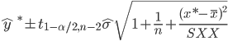=
= = (0.534j9, 2.4852). Therefore we can say with 95% confidence that, when x = 3, a random realization y will fall somewhere between 0.5349 and 2.4852.

(I did the above by hand/calculator, but it can be verified with the following code:

y <- c(0.34,1.28,1.16,2.11,2.66)
x.simple <- c(1,2,3,4,5)
x <- matrix(c(1,1,1,1,1,1,2,3,4,5),ncol=2,byrow=F)

beta <- solve(t(x) %*% x) %*% t(x) %*% y
beta # regression coefficients

y.pred <- x %*% beta
e <- y - y.pred
RSS <- sum(e^2) # residual sum of squares
MSE <- RSS / 3 # mean square error (sigma-squared)
RMSE <- sqrt(MSE) # root mean square error (sigma)

# variance-covariance matrix for regression estimates
MSE * solve(t(x) %*% x)

# proper regression analysis - verify that things add up
obs.model <- lm(y~x.simple)
summary(obs.model)

# confidence/prediction intervals
testvalue <- data.frame(x=3)
predict(obs.model,testvalue,interval="confidence")
predict(obs.model,testvalue,interval="predict")

The last two predict functions give me error message. Anyone successfully execute this code? --- Sen 08/04/2015
Sorry, I changed variable names a few times in the course of writing this code and never ran it “fresh.” I’ve corrected the errors and updated the code above so it should run correctly now. Thank you for catching that. --Sean 8/11/15

Question III (Chris Shannon on 7/26/2015)

Part A

1)

H0: , HA: , p-value =
DO NOT Reject H0.
For this one, I got the p-value as 1 - P(X <= 5) = 1 - 0.939 = 0.061, therefore we do not reject H0. The p-value is the probability of a result as extreme or more extreme than the observed data, which is the probability that x is 6 or greater, which is 1 minus the probability that x is 5 or less. G Long 8/5/15
Thanx, G Long. I’ve made the changes. -- Chris Shannon 8/6/15

2)
Mid-p-value:
For this one, I get P(x = 6) = 0.982 - 0.939 = 0.043 and P(x =>7) = 1 - 0.982 = 0.018, so the mid-p value = 0.0395. The result is the same - reject H0. G Long 8/5/15
Thanx, G Long. Good catch. I should have used 0.982 = P(X <=6). Changes made - Chris S. 8/6/15

3)
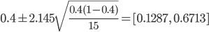 where t(0.975, 15-1) = 2.145
(Shouldn’t we prefer Wilson CI’s? --Sean 7/27/15)
(Not sure. It’s a bit complex, though. Would we be expected to remember that for the test? -- Chris 7/27/15 @ 18:53)
(It is very complex, yes…. hard to believe we’d be expected to remember it; but the notes say explicitly that a CI of this sort is inappropriate since the assumptions for it are not met. --Sean 7/27/15)
(But then np = 15(0.4) = 6 > 5 and n(1-p) = 15(0.6) = 9 > 5, so this could work. I guess the problems come about especially when the probability is in the tails - Chris 7/27/15)
(Fair enough; professors have indicated in the past that grading on this is not so tough, so we could simply present the Wald CIs as above and make a note that something like the Wilson CIs may yield more accurate results. --Sean 7/27/15)
(Making that caveat with Wald CI sounds safest. -- Chris 7/27/15)

What about using the A-C interval y*=y+2,n*=n+4,p*=y*/n*? D.Bartkowiak 8/9/15

Isn’t A-C recommended only when n>=40? -O. Pena 8/9/15
(Correct, Oscar. --Sean 8/17/15)

Part B

1)
H0: , HA: ,
DO NOT Reject H0.

2)
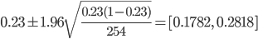
Why use 0.4? --Sen 08/04/2015
Yes, 0.4 is a mistake, carried over from part A of the problem. Changing to 0.4 under the sqrt sign to 0.23 and updating the result. -- Chris 08/04/2015

3)
When n is sufficiently large a binomial distribution approximates a normal distribution.

Question IV (Chris Shannon on 7/26/2015)

1)
One major concern that potentially threatens the validity of the model fit by Miller (2013) is the low Adjusted R-squared: 0.45. This tells us that less than half the variability is explained by the model. This can lead to improper predictions and unexpected outcomes.
I would also say that variance is not constant, which is needed to make inferences from the model. GabrielleG 072915
I also put that there was a significant interaction between Day/Night and temperature as shown in the graph which is not accounted for in the model G Long 8/13/15

2)
The following is a recommendation: Add interaction terms.
- Remove variables with high p-values step-by-step until I have a set of main effects whose p-values are significant.
- Start adding interactions from the main effects.
  - Add the most significant interaction effects one-by-one, adding the most significant effect first and then the next most significant others.
- For each interaction added, reassess the fit of all the variables and then if some variables are no longer significant, they may be dropped.
- Repeat steps 2 and 3 until no more significant interactions are found.

3)
Keep Saturday, Sunday, Tuesday, Thursday, Friday (because of their high means and high Q3s)
Keep all months except October
Keep Bobblehead promotion and Opponents from Large Metro Areas.
Keep Attendance vs. Temperature
Aug. 2013 Exam Discussion

Discuss.
G Long - question 1
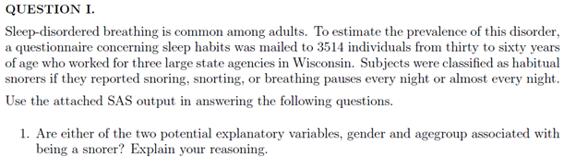
Yes, both age group and gender appear to be significant factors since the chi square statistic is greater than the critical value in both cases

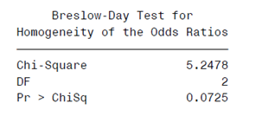
Since the p-value > 0.05, we do not reject the null hypothesis that the odd ratios differ
For the 30 to 39 age group, the 95% CI for the odds ratio is [0.4734 0.7646]
For the 40 to 49 age group, the 95% CI for the odds ratio is [0.4516 0.6981]
For the 50 to 59 age group, the 95% CI for the odds ratio is [0.2913 0.529]
Since the confidence intervals all overlap, we conclude that the odds ratio for being a snorer between women and men do not differ significantly

I believe that the Breslow-Day Test has as the null hypothesis that the odds ratios are equal. This would mean that the odd ratios do not differ since the p-value >.05. -Oscar P 8/16/2015
Good catch, thanks - G Long 8/19

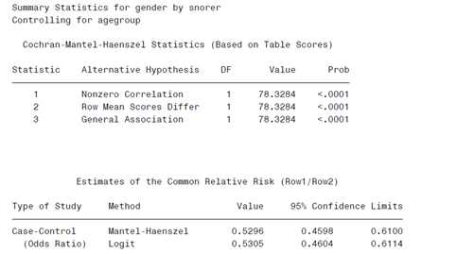
There is significant evidence of conditional dependence of snoring and gender, controlling for age group

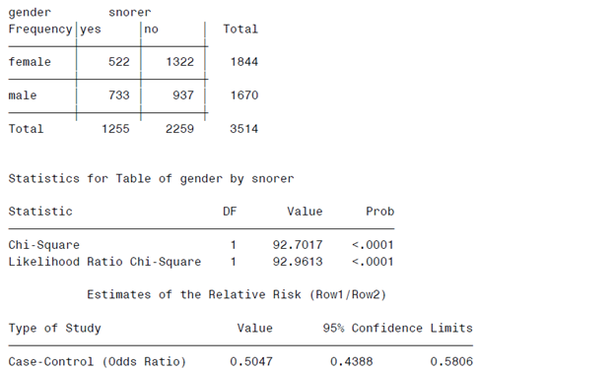

Per the chi-square test and the odds ratio test, there does appear to be evidence of dependence of snoring and gender, ignoring the effect of age group

Since we do not reject the hypothesis that the odds ratios differ, it is more appropriate to use the test in part 4. This will result in greater power to reject the null if it is in fact false

The Breslow-Day test resulted in failing to reject the hypothesis that the odds ratio are the same. Therefore wouldn’t it be more appropriate to use the CMH test as was done in part (3). -Oscar P. 8/16/2015
I also came to the same conclusions as Oscar. Because the B-D test failed, it suggests that we can not ignore the effects of the age group. Monica 8/17/15
Thanks for the correction! - G Long 8/19
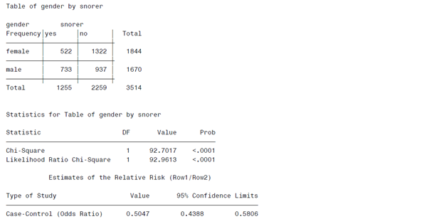

Ψ_hat = 522*937/(1322*733) = 0.5047
Log(Ψ_hat) = -0.6836959
MSE(Log(Ψ_hat)) = (1/(n11)+1/(n12)+1/(n21)+1/(n22))^.5 = 0.0714397
CI (Log(Ψ_hat)) = 0.5047 +/- 1.96*0.0714397 = [-0.8237177, -0.543674]
CI(Ψ_hat) = [exp(-0.8237177), exp(0.543674)] = [0.4387973, 0.5806111]
(For a common odds ratio, wouldn’t you use the Cochran Mantel-Haenszel Statistic [0.4598, 0.6100] or corresponding logit statistic [0.4604, 0.6113] for an assumed common odds ratio? Chris Shannon - 7/28/15)
I would assume the same as Chris based upon example on 642 HO#13 pg 62. Monica 8/17/15
Simpson’s paradox refers to a situation where a lurking variable (one not considered in the data analysis) leads to an incorrect interpretation of the data. For example, if we averaged the data over the age group variable, it might lead us to conclude that gender was a significant predictor of snoring, but if we looked at the data separately for each age group, we might find that gender was not a significant predictor within each age category. That does not appear to be the case here – gender is significant both overall and within each age group.

G Long - question 2
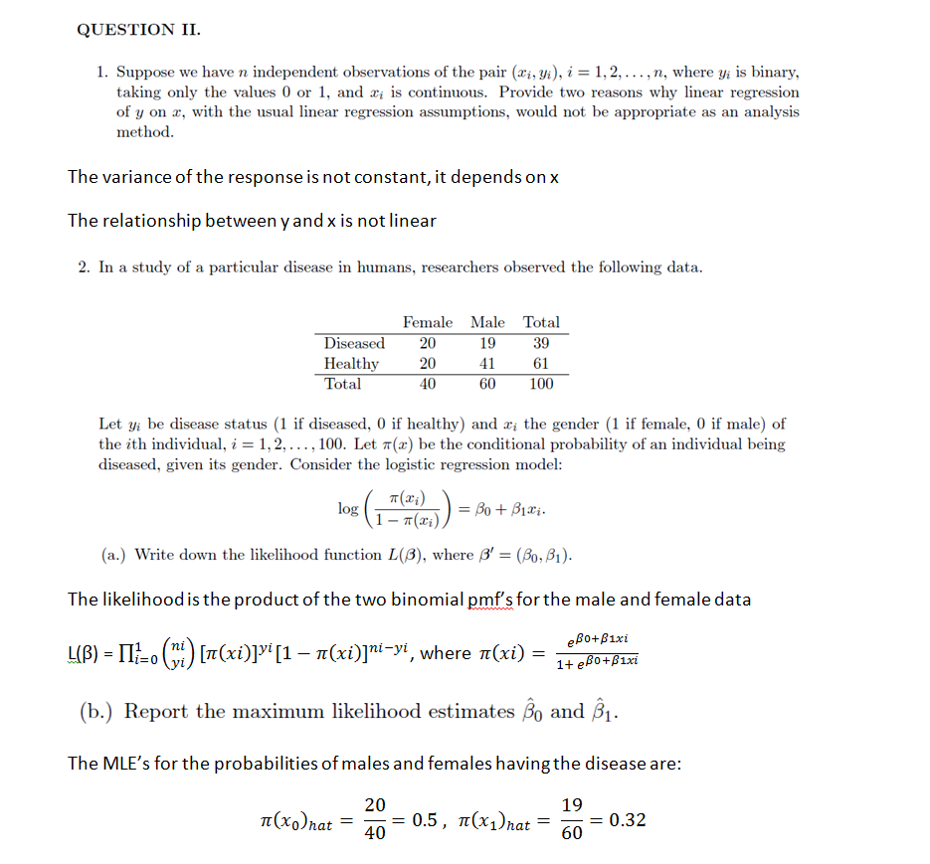

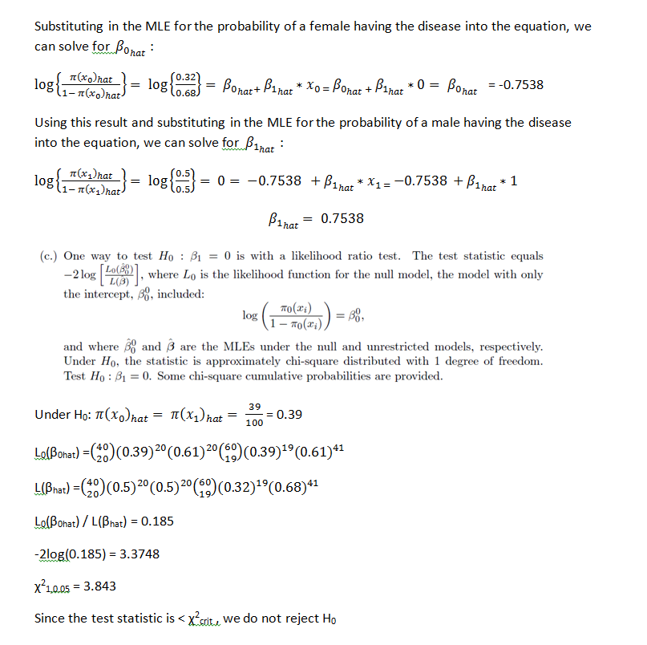

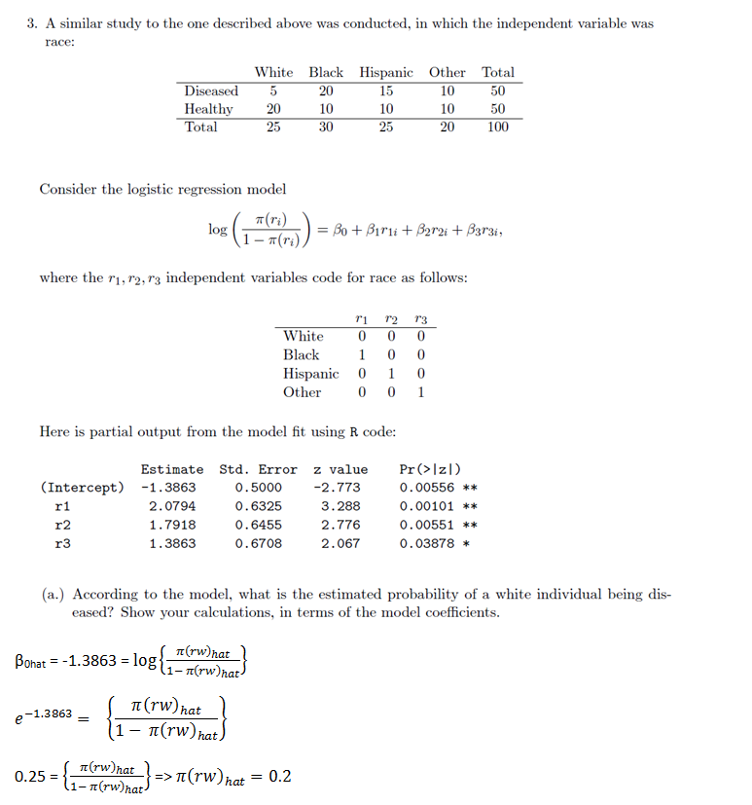

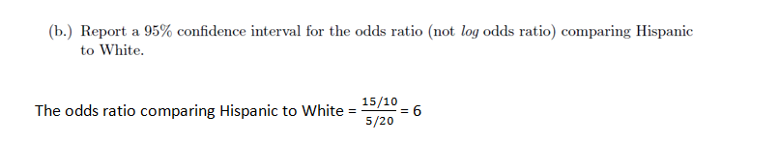
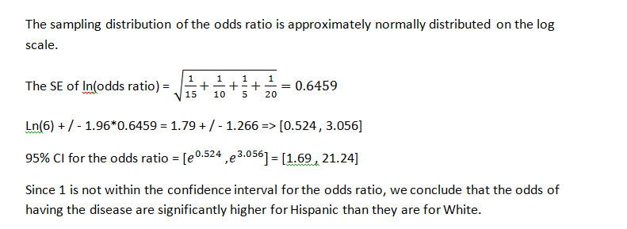

Question IV (Chris Shannon - 7/29/2015)

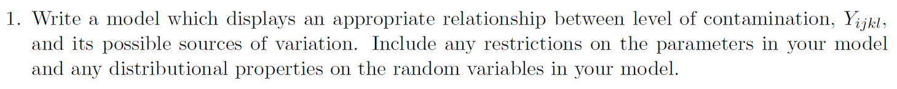

Term | Definition
 | General mean.
 | Fixed effect of i-th level of food.
 | Fixed effect of j-th level of method.
 | Fixed effect of ij-th level of food*method.
 | Random effect of kth-level of laboratory in method, distributed iid .
 | Random effect of ik-th-level of food*laboratory in method, distributed iid .
 | Random effect of experimental error.

C1 Normality:
The QQ-plot and histogram both suggest normality, with some slight left-skewing in the data set.

C2 Equal Variance:
The predicted vs. residuals plot seems random, which suggests equal variance condition is met. No patterns stand out that might indicate unequal variance.

C3 Independence:
Independence is guaranteed by the randomization design.

Source Variation | DF | E(MS)
Food | (3-1) = 2
Method | (4-1) = 3
Food*Method | (3-1)(4-1) = 6
Lab/Method | 4(5-1) = 16
Food*Lab/Method | 4(3-1)(5-1) = 32
Error | 3*4*5(2-1) = 60

degree of freedom of Lab(Method)=4(5-1) = 16 Jingjing Liu 8/6/15
Whoops, yes. Corrected. Leaving it red. Thanx! Chris Shannon 8/7/15
(Rule-Table for constructing E(MS) - not asked for on exam - see O Kuehl, Ch 7.6, page 255 - 258)

 |  | F | F | R | R
 |  | 3 | 4 | 5 | 2
sv name | sv | i | j | k | l
Food |  | 0 | 4 | 5 | 2
Method |  | 3 | 0 | 5 | 2
F*M |  | 1 | 1 | 5 | 2
Lab/M |  | 3 | 1 | 1 | 2
F*L/M |  | 1 | 1 | 1 | 2
Error |  | 1 | 1 | 1 | 1

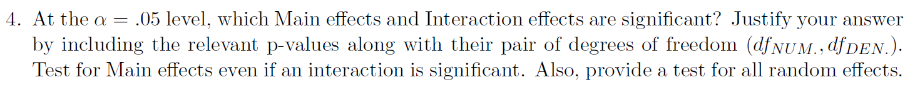

Effect | Hypothesis | Rule | Test statistic | p-value
Food |  | If F₀ > F(0.95, 2,60) then reject H₀ | 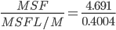 | 0.0002
Method |  | If F₀ > F(0.95, 3,60) then reject H₀ | 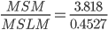 | 0.0014
Food * Method |  | If F₀ > F(0.95, 6,60) then reject H₀ | 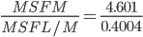 | < 0.0001
Lab/Method |  | If F₀ > F(0.95, 16,60) then reject H₀ | 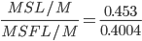 | 0.3705
Food*Lab/Method |  | If F₀ > F(0.95, 32,60) then reject H₀ | 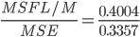 | 0.2734
I believe these denominator df’s should be 32, 16, 32, 32, 60 from top to bottom. -D.Bartkowiak 8/15/2015
Since the interaction between Method * Food is significant, I think we should group the Method at each level of Food.
My answer: for Meat, Group 1: {M1, M3}, {M2, M3}, {M2,M4}
for Fruit: Group 1 {M1,M2, M3, M4}
for VEG: Group 1: {M3,M4}, {M4,M2,M1} Jingjing Liu 8/6/2015
Jingjing, I think your answer would also be accepted. But the way I read the question is that they are asking us to compare the marginal means of Method, which is essentially telling us that we are not interested (for the purposes of the question) in the conditional means. Anyone else have an opinion about this? - Chris Shannon 8/7/15
Further update: I agree with your answer now. Found this in lecture 30 from Dr. Longnecker:
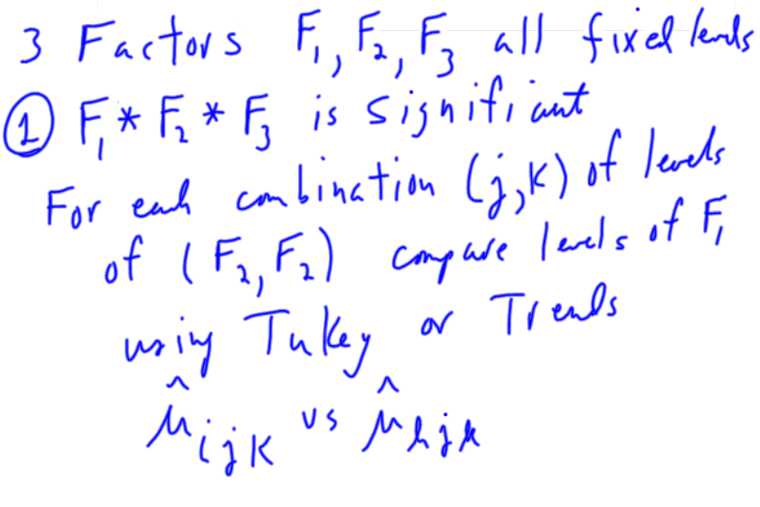
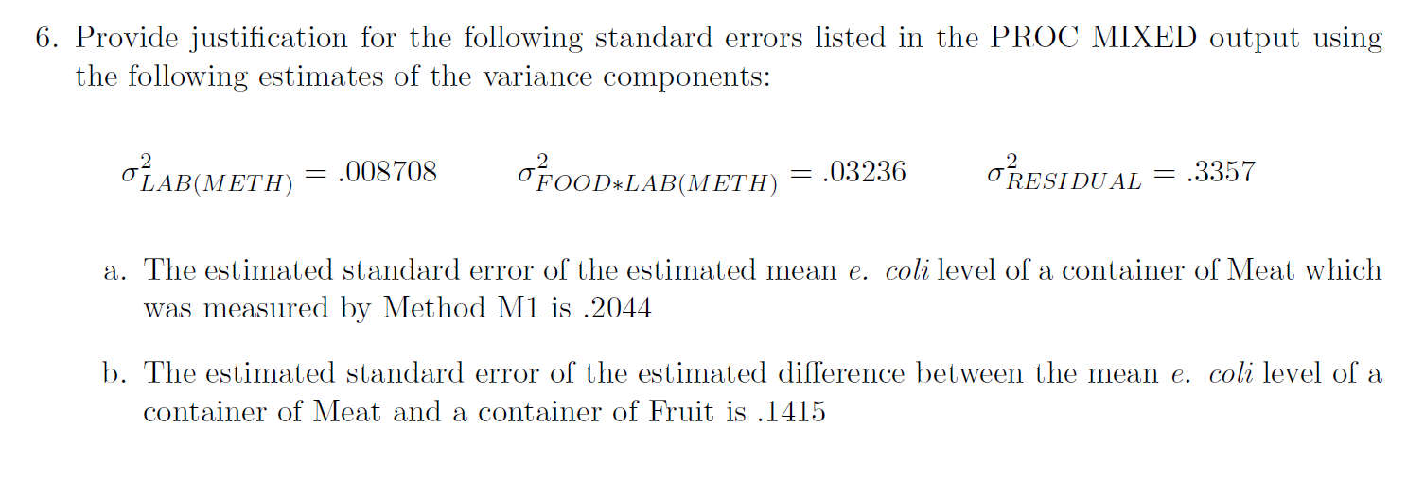
- 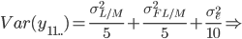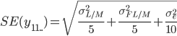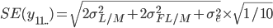

Take the estimate (13.0870), standard error (0.2044), and degrees of freedom (47.8) from the SAS LS Means printout:

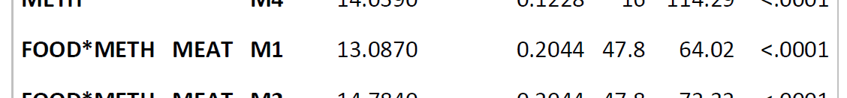

And then calculate the confidence interval. To calculate the t-value from the chart for 48 degrees freedom, take t(0.975, 40) - t(0.975,60) = 2.021 - 2.000 = 0.021, multiply this by the proportion of the difference between 40 and 60 degrees of freedom that constitutes 48 degrees freedom, and then subtract from t(0.975,40) =>

So,

2014 Jan

Problem I

Part A
1. Type of Randomization
RCBD with split-split-plot design I think it’s actually CRD with split-split-plot. If Field were a blocking factor, it would have to be included as a source of variation in the ANOVA table, but there aren’t enough total df to include it. Also, in a complete block design each block would receive every treatment, which doesn’t happen here because of each field only gets one variety of wheat; if anything, it would be a BIBD, but it doesn’t meet all of the criteria. (Kate Mullan 8/10/15)

Kate makes a great point about this. I think it is a CRD as well. It just seems that many times field is used as a blocking factor that it is easy to jump to that conclusion. -Oscar Pena 8/10/15

2. Type of Treatment Structure
Varieties (2) * Treatments (3) * Amount (2) crossed factorial structure
3. Identify each of the factors as being Fixed or Random
Fields-random, blocking factor
Varieties-Fixed
Treatments-Fixed
Amount-Fixed
I think field should be nested within variety, Field(variety). Jingjing 8/14/2015
4. Describe the Experimental Units and Measurement Units.
EU for Varieties is Field; EU for Treatment is tract; EU for Amount is half of tract.
MU is half of tract
5. Describe the Measurement Process: Response Variable, Covariates, SubSampling, Repeated Measures.
Response Variable is yield of wheat. No Covariates, No SubSampling, No Repeated Measures.
6. An ANOVA Table with just the following information: Sources of Variation and Degrees of Freedom.
Sources of Variation | Degrees of Freedom`
Varieties | 2-1=1
Treatments | 3-1=2
Amount | 2-1=1
Varieties*Treatments | 1*2=2
Varieties*Amount | 1*2=2
Treatments*Amount | 2*1=1
Varieties*Treatments*Amount | 1*2*1=2
Error | 2*3*2=12

I also have error for each split - see page 480 in Kuehl text
error1 df=(r-1)(a)=(4-1)(2)=6
error2 df=(a)(r-1)(b-1)=12
error3 df=(ab)(r-1)(c-1)=18
total df=n-1=47
GabrielleG 080915
I got the same answer as Gabrielle, Jingjing 08/14/15

I’m having trouble matching the terms “Varieties”, “Treatments” and “Amounts” to the actual problem. Could someone map these terms to the letters F I W and C as they are used in the problem? - Chris Shannon 8/17/15.

Are you looking at the Jan 2014 exam? I don’t see C being used. Hope this helps.
Fields are F1-F8
Varieties are given V1 and V2
Treatments - W1 W2 and W3
Amounts are denotes L and H
Oscar P 8/17/15

Here is a screenshot from my Jan 2014 exam (wraps to next page). It seems to be different - Chris Shannon:

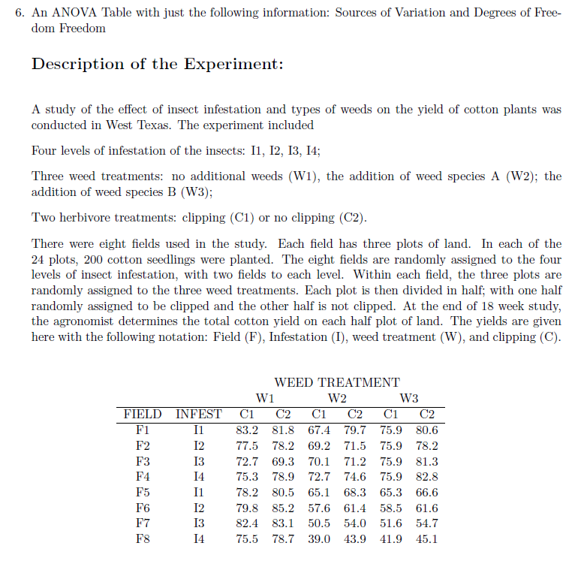
For anyone that thought the above experiment was a CRD Split-Split Plot Design, here is a version of the ANOVA table for that. As Kate mentioned in the above discussion, there are not enough df for the experiment to be an RBCD. You can see this if you incorporate the blocks as in page 17 of HO 12. In my opinion, it seems that the above table is the same one as I just posted indicating it’s in fact a CRD.-Oscar P. 8/19/2015

Source | Formula | DF
Variety (V) | a-1 | 1
Error(1) | a(r-1) | 6
Weed Treatment (W) | b-1 | 2
W*V | (a-1)(b-1) | 2
Error(2) | a(b-1)(r-1) | 12
Amount (Am) | c | 1
Am*V | (a-1)(c-1) | 1
Am*W | (b-1)(c-1) | 2
Am*W*V | (a-1)(b-1)(c-1) | 2
Error(3) | ab(c-1)(r-1) | 18
Total | n-1 | 47

Part B
1.C 2.P 3.M 4.P 5.S 6.I

I obtained the same responses for Part B -Oscar P. 8/10/15
I also got the same responses for Part B, which is good -- I was a little alarmed by the duplicate answer! --Sean 8/11/15

Problem II
1. β₀=1.15235, β₁=-2.62637, β₂=-0.55213, β₃=5.02318
2. Δy= β₁ when z=0
95% CI -2.62637±1.96*0.16003
3. β₁+ β₃ ???? => -2.62637 + 5.02318 = 2.39681 - Chris Shannon 8/16/2015
4. Adjusted R squared measures the power of the linear fitting which means how good the linear fit is. R-squared = Explained variation / Total variation
Simon Sheather in his book on Regression (page 137, in chapter 5), states that because adding irrelevant variables increases R², one should use R²_{adj} to compensate because RSS/(n-p-1) is an unbiased estimator of var(e_{i}) while SST/(n-1) is an unbiased estimator of var(Y_{i}) when b1 = b2 = … = bp = 0. - Chris Shannon 8/16/2015
5. H₀: β₀=β₁=β₂=β₃=0; H_{a}: at least one in β₀,β₁,β₂,β₃ is not equal to zero.
I think the F test on the bottom output should not include the intercepts, just the predictors.
H₀: β₁=β₂=β₃=0; H_{a}: at least one in β₁,β₂,β₃ is not equal to zero.
To get the degrees of freedom for the F test
df2 = n-p-1 = 250-3-1 = 246
df1 = 3 (# parameters that distinguish between Ho and Ha) Monica 8/15/2015
6. Equal variance assumption is not met???? The variance looks pretty good; the x vs. resids plot looks random and the z vs. resids boxes are about the same size. The first scatter supports linearity and the histogram suggests normality. I wasn’t sure about independence of errors--can we evaluate that using these plots?

I don’t think we can evaluate the independence of the errors with these plots. I think from the plots we don’t see any assumptions being violated. This is ok as the question states “If any”.- Oscar P. 8/10/15

I agree that none of the required assumptions (normality and equal variance) have not been violated. Might want to say there is not enough information to check independence. - Chris S. 8/16/2015

7. (0.5035)² ??? Leave it unsquared. The question asks for an estimate for sigma, not sigma squared. (Kate Mullan 8/10/15)

I believe part 1 for problem II requires a qualitative answer for each of the regression coefficients such as Bo is the mean response when x=0 and z=0. Part 2 looks fine to me. Part 3 should be correct as well. For part 4, should you also mention that the adjusted R-squared accounts for the number of predictor variables in the model as well? Part 5 looks fine. -Oscar P. 8/10/2015

Problem III
Part A
1. Xbar~N(20,5/4), Ybar~N(24,16/25)
2. W~N(-4,5/4+16/25); P(Xbar < Ybar )=ɸ(Ybar)- ɸ(Xbar)
3. 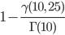
4. K=, m = 20

I just noticed that I had the wrong SDs for Xbar and Ybar. Nm I worked it out. Var(X-bar)=Var(X)/n=25/20=5/4, etc.
Isn’t the Std deviation of X-bar = sqrt(25/20) = 5/sqrt(20)? G Long 8/15/15

Hey G Long, yes that is the Std. Dev of X-bar, the notation however is usually N(mean, variance), that is why it is written as 5/4. -Oscar P. 8/15/15

Can you provide a reference on how you solved 3 and 4, or show some of your work? I had trouble with these.
GabrielleG 081015

For #3, I looked at the wikipedia page for chi square distribution.

Hey Gabrielle, here is a small explanation for problem 4.

An r.v. that has a t-distribution has the following form 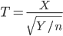 where X~N(0,1) and Y~ with n degrees of freedom. m=20 because that is the number of terms in the summation for U which corresponds to the chi-square portion of the t-distribution.

K can be found by first standardizing the numerator to be distributed N(0,1). Since 20 was subtracted from the mean, then it is already centered. Now you need to divide by the standard deviation of X-bar-20 which is sqrt(5/4) to finish standardizing it. U however is not distributed chi-squared as is. U is sum of all terms (X_{i}-X-bar)², and each X_{i}-X-bar must be distributed N(0,1). Since X~N(20, 25) while X-bar~N(20, 5/4) this tells us that X-Xbar ~ N(0, 25+5/4) so we must first divide X-Xbar by the appropropriate standard deviation in order to make it N(0,1). From this we have

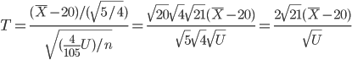 .
This gives a value for K of . l

Isn’t the SD of X-bar sqrt(5/4) for standardizing, the numerator of part 4 (X-bar - 20)? - DBartkowiak 08/10/15

David is right about that. I have corrected the whole thing. -Oscar P 8/10/15

For reference you can use Probability and Statistics by Evans and Rosenthal. The latter part of Ch. 4 has the forms for distributions like T, Chi-square, F and others.

-Oscar P 8/10/15

I got different answer for problem 2. P(xbar<ybar) = P[(xbar-ybar) <0]= P[W<0]=P[(W+4/sqrt(1.89)) < 0]= ɸ(2.9).
problem 3: var(xi-xbar) var(xi) + var(xbar), since xi and xbar are correlated. I used the trick to write xbar= xi/20 + 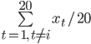 (the part that contains xi and the part that does not contain xi).
xi-xbar= xi - (xi/20)- ( ) = -
thus var(xi-xbar)= * var(xi) + *19*var(xi)= * 25 + *19*25=23.75

Then is distributed at N(0,1)
thus 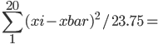U/23.75 is distributed at chisq(20).
thus P[U>50] = P[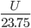> 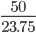] = P[> ] = 1- G(2.105), G is the cdf of chisq(20). Jingjing 08/14/15

Where did you get the idea to do this for problem 3? I just realized that what you are doing is just Var(Xi)- Var(X-bar) since (25 - 5/4) = 23.75 Oscar P -8/15/15

For 3., it just asked for an expression, so I did this: 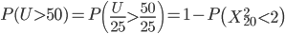 - Chris Shannon 8/16/15

That works just fine, I think the main question is whether they were treating X-bar in the U definition as an RV or a constant. If it is a constant then Chris’ approach is correct. It is also the simplest way to answer so it is probably the right approach. Oscar P.

I’m guessing that x-bar is a constant, since U is defined as sigma(1..20) (X-X-bar)^2. - Chris S.

Yeah, I agree with your approach. -Oscar P.

For question 4, I’m wondering if this is a trick question: (X-bar - 20) is zero. So K and m could be anything, couldn’t they? (I look forward to others views on this. I’ll hold my thoughts on x-bar as an r.v.) In retrospect, it’s probably best to say that you’re treating X-bar as an r.v. and then solve as everyone else has been doing. Chris Shannon 8/16/15

Question 4: I’m getting k = sqrt(20) and m = 19

Yes, k=sqrt(20). For X-bar as an r.v. for question 4, my first impulse was to put 19, but I think that is connected with the number of parameters we estimate for a model. I’m not entirely clear myself on this, but I am thinking 20 would be for m. 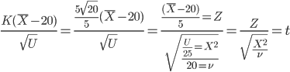- Chris Shannon 8/16/15

Here is my approach for finding K. It is a large image so hopefully it doesn’t mess up the document. Oscar P.
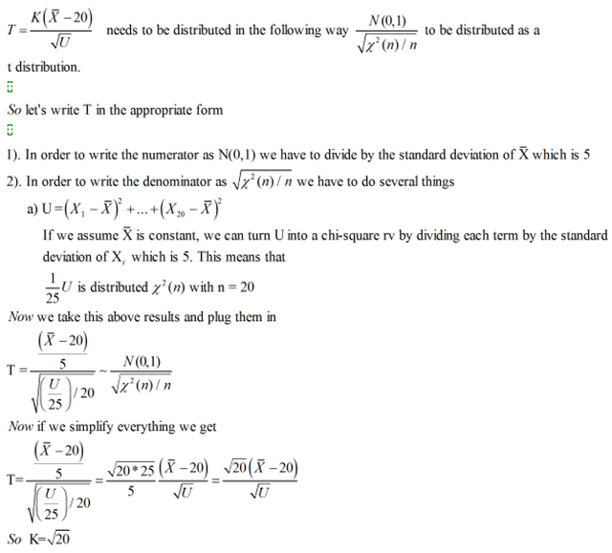
Great approach, Oscar! One thing I’m finding for myself that by trying to code these things in equations it helps me avoid the mistakes I make by trying to take shortcuts with paper and pencil. Now it’s just me forcing myself to be that methodical with a pencil. ;-) - Chris Shannon 8/16/15.

According to the rosenthal textbook, the degrees of freedom for the t-distribution is the same as that of the Chi-square distribution U, so m = 20. -Oscar P Thanks, looks like I need to review my 630 notes on this topic - Monica 8/16/15 Thanx Oscar! - Chris S.

Part B
- U~N(0, 61) and V~N(-8, 23)
- C1=⅙, C2=2, C3=¼, C4= -3, C5=2
- C1=⅔, C2=2, C3=2, C4= -3, C5=2, C6=C7=1

Question IV

- The expected value of Y is a linear combination of the betas; E(Y) is linearly related to the betas.
- Least squares criterion: Minimize the sum of squares of vertical distances between observed and predicted y-values. I.e., minimize RSS = 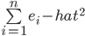 [not sure what formulas should be included]
- Gauss-Markov: assumption of normality not required for LSE’s of betas to be unbiased
- Assumption of normality not required (??? not sure about this)
- All assumptions must be true to conduct hypothesis tests. Or is normality not needed for large enough samples? (I’m looking at the flow chart on Sheather page 103, which suggests that normality is only needed for small n.)

***If anyone has a strong grasp/good resource on which assumptions are and are not necessary for certain tasks (calculating unbiased estimators, constructing confidence/prediction/tolerance intervals, conducting hypothesis tests), please let me know! katemullan1@gmail.com Thanks :)

For 2. I was going to use minimize RSS=sum(ei^2) = e’e = (y-xb)’(y-xb) = y’y-y’xb-b’x’y-b’x’xb =y’y-2y’xb-b’x’xb
dRSS/db = -2x’y+2x’xb → 2x’y=2x’xb → (x’x)^-1(x’y)=b-hat though I don’t know how necessary this is to show/derive. D.Bartkowiak 8/10/15

You’re probably right to include all of that.

Here is what I put for 3, 4 and 5: G Long 8/16/15
3) I had that the errors must have an expected value of zero for beta-hat to be unbiased. Therefore independence and homoskedasticity are not required, nor do they have to be normally distributed.
4) The constant variance assumption is also required for S to be an unbiased estimate of sigma-squared, normality is not required
5) All the assumptions are required. Although, I think you are correct about this not being required for large n

For (5), yes, residual normality not req’d when n is large for unbiased standard errors/F-tests. Residual normality is always req’d, regardless of sample size, for accurate prediction intervals, but that’s it. --Sean W., 8/17/15

January 2012
Started Chris Shannon - 8/10/2015

Question I
If the log-transformed observed values belong to a Weibull distribution, then a straight line will approximate the points in the plane given in the plot above according to the equation:

log(V_{i}) = 3.87 + 0.1099Q(u_{i})

Because the log-transformed Weibull distribution is a location-scale distribution, the intercept and slope of the line will approximate the transformed parameters of the log-Weibull distribution if the observed data is from a Weibull distribution.

From here onwards we solve for u_{i} to get the CDF to show that the regression intercept and slope are parameters from a Weibull distribution.

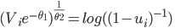
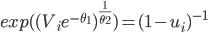
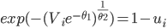
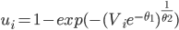
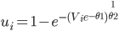
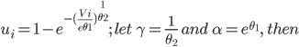

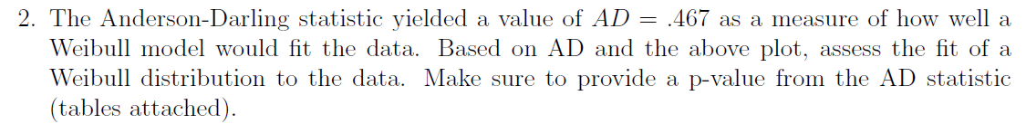
The above plot shows that the data is somewhat close to the straight line, and the Anderson-Darling statistics does not give any evidence of a deviation from the Weibull distribution. The test statistic is:

AD* = 0.467 < AD_{crit}= 2.492
p-value = P(0.467 < 2.492) = 0.2019 + [(0.467-0.45)/0.05] x (0.2532 - 0.2019) = 0.2193

I get p-value = 0.2193, no change to the conclusion though. -D.Bartkowiak 8/12/2015
Yes, error in punching in the numbers on the calculator. Thank you for catching it. I changed the answer from 0.2036 to 0.2193 - Chris Shannon 8/12/2015

I have a quick question about this. When calculating the p-value of the AD statistic don’t we need to use the modified AD measure since the parameters are originally unspecified? This will not change the conclusion and according to table 5 the p-value will be between .25 and .1. since the modified AD statistic is .487885. (I calculated a p-value of .24077 using the modified statistic and table 2) -Oscar P 8/16/15

I just assumed that since the AD statistic is given to us that we just use that. -- Chris Shannon 8/17/15

Thanks, I wonder if they will be nitpicky about things like that. -Oscar P. 8/17/15

Since the p-value of 0.2193 > 0.05, we conclude H0, that the observed values are from a Weibull distribution.

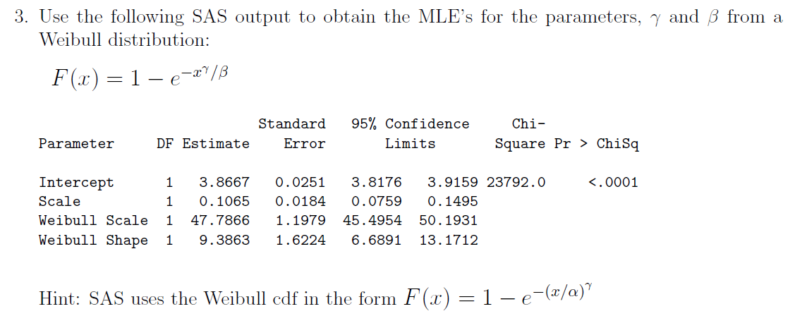

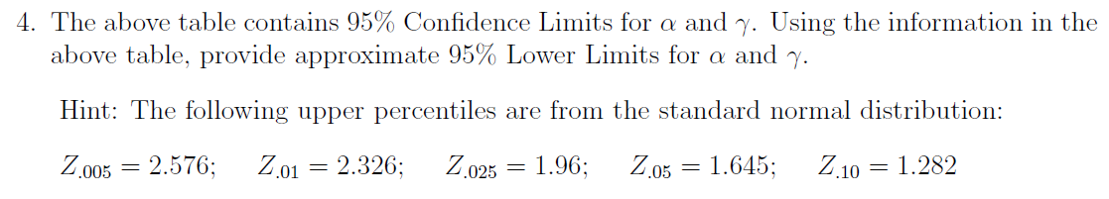

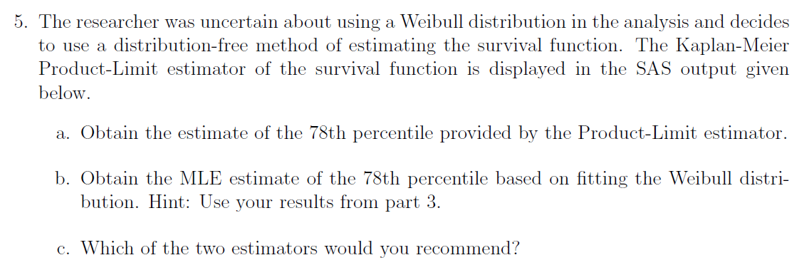
- 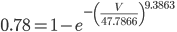; solve for V.
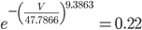
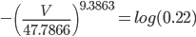
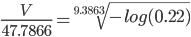
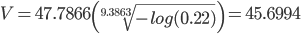

I think that you are taking the log base 10 when computing V, but you should be using the natural log since you are canceling the exponential in the Weibull. The result should be V=49.946. -Oscar. P 8/16/15
Yes, you are right. I’ve been using the log instead of the ln on my TI-83. - Chris Shannon 8/17/15

- I would recommend the Kaplan-Meier Product-Limit estimator, because it is based on the data, because the Weibull reference plot shows that the data only loosely fit a Weibull distribution, and because the difference between the two estimators given the range of the data is large.

Question II
1)

C₁ Normality | Yes, the condition is satisfied.  Shapiro-Wilk, Kolmogorov-Smirnov, Cramer von Mises, and Anderson-Darling test statistics all have p-values above 0.15 > 0.05 significance level. Additionally, the QQ Normal plot shows that the residuals closely fit a straight line.
C₂ Equal Variance | Yes, the condition is satisfied.  The Brown-Forsythe test for constant variance returns a test statistic of 0.50 with a p-value of 0.85, so we do not reject the null hypothesis of the variance being constant.
C₃ Independence | Yes, guaranteed by the randomization design.

2)

Source | df_{num} | df_{denom} | p-value
Q | 2 | 12 | < 0.0001
M*Q | 4 | 12 | < 0.0001
R(M) | 6 | 12 | 0.0016

3) (Copy-and-pasted from SAS printout included with exam.)

Do we need an actual number estimate? I see the covariance parameter estimate table which gives the variances for the first 3 terms, but what about the fourth term? -Oscar P. 8/17/2015

I don’t think so. Any other time they’ve asked for the E(MS) on an Anova question they only ask for that much. At least that’s my feeling. Could be wrong here. -- Chris 8/17/2015

4) Since there is a significant interaction between M and Q, we should separate the levels of Grade (Q) at each level of Method (M):

M1: {Q1,Q2}, {Q3}
M2: {Q1}, {Q2}, {Q3}
M3: {Q1}, {Q2,Q3}

What is the level of alpha_{pc} that we need to run the comparisons at? Is it just alpha/M where M is the number of comparisons or is it just alpha=.05 since we are using the adjusted Tukey values?
- Oscar P. 8/17/15

The problem says -- Chris Shannon 8/17/15
I think we shoud us pc=0.05/9=0.0056. Since we are comparing 3 pairs of Q at 3 levels of M, M=3*3=9

Well in this case since we are using the output from the Mixed procedure which already comes adjusted for Tukey, we should just use the alpha=.05. Ideally you would use the unadjusted p-value and compare to alpha/9. I am not sure if the P-values column before the adjusted column are the unadjusted values. If they are and you compare them to .05/9, you still get the same groupings. If anyone knows for a fact those are the unadjusted p-values let me know. -Oscar P. 8/19/15
5)
CI_{95%}=

6)
- SS Quality
- SS Quality X Manufacturer
- SS Run(Manufacturer)

Question III
1)
- Chi-squared with 5 degrees freedom, since a Chi-squared by definition is 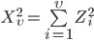
- Student’s t with 6 degrees of freedom, since 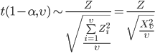
- F-distribution with 1 and 6 degrees of freedom, since F is a Chi-squared over a Chi-Squared.
- t-distribution with one df or Cauchy distribution.
- F-distribution with 2 and 3 degrees freedom.

2)
- E(U) = E(2X + 3Y - 5) = 2E(X) + 3E(Y) - E(5) = 2(2) + 3(-3) - 5 = 4 - 9 - 5 = -10
Var(U) = Var(2x + 3Y - 5) = 4Var(X) + 9Var(Y) = 4(8) + 9(5) = 77
U ~ N(-10,77)
E(V) = E(X - CY) = E(X) - CE(Y) = 2 - 3C
Var(V) = Var(X - CY) = Var(X) + C²Var(Y) = 8 + 5C²
V ~ N(2 + 3C, 8 + 5C²) Since E(Y) = -3, shouldn’t E(V) = 2 + 3C? --Sean W., 8/13/15 Yes, it should. Thanx for catching it! Changes made throughout problem. Chris Shannon 8/13/15
- U and V are by definition jointly normal:
Therefore if we show that the correlation of U and V = 0, then U and V are independent.
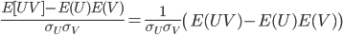
(If E(UV)-E(U)E(V) = 0, then we need not worry about )
since X and Y are independent
start reducing the E(X²) and E(Y²) terms
now we have E(UV) in terms of all known values
; and
So,
The value of C that makes U and V independent is 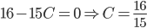

- Since , C_{1..4} must be chosen to make X and Y standard normal random variables.
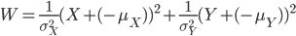
C₁ = ⅛, C₂ = -2, C₃ = ⅕, C₄ = 3, C₅ = 2
- 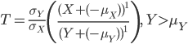, C₁ =, C₂ = -2, C₃ = 1, C₄ = 3, C₅ = 1, C₆ = 1
- 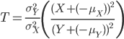, C₁ = ⅝, C₂ = -2, C₃ = 2, C₄ = 3, C₅ = 2, C₆ = 1, C₇ = 1

Question IV
1)
- It is not correct to test Y with a Shapiro-Wilk test because Y is a linear combination of fixed effects and the the residual error term, which is distributed as N(0,1). It is correct to test the residual error with Shapiro-Wilk.
- I_{nxn} is the identity matrix of dimensions nxn.
- There p+1 unknown parameters, which include β₀ for the intercept and β₁ … β_{p} for slopes of the predictors describing the relationship of X with Y.
- Would it make sense to replace Y with to arrive at
the result in part f? -D.Bartkowiak 8/13/15
Yeah, I think so. - Chris Shannon 8/13/15
- Yes, is an unbiased estimator of since

2) I’d disagree with this conclusion as R-Squared is not an indicator of model validity and is not invariant under transformation. If Model 2 is invalid (if it violates one of the assumptions for MLR) then it does not matter how much larger the value of R-Squared is compared to Model 1.
D.Bartkowiak 8/13/15
(Moving on to other things - will appreciate others’ insights into the answer on this one.) - Chris Shannon 8/12/15)
Jan. 2013 Exam Discussion

Problem I
- is the mean response for subjects when (i.e., for wild-type males with average consumption).
is the difference in means between wild-type males of average consumption and wild-type females of average consumption.
is the difference in means between wild-type males of average consumption and knockout males of average consumption.
is the increase in the mean of Y for each one-unit increase in food consumption from the average for wild-type males.
is the difference in the increase in the mean of Y for each one-unit increase in food consumption from the average for wild-type females and the same increase for wild-type males.
I think you have B1 and B2 backwards. I am also not sure of B4. B4 only comes into play for knockout gene females, but I am not sure how to describe this-Oscar P. 8/17/15

- Recall that . (Let’s call the resulting matrix V).
Thus,
Hence, .
Then, the CIs are given by
I got different answer using =, with v’=[0 1 0 0 -1]. However, my =
Then, the CIs are given by 0.8142 (-1.94, 3.57) Jingjing 081515
Ironically this was the answer I got originally, using -2Cov instead of +2Cov! (It should be -2Cov since one is subtracted from the other; your answer is right.) --Sean W. 8/16/15
Jingjing and Sean, I also got (-1.94,3.57). Since the interval includes 0, we have insufficient evidence of a genotype*gender effect, right? Gabrielle G 081615
- There is some evidence that the knockout treatment increases time spent exercising (by approximately 1 minutes, p < .05). Note, however, that variable selection methods produce questionable p-values. As such, this finding should be considered provisional until and unless the reduced model is successfully fitted to data from a new sample, ideally gathered under identical experimental conditions.

In the opening statement of the problem you are told that the F-test has shown that B1 and B4 are both 0. Shouldn’t this be enough to show that there is no effect due to the knockout gene? Usually when the interaction is significant you want to keep the variables that constitute the interaction, but in this case neither the effect nor the interaction are significant. -Oscar P. 8/17/15

I said there’s “some” evidence simply because the variable-selected model shows it as being significant, and it is apparently better-fitting than the interaction model. (Plus dropping interactions, significant or not, can change the interpretation of first-order coefficients). --Sean W., 8/17/15

One thing that we can also consider is that there might be multicollinearity in the data. It is strange that in the original model the knockout gene, gender, and interaction are all insignificant while the model is still significant. We are not told this, but it could very well be that a certain gender of mice was used more often for the knocking out of the gene thus causing the variables to be correlated and offer the same information to the model.
-Oscar P. 8/19/15
Problem II
- For a distribution X ~ Poisson(), E(X) = Var(X) = . Thus, 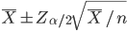 is effectively equivalent to the usual (distribution-free) confidence intervals. Additionally, because the sample size is relatively large, the distribution of sample means is approximately normal, so may be used.
(This actually does work reasonably well. R code follows:

i = NULL
m = NULL
n = 48
for(i in 1:10000){
m[i] = mean(rpois(n,2.04))}

xbar = mean(m)
se = sqrt(xbar/n)
z = qnorm(.975)
moe = se*z
lcl = xbar - moe
ucl = xbar + moe

(length(m[m<lcl])+length(m[m>ucl]))/10000

- No. Severe overdispersion is present. If this were Poisson distributed, the mean should be close to the variance, but the variance is over 4 times the size of the mean, so Poisson is a poor fit.
- Good fit to the specified distribution. However, in this case, , so we reject the null and conclude the data are a poor fit to the Poisson distribution.
- Residual variance looks nonconstant, which is fatal for prediction intervals regardless of sample size. (For completeness, we can also state that the variables (tornadoes, killer tornadoes) do not even appear to be linearly related, and on a minor note the R^2 is pretty low as well.) -Oscar P. 8/17/15

Problem III
- a)
b)
c)
- 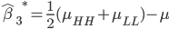
- a)
b)
c)

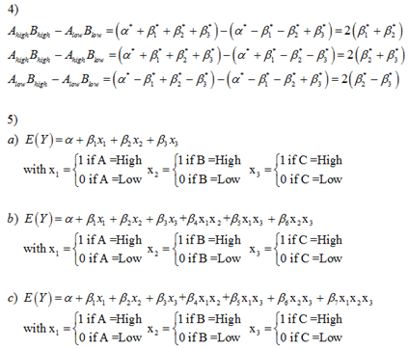
6) If anyone has thoughts on how to best answer this. -Oscar P 8/17/15
Here’s my guess -Kate Mullan 8/19/25

Question 4
- C1: The Shapiro Wilkes test yields a p-value of .8877. All other statistics KS, CvM, and AD point to a good fit for the normal distribution. QQplot looks good as well.
C2: BFL test has a p-value of .4948 meaning that we fail to reject the null hypothesis of equal variances.
C3: Trust that the design of the experiment yielded independent data? No indication of spatial or time correlation.
2) I had to modify the previous solution since the interpretation was different than what was asked.

Let be the lth observation within the ijkth treatment combination, be the fixed effect of the ith Type, be the fixed effect of the jth thickness, be the random effect of the kth machine within the ith machine type, and be an error which is iid N(0,) and independent of . Then, our model is
.

additional model assumptions: Greg L 7/15/15
distribution properties: (642 HO9, pg 5)
are idd N(0,)
are idd N(0,)
are idd N(0,)

3) So this question requires you to use the GLM procedure with the Tests for Mixed Model Analysis of Variance table. Don’t use the first table as this does not give appropriate F values for the tests since it uses MSerror as the denominator for all tests. With this in mind

Effect - all have p-value<.001 | DF | DF
Thickness | 2 | 12
Type*Thickness | 4 | 12
Mach(Type) | 6 | 12

4)
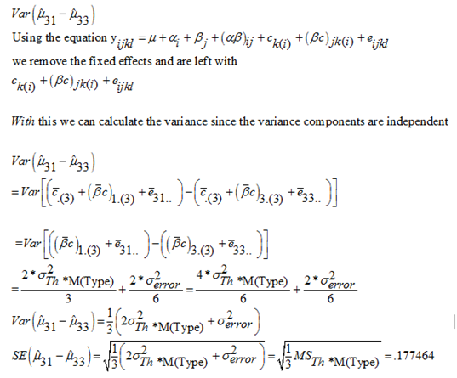
5) Since there is a significant interaction between Type of machine and Thickness, we need to compare the means for each type of machine separately for the different levels of the thickness.

.02 mm = {PCO, HO} , {CA}
.04 mm = {CA, HO, PCO }
.06 mm = {PCO, CA, HO}

***********************************CORRECTED ANSWER***********************************
using the output on page 9, and keeping alpha=.05 to use the adjusted Tukey table, I got the following groupings.
.02 mm = {HO} , {CA}, {PCO}
.04 mm = {HO, PCO} , {HO, CA}
.06 mm = {HO, PCO}, {CA}
************************************************************************************************
in the .06mm thickness group, I have {CA} and {PCO,HO} using alpha=.05/3=.017
GabrielleG 081815
I’m getting your grouping Gabrielle if I use the output on SAS page 9 but get the grouping of {PCO, CA, HO} if I use the output on SAS page 13. Not sure why it’s different. Monica 8/18/2015

I was using the output on page 13, but I just realized that those are measuring differences between the means. What we want to do is just group based on the means so the output on page 9 should be used. I will correct the groupings. According to lecture 21, at around minute 23, the ideal thing to do in this situation is to use unadjusted p-values and compare to alpha/M = .05 / ( (3choose2)*3). The (3choose2)*3 comes from the fact that we are comparing pairs of types
(HO,PCO) (HO,CA) (PCO,CA) separately at each level of thickness, so we have 9 comparisons. Unfortunately the Tukey adjustment is adjusting for (9choose2). I am not exactly sure what to use as the p-value for comparison since we only have the adjusted. I would assume that he wants us to use .05 even though it is meant for 36 comparisons and not 9. If anyone has any thoughts on this, jump in.-Oscar P. 8/18/15

Maybe it’s kinda like the back-transformation correction: We should acknowledge it, but not necessarily do it in this context. Like you said, we can’t--we don’t have the unadjusted values, but we can say “we should use unadjusted p-values and adjust alpha instead.” -Kate Mullan 8/19

You are probably right Kate. The only thing I am trying to figure out now is what is the proper output to use when making the comparisons. According to some of Dr. Longneckers lecture videos, he does use the Difference in means output like we are given on page 13.-Oscar P. 8/19/15

My thinking is that PROC GLM incorrectly calculates the differences in variances as well for mixed models; thus, we should be using the information from page 13 that was calculated using Proc Mixed - I could be remembering this incorrectly. -D.Bartkowiak 8/19/2015 (PS: Good luck everyone!!!)

Thanks David. I think you are right. I remember him saying that for mixed models we can’t trust GLM with the SE of the means either. -Oscar P. 8/19/2015

6)
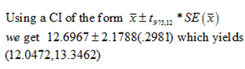
7) I am not sure what this question is going for. The best thing I can come up with is measuring the rigidity of the coil as a covariate. With this information, you can see how the rigidity of the coil affects its uniformity. Maybe the more rigid a coil is, it is harder to for the machines to get them uniform.

