SUMMARY REPORT
Lab 8: ASP.NET Core – Code First : Razor & MVC
1. Introduction
The purpose of this lab is to learn how to build ASP.NET Core Web Applications using the Code First approach with Entity Framework Core.
In this lab, two different ASP.NET Core architectures were implemented:
- ASP.NET Core Razor Pages
- ASP.NET Core MVC
The exercises help students understand how to:
+ Create web applications using Visual Studio
+ Define database schemas using C# models
+ Configure database connections
+ Perform migrations using Entity Framework Core
+ Test applications
+ Upload projects to GitHub

2. Exercises lab 8
Exercise 1: ASP.NET Core Web Application with Razor Pages
Description
In this exercise, I created a School Management web application using ASP.NET Core Razor Pages and applied the Code First approach to generate the database from C# classes.
What I Did
B1: Created a new Razor Pages project
B2: Installed Entity Framework Core packages
B3: Modified navigation menu
B4: Created data models
B5: Configured DbContext
B6: Connected SQL Server database
B7: Created migration and database
B8: Ran and tested the application
What I Learned
Through Exercise 1, I learned the basic structure of an ASP.NET Core Razor Pages application and how its page-based architecture organizes both the interface and logic in a simple and clear way. This helped me understand how Razor Pages supports fast development for CRUD applications.
I also learned the Code First workflow, where the database schema is created automatically from C# model classes instead of being manually designed. This makes development more efficient and keeps the application models consistent with the database.
In addition, I gained knowledge about entity relationships by defining connections between models such as Department, Course, and Student using navigation properties and foreign keys.
Finally, I practiced the database migration process, including creating migrations and updating the database using Entity Framework Core commands, which allowed the application to generate and synchronize the database structure successfully.

Step 1 — Create Project in Visual Studio
Visual Studio → Create New Project (Razor Pages selected)
Step 2 — Install Entity Framework Packages
Manage NuGet Packages
=> Microsoft.EntityFrameworkCore.SqlServer
=> Microsoft.EntityFrameworkCore.Tools
Step 3 — Modify _Layout.cshtml
Pages/Shared/_Layout.cshtml
menu Students, Courses, Instructors…
Step 4 — Create Data Models
folder: Models/
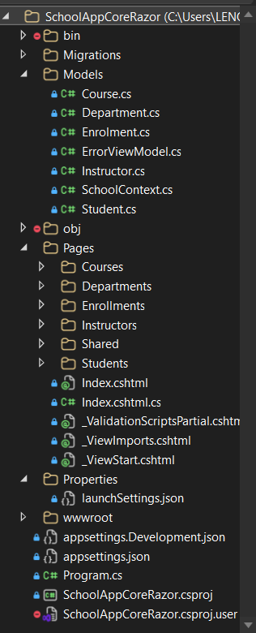
+ Department.cs + Course.cs + Instructor.cs + Student.cs + Enrollment.cs
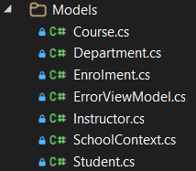
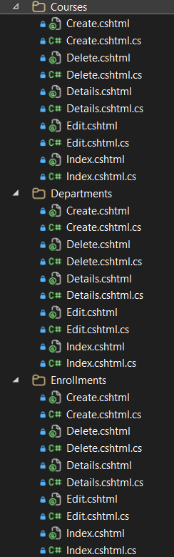
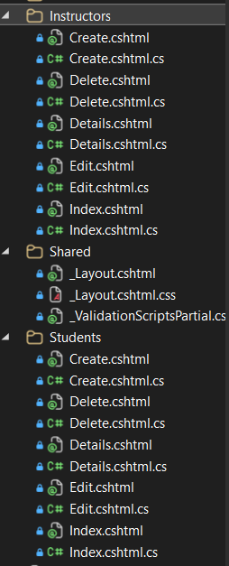
Step 5 — Create DbContext
Models/SchoolContext.cs
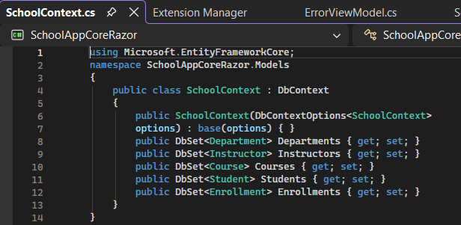
Step 6 — Configure Database Connection
- appsettings.json
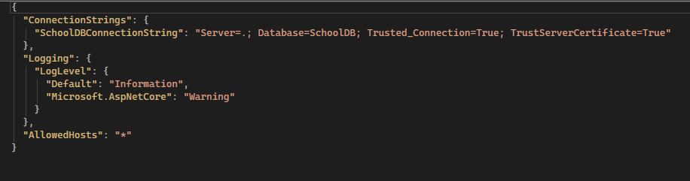
- Program.cs
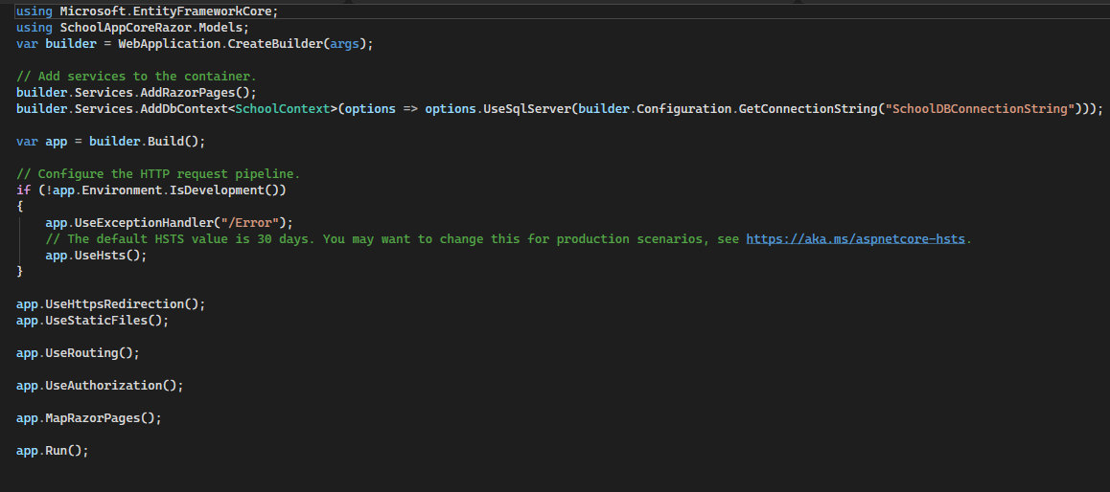
Step 7 — Migration & Update Database
Commands:
Add-Migration InitialCreate
Update-Database
In this step, I created and applied the initial database migration using Entity Framework Core. The commands Add-Migration InitialCreate and Update-Database were executed in the Package Manager Console to generate and update the database based on the defined models.

Step 8 — Run Application (F5 Output)
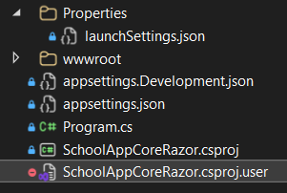
Browser running app
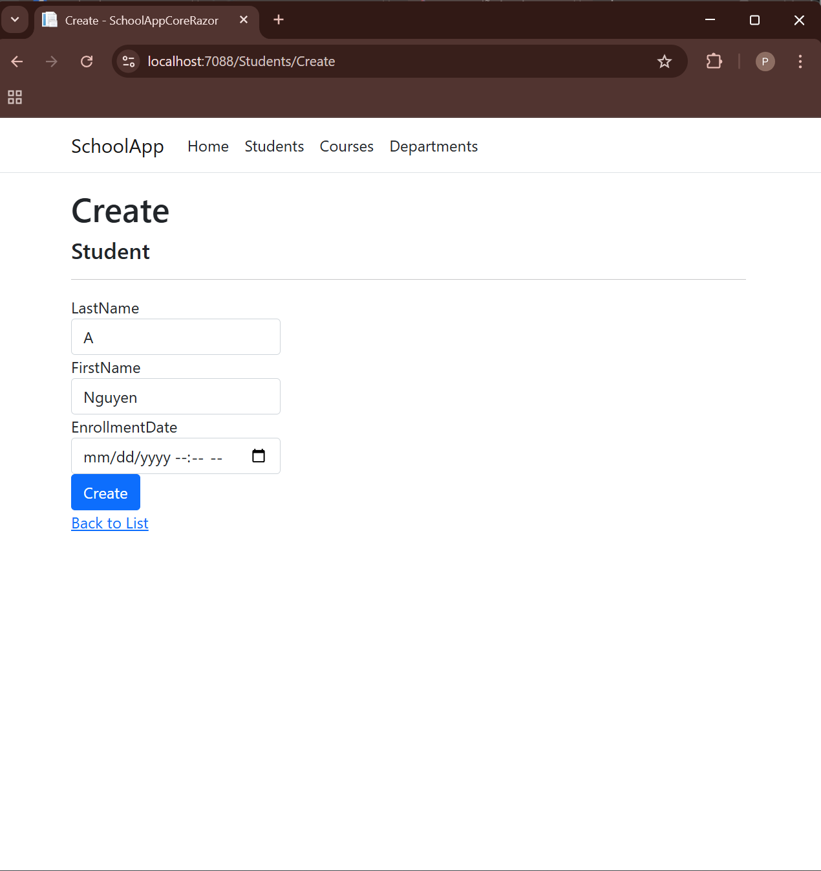
Exercise 2: ASP.NET Core MVC Application
In this exercise, I developed the same School management application using the ASP.NET Core MVC architecture. The goal was to understand how MVC organizes application components into separate layers and manages data using the Code First approach.
What I Did:
- Created a new ASP.NET Core MVC project in Visual Studio.
- Added data models and configured the DbContext class.
- Generated Controllers and Views using Entity Framework scaffolding.
- Configured the database connection and applied migrations.
- Ran and tested the application to verify CRUD functionalities.
What I Learned:
+ The overall structure of the MVC architecture.
+ The separation of responsibilities between Model, View, and Controller components.
+ Key differences between Razor Pages and MVC in terms of structure and development approach.
Exercise Steps
Step 1 — Create MVC Project
A new ASP.NET Core Web Application was created using the MVC template in Visual Studio. The project structure including Controllers, Models, and Views folders was automatically generated.
Step 2 — Modify _Layout.cshtml
The navigation menu in Views/Shared/_Layout.cshtml was updated to include links for Students, Courses, Instructors, Enrollments, and Departments, allowing easier navigation between pages.
Step 3 — Models Creation
Data model classes such as Department, Course, Instructor, Student, and Enrollment were created inside the Models folder to define the database schema using the Code First approach.
Step 4 — DbContext
The SchoolContext class was implemented to manage database connections and represent entity sets using DbSet properties.
Step 5 — Database Configuration
The database connection string was configured in appsettings.json, and the DbContext service was registered in Program.cs to enable Entity Framework Core integration.
Step 6 — Controllers & Views
Controllers and Views were generated automatically using scaffolding with Entity Framework. This enabled CRUD operations for all entities within the application.
Step 7 — Run Application (F5)
The application was executed by pressing F5 in Visual Studio. The MVC web application ran successfully, and all pages displayed and interacted with database data correctly.

Exercise 3: Upload Projects to GitHub
Uploaded both Razor and MVC projects to GitHub repository.
=> Create Repository -> Push Code from Visual Studio -> Repository on GitHub
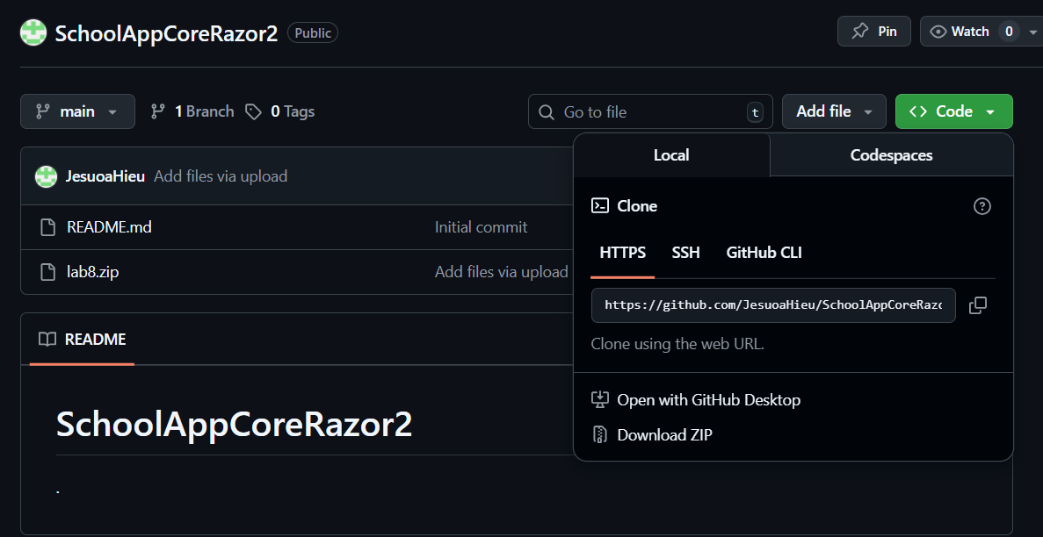
Link github:
https://github.com/JesuoaHieu/SchoolAppCoreRazor2.git
3. Conclusion
Through this lab, I gained practical experience in building ASP.NET Core applications using the Code First approach. I learned how Entity Framework Core automatically generates databases from C# classes and how Razor Pages and MVC differ in structure and usage.
One challenge I faced was configuring database migrations and ensuring the connection string worked correctly. However, after troubleshooting, I successfully deployed and ran both applications.
Overall, this lab improved my understanding of modern web development using ASP.NET Core and database integration.

