REPORT – WEB APPLICATION DEVELOPMENT

1. Student Information
Student1: Phạm Minh Trung
MSSV student1: 524H0133
Student2: Nguyễn Quang Phong
Student student2: 524H0120

2. Introduction
This report presents the development and implementation of a web-based Order Management System built using ASP.NET Core MVC. The project aims to provide a comprehensive understanding of how different components in the .NET ecosystem can be integrated to build a complete application, from desktop interface to web-based systems and testing.
Throughout the development process, the project is divided into several main parts, each focusing on a specific aspect of application development. These components include:
- GUI application developed using Windows Forms combined with RDLC to generate and display detailed reports
- Web application built with ASP.NET Core MVC to manage orders, items, and related data through full CRUD operations
- Authentication system that allows users to log in and access the system securely
- Unit testing using xUnit to verify the correctness and reliability of the implemented features
Each of these parts plays an important role in completing the overall system. The desktop application focuses on report generation and data visualization, while the web application provides a more flexible and scalable way to interact with the data. The authentication mechanism ensures that only authorized users can access the system, and unit testing helps improve code quality by detecting potential issues early in the development process.

3. Exercise 1 – Windows Forms + RDLC Report
3.1 Objective
The objective of this exercise is to develop a desktop application using Windows Forms and integrate RDLC reporting to display order data in a structured and visually organized format. This task focuses on understanding how to present data effectively through reports rather than simple raw outputs.

3.2 Implementation
In this exercise, a Windows Forms application was created as the foundation for building the reporting feature. The implementation process involves several important steps, starting from designing the data structure to configuring the report display.
The main tasks carried out include:
- Creating a WinForms project to build the graphical user interface
- Designing and defining the necessary database models, including Order, OrderDetail, and Item, to represent the data clearly
- Creating an RDLC report file to format and present the data in a professional layout
- Configuring the Dataset and integrating the ReportViewer control to connect the data source with the report
These steps ensure that the application is able to retrieve, process, and display data in a meaningful way.

3.3 Screenshot
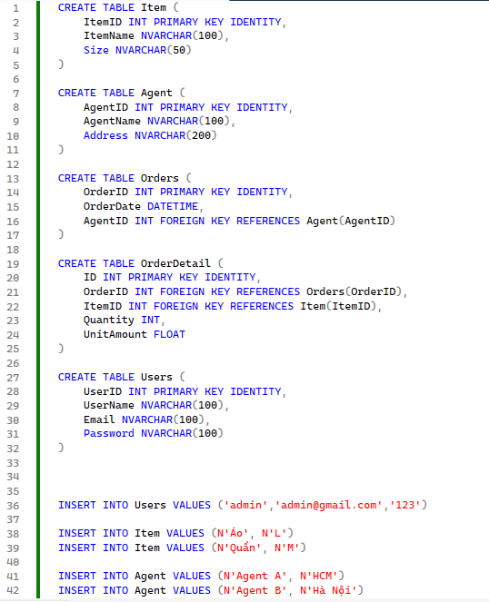
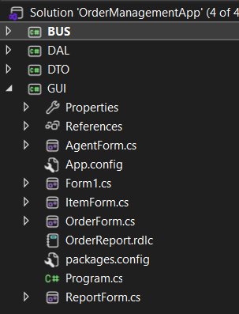
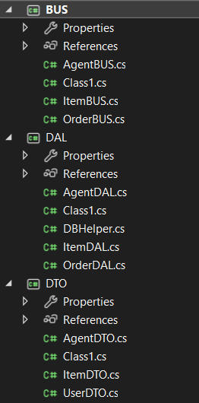
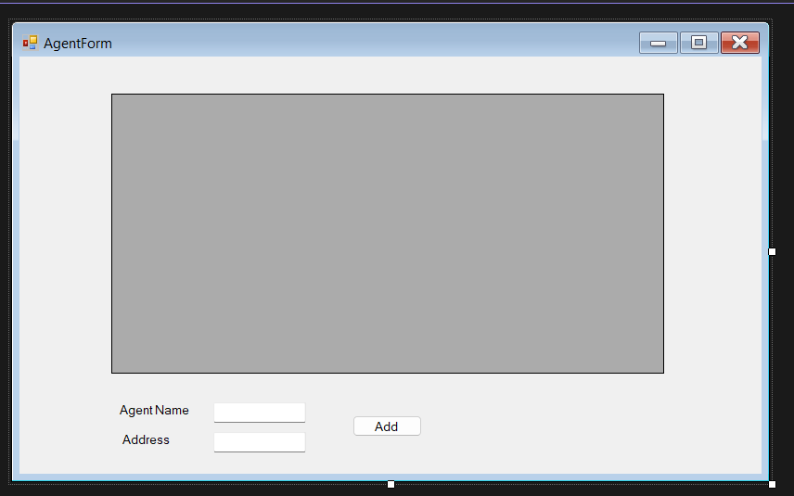
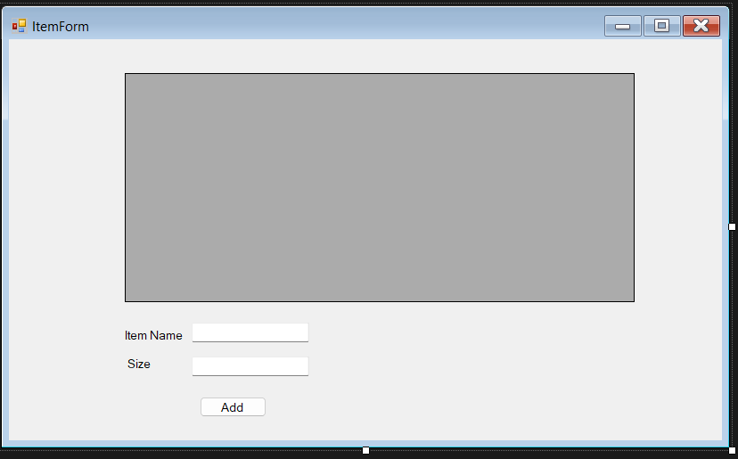
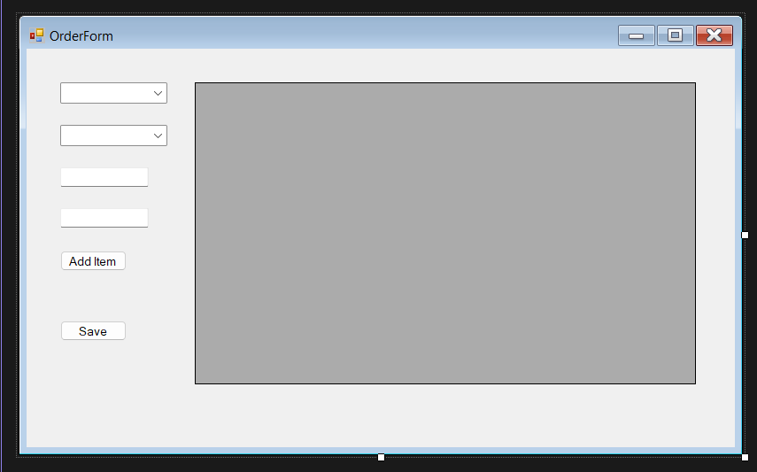
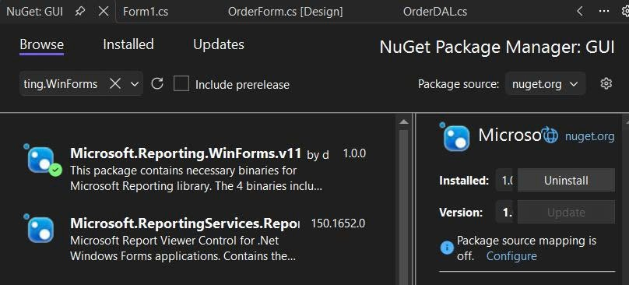
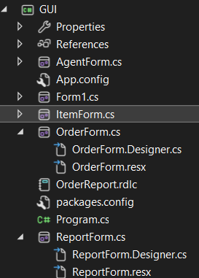
3.4 Result
The final application is able to successfully generate and display order reports using RDLC. The data is presented in a structured format, making it easier to read and analyze. This exercise demonstrates how reporting tools can enhance data visualization in desktop applications and provides a solid foundation for more advanced reporting features in future development.

4. Exercise 2 – ASP.NET Core MVC CRUD
4.1 Objective
The objective of this exercise is to build a web-based application using ASP.NET Core MVC that supports full CRUD (Create, Read, Update, Delete) operations. The system is designed to manage core entities in the application, including Orders, Items, and OrderDetails, allowing users to interact with the data through a web interface.
4.2 Implementation
In this exercise, the application is developed using the ASP.NET Core MVC framework, which follows the Model-View-Controller architecture to separate concerns and improve maintainability. The development process involves connecting the application to a database and generating the necessary components to handle user interactions.
The main implementation steps include:
  - Creating a new ASP.NET Core MVC project as the foundation of the web application
  - Using Entity Framework Core with the Database First approach to generate models directly from the existing database
  - Automatically generating model classes that represent database tables such as Orders, Items, and OrderDetails
  - Using the Scaffold feature to quickly create Controllers and Views for handling CRUD operations
The system includes the following main controllers:
+ OrdersController, which manages order-related operations
+ ItemsController, which handles item data
+ OrderDetailsController, which manages the relationship between orders and items
This structure allows the application to handle data efficiently while maintaining clear separation between logic and presentation.

4.3 Key Code
One of the key parts of this exercise is handling multiple items within a single order. The following code demonstrates how order details are created dynamically based on user input:
for (int i = 0; i < itemIds.Length; i++)
{
OrderDetail detail = new OrderDetail
{
OrderId = order.OrderId,
ItemId = itemIds[i],
Quantity = quantities[i],
UnitAmount = 0
};
_context.OrderDetails.Add(detail);
}
This loop iterates through the list of selected items and creates corresponding OrderDetail records. It ensures that each order can contain multiple items, which is an important requirement in real-world order management systems.

4.4 Result
The final system successfully supports full CRUD operations for all main entities. Users are able to create new orders, update existing data, delete records, and view detailed information through a web interface. Additionally, the system allows adding multiple items into a single order, demonstrating the correct handling of relationships between entities. This exercise highlights the effectiveness of ASP.NET Core MVC in building scalable and maintainable web applications.

5. Exercise 3 – Login System
5.1 Objective
The objective of this exercise is to implement a basic authentication system that allows users to log into the application securely. This feature ensures that only authorized users can access the system and its functionalities, which is an essential requirement for most real-world applications.

5.2 Implementation
In this exercise, a login mechanism is developed within the ASP.NET Core MVC application. The implementation focuses on handling user input, validating credentials, and controlling access to the system based on authentication results.
The main steps involved in this process include:
- Creating an AccountController to handle login-related actions
- Designing a Login View that allows users to enter their username and password
- Validating the entered credentials against data stored in the database
When a user submits the login form, the system checks whether the provided username and password match an existing account. Based on the result, the application either grants access or displays an error message.

5.3 Key Code
The following code demonstrates the core logic used to validate user login:
if (user != null)
{
return RedirectToAction("Index", "Orders");
}
else
{
ViewBag.Error = "Invalid login";
}
If the user exists in the database, the system redirects them to the main Orders page. Otherwise, an error message is displayed to inform the user that the login attempt has failed.
5.5 Result
The login system works correctly and allows users to access the application only when valid credentials are provided. This feature improves the security of the system and enhances user experience by ensuring that only authenticated users can interact with the application. It also serves as a foundation for more advanced authentication and authorization mechanisms in future development.

6. Exercise 4 – Session & Navigation
6.1 Objective
The objective of this exercise is to enhance the previously implemented login system by introducing session management and improving navigation within the application. This helps maintain the user’s login state and ensures a smoother and more secure user experience when interacting with different pages.

6.2 Implementation
In this part, the application is extended to manage user sessions after a successful login. Instead of requiring users to log in repeatedly, the system stores user information in a session, allowing the application to recognize authenticated users across multiple requests.
The main implementation steps include:
- Using Session to store important user information after login
- Redirecting users to appropriate pages once authentication is successful
- Protecting certain pages so that only logged-in users can access them
By applying session management, the system can track whether a user is logged in and restrict access to sensitive features accordingly. This approach improves both usability and security of the application.
6.3 Screenshot
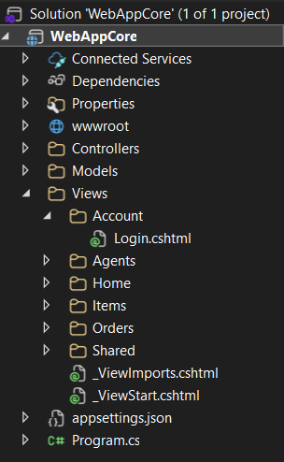
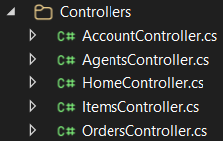
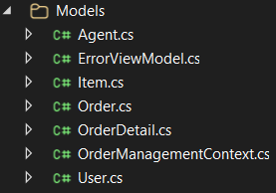
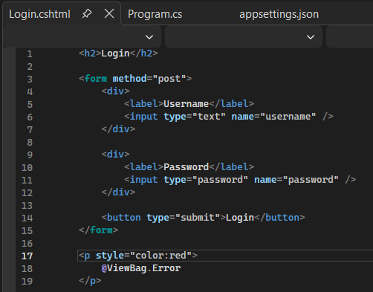
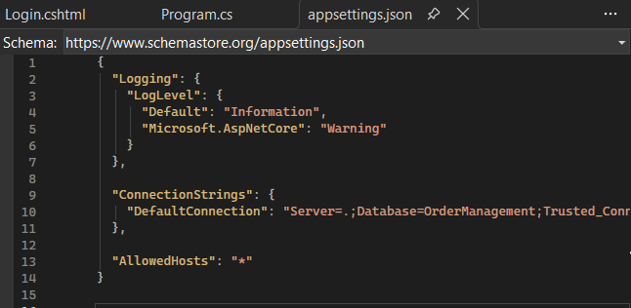
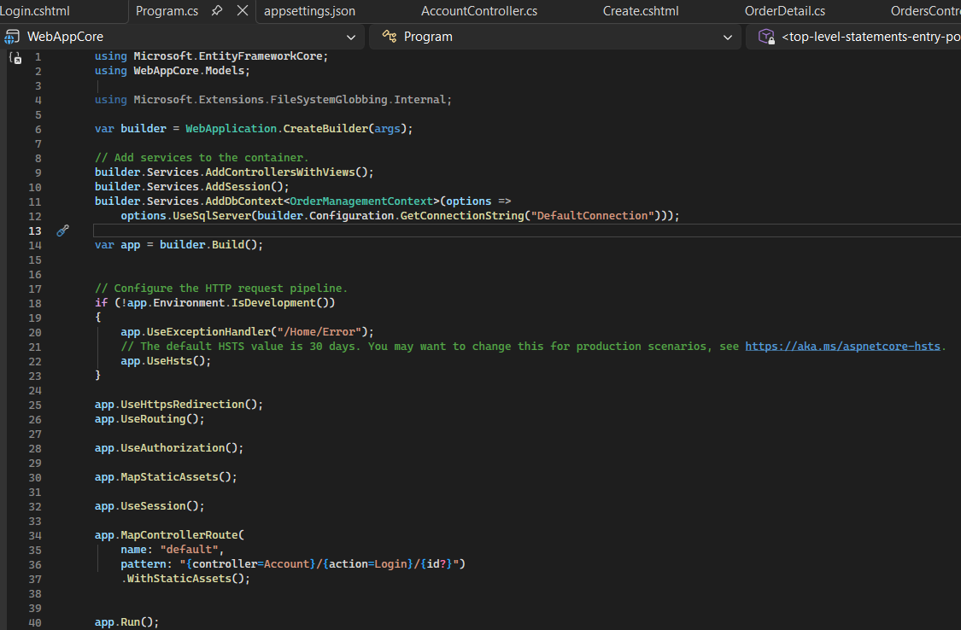
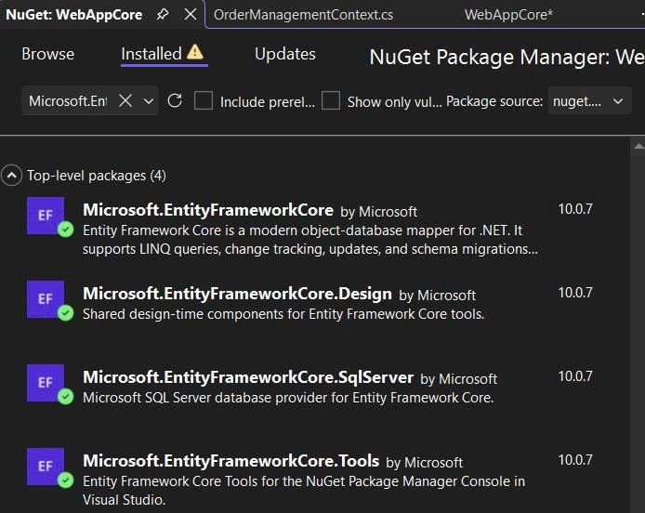
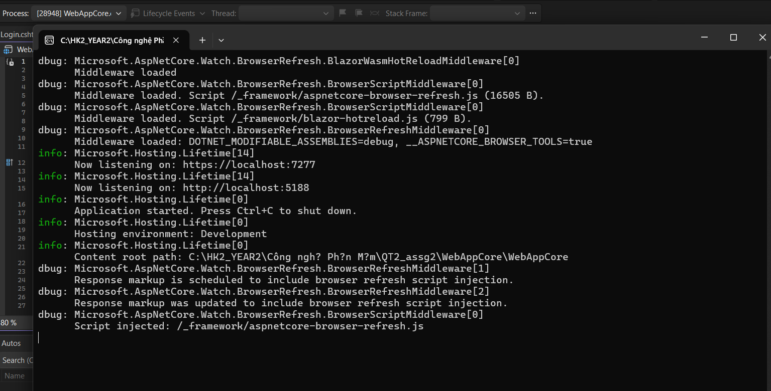
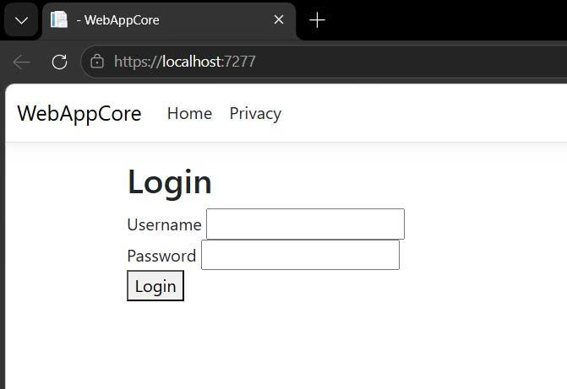
6.4 Result
The system is able to maintain the user’s login state throughout the session, allowing seamless navigation between pages without requiring repeated authentication. This enhancement significantly improves the overall user flow and provides a more realistic experience similar to modern web applications.

7. Exercise 5 – Unit Testing (xUnit)
7.1 Objective
The objective of this exercise is to validate the correctness and reliability of the application by implementing unit testing using the xUnit framework. This step ensures that important functionalities, such as login and data processing, work as expected and helps detect potential issues early in the development process.

7.2 Implementation
In this exercise, a separate test project is created to isolate testing logic from the main application. The goal is to simulate real scenarios and verify that the system behaves correctly under controlled conditions.
The main steps involved include:
- Creating a dedicated xUnit Test Project within the solution
- Adding a reference to the main project so that controllers and models can be accessed
- Using an InMemory Database provided by Entity Framework Core to simulate database operations without affecting real data
By using an in-memory database, the tests can run quickly and independently, making them efficient and safe for repeated execution.

7.3 TestHelper
To support testing, a helper class is created to initialize the database context using the InMemory provider:
public static OrderManagementContext GetDbContext()
{
var options = new DbContextOptionsBuilder<OrderManagementContext>()
.UseInMemoryDatabase(Guid.NewGuid().ToString())
.Options;
return new OrderManagementContext(options);
}
This approach ensures that each test uses a separate database instance, avoiding conflicts and ensuring consistent test results.

7.4 Test Case
A sample test case is implemented to verify the login functionality:
[Fact]
public void Login_Success()
{
var context = TestHelper.GetDbContext();
context.Agents.Add(new Agent
{
AgentId = 1,
AgentName = "admin",
Password = "123"
});
context.SaveChanges();
var controller = new AccountController(context);
var result = controller.Login("admin", "123");
Assert.NotNull(result);
}
This test simulates a valid login scenario by inserting test data into the in-memory database and verifying that the system returns a valid result when correct credentials are provided.

7.5 Screenshot
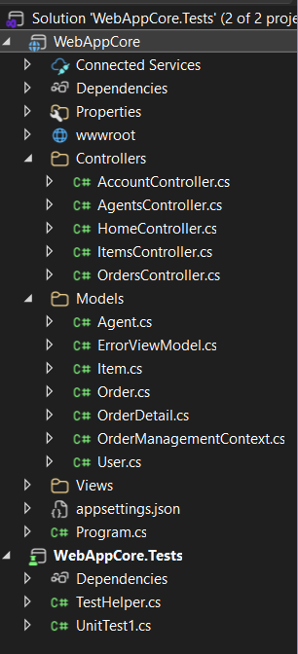
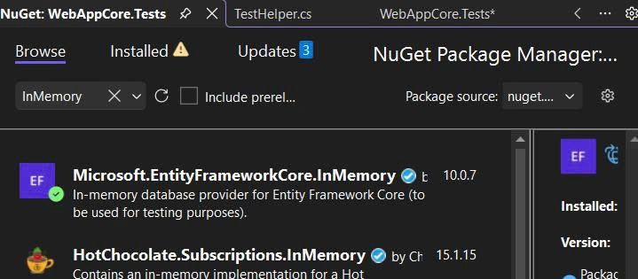
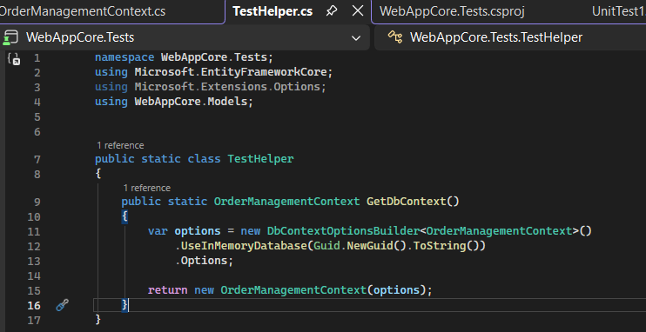
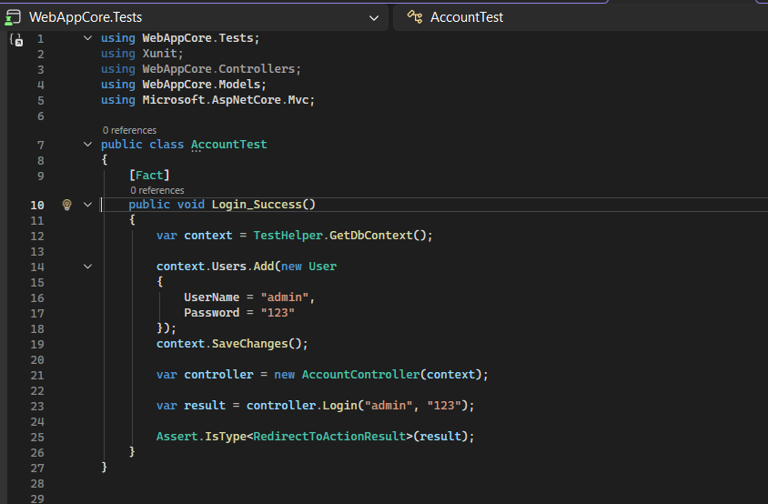
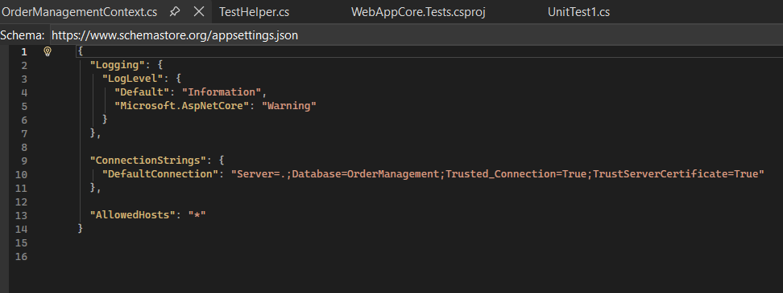
7.6 Result
All unit tests run successfully after resolving configuration issues related to the database context. The use of the InMemory database helps avoid conflicts between different database providers and ensures that the tests are isolated from the main application. This exercise demonstrates the importance of testing in improving code quality and reliability, as well as providing confidence that the application behaves as expected.

8. Challenges and Solutions
During the development of this project, several challenges were encountered across different stages. These issues required careful analysis and appropriate solutions to ensure the system functioned correctly.
One of the initial problems occurred when working with RDLC reports, where the Report Viewer was not properly installed or configured. This prevented the report from displaying as expected. The issue was resolved by installing the correct Report Viewer components and ensuring that the project referenced them properly.
Another major challenge involved conflicts in Entity Framework Core configuration. Specifically, multiple database providers were being registered at the same time, which caused runtime errors. This problem was fixed by adjusting the DbContext configuration and ensuring that only one database provider was used in each context, especially when switching between SQL Server and the InMemory database.
In the login functionality, errors occurred due to incorrect or missing data in the database. As a result, valid login attempts failed during testing. This was resolved by inserting correct sample data and verifying that the login logic matched the database structure.
Finally, unit testing initially failed due to issues with database configuration and dependency conflicts. The solution was to use the InMemory database for testing purposes, which isolated the test environment from the main application database and eliminated conflicts. This approach allowed tests to run successfully and consistently.
Overall, these challenges helped improve understanding of the development process and reinforced the importance of proper configuration, debugging, and testing in building reliable applications.

9. Conclusion
In conclusion, this project successfully demonstrates the development of a complete application using the .NET ecosystem, combining both desktop and web technologies. Through a series of exercises, the system was gradually built and improved, covering essential aspects of modern application development.
The project includes several key achievements, such as:
+ A desktop application using Windows Forms integrated with RDLC for reporting
+ A web-based application developed with ASP.NET Core MVC following the MVC architecture
+ An authentication system that allows users to log into the application securely
+ Unit testing implemented with xUnit to ensure the correctness and reliability of the system
Each component contributes to a better understanding of how different technologies can work together within a single project. The process of building, debugging, and improving the system also provides practical experience in handling real-world development challenges.
Overall, this project significantly enhances understanding of full-stack .NET development, including frontend interface design, backend logic processing, database interaction, and testing. It serves as a solid foundation for developing more complex and scalable applications in the future.

10. Contribution (LAST PAGE)
This project was developed collaboratively by two team members, with both participants actively contributing to all stages of development. The work was carried out in parallel, where tasks were divided evenly and implemented step by step to ensure consistency and efficiency.
Both members were involved in designing the system, implementing features, fixing errors, and testing the application. Instead of separating the work into isolated parts, the team followed a collaborative approach in which each feature was discussed and developed together, ensuring that both members fully understood the entire system.
The contributions are summarized as follows:
- Both members jointly developed the Windows Forms application and RDLC reporting in Exercise 1
- The ASP.NET Core MVC web application in Exercise 2 was implemented together, including models, controllers, views, and CRUD functionalities
- The login system and session handling in Exercises 3 and 4 were collaboratively designed and tested
- Unit testing in Exercise 5 was also performed together, including writing test cases and resolving configuration issues
Throughout the project, both members contributed equally in coding, debugging, and completing all required functionalities. This collaborative working style helped improve problem-solving skills, ensured better code quality, and allowed the team to complete the project effectively within the given time.

