Process to create Full Stack Assessments on the product

1. Go to The product-http://yaaksha.com/.Login through following credentials-
2. [User-system@iiht.com](mailto:User-system@iiht.com)
3. Password-1234
4. Company-IIHT
5. In an offline mode create a Project Specification document on lines of this-EMart.doc Once the document is created, share it with Operation team. They will upload the document on to the product file server and share the document URL.
6. As of now the product supports creating full stack assignments that doesn’t involve UI. Idea is to come up with a document that translates in to interfaces and telling the end user to code the implementation to these interfaces.
   * 1. Example-

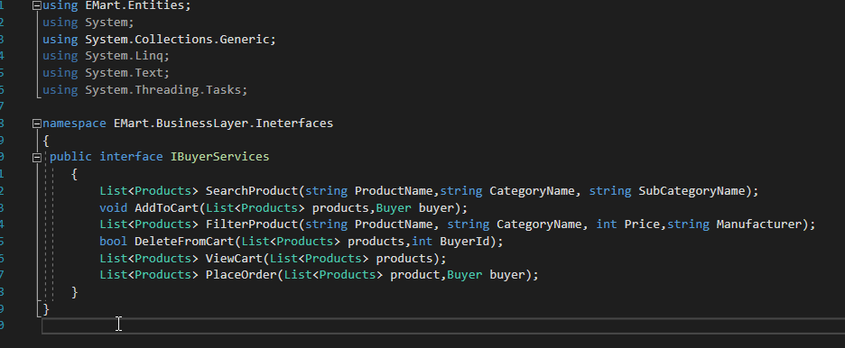

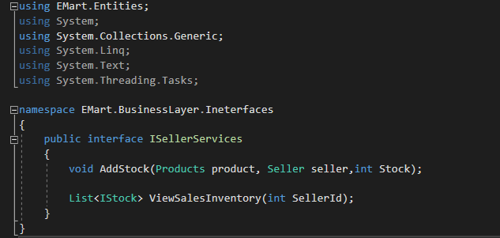

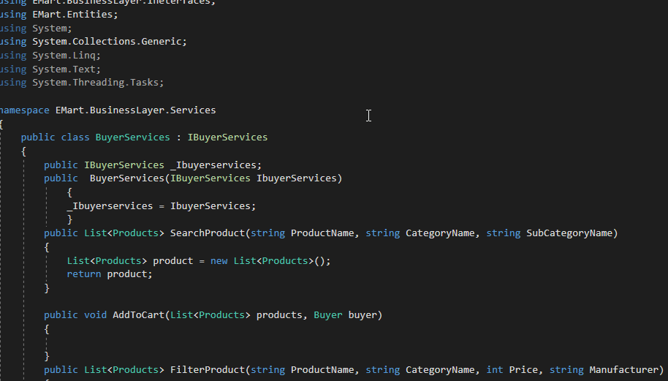

The business document talks of end user writing a program to search a product based on product name, category name and subcategory name.

1. Once the business document is written, we as Content creators, should come up with a template code base for the business specification document. The template code base should comprise of following-
2. Interfaces
3. Implementation classes with do nothing methods(to be updated by end user)
4. Test Cases with full implementation (End Users can’t edit the test cases as that area is read only)
5. Input files
6. Since the content writer also shares the input files, if any, as needed for the assignment, he need to share a file called Problem.txt with operations team that lists the mapping between test case and supposed expected output. E,g, below
   * 1. Testcase1=5
     2. Testcase1=1
     3. Testcase3=5

Above means there are 3 test cases in the assignment and the values are the expected output.

1. So imagine the end user completing and submitting the assignment will trigger an automation program to run the test cases again. Automation program will compare the results of test cases run with the values stored in the Problem.txt to figure out if test cases indeed succeeded.
2. The template code base created need to be exported into Github (Public repository) and the link be noted. Now the offline tasks needed to be created to support creating the product full stack assessment are done.
3. The template code base must have at their root location 2 files(if the assignment requires a database connect support)
4. NHibernate helper
5. NHibernate config

* Port=3306
* User=root
* Password=root

1. Use the same values in your NHibernate Helper file. For every new browser session ,port info will change and it is the end user responsibility to update the file. User/Password/Schema info will be provided to end user as a part of another document(not in scope) that can be downloaded from the exam window.