**Process to Create Full stack Assessments on the product**

1. Go to the Product -http://yaaksha.com/.Login through following credentials-

* [User-system@iiht.com](mailto:User-system@iiht.com)
* password- 1234
* Company-IIHT

1. In an offline mode create a project specification document on lines of this -i.e Stock Market Chart <http://165.22.223.25/file-server/assessment/docs/Java> REGEX JDBC V1.docx Once the document is created, share it with operation team.
2. As of now the product supports creating full stack assignments that doesn’t involve UI, Idea is to come up with a document that translate into interface and telling the end user to code the implementation to these interfaces.

Example-

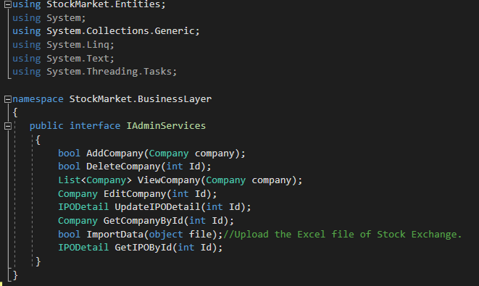

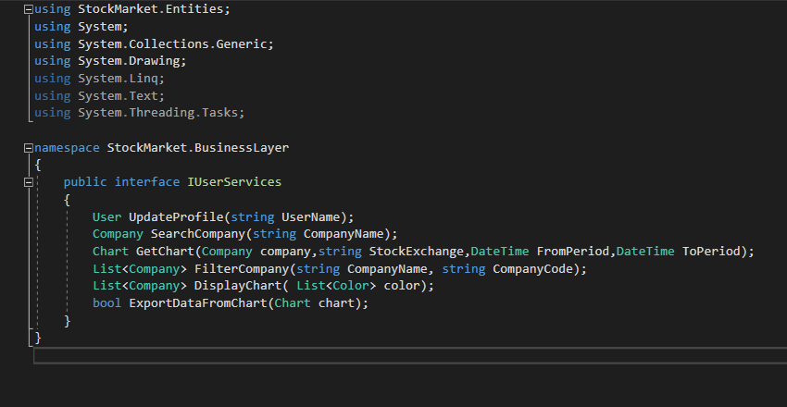

1. The business document talks of end user writing a program to Admin should have a permission to create , Delete, Update company and details should be saved in database.

The User should have have a permission to search company and view Stock charts of company.



1. Once the business documents is written, We, as Content creators, should come up with a template code base for the business specification document. The template code base should comprise of following-

* Interfaces
* Implementation classes with do nothing methods.
* Test Cases with full implementation
* Input Files

1. Since the content writer also shares the input files ,if any, as needed for the assignment ,he need to share a file called problem.txt with Operation team that lists the mapping between test case and supposed correct expected output.
2. The template code base created need to be exported into GitHub and the link to be noted. Now the Offline tasks needed to be created to support creating a product full stock assessment are done.
3. The template code base must have at their root location 2 files(if the assignment requires a database connect support)

a) NHibernate helper

b) NHibernate config

* Server= LocalServer
  + Port=3306

• User=root

• Password=root

1. Use the same values in your NHibernate Helper file. For every new browser session ,port info will change and it is the end user responsibility to update the file. User/Password/Schema info will be provided to end user as a part of another document(not in scope) that can be downloaded from the exam window.