**process to create Full Stack Assessments on The Product**

process to create Full Stack Assessments on The Product

1. Go to The Product-http://Yaaksha.com/.Login through following credentials-

a.User-system@iiht.com

b.password-1234

c.Company-IIHT

2.in an offline mode create a project Specification document on lines of this-

Emart.docx

once the document is created,share it with operations team.they will upload the document on to the product file server and share the document URL.

3.As of now The Products Supports creating fullStack assignments that does not involve UI.idea is to come Up with a document that translates into interfaces and telling the end user to code the implementation of these interfaces.

**example:**

**1.BuyerService**

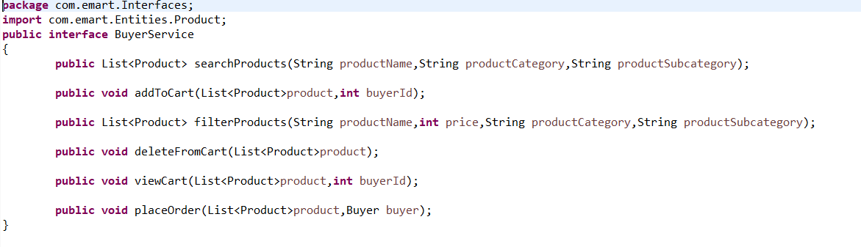

**2.LoginService**

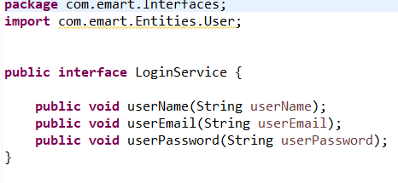

**3.SellerService**

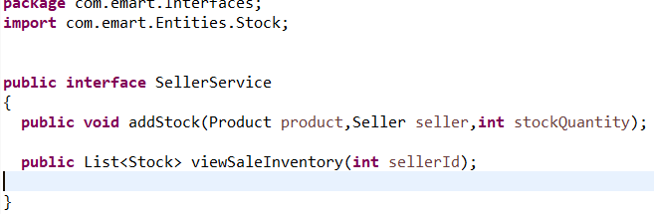

The business Document talks of end User writing a program to read an input file using REGEX to find out the count of no of occurences of a key word and save the count into database.

4.once the business document is written,we,as content creators,should come up with a template code base for the business specification document,The template code should compromise the following-

a.Interfaces

b.implementation classes with do nothing methods(to be updated by

end user)

c.Test Cases with Full implementation(End users cant edit that test cases as that area is read only)

d.Input files

5.since the Content Writer also Shares the input files,if any,as needed for the assignment(in this case the file with dummy text on which **REGEX** is applied),he need to share a file called problem.txt with Operations team that lists the mapping between test case and supposed correct Expected Output.Eg below

testcase1=5

testcase2=1

testcase3=5

Above means there are 3 test cases in the assignment and the values are the expected output.

So imagine the end user Completing and Submitting the assignment will trigger an automation Program running to run the test cases again.Automation Program will Compare the results of the test cases run with the values stored in the problem.txt to figure out if test cases indeed Succeeded.

6.The template Code base Created need too be exported int Github(Public repository)and the link be noted.now the offline tasks needed to be created to support creating a product the full stck assessment are done.

7.The template Code base must have at their root location 2 files(if the assignment requires a database Connect Support)

a.MySql(Database tables creation Script)

b.hibernateProperties(refer the hibernate config.xml).

User/Password/Schema info will be provided to end User as a part of another document(not in Scope)that can be downloaded from the exam Window.