Universidad Tecnológica de Durango
Tecnologías de la Información
Proyecto integrador I

LICENCIATURA EN INGENIERÍA EN TECNOLOGÍAS DE LA INFORMACIÓN E INNOVACIÓN DIGITAL
“Software para el Departamento de Psicopedagogía de la UTD”
Diciembre 2025

Authors
Students:
Barraza Torres Jesús Daniel
Teacher:
Raúl Iván Herrera González M.A.
Universidad tecnológica de Durango

Contact to:
jesus_3141240166@utd.edu.mx

Contenido
Authors 2
Propósitos 5
General 5
Específico 5
Actividades del reporte 6
Ejercicio 1 6
Ejercicio 2 7
Conclusiones 8
Bibliografía 9

Abstract
The Technological University of Durango has several departments beyond those related to educational materials, which provide services to students with the goal of helping them perform optimally in both their studies and overall well-being, allowing them to continue their academic projects successfully.
One of these departments is the Psych-pedagogy Department, which is responsible for maintaining students’ emotional well-being—particularly for those who have been reported for socio-emotional issues—with the purpose of ensuring their integrity in cooperation, teamwork, and other extracurricular activities organized by the institution.
However, the Psych-pedagogy Department experiences time inefficiencies due to the need to manually record and organize appointments and related notes, which significantly slows down their processes.
The goal of this project is to reduce this registration time by developing software that can be used by the department’s staff to streamline their operations and maintain optimal performance.

Resumen
La Universidad Tecnológica de Durango posee varios departamentos más allá de los de material educativo los cuales cumplen con la función de otorgar servicios a los estudiantes con el objetivo de que puedan rendir de manera óptima sus servicios tanto de estudio como de bienestar general para continuar con sus proyectos.
Uno de estos departamentos es el departamento de psicopedagogía, los cuales se encargan de mantener el bienestar emocional del estudiante (generalmente aplicado a los estudiantes los cuales han sido reportados por problemas a nivel socioemocional) con el fin de mantener la integridad del estudiante ante la cooperación, el trabajo y otras actividades extraescolares que emite la institución.
Sin embargo, el departamento de psicopedagogía posee una falla de tiempo al tener que estar registrando y diagramando las citas y notas de las mismas de manera manual, alentando mucho sus procesos.
El objetivo del proyecto es el de reducir este tiempo de registro utilizando un programa de software que pueda ser utilizado por los trabajadores de dicho departamento y así agilizar sus procesos para mantener un rendimiento ideal.

Introducción
At the Technological University of Durango, psychology departments were implemented with the objective of “Brindar atención a estudiantes con dificultades en sus actividades escolares, personales, familiares y sociales...” (Universidad Tecnológica de Durango, s.f., p. 8).
This support is essential because it allows individuals to face challenges using their emotional abilities. As stated by experts from La depresión: “La salud mental es un estado de bienestar emocional y mental...” (La depresión, s.f.).
Given the importance of mental health, psychological support must reach those who need it as quickly as possible. However, at the Universidad Tecnológica de Durango, there is a problem: the response capacity of the psychology department depends on whether appointments are correctly organized and recorded, which may lead to serious issues.The objective of this study is to determine whether the response time of psychological support affects the outcomes and to justify the need for faster psychopedagogical intervention. The findings may improve services in other institutions and support future research.

Marco teórico
Mental health in university environments is essential for students’ development and performance. “En el entorno universitario es común que se enfrenten a condiciones socioambientales que afectan su bienestar mental.” and “La personalidad y la influencia de variables bio-psico-socio-culturales y espirituales...” (Regalado Chamorro et al., 2023).
Stress within the university often generates psychological problems, and adequate measures are essential:“Atender a los jóvenes con depresión o ansiedad es crucial...” (Herrera & Rojas, 2025).

Metodología

Descripción del proceso seguido
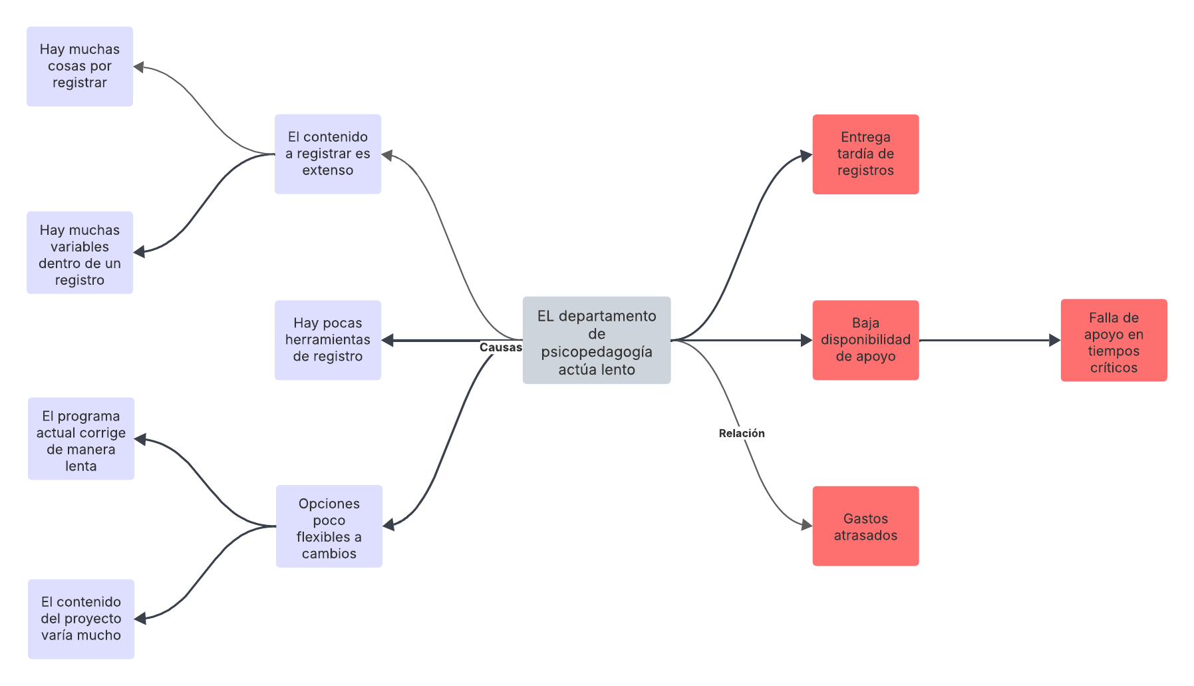
To develop the program, several planning methodologies were used. The first step was to identify the problems of the university’s local department, which led to the creation of a problem-tree diagram.
Figure 1. Tree diagram of the problem on the project's context.

After that, the direction of the program was defined using the CANVAS model, adapted to the specific context of the university.
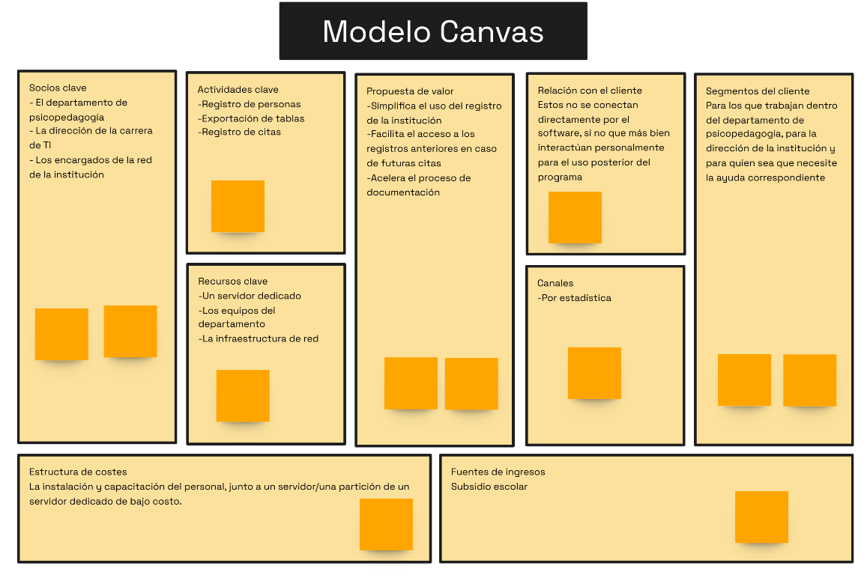
Figure 2. CANVAS preliminar model
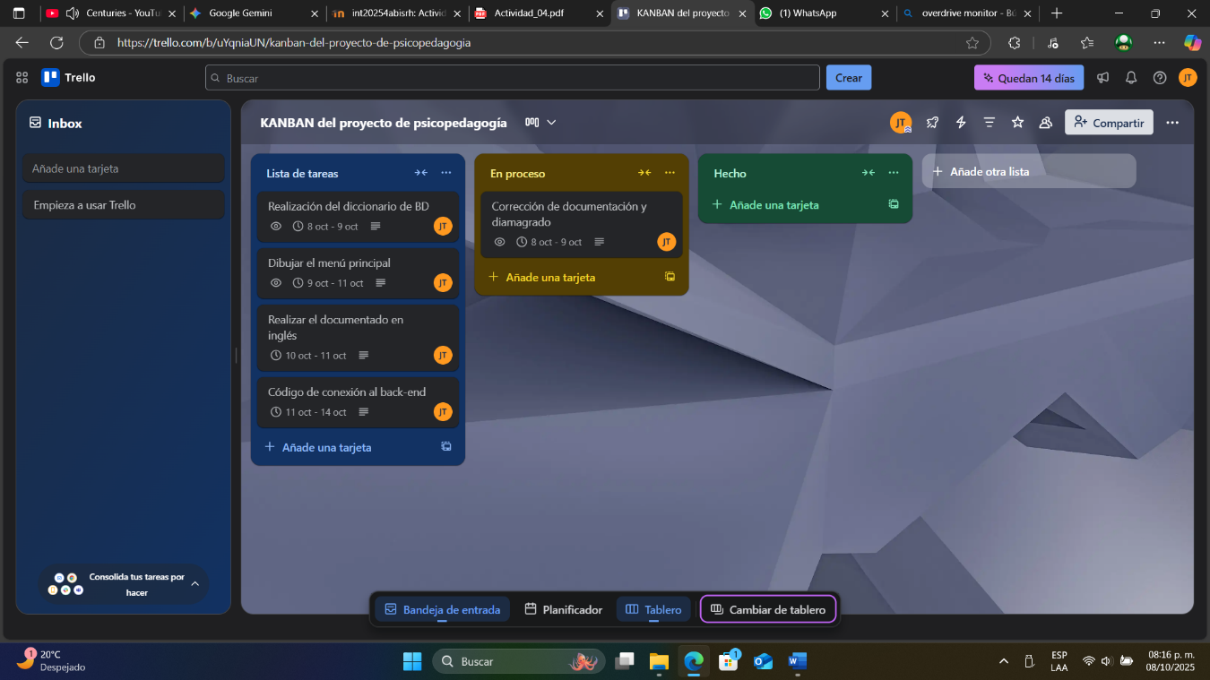
A KANBAN board was then created to maintain time organization throughout the project.
Figure 3. Day 1's KANBAN project

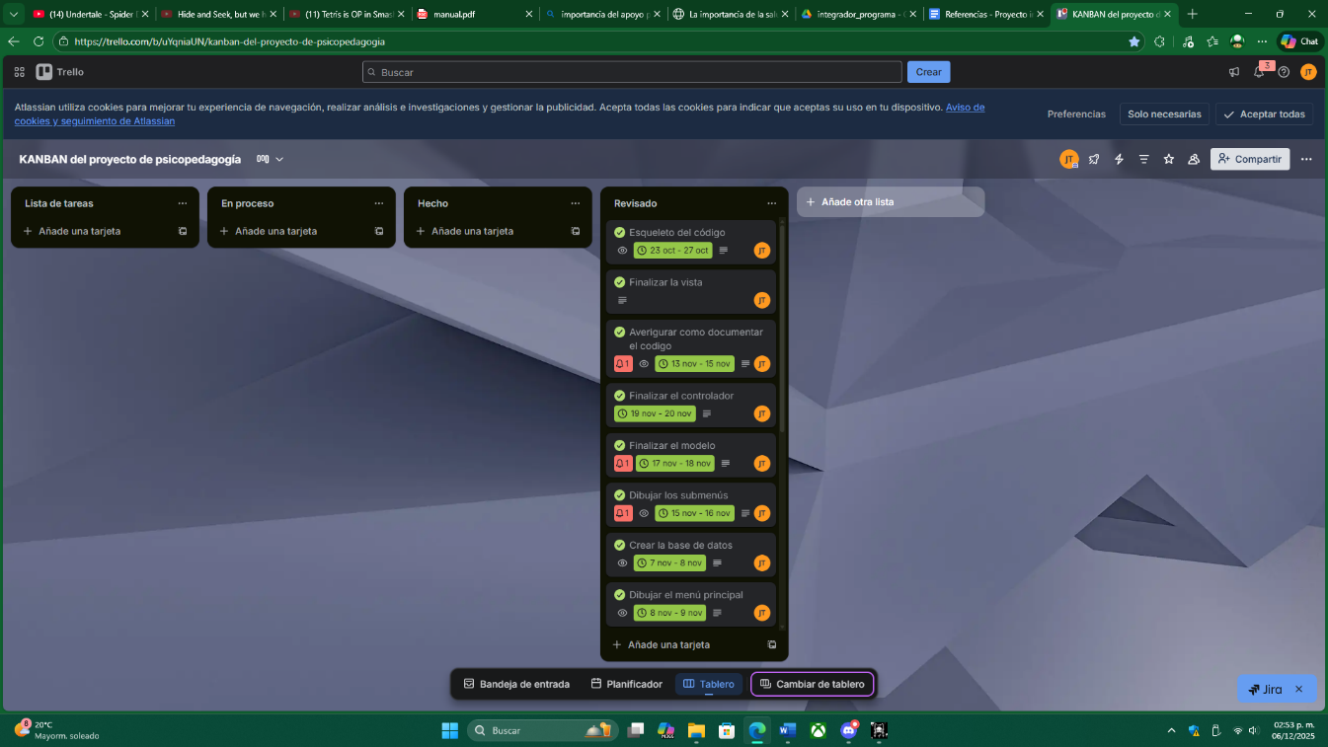
Project resources
Figure 4. last day's KANBAN TABLE
- Framework (design): Figma
- Software (IDE): Visual Studio Code
- Programming language: Python
- GUI framework: Flet
- Database server: MySQL (XAMPP)

Etapas del Desarrollo
Psychology plays an essential role in university environments. “Los estudiantes universitarios enfrentan una serie de desafíos...” (Escobar Telner, 2024).
Now, it will be shown the UML diagrams.
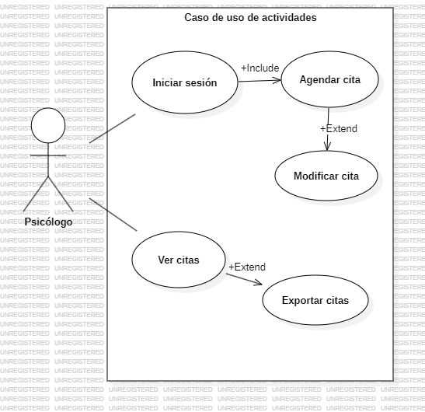
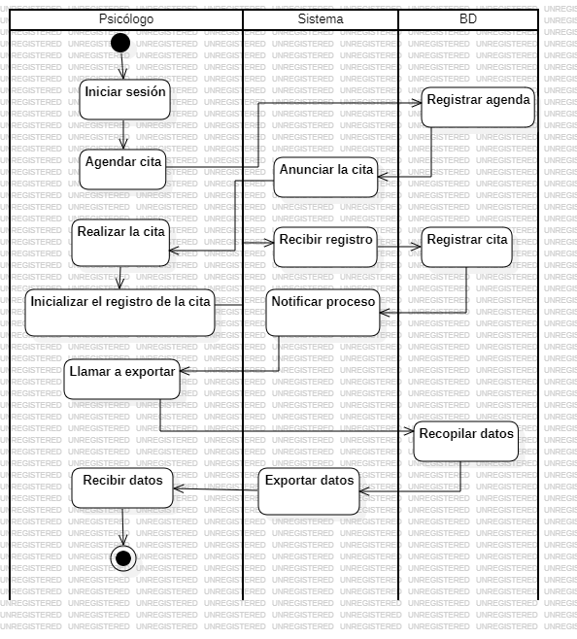
Figure 5. Use case diagram
Figure 6. Activity diagram
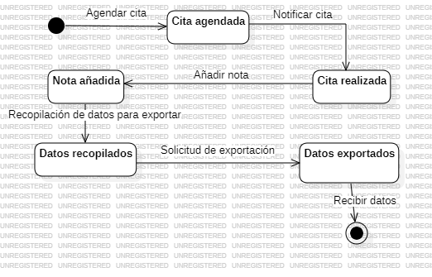
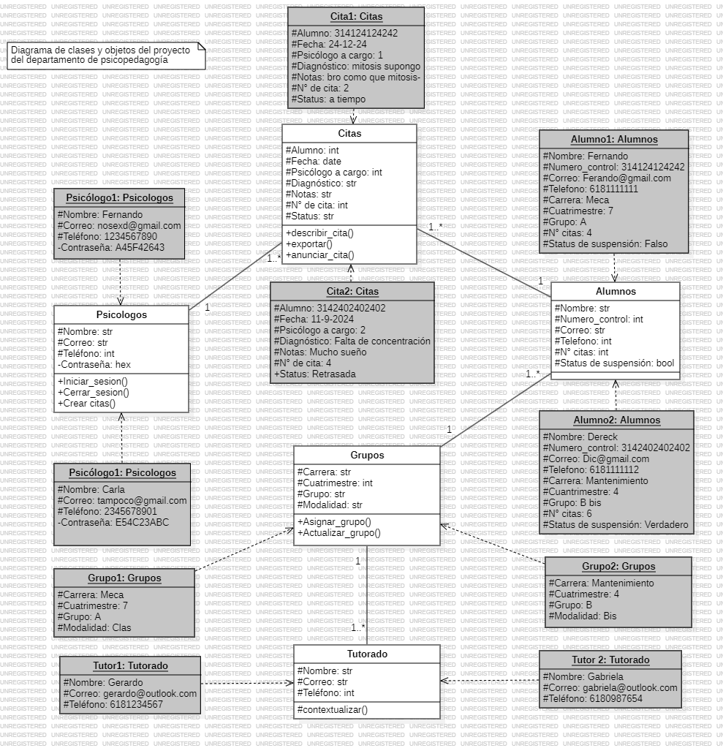
Figure 7. States diagram
Figure 8. Clases and objects diagram

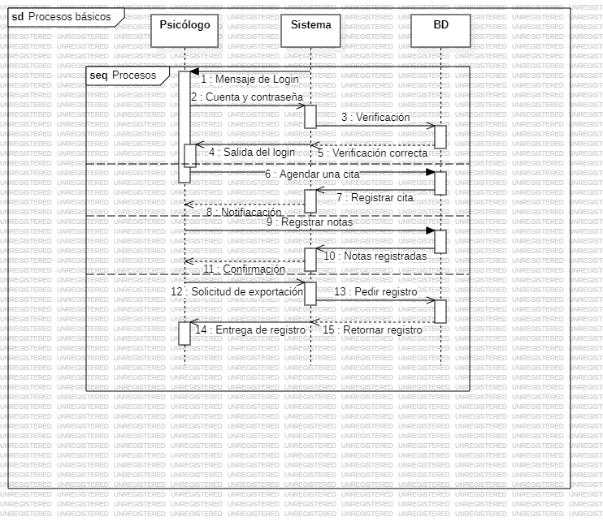
Figure 9. Process diagram

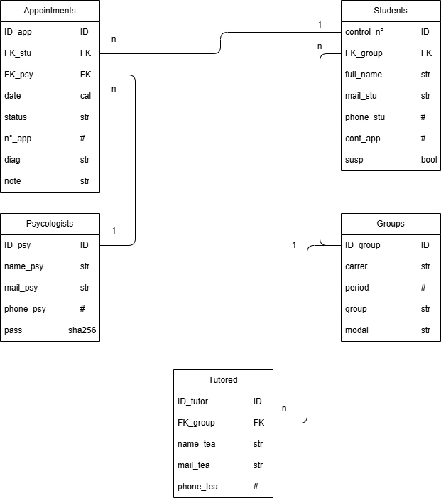
After analyzing the problem, UML diagrams, class diagrams, activity diagrams, state diagrams, and the system’s logical-relational model were created to outline the software architecture and the flow of appointments through the system.
Figure 10. Logical-Relational diagram

Resultados
The resulting software can be described as: “Software para el departamento de psicopedagogía de la Universidad Tecnológica de Durango.”
More specifically, it is a system that enables appointment management and communication with students and/or tutors. As of today, the program does not present recorded results, so expected results are shown.

Technical results
The program has two main functions:
- Communication with the student/tutor
- Appointment management (modification and deletion)
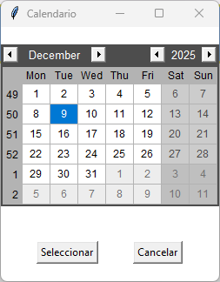
Evidence of the running system is shown in screenshots such as the calendar submenu, login screen, and tutor menu.
Figure 11. Calendar submenu working

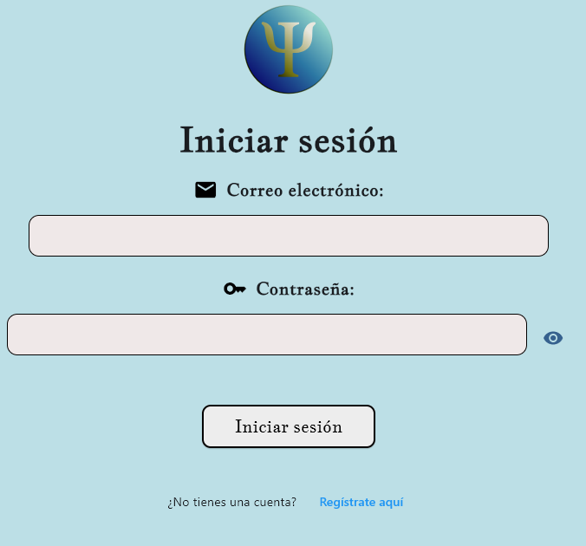
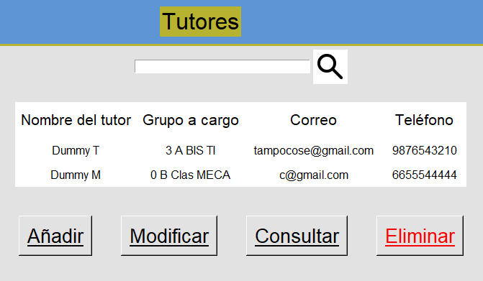
Figure 12. Working "Login" menu
Figure 13Functional tutors menu with imaginary data

Análisis comparativo
The project’s objectives changed significantly over time. Initially, the program did not include communication and human-resource management functions, but these became essential due to the needs of the department.
The previous system relied on Excel tables, which posed security risks and lacked centralization.
The new system centralizes processes and reduces unnecessary steps while improving data verification.

Discusión

Interpretation of results
Based on the projected data, the program has a high probability of delivering effective performance. It includes all functions necessary for the department, and since it is used by a single group of users, its security is considered relatively adequate.

Project contributions
The system drastically improves appointment registration and reduces workload by eliminating the need for multiple tools. It increases efficiency and scalability and allows long-term operation without complexity.

Limitations and possible solutions
One limitation is the format in which data is exported. Although Excel reflects the database, some formats are missing. This can be solved by implementing additional data-processing functions.

Conclusiones
Since the program has not yet been fully implemented, it does not provide complete results. However, a positive projection is expected through improved efficiency and user satisfaction in the Psychopedagogy Department.
The program may be applied in other departments or psychological settings.
Future potential improvements include instant messaging features and expanded data-export options.

References
Escobar Telner, V. (2024, Julio 16). La importancia de la salud mental en el entorno universitario. ADN UNDAV. Retrieved Diciembre 10, 2025, from https://adn.undav.edu.ar/la-importancia-de-la-salud-mental-en-el-entorno-universitario.html
Herrera, P., & Rojas, D. (2025, January 6). Programa Espora, modelo integral de salud mental estudiantil. UNAM Global. Retrieved December 10, 2025, from https://unamglobal.unam.mx/global_revista/programa-espora-modelo-integral-de-salud-mental-estudiantil/
La depresion. (n.d.). Importancia de la ayuda psicológica: La salud mental como prioridad. Retrieved Diciembre 10, 2025, from https://queesladepresion.com/importancia-de-la-ayuda-psicologica/
Regalado Chamorro, M., Baltazar Ayquipa, H., Pineda Florián, F., & Medina Gamero, A. (2023). La salud mental en los jóvenes universitarios: un desafío para las instituciones. Elsevier. Retrieved Diciembre 10, 2025, from https://www.elsevier.es/es-revista-atencion-primaria-practica-24-articulo-la-salud-mental-jovenes-universitarios-S2605073023000160
Universidad Tecnológica de Durango. (s.f.). Manual de organización: Departamento de Psicopedagogía [Manual]. Universidad Tecnológica de Durango.

Anexes
Código en GitHub: Jesus-Barraza/codigo-psico: Este es el codigo del programa del departamento de psicopedagogía de la UTD.
Evidencia de audios: https://drive.google.com/drive/folders/1NwOXMgneM5xzv-dbrow2GJgpbMmCdIgU?usp=drive_link
Diseño en Figma: https://www.figma.com/proto/iyZ6bsTEoFU2E3zH275nD7/Proyecto-integrador?node-id=0-1&t=mzKtG0pdunXXXkpG-1

