Universidad Tecnológica de Durango
Tecnologías de la Información
Programación Orientada a Objetos

Prácticas
“Evidencias de Prácticas”
Alumnos:
- Barraza Torres Jesús Daniel
3°A BIS
Docente:
- Ing. Dagoberto Fiscal Gurrola, M.T.I.
Septiembre 2025

Contenido
Tabla de Ilustraciones 5
Actividad 1 6
Minimum Requirements 6
Technical Requirements 6
Operating Systems 6
User Guide 6
Register User 6
Login 7
Close the Program 7
Settings and Notifications 7
Notifications 8
Settings 8
Calendar 8
Appointments Menu 9
Students Menu 9
Tutors Menu 9
Log Out 10
Insert 10
Update 10
Delete 11
Contact 11
Retroalimentación 12

Tabla de Ilustraciones
Ilustración 1 Evidencia de DRIVE de FUNDAMENTOS DE PROGRAMACIÓN 3

Minimum Requirements

Technical Requirements
The psychology department program has requirements because it will be stored on the computers provided by the university. It is important to clarify that the program requirements do NOT add to Windows requirements.
Technical Requirements:
- 256 MB RAM
- 0.5 GHz Processor

Operating Systems
- Windows 9x (11, 10, 8.1, 8, 7, XP, Vista)

User Guide

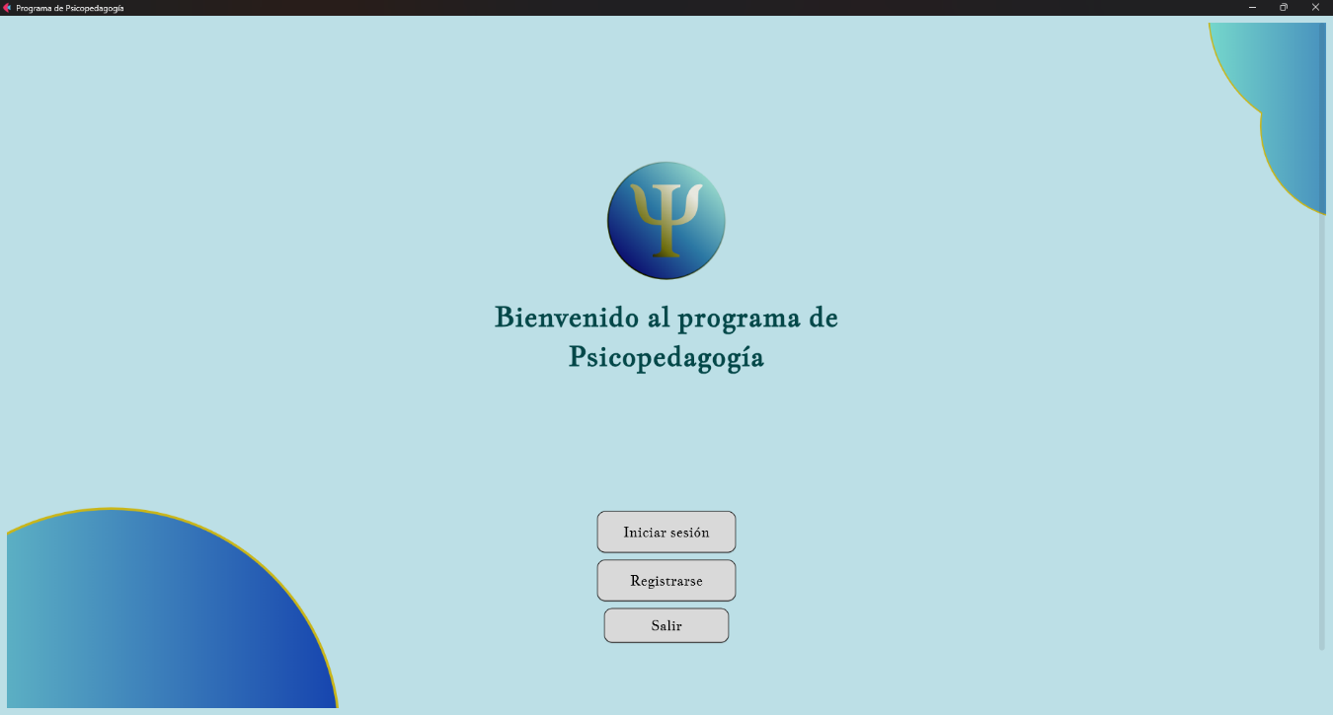
Register User
Figure 1. Initial screen
On this screen, there are 3 options: Log in, Register, and Exit. To register a new user, simply click the “Register” button and proceed to the next screen.
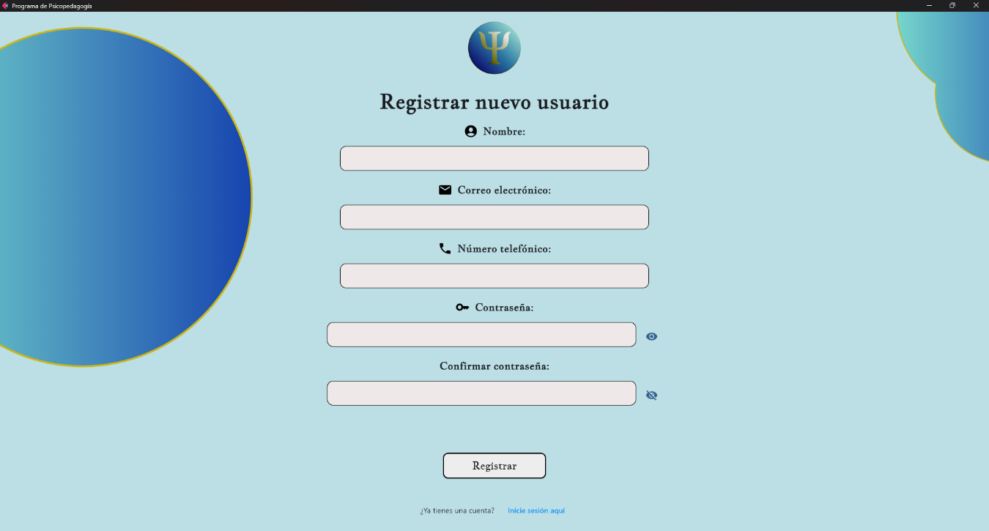
Note: If you cannot see all the buttons, you must scroll down to move everything in that direction.
Figure 2. "Register" screen

This screen requests the following:
- Full name (Please use the complete name)
- Email address
- Phone number
- Password
- Confirm password
All fields must be filled out correctly to register a new user. For the phone number, you must enter the area code and subscriber number (the standard 10-digit number).

Login
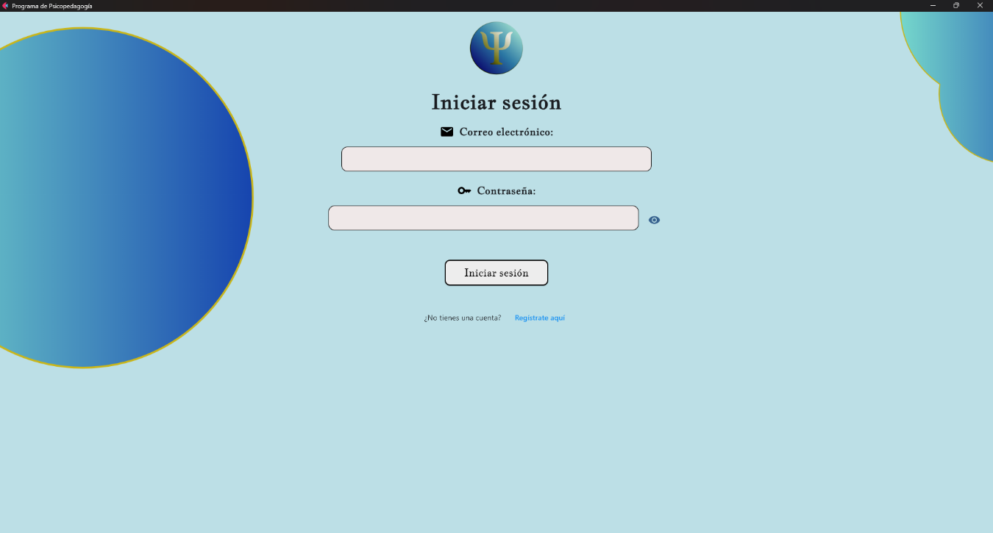
In Illustration 1 above, we can see another button in the program. Once you click the button, it will take you to this option:
Figure 3. "Login" menu
This screen simply asks for two pieces of information:
- Email address
- Password
Once you enter the data, if it is correct, you will be taken to the main menu screen.
Note: As of the creation date of this document, another application will open where the main screen is located.
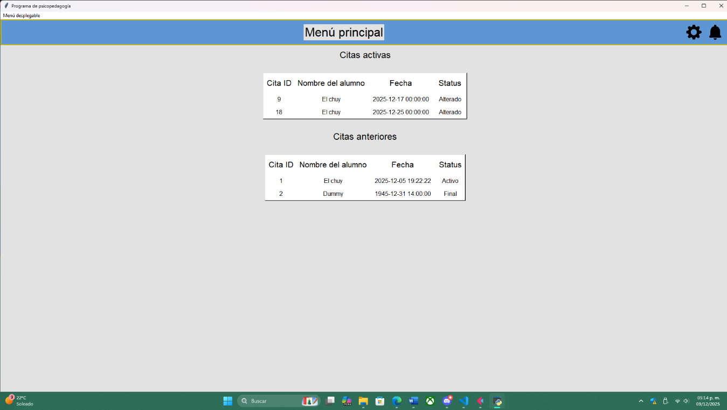
Once you finish logging in, you will appear in the main menu.
Figure 4. Main menu

Close the Program
You can close the program at any time by clicking the X on the window tab, but if you want to close the program normally, on the home page (Illustration 1) there is an Exit button. This will close the program conventionally.

Settings and Notifications

Once inside the main menu (Illustration 4), you can access the settings and notifications screens through these two buttons:
Figure 5. Configuration and notification buttons
These buttons allow you to go directly to the following menus:

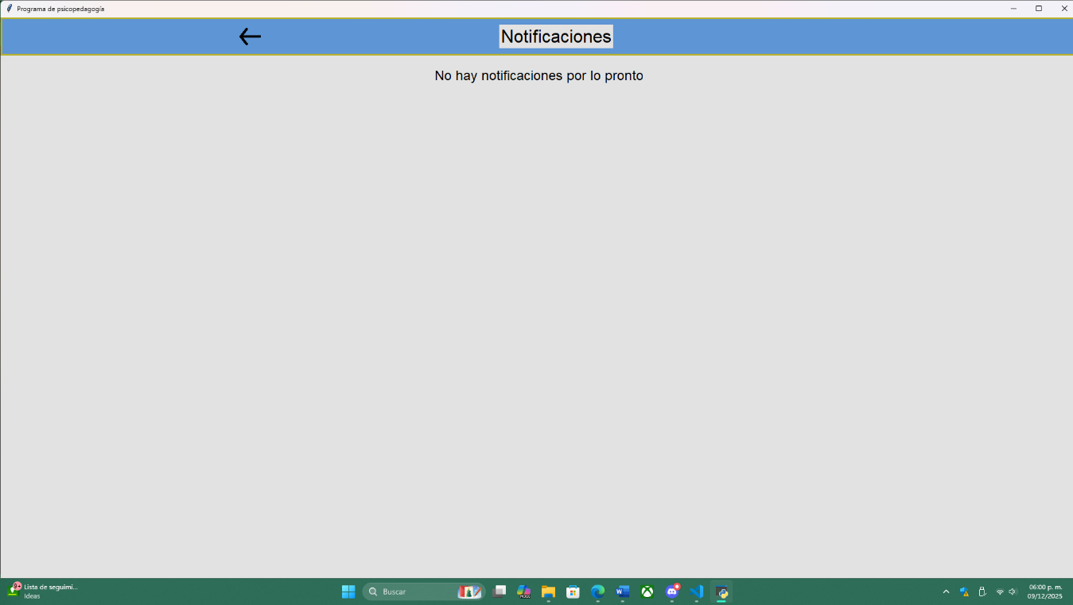
Notifications
Figure 6. Notification screen
In the notifications screen, all notifications related to students, tutors, and appointments will appear.

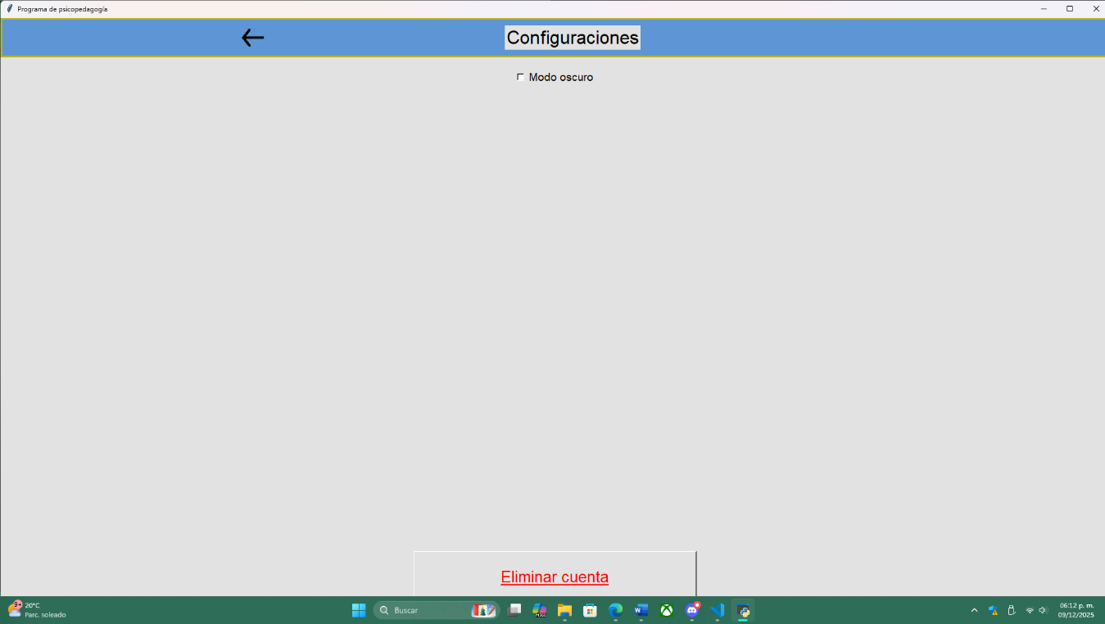
Settings
Figure 7. Settings
Note: For now, this does not notify anything.
In the settings tab, there are two options:
- Dark mode
- Delete account
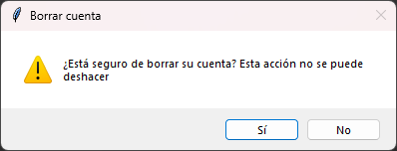
The dark mode function changes the colors to darker tones, while the delete account button triggers an alert.
Figure 8. Delete the account
If you confirm, the account, its associated appointments, and all related data will be deleted, and you will be returned to the home menu.

Calendar
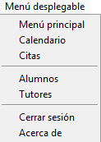
Once inside the program, you can navigate through the menus using the dropdown menu at the top left.
Figure 9. Dropdown menu
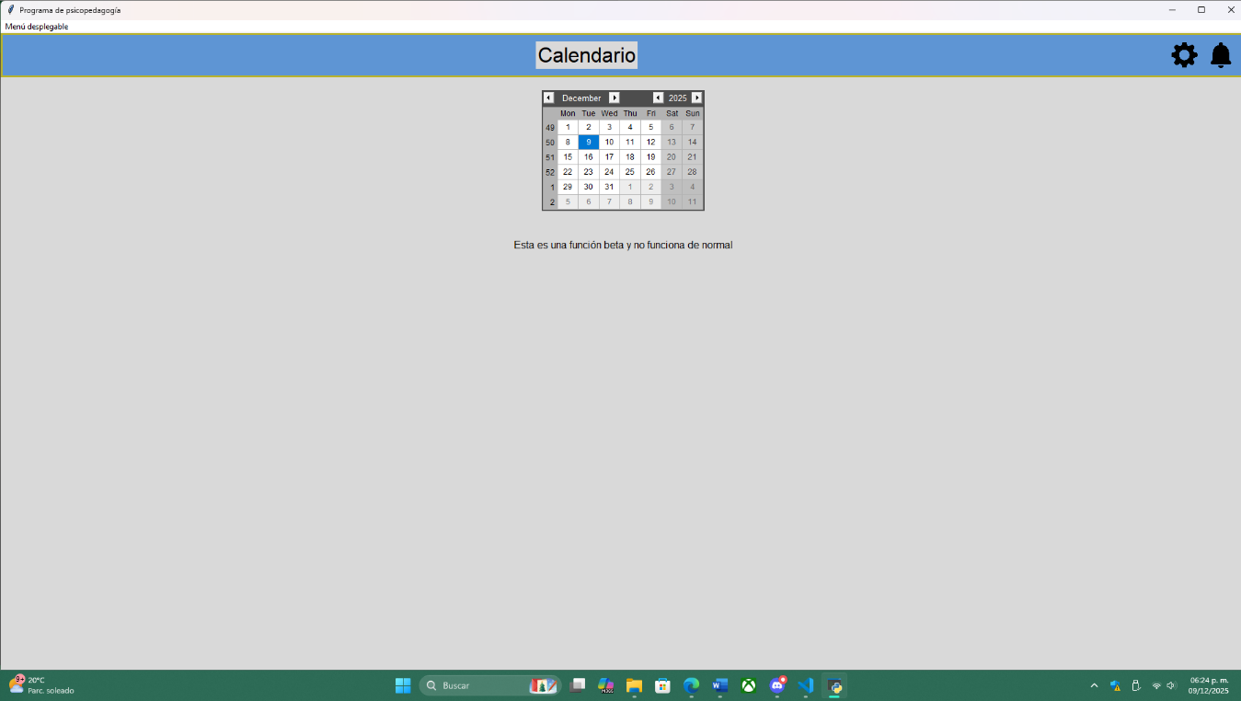
From this submenu, you can access the program menus. The first accessible menu is the calendar menu.
Figure 10. Calendar
In this menu, there is a calendar that currently has no function.

Appointments Menu
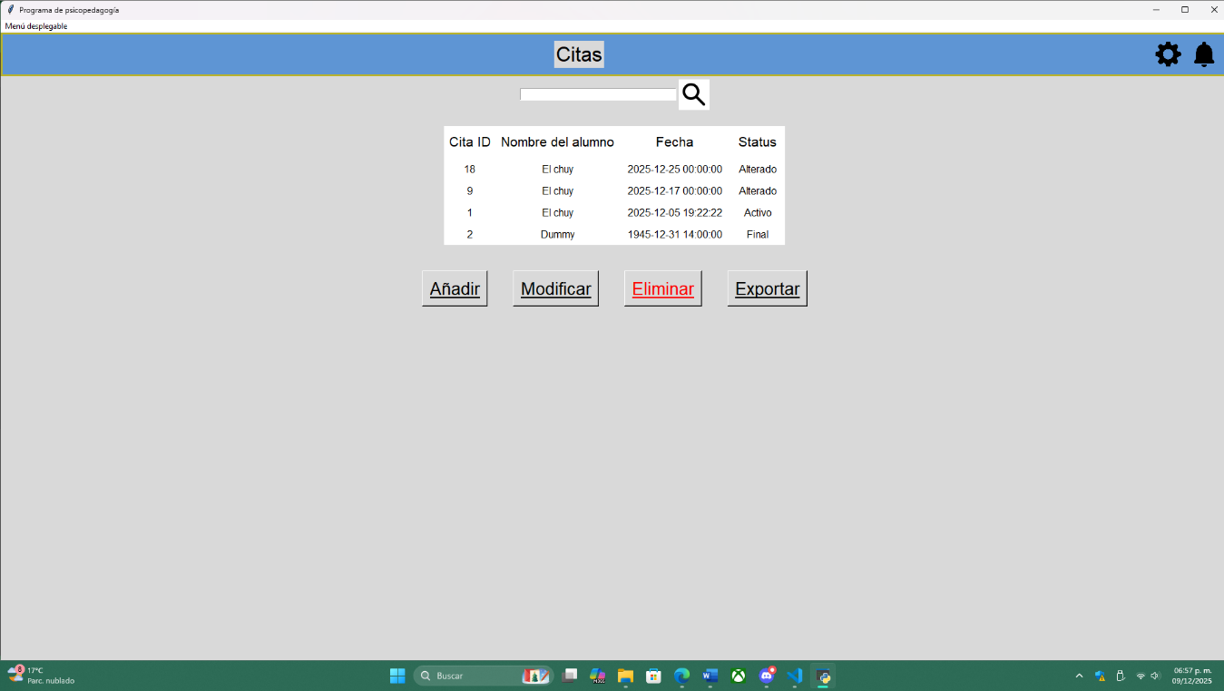
From Illustration 9, you can enter the menus directly, and one of them is the appointments menu.
Figure 11. Appointments
From the appointments menu, you can search directly for someone’s appointment. By searching for the student’s name in the search bar and clicking the search button, you can filter appointments by student name, showing status and name.
This menu has 4 additional functions:
- Add
- Modify
- Delete
- Export

Students Menu
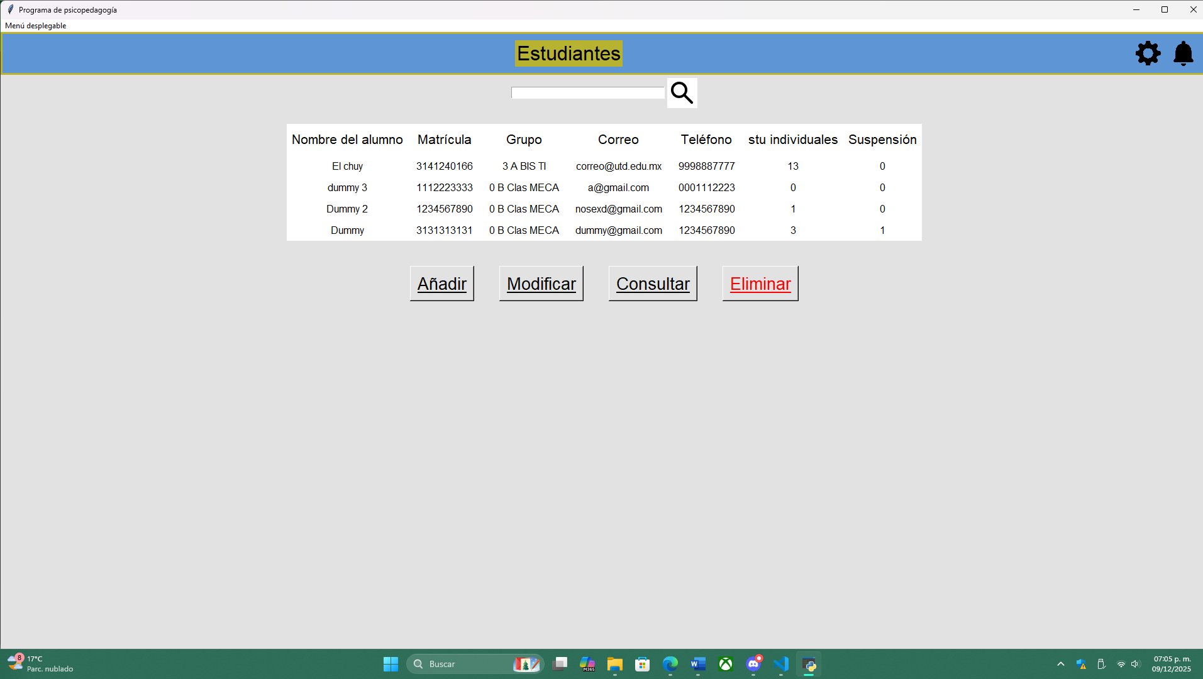
Within the same submenu, you can directly access the student’s menu.
Figure 12. Students
In the student’s section, we can see similar terms and functions to those in the appointment’s menu:
- Add
- Modify
- Consult
- Delete

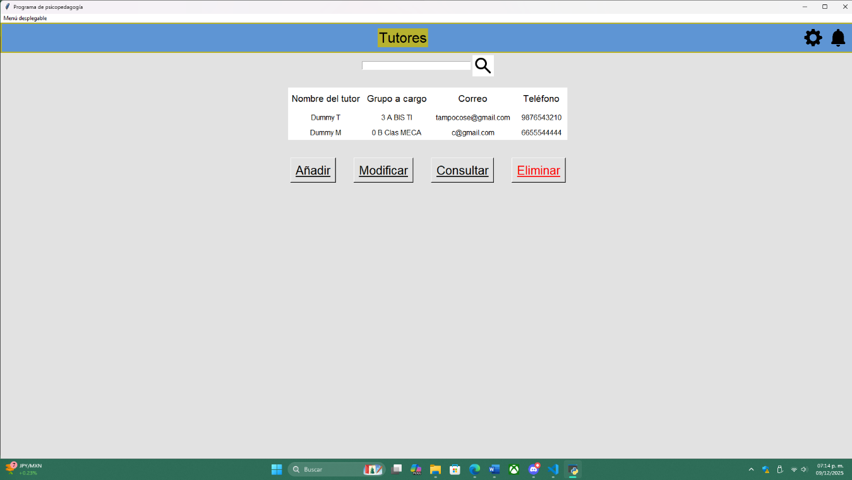
Tutors Menu
Figure 13. Tutors
This menu is almost identical to the student’s menu, with the same functions.

Log Out
If you want to log out normally, select the logout option from the submenu. This will open the initial menu and clear the credentials.

Insert
Note: The insert function works almost identically for students and tutors.
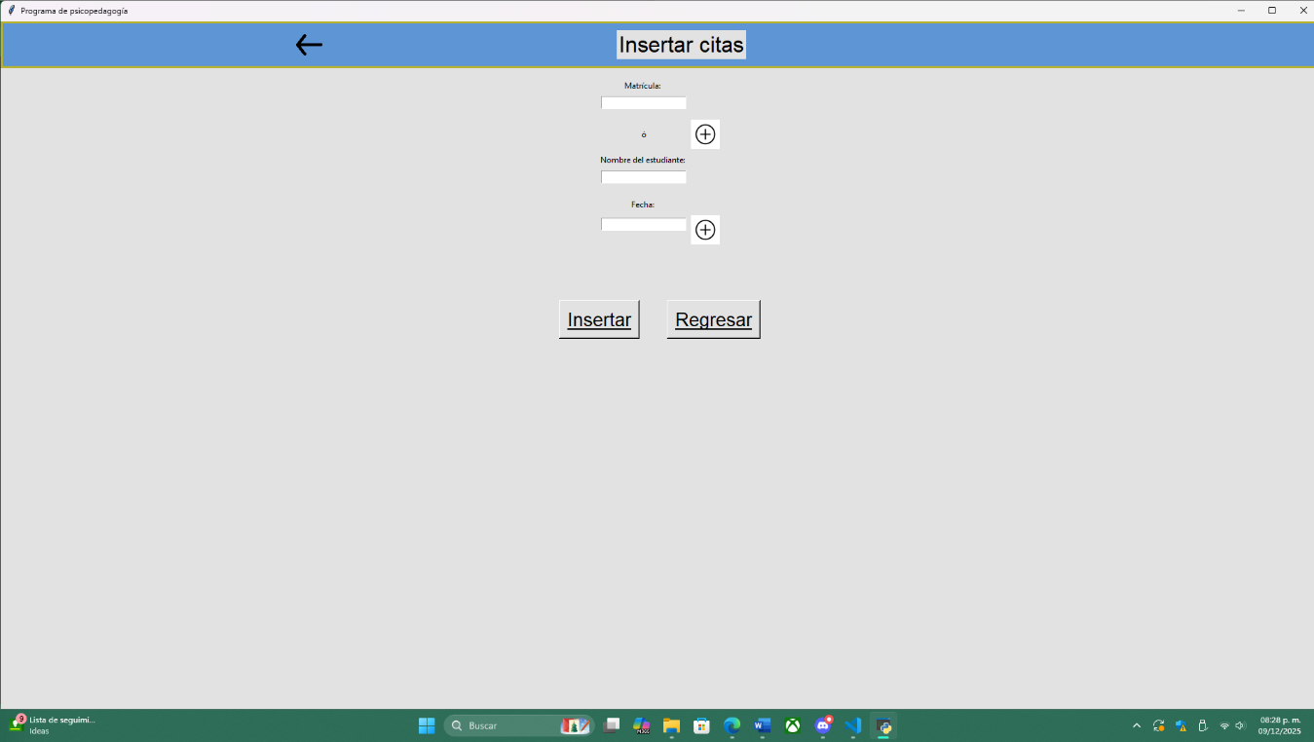
Within the menu sections, one of them is “Insert,” shown below.
Figure 14. Insert
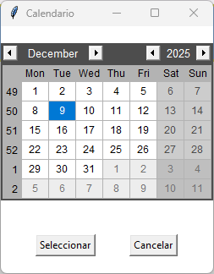
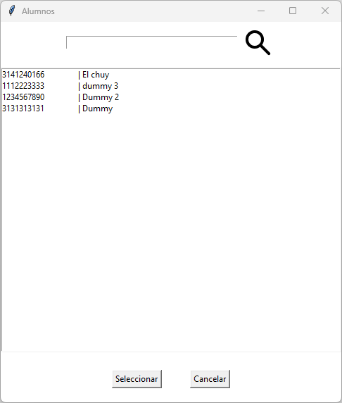
Here we can see the fields that must be filled with data. If you do not remember the exact data, you can open the + button menu to select the information.
Figure 15. Students submenu
Figure 16. Calendar submenu
To select an option, click it and then click “Select.” The selected data will automatically fill the search list.
To finish inserting data, click the “Insert” button. A message will appear indicating whether the program completed the action successfully.

Update
Note 1: These functions are similar in the “students” and “tutors” tables.
Note 2: The functions for adding data are similar.
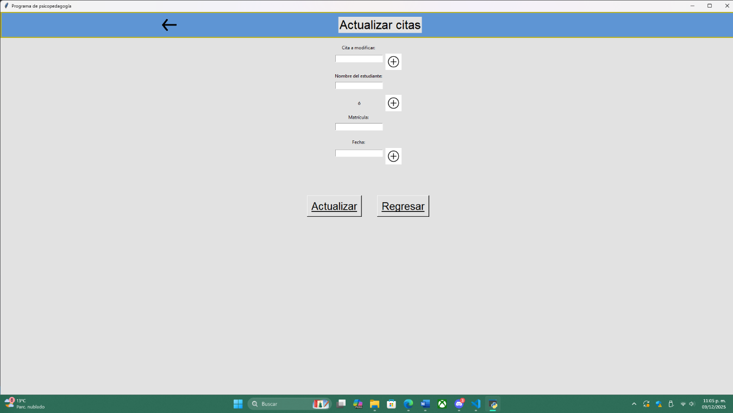
To update data, click “Modify” in the corresponding menu and the page will open.
Figure 17. Update
From there, the functions remain similar. Once you finish filling out the fields, press the “Update” button.

Delete
Note: These functions are similar in the “students” and “tutors” tables.
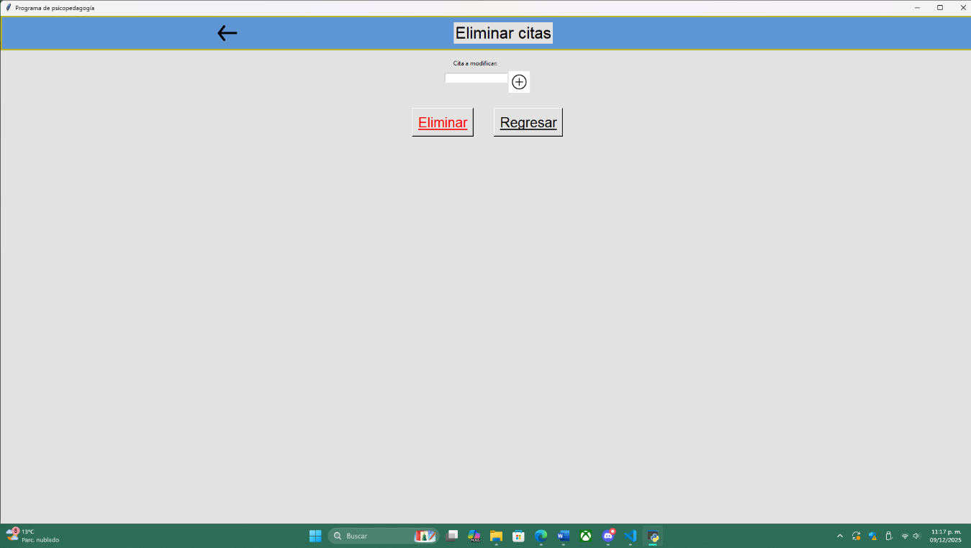
To delete data, press the “Delete” button and the following screen will open:
Figure 18. Delete
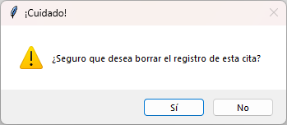
On this screen, enter the appointment ID to delete and then click Delete. When you do this, a confirmation message will appear:
Figure 19. Delete register
Once confirmed, the program will delete the appointment record and show a notification.

Contact
If you need information and/or support regarding the program, contact us:

Location: Technological University of Durango

Phone: 6182774912

Support:
Barraza Torres Jesús Daniel
jesus_3141240166@utd.edu.mx

