Practice 3.1 Correlations & Linear Regression
Barraza Torres Jesús Daniel
2025-08-14

Correlation
A correlation is where a data has something to do with other; where if one data on a database changes, the other changes either in the same direction or in opposite direction

possitive correlation
Is where the data varys at the same rate between data
sleep_hours <- c(6, 7, 8, 9, 10, 11)
test_score <- c(60, 70, 80, 90, 95, 100)
correlation1 <- cor(sleep_hours, test_score)
cat("The correlation of sleep time and test scores are: ", correlation1)
## The correlation of sleep time and test scores are: 0.9885054
#Dispersion Graphic
plot(sleep_hours, test_score,
main="Sleep hours vs test scores",
xlab="Sleep hours",
ylab="Test score",
pch=19, col="#766987")
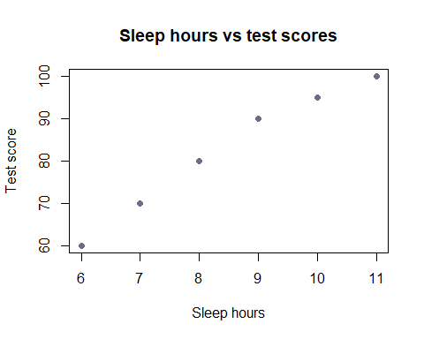

Negative correlation
A negative correlation is where the data varys at the opposite rate between data
time_driving <- c(0, 1, 2, 3, 4, 5)
combustible_left <- c(100, 85, 75, 50, 40, 25)
correlation2 <- cor(time_driving, combustible_left)
cat("The correlation between the time driving and combustible left is: ", correlation2)
## The correlation between the time driving and combustible left is: -0.994113
#Dispersion graphic
plot(time_driving, combustible_left,
main="Time driving vs combustible left",
xlab="Time driving",
ylab="Combustible left",
pch=19, col="#af4566")
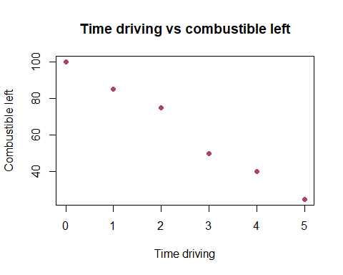

No correlation
There’s no correlation where, while one data modifies, the other either remains the same or varys vay too umpredictadely
rest <- c(6, 4, 7, 8, 4, 5)
drink <- c(1, 0, 4, 3, 7, 0)
correlation3 <- cor(rest, drink)
cat("The correlation between the time sleeping and the drinks tolerated is:", correlation3)
## The correlation between the time sleeping and the drinks tolerated is: 0.04472136
#Dispersion Graphic
plot(rest, drink,
main="Sleep time vs drinks tolerated",
xlab="sleep time",
ylab="drinks tolerated",
pch=19, col="#56ad43")
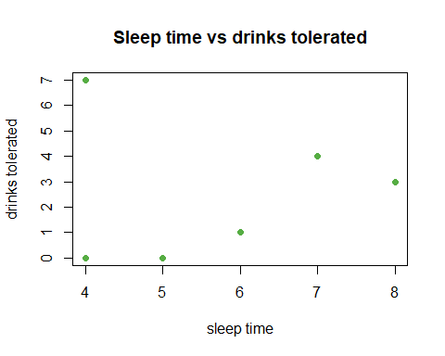

MTCARS RELATIONS
#Importing a dataset, correlate the data between miles per gallon and the number of cylinders
data("mtcars")
milespergallon <- mtcars$mpg
cylinders <- mtcars$cyl
correlation4 <- cor(milespergallon, cylinders)
cat("The correlation between the miles per gallon and the cylinders of cars is: ", correlation4)
## The correlation between the miles per gallon and the cylinders of cars is: -0.852162
#Dispersion Graphic
plot(milespergallon, cylinders,
main="Miles per gallon vs number of cylinders",
xlab="Miles per gallon",
ylab="Number of cylinders",
pch=19, col="#3576cd")
