TradeOps
A Data Warehouse for Prop-Firm Futures Trading Operations
Course | IE6750 Data Warehousing & Integration
Assignment | Milestone 1: Problem Definition and Operational Database
Group Number | Group 08
Participant | Jesus D. Jimenez Ballestas (individual)
Project Title | TradeOps: A Data Warehouse for Prop-Firm Futures Trading Operations
Data Source | Generated through a seeded Python script (synthetic), using real contract specifications

1. Project Summary
This project builds a data warehouse for a futures trading operation that trades with capital from proprietary trading firms (“prop firms”) instead of its own money. The operation runs dozens of evaluation and funded accounts across several firms, and one trade is copied into every active account at once. Each firm has its own rules, fees, and payout schedule, so the data needed to judge the operation is spread across many dashboards and platform exports. The goal is to bring that data into one place and answer a simple question that is hard to answer today: is the operation actually profitable after fees, and which strategies, instruments, and firms are driving the results?

2. Operational Business Context
A prop firm sells a trader access to an evaluation account (for example, a $50,000 account for a monthly fee). The trader must reach a profit target without letting the balance fall below a trailing drawdown floor, which follows the account’s highest balance. Some firms also enforce a daily loss limit and a consistency rule that caps how much of the total profit can come from a single day. If the trader passes, the firm issues a funded account, usually for an activation fee. The trader can then request payouts and keeps most of the profit (commonly 90%). If the balance touches the drawdown floor, the account is lost.
The operation in this project runs that cycle at scale. The day-to-day business processes, which the operational database must support, are:
- Account management: buying evaluations, paying monthly and reset fees, and activating funded accounts after a pass.
- Trade execution: a leader account places a trade and copy-trading software repeats it in every follower account, each with its own position size and fills.
- End-of-day statements: each firm reports the account’s ending balance, high-water mark, and drawdown floor.
- Rule monitoring: recording drawdown breaches, daily loss limit hits, and consistency flags.
- Payouts: requesting withdrawals from funded accounts on each firm’s payout cycle.
These processes are transactional. They insert and update a few records at a time and need only current data, which is the OLTP workload described in Section 3.1 of Vaisman and Zimányi (2022). The analysis the operation needs is the opposite kind of workload, which is why a separate warehouse is justified.

3. Problem Definition
Problem statement. The operation cannot reliably measure its true return because costs (evaluation fees, resets, activations) and income (payouts) are recorded separately from trading results, and each firm reports them in a different format. It also cannot see which strategies, sessions, and instruments cause the drawdown breaches that destroy accounts, or whether copied trades perform worse than the leader trade. This project will design an operational database that captures all of these events, and later a data warehouse that integrates them for multidimensional analysis.
The main business questions are:
- What is the net return of the operation (payouts received minus all fees) by firm, plan, and month?
- Which strategies and instruments produce the most net P&L, and which produce the most rule violations?
- How does performance change by trading session and on high-impact economic event days (CPI, NFP, FOMC)?
- What percentage of evaluations pass, how long does passing take, and how long do funded accounts survive?
- How much slippage does copy trading add compared with the leader trade?
Scope. The project covers futures trades, account lifecycles, fees, balances, rule events, and payouts from January 2025 through August 2026. It does not cover live market data, order-book data, or personal tax reporting.

4. Operational Database
The operational database, TradeOps, has 16 tables in Third Normal Form. The DDL is written in PostgreSQL syntax and was loaded and tested in DuckDB, with all primary key, foreign key, and CHECK constraints enforced during the load. Figure 1 shows how the tables relate. A full ERD will follow in later milestones, and this schema is its starting point.
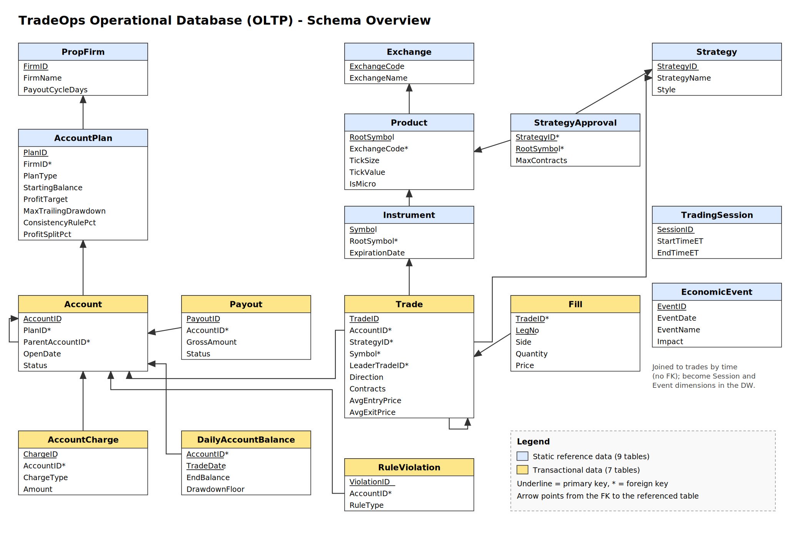
Figure 1. TradeOps operational schema (blue = reference data, yellow = transactional data)

4.1 Static Reference Data
Reference data changes rarely and describes the “who, what, and where” of each transaction. These tables will become most of the warehouse dimensions.
Table | Contents | Rows
PropFirm | The three firms traded with and their payout cycle | 3
AccountPlan | Each firm’s plans: starting balance, profit target, trailing drawdown, daily loss limit, consistency %, profit split, fee | 8
Exchange | CME, CBOT, NYMEX, COMEX | 4
Product | 12 futures products (e.g., NQ, MNQ, ES, CL, GC) with real tick size and tick value | 12
Instrument | Individual contract months (e.g., NQZ5) with expiration dates | 164
Strategy | Five trading strategies and their style and timeframe | 5
StrategyApproval | Which products each strategy may trade, with a contract limit (M:N) | 24
TradingSession | Asia, London, NY Open, NY Midday, NY Close time windows (ET) | 5
EconomicEvent | Rule-based calendar of CPI, NFP, FOMC, retail sales, jobless claims, and EIA releases | 245
Table 1. Reference tables

4.2 Transactional Data
Transactional data records business events as they happen. These tables will feed the warehouse fact tables.
Table | Contents | Rows
Account | Every evaluation and funded account, its plan, status, and the evaluation it came from | 134
AccountCharge | Evaluation, monthly, reset, and activation fees | 220
Trade | Round-trip trades with entry/exit time and price, contracts, commission, and leader trade | 6,322
Fill | Individual executions for each trade, including scale-outs | 13,944
DailyAccountBalance | End-of-day statement: start and end balance, high-water mark, drawdown floor | 2,916
RuleViolation | Drawdown breaches, daily loss limit hits, and consistency flags | 143
Payout | Payout requests with gross amount, trader share, and status | 63
Table 2. Transactional tables

4.3 Data Source and Design Notes
The data is generated by a seeded Python script, so it can be rebuilt exactly. It is modeled on a real operation I run, but it is synthetic and does not contain my actual trading records. Product specifications (tick size and value) match the real CME Group contracts, and the economic calendar follows the real release patterns (for example, NFP on the first Friday of the month). The firm names are real, but the plan rules and fees are simplified values stored as reference data, so they can be changed without touching any code. Over the 20-month period the simulation produced 102 evaluations (32 passed), 32 funded accounts, $17,497.60 in fees, and $58,950 in paid payouts to the trader.
A few design choices will matter in later milestones:
- Rules live on AccountPlan, not Account. Profit target and drawdown depend on the plan, so storing them on each account would create a transitive dependency and break 3NF.
- Two self-referencing foreign keys. Account.ParentAccountID links a funded account to the evaluation that earned it, and Trade.LeaderTradeID links each copied trade to its leader (1,014 leader trades and 5,308 copies).
- Fill is a weak entity keyed by (TradeID, LegNo), so a trade can have several exit legs.
- P&L is not stored. It is derived from prices, contracts, and tick value, which avoids redundancy in the OLTP system. The ETL process will calculate it for the warehouse.

5. Planned Analysis (Future Milestones)
The analysis goals below may change as the course goes on, but they show how the operational data maps to a multidimensional model.

5.1 Candidate Facts and Dimensions
Fact (grain) | Measures | Dimensions
Trade (one row per trade) | Net P&L, gross P&L, contracts, commission, slippage vs. leader, hold minutes | Date, Time/Session, Account, Plan, Firm, Instrument, Product, Strategy, Event day
Daily account snapshot (one row per account per day) | End balance, cushion to drawdown floor, high-water mark | Date, Account, Plan, Firm
Account cash flow (one row per charge or payout) | Fee amount, payout amount, trader share | Date, Account, Plan, Firm, Flow type
Table 3. Candidate fact tables
The dimensions have natural hierarchies for roll-up and drill-down: Day → Month → Quarter → Year; Time → Session; Instrument → Product → Asset Class; Account → Plan → Firm; and Strategy → Style.

5.2 Measure Additivity
Following Section 3.1.2, the measures need different aggregation functions, which is a correctness issue for summarizability:
- Additive: net P&L, contracts, commission, fees, and payouts can be summed across every dimension.
- Semi-additive: end balance and drawdown cushion can be summed across accounts on one day, but across time they need the last value or an average.
- Non-additive: win rate, profit factor, and pass rate are ratios. The warehouse will store their counts and sums and compute the ratio at query time.

5.3 Analysis Directions
- Return on fees: roll up payouts and charges to Firm and Month, then drill across to trading P&L to see net return by firm.
- Strategy and session performance: dice the trade cube by Strategy and Session to find where each strategy makes or loses money.
- Risk and early warning: slice the daily snapshot on accounts that later breached to see how their drawdown cushion shrank before the breach.
- Event-day effects: compare P&L and violations on CPI, NFP, and FOMC days against normal days.
- Copy-trading quality: compare each copied trade with its leader to measure slippage by firm and platform.
- Account lifecycle: pass rate and days-to-pass by plan, and funded account survival time.

5.4 Considerations for Later Milestones
- ETL: trades and fills can be loaded incrementally by entry time, and P&L will be calculated during transformation.
- Slowly changing dimensions: firms change plan rules and fees often, so the Plan dimension is a good candidate for a Type 2 SCD to keep history.
- Integration: in a real deployment each firm exports data in a different format, which matches the “integrated” characteristic of a data warehouse in Section 3.3.

6. Shared Spreadsheet Entry
Field | Entry
Group number | Group 08
Group members | Jesus D. Jimenez Ballestas
Project topic | TradeOps: Prop-Firm Futures Trading Operations
Short description | Operational database and data warehouse for a copy-traded futures operation across multiple prop firms, tracking accounts, fees, trades, fills, balances, rule violations, and payouts to measure net return and risk.
Type of data source | Generated through Python scripts (synthetic, seeded), using real CME contract specifications

References
Vaisman, A., & Zimányi, E. (2022). Data warehouse systems: Design and implementation (2nd ed.). Springer.

