GSE98923 co-expression analysis
  - CEMiTool baseline - 54-sample balanced design
2026-09-21
Table of Contents

1 Scope
This report documents the computational analysis of the balanced 54-sample subset of GEO accession GSE98923 used in the CEMiTool baseline workflow.
The report is intended as an analysis record and potential supplementary document for a scientific manuscript. Large machine-readable matrices are not printed in full in the document; complete files are preserved separately and indexed in the supplementary manifest.

2 Experimental design
The analysis contains 54 samples, covering two cultivars, three developmental stages, three years, and three biological replicates per cultivar-stage-year combination.
Sample counts by cultivar, developmental stage, and year.
Cultivar | Stage | Year | Freq
Cabernet Sauvignon | FruitSet | 2012 | 3
Pinot noir | FruitSet | 2012 | 3
Cabernet Sauvignon | Harvest | 2012 | 3
Pinot noir | Harvest | 2012 | 3
Cabernet Sauvignon | Veraison | 2012 | 3
Pinot noir | Veraison | 2012 | 3
Cabernet Sauvignon | FruitSet | 2013 | 3
Pinot noir | FruitSet | 2013 | 3
Cabernet Sauvignon | Harvest | 2013 | 3
Pinot noir | Harvest | 2013 | 3
Cabernet Sauvignon | Veraison | 2013 | 3
Pinot noir | Veraison | 2013 | 3
Cabernet Sauvignon | FruitSet | 2014 | 3
Pinot noir | FruitSet | 2014 | 3
Cabernet Sauvignon | Harvest | 2014 | 3
Pinot noir | Harvest | 2014 | 3
Cabernet Sauvignon | Veraison | 2014 | 3
Pinot noir | Veraison | 2014 | 3

3 Expression data
The processed matrix used for CEMiTool contains 29971 genes and 54 samples.
Expression values were derived from the processed RPKM matrix distributed with GSE98923 and transformed as:
$$\log_{2}(RPKM+1)$$
The complete matrices are available under:
- data/processed/expression_rpkm.tsv
- data/processed/expression_log2rpkm.tsv

4 CEMiTool analysis
CEMiTool identified 11 modules in the baseline analysis.
The analysis used Pearson correlation, an unsigned network, a signed TOM, a minimum module size of 30, and a fixed random seed of 1234.
Automatic beta selection did not identify a usable value in the initial baseline run. To reproduce the established 54-sample baseline, the soft-thresholding power was fixed explicitly at beta = 10 using set_beta = 10 and force_beta = FALSE. This value is specific to the present expression matrix and should be re-evaluated if the sample set, normalization, or filtering changes. The recorded beta for this run is 10.
Recorded analysis parameters.
parameter | value
dataset | GSE98923
samples | 54
transform | log2(RPKM+1)
correlation | pearson
network_type | unsigned
tom_type | signed
beta_strategy | manual_set_beta_beta10
set_beta | 10
force_beta | FALSE
beta | 10
r2 | 0.706374247063269
filter | TRUE
filter_pval | 0.1
min_module_size | 30
seed | 1234
modules | 11

5 Diagnostic and analysis figures
All figures generated by the analysis are stored in results/figures/. PDF figures are converted to PNG copies for reliable inclusion in Word and HTML reports.

5.1 beta_r2
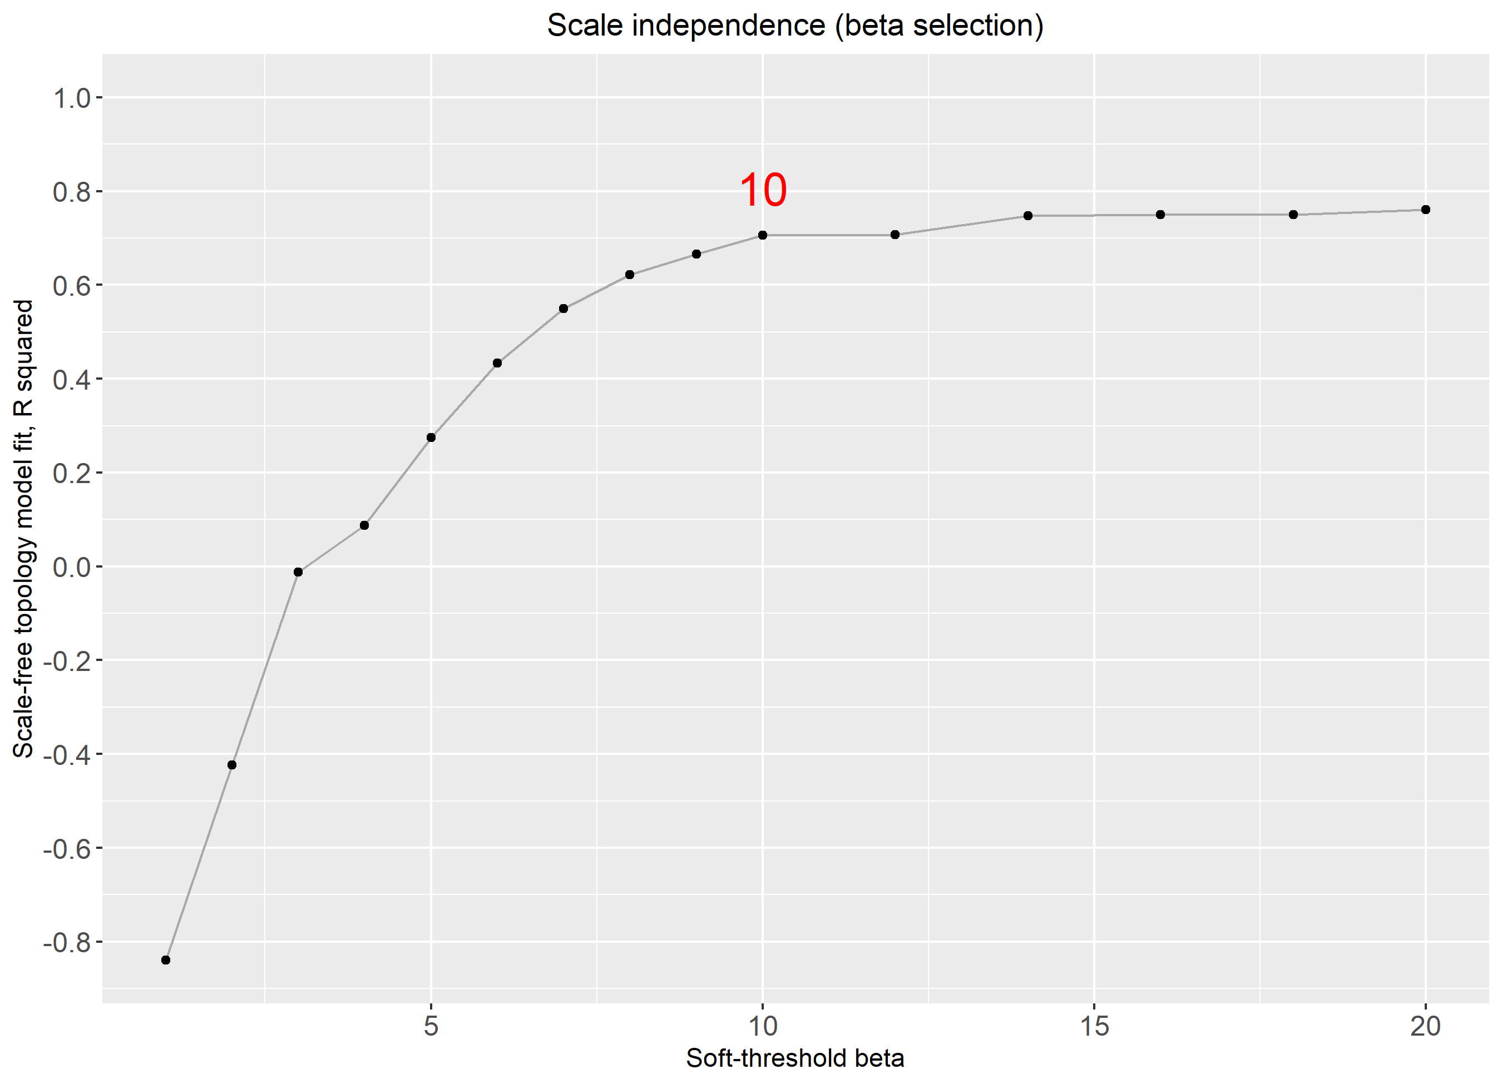

5.2 gsea
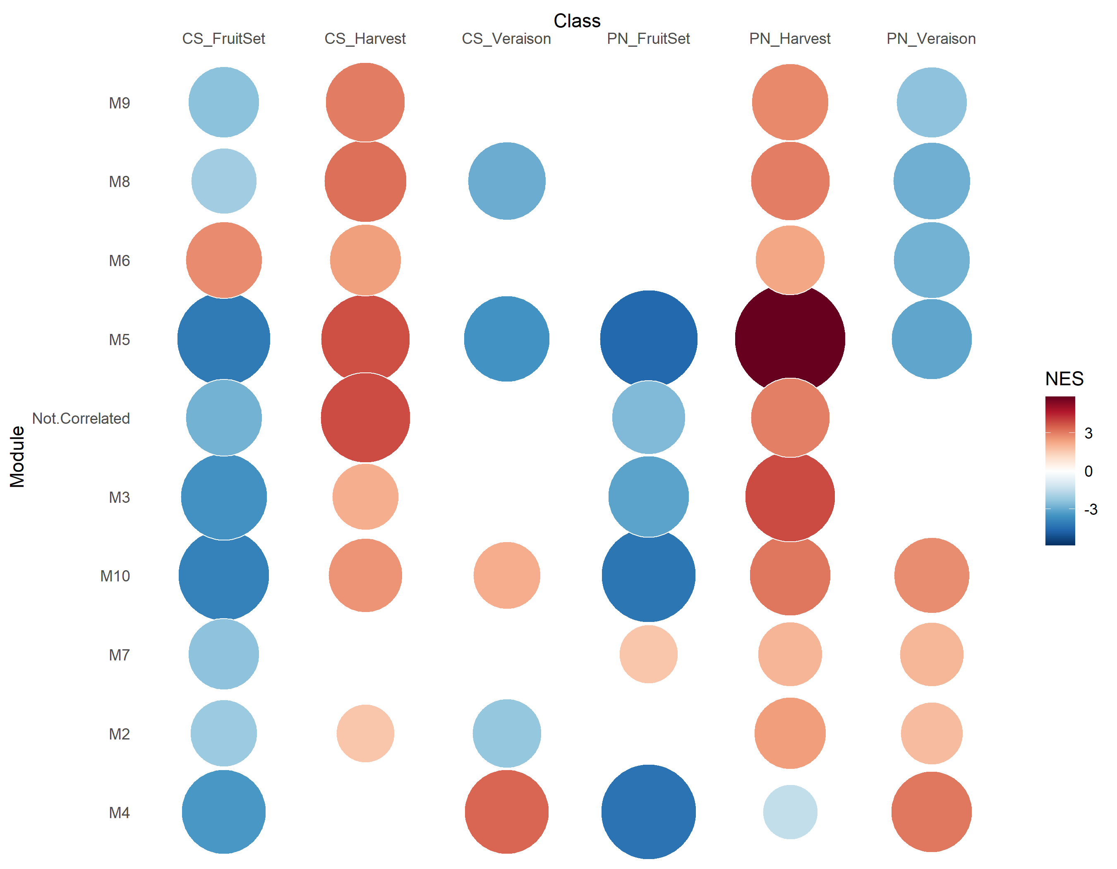

5.3 hist
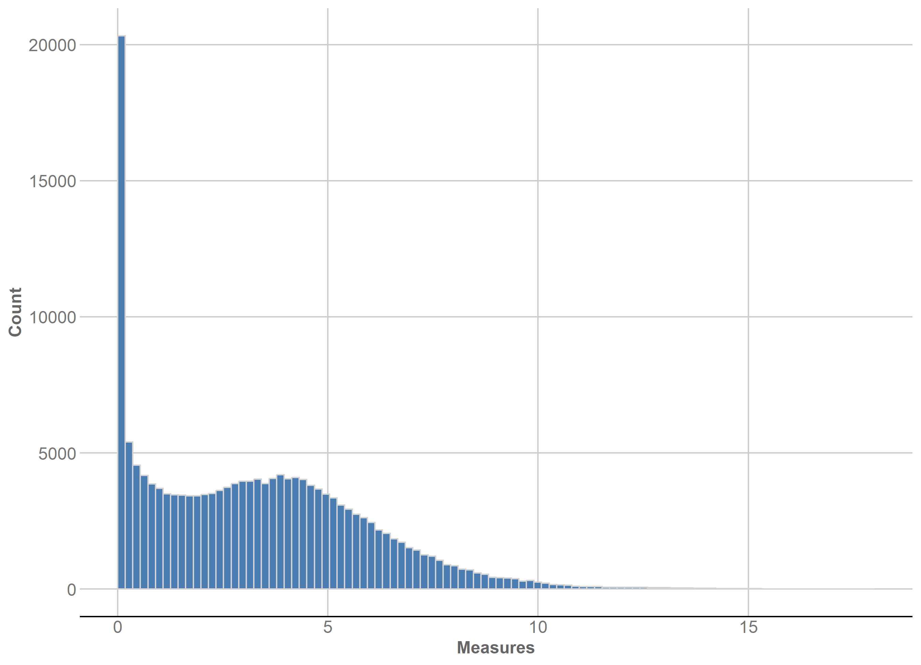

5.4 mean_k
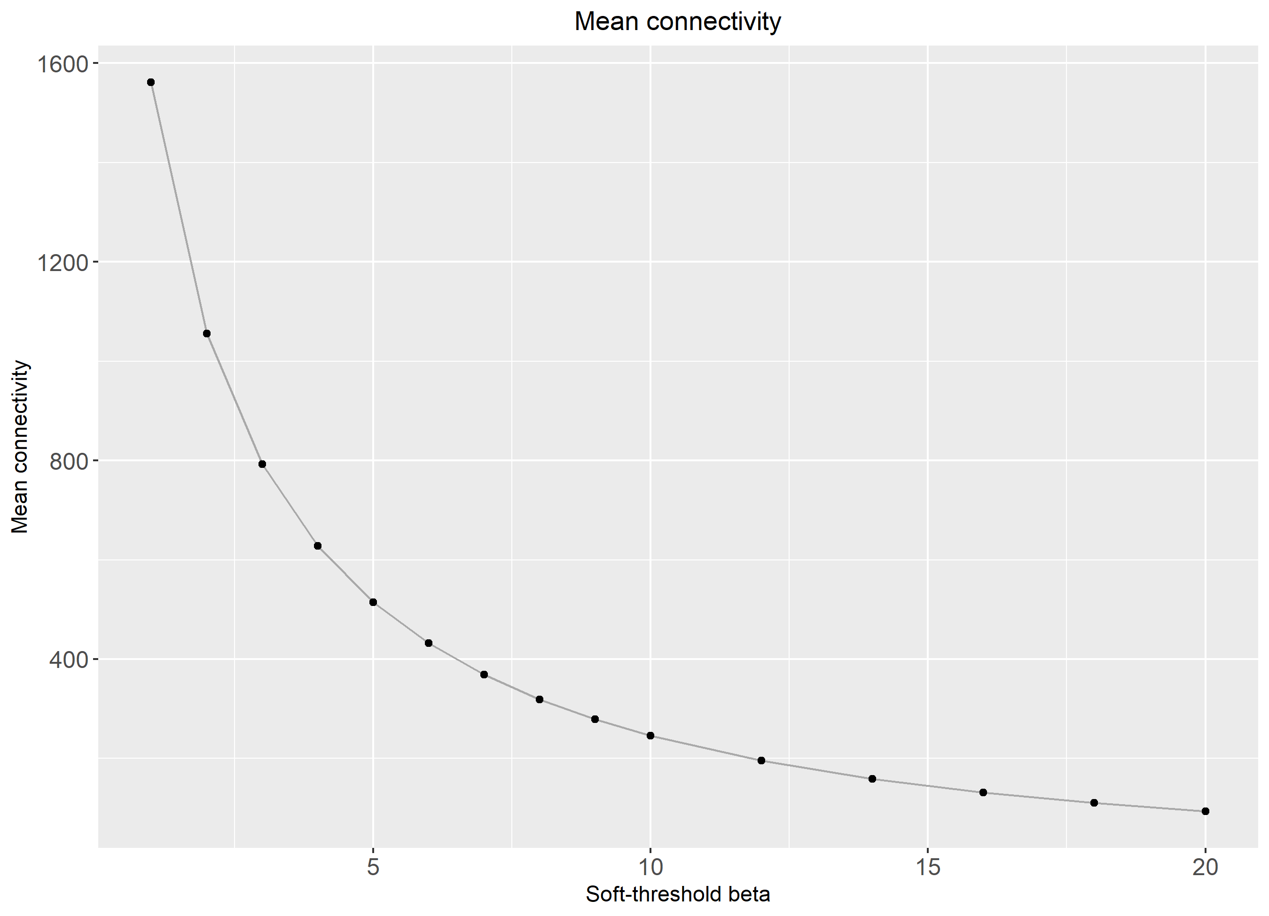

5.5 mean_var
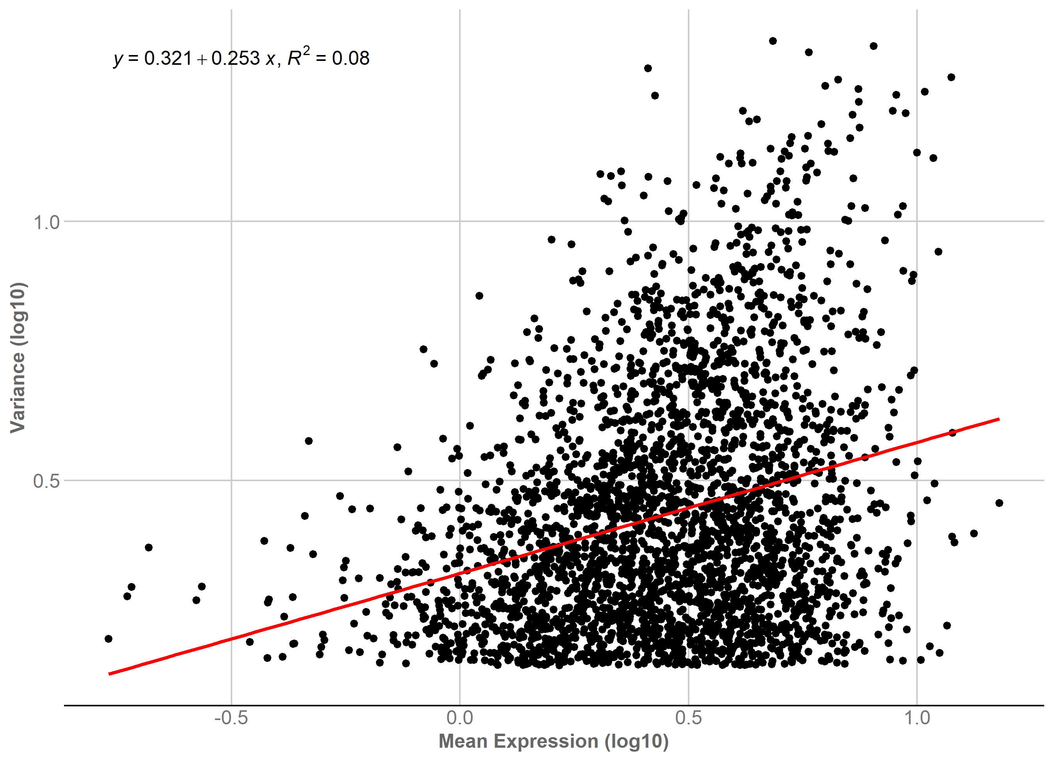

5.6 profile_M1
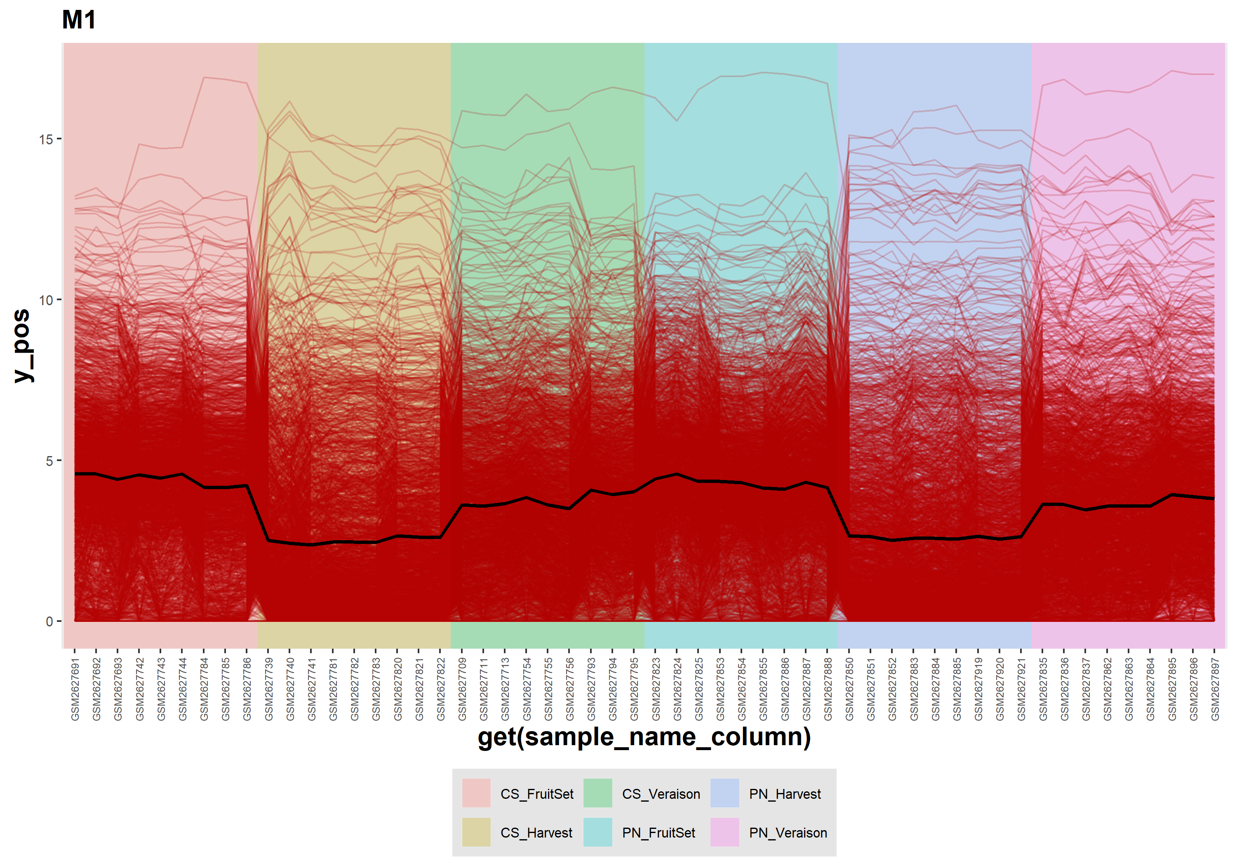

5.7 profile_M10
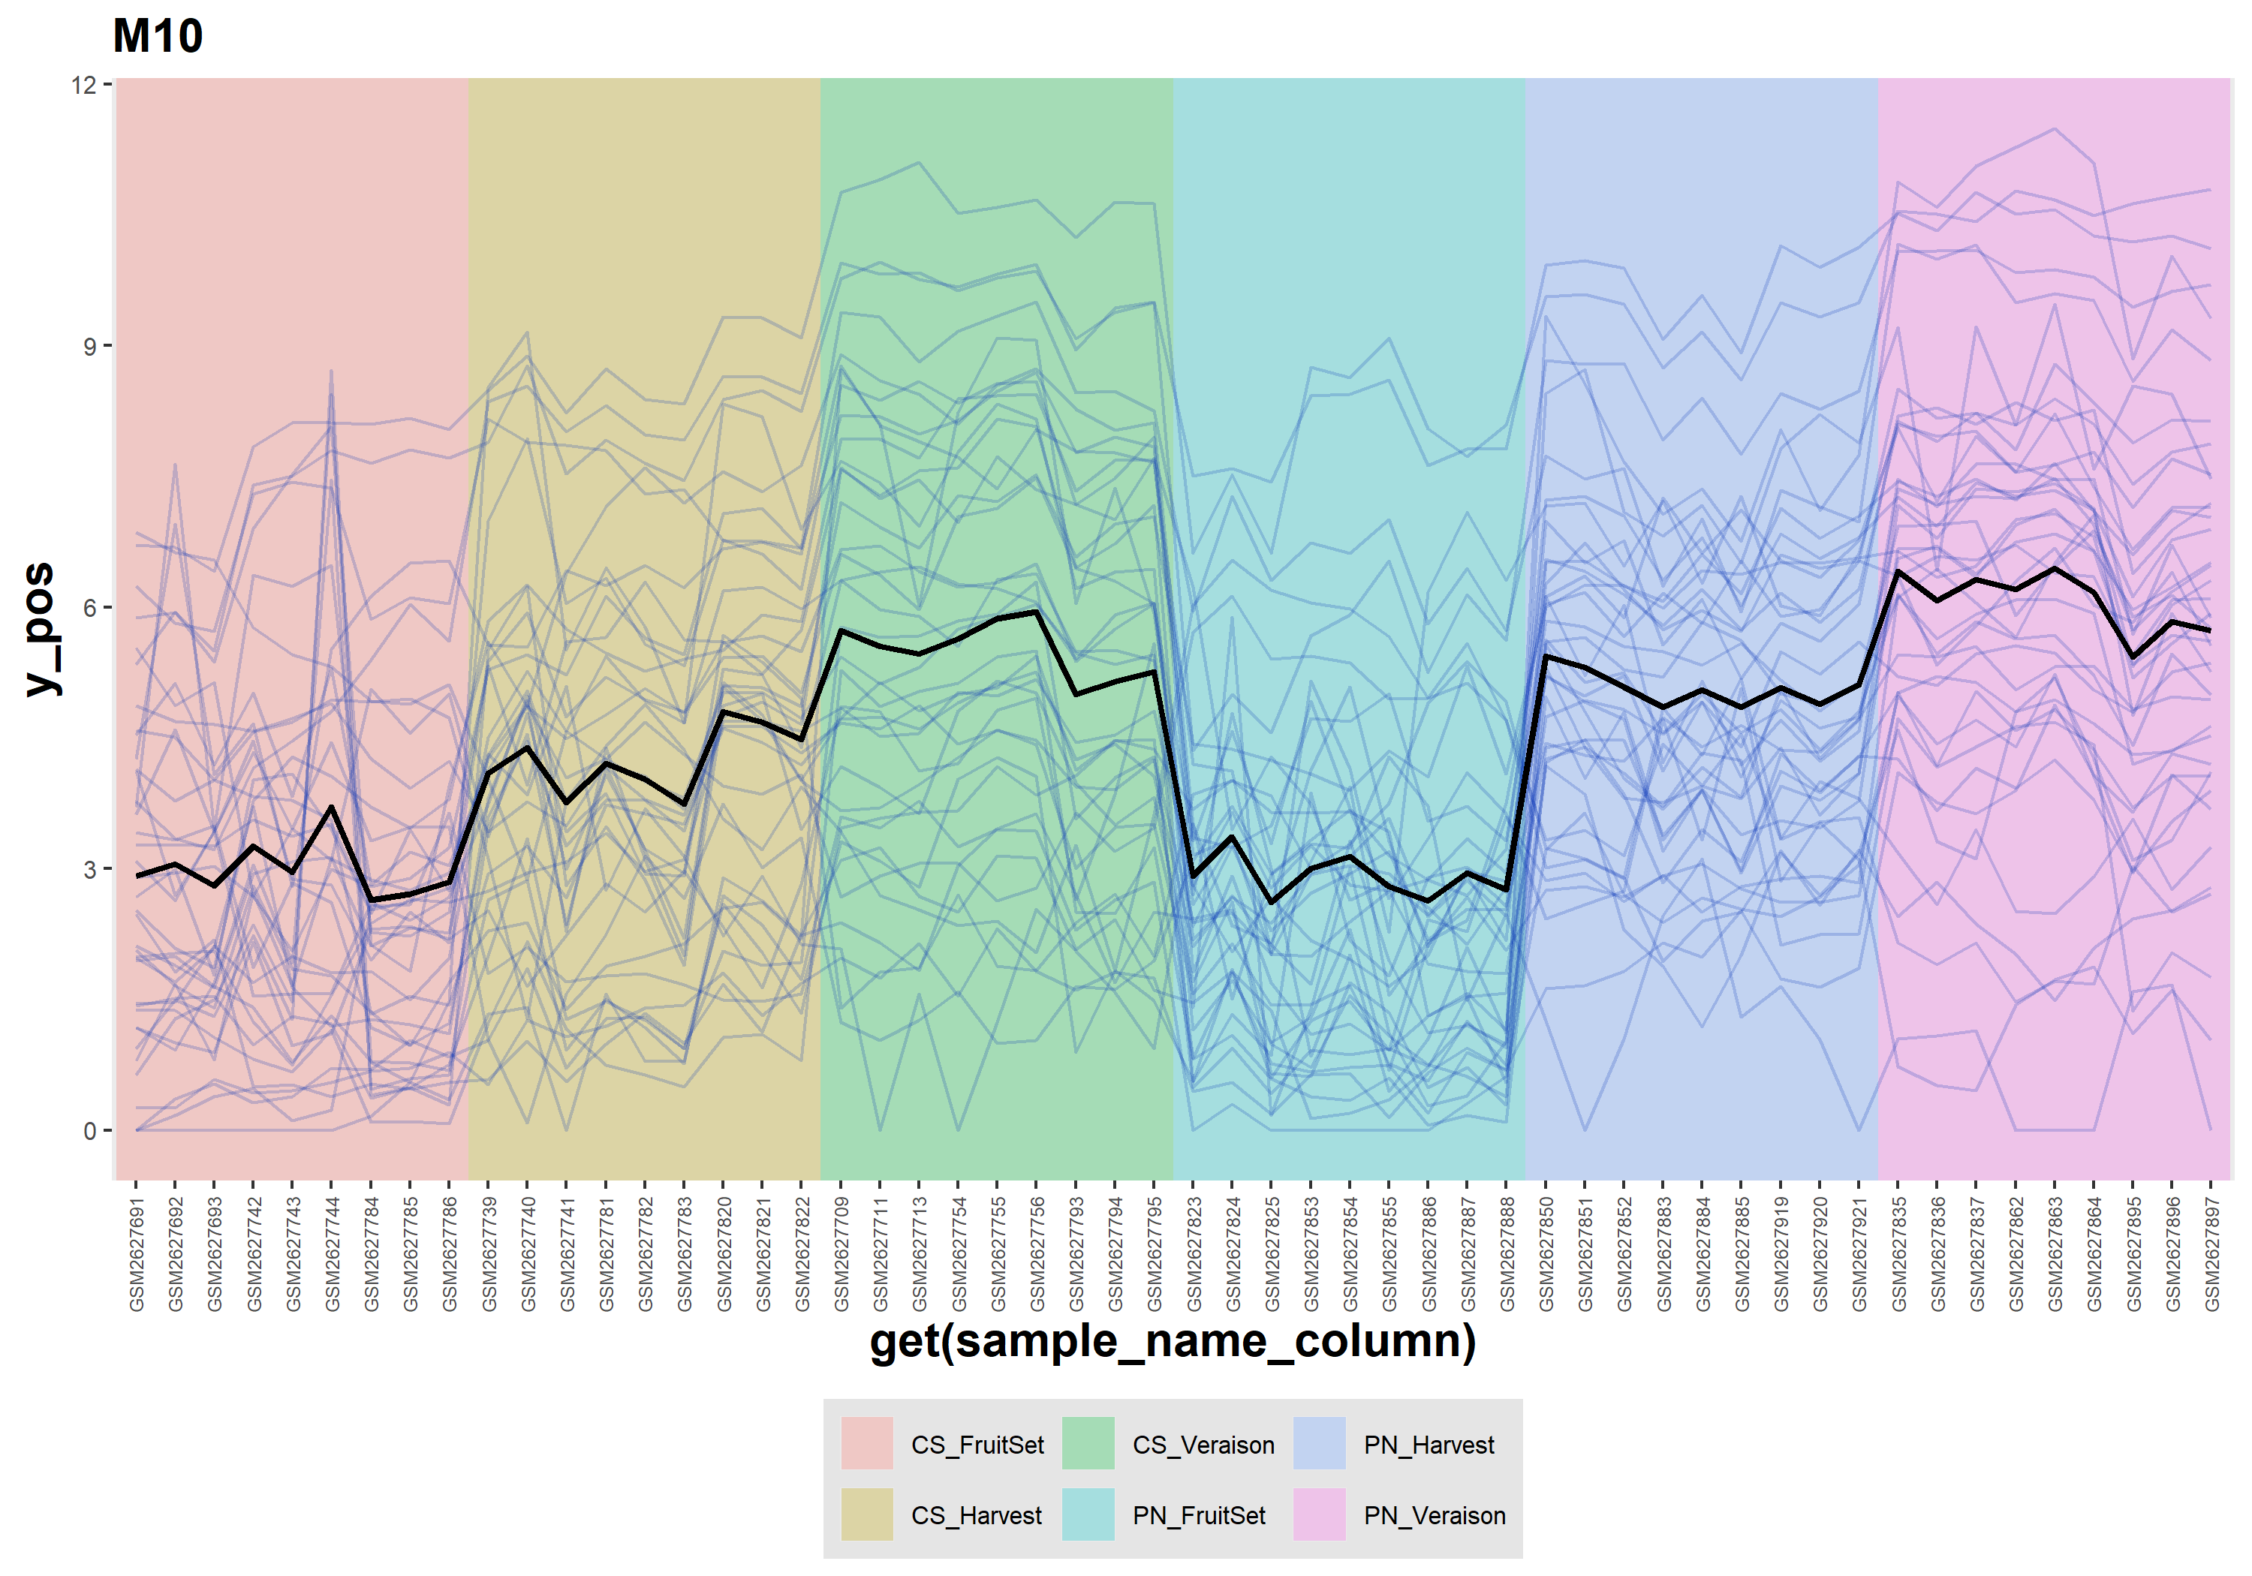

5.8 profile_M2
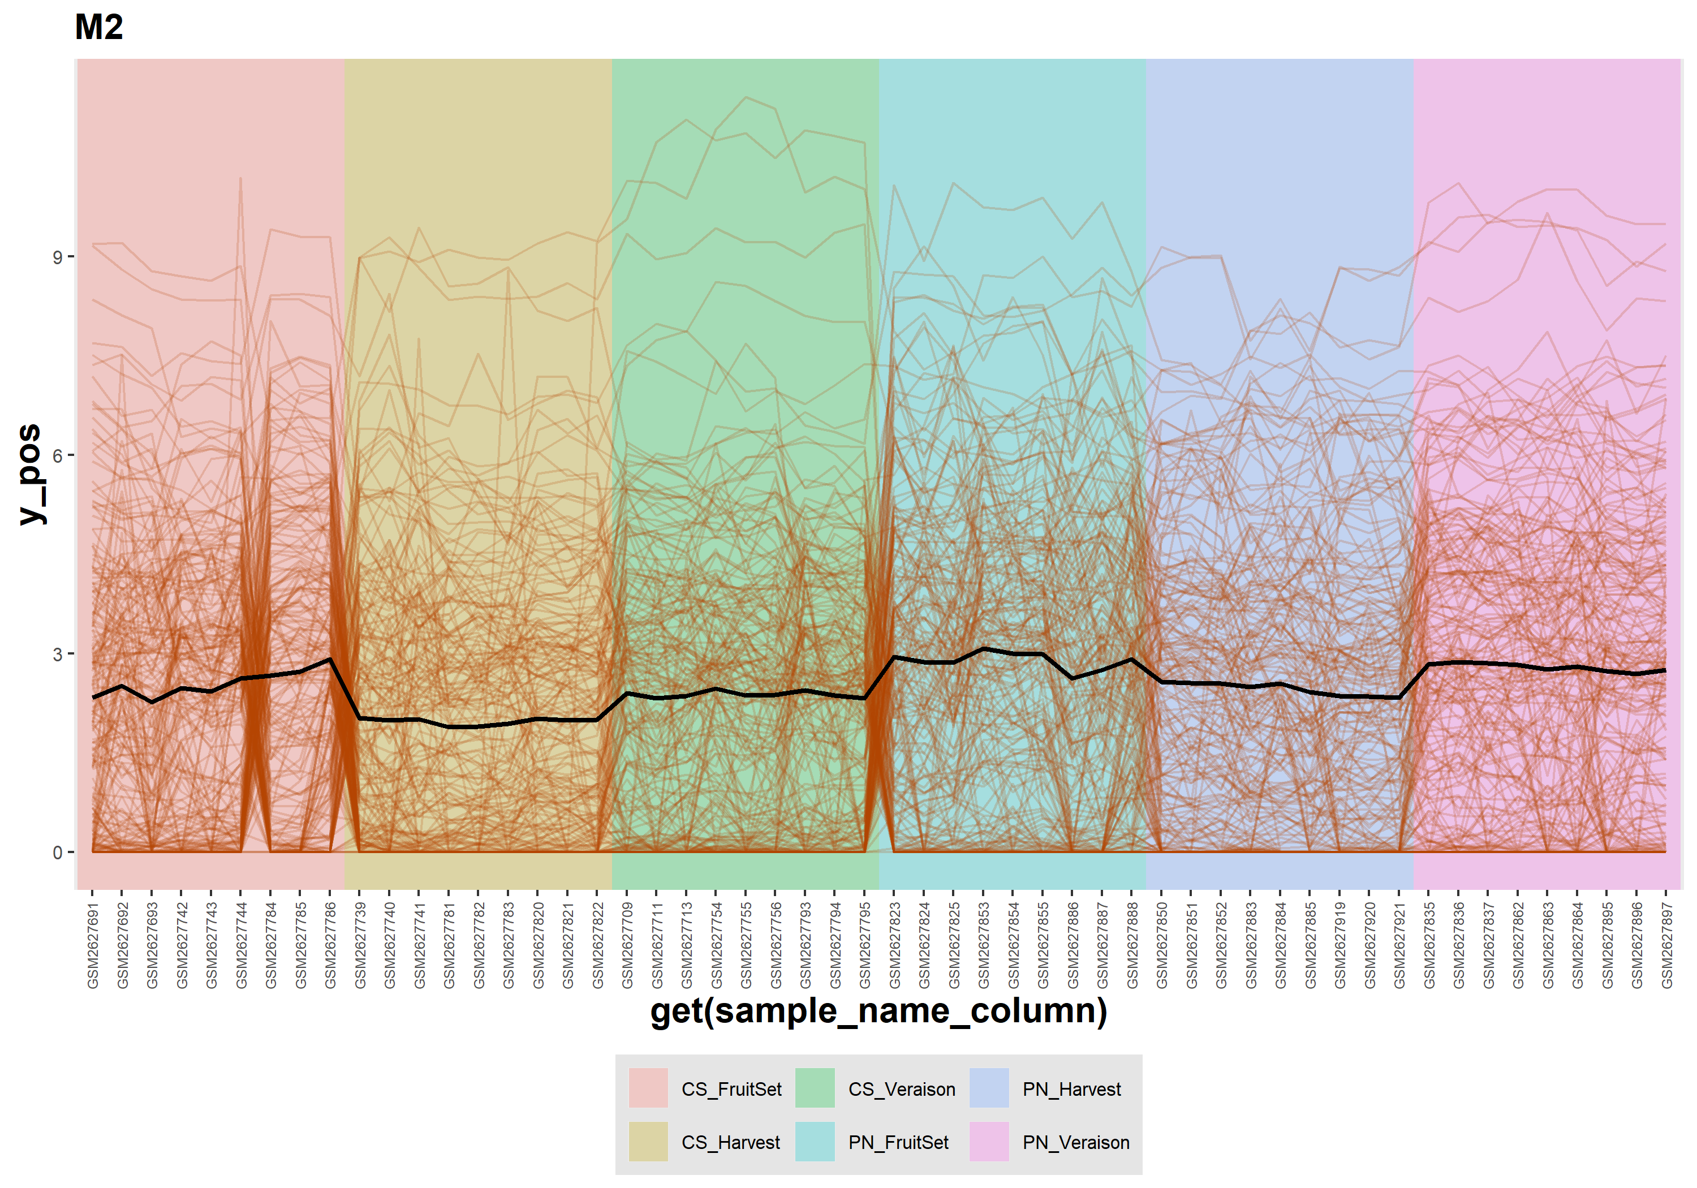

5.9 profile_M3
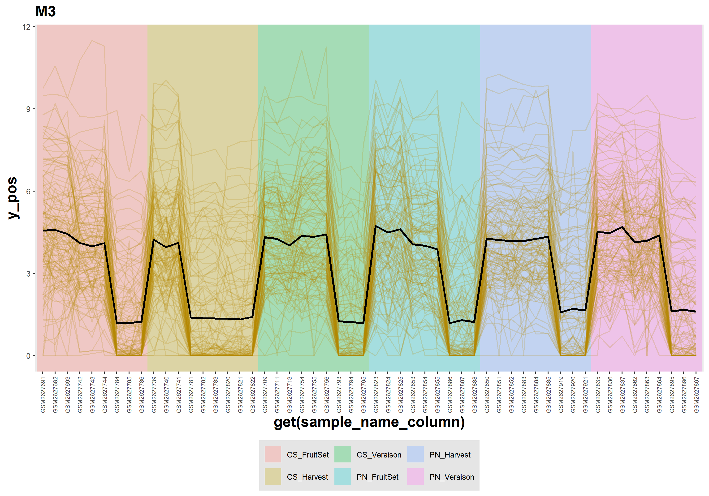

5.10 profile_M4
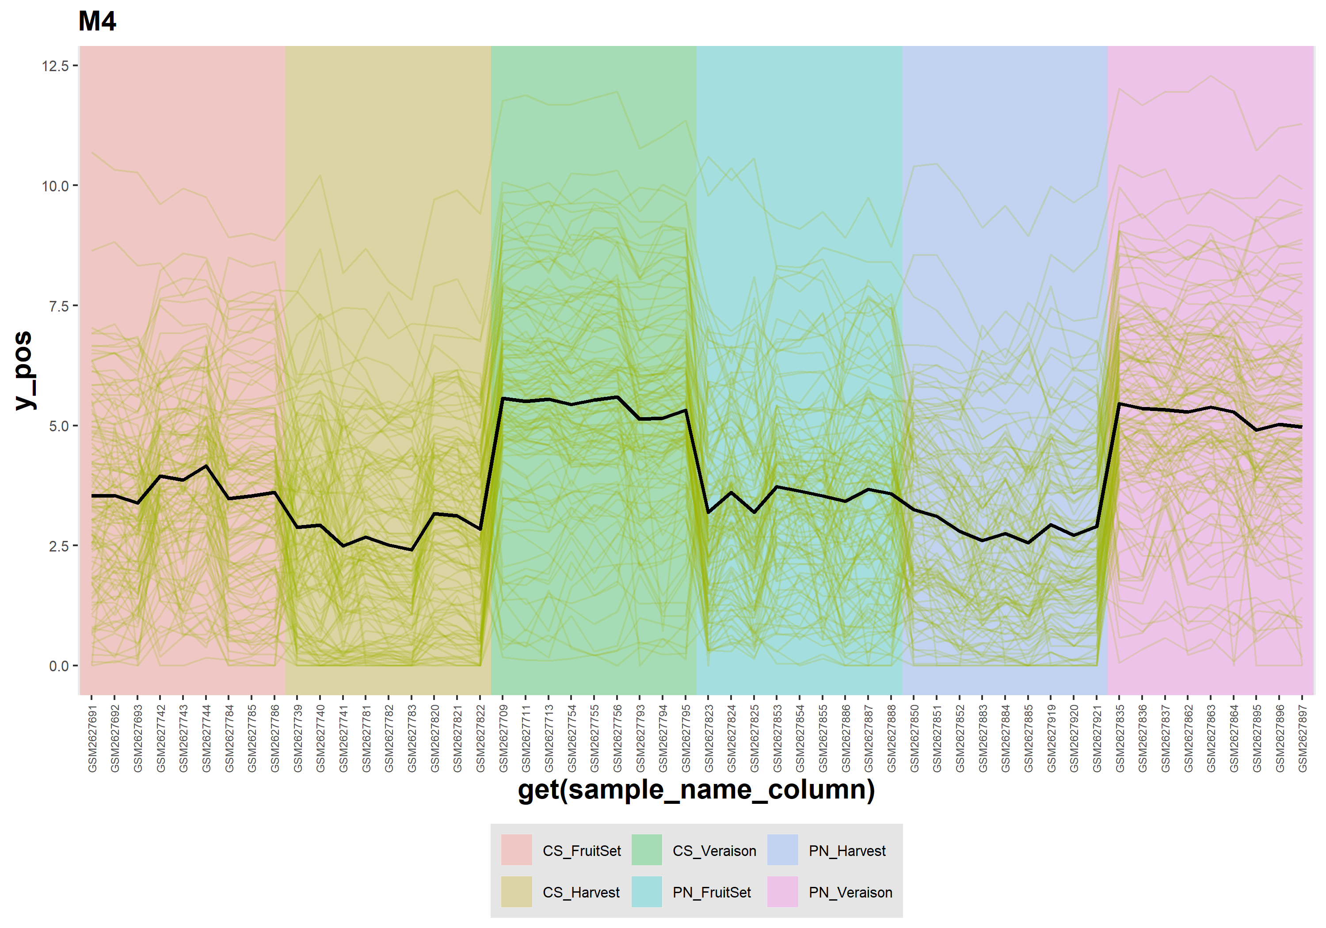

5.11 profile_M5
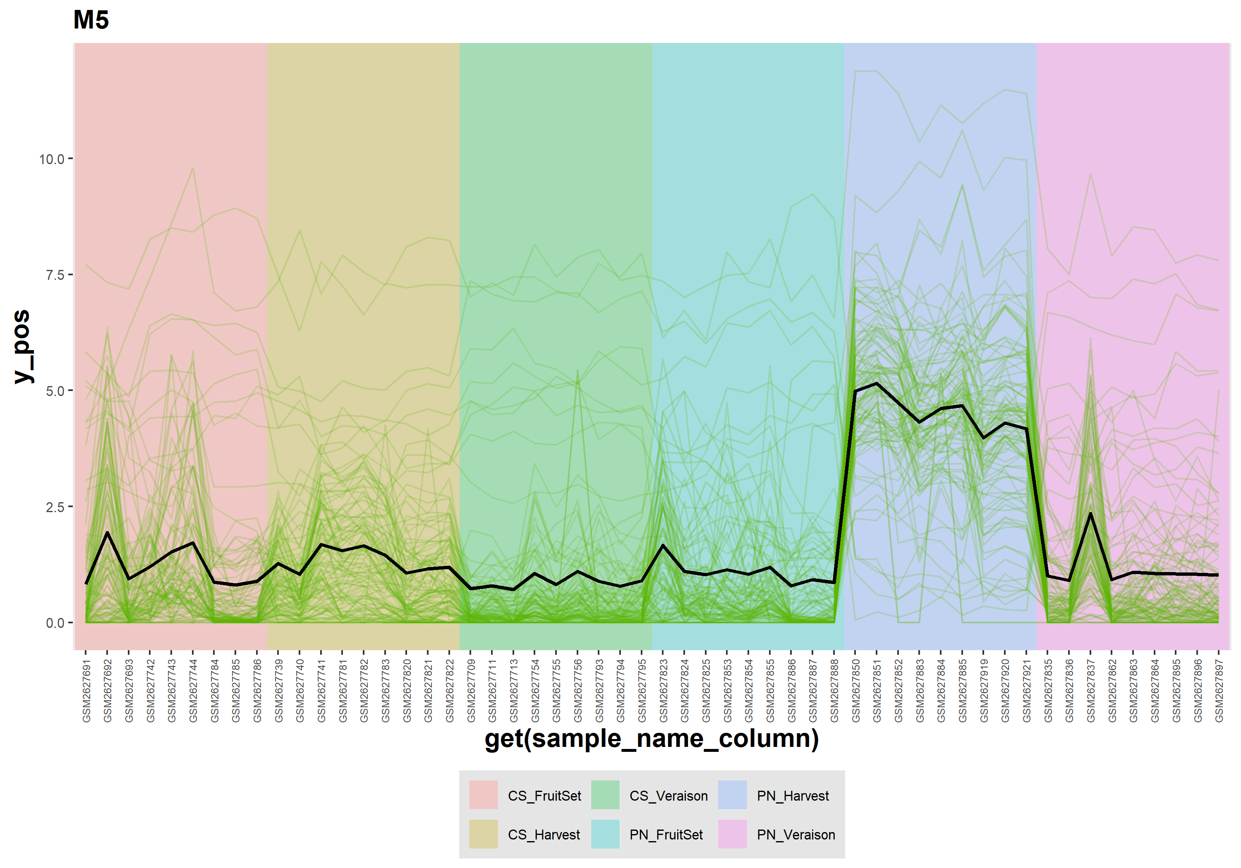

5.12 profile_M6
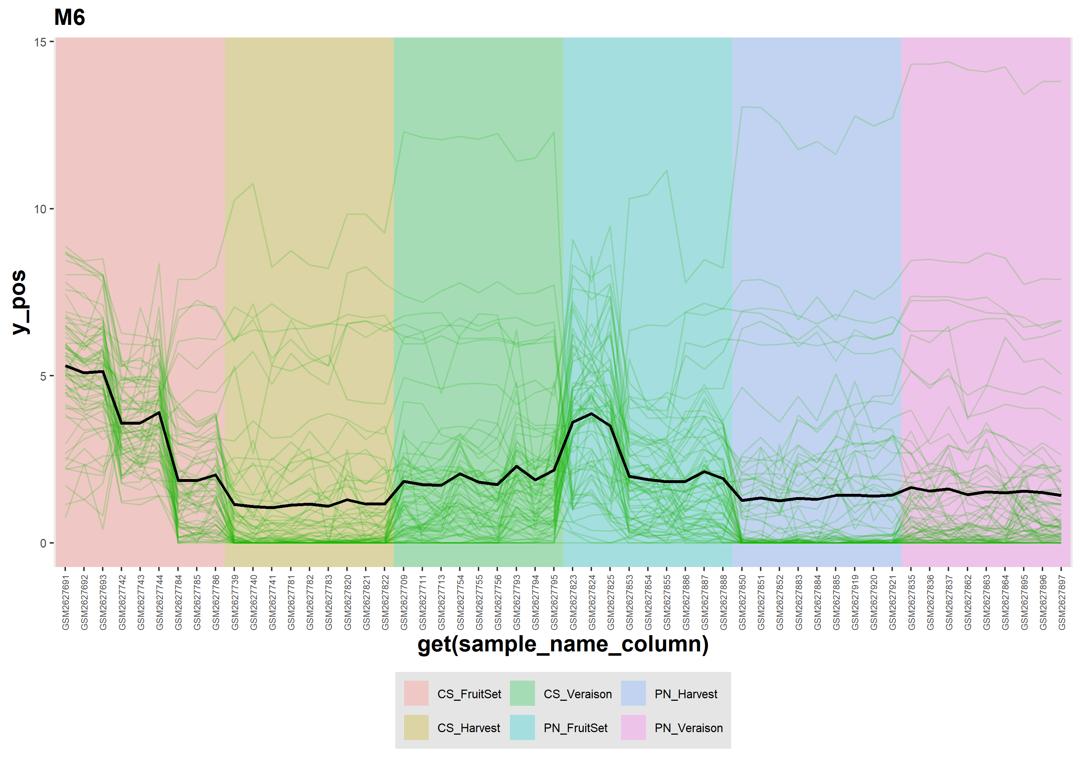

5.13 profile_M7
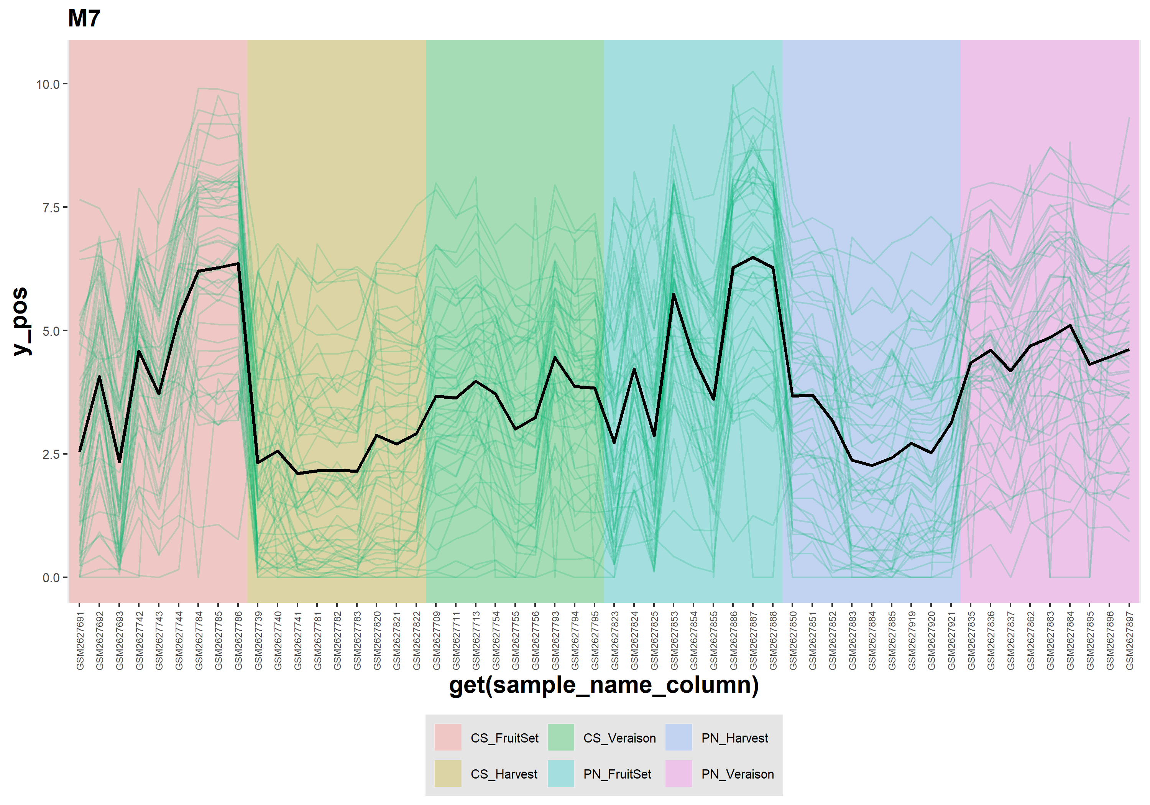

5.14 profile_M8
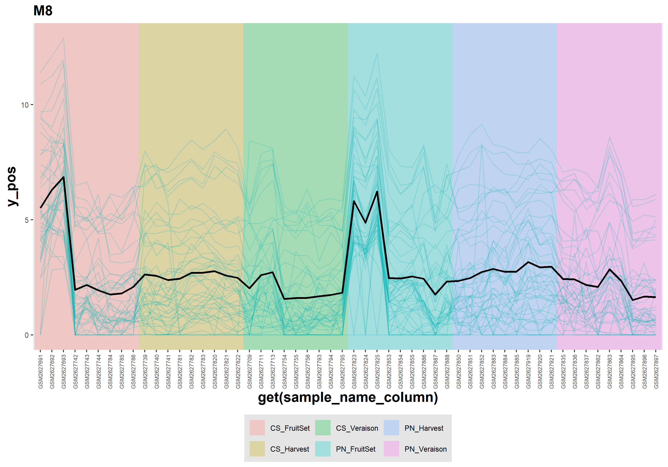

5.15 profile_M9
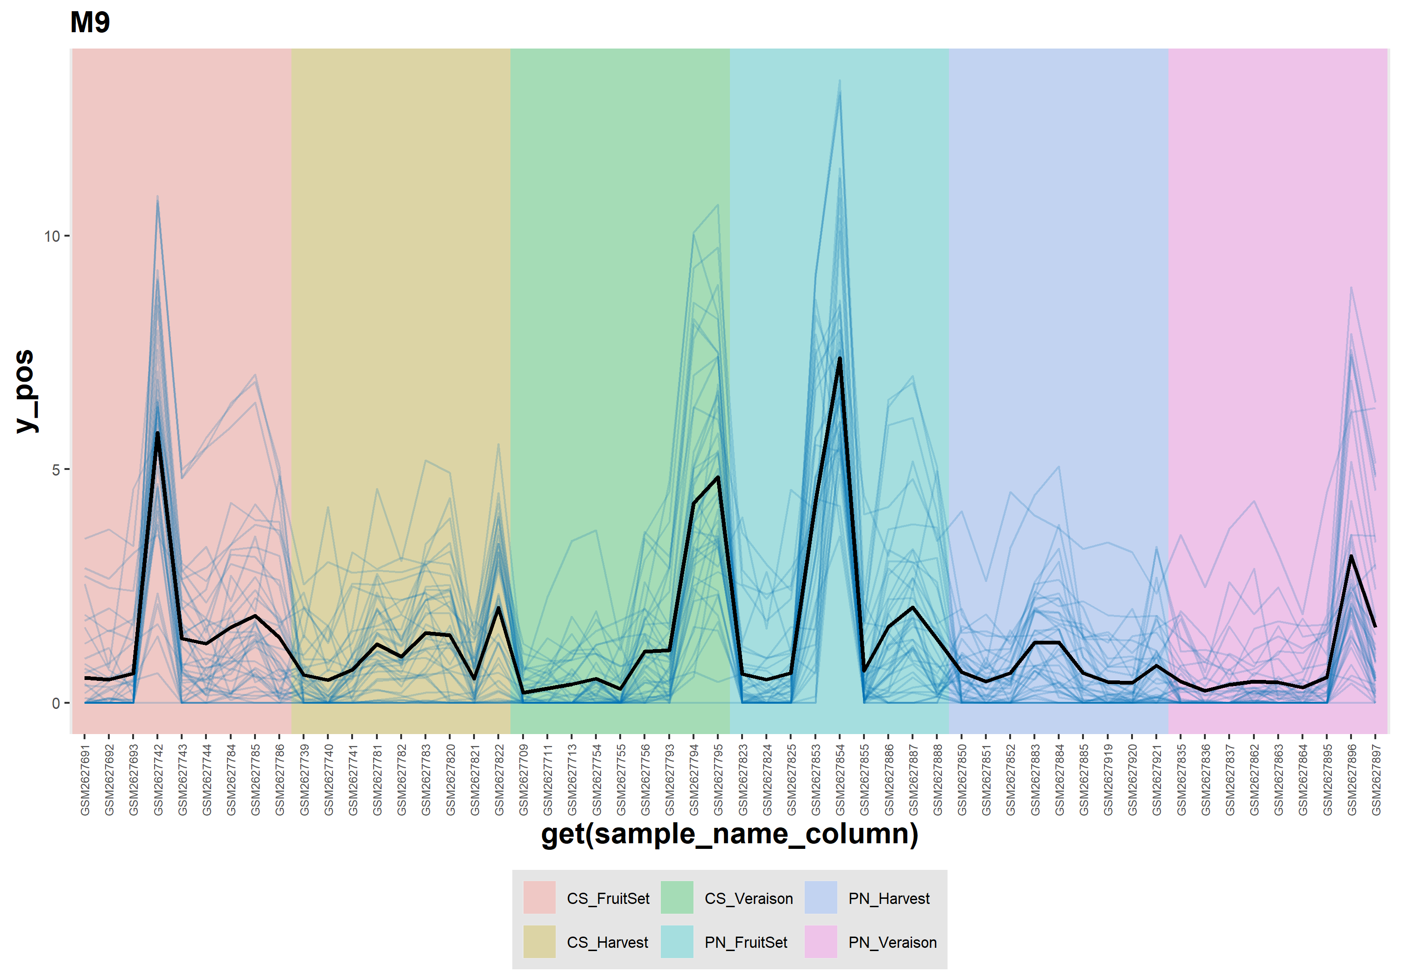

5.16 profile_Not_Correlated
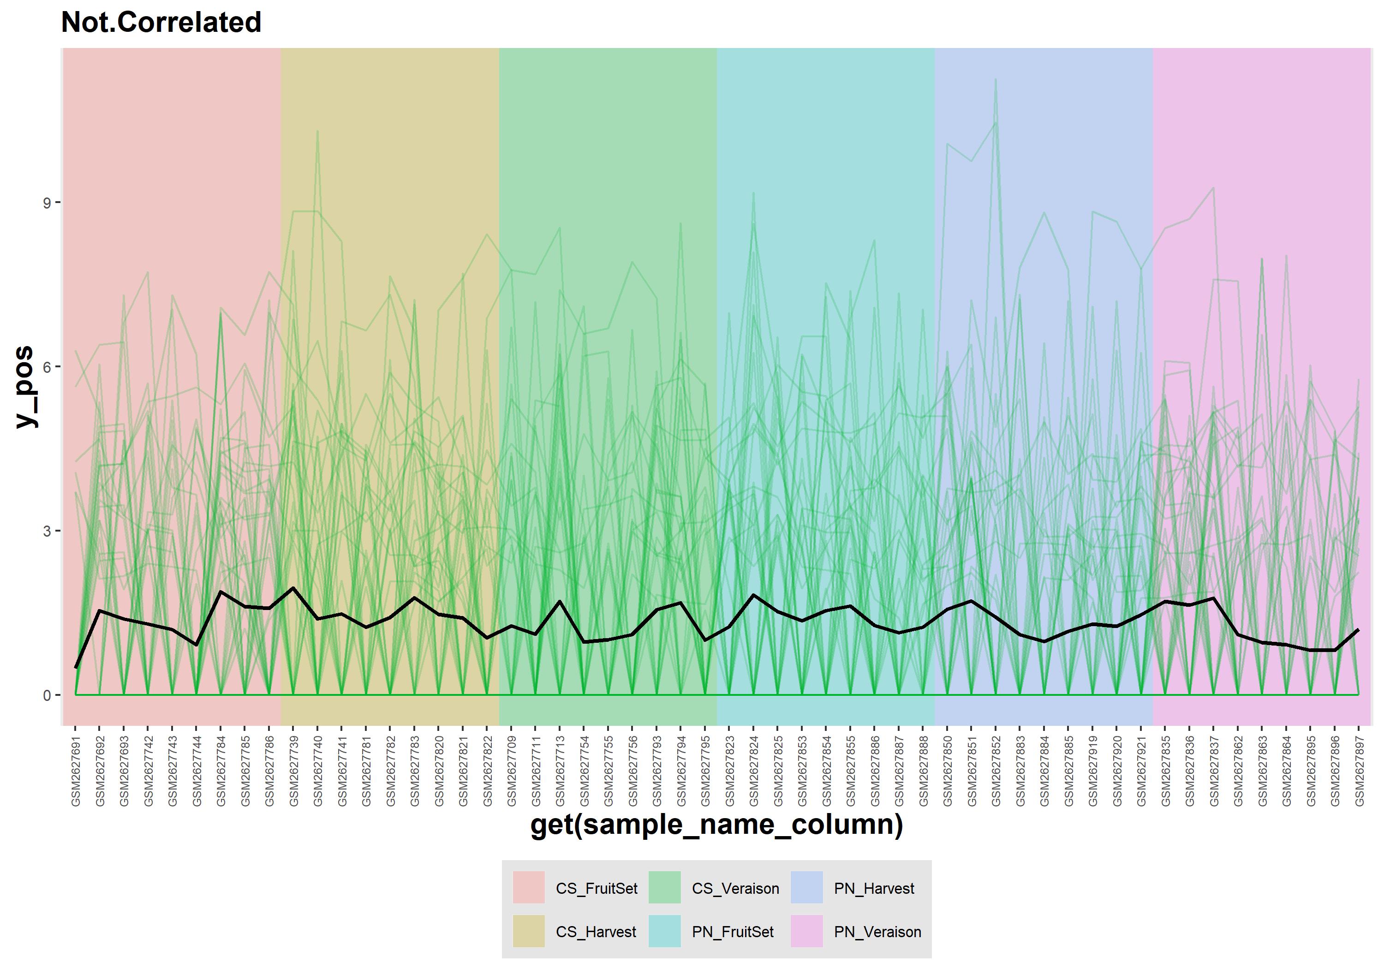

5.17 qq
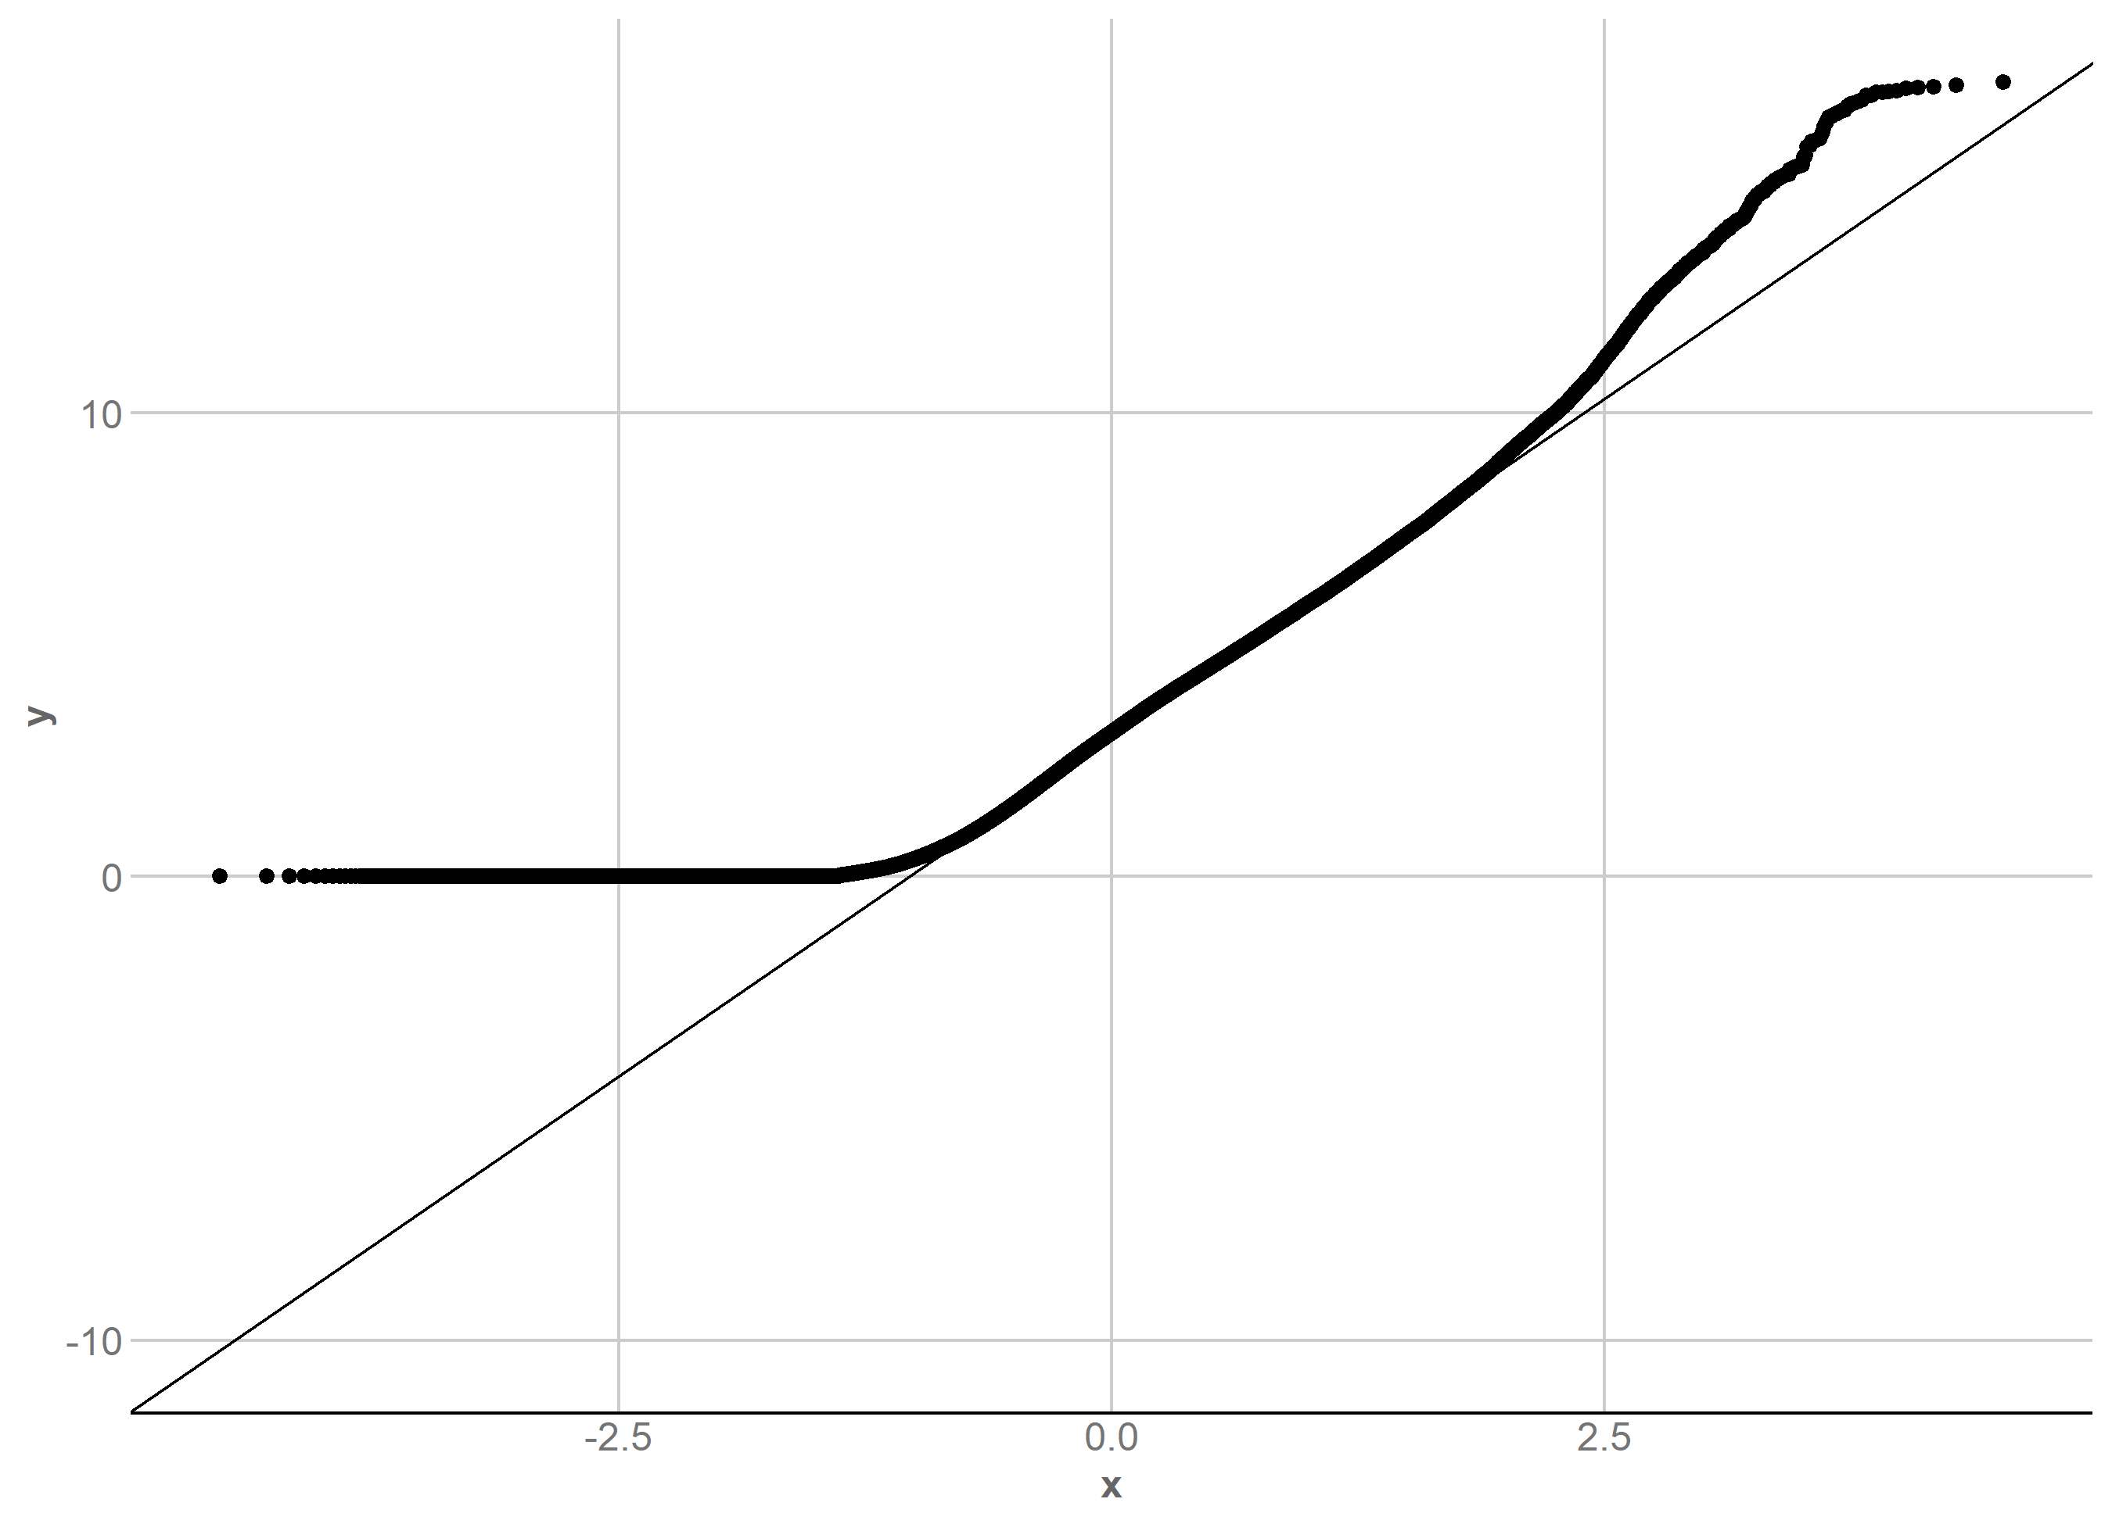

6 Exported result tables
The following section provides a compact view of every tabular result exported by CEMiTool. Complete tables remain available as machine-readable files under results/tables/.

6.1 beta_fit_indices.tsv
Dimensions: 15 rows x 10 columns.
beta_fit_indices.tsv
Power | SFT.R.sq | slope | truncated.R.sq | mean.k. | median.k. | max.k. | Density | Centralization | Heterogeneity
1 | 0.8394009 | 1.5707687 | 0.7946939 | 1561.85711 | 1754.66121 | 2111.9801 | 0.5122523 | 0.1805457 | 0.3207976
2 | 0.4232012 | 0.3873307 | 0.5948254 | 1055.58487 | 1206.78781 | 1705.7211 | 0.3462069 | 0.2133693 | 0.4790910
3 | 0.0123211 | 0.0444688 | 0.7254709 | 792.10695 | 884.92845 | 1453.8582 | 0.2597924 | 0.2171812 | 0.5801171
4 | 0.0875404 | -0.1174076 | 0.8310439 | 627.73973 | 675.70175 | 1274.2760 | 0.2058838 | 0.2121878 | 0.6544427
5 | 0.2744513 | -0.2192085 | 0.8129080 | 514.61128 | 528.42690 | 1136.6584 | 0.1687803 | 0.2041506 | 0.7137761
6 | 0.4333524 | -0.3044837 | 0.7362054 | 431.82894 | 421.50854 | 1026.4451 | 0.1416297 | 0.1951480 | 0.7635877
7 | 0.5495793 | -0.3627214 | 0.6942176 | 368.65752 | 339.87135 | 935.4799 | 0.1209110 | 0.1860264 | 0.8068294
8 | 0.6217077 | -0.4267637 | 0.6648029 | 318.95073 | 277.02872 | 858.7238 | 0.1046083 | 0.1771490 | 0.8452677
9 | 0.6650263 | -0.4781301 | 0.6414873 | 278.90991 | 228.17373 | 792.8474 | 0.0914759 | 0.1686699 | 0.8800415
10 | 0.7063742 | -0.5251829 | 0.6502824 | 246.04985 | 189.37337 | 735.5400 | 0.0806985 | 0.1606465 | 0.9119266
12 | 0.7067470 | -0.6147726 | 0.6230659 | 195.57118 | 134.48070 | 640.3966 | 0.0641427 | 0.1459880 | 0.9690884
14 | 0.7472853 | -0.6734742 | 0.6797739 | 158.91923 | 97.11593 | 564.3466 | 0.0521218 | 0.1330578 | 1.0196729
16 | 0.7496827 | -0.7344417 | 0.6990696 | 131.36780 | 72.38920 | 502.0230 | 0.0430855 | 0.1216459 | 1.0654044
18 | 0.7495778 | -0.7871557 | 0.7234977 | 110.09929 | 53.69994 | 449.9688 | 0.0361100 | 0.1115423 | 1.1073859
20 | 0.7605758 | -0.8268108 | 0.7500230 | 93.33028 | 40.81002 | 405.8351 | 0.0306101 | 0.1025615 | 1.1463678

6.2 enrichment_es.tsv
Dimensions: 10 rows x 7 columns.
enrichment_es.tsv
pathway | CS_FruitSet | CS_Veraison | CS_Harvest | PN_FruitSet | PN_Veraison | PN_Harvest
M10 | -0.7230231 | 0.5985374 | 0.4662943 | -0.7631498 | 0.7632057 | 0.5953022
M2 | -0.2702467 | -0.4045229 | 0.1897572 | 0.1528338 | 0.4009491 | 0.3168241
M3 | -0.4928964 | -0.0775830 | 0.2777637 | -0.4016256 | 0.2979030 | 0.5528034
M4 | -0.4797068 | 0.7662442 | -0.2166083 | -0.5704144 | 0.7178583 | -0.2388118
M5 | -0.5946456 | -0.6852390 | 0.5099956 | -0.6279539 | -0.5903679 | 0.8708191
M6 | 0.5981419 | -0.2428080 | 0.3700474 | 0.1467911 | -0.5620152 | 0.3800916
M7 | -0.4028705 | -0.2620536 | -0.2969209 | 0.3406279 | 0.5067387 | 0.3471849
M8 | -0.3513185 | -0.6778466 | 0.5233773 | 0.3072853 | -0.6231626 | 0.5444628
M9 | -0.4249585 | -0.1595745 | 0.5184045 | 0.3130987 | -0.5479842 | 0.5255984
Not.Correlated | -0.4570197 | -0.1856715 | 0.6155754 | -0.4134418 | -0.2873009 | 0.5145339

6.3 enrichment_nes.tsv
Dimensions: 10 rows x 7 columns.
enrichment_nes.tsv
pathway | CS_FruitSet | CS_Veraison | CS_Harvest | PN_FruitSet | PN_Veraison | PN_Harvest
M10 | -3.959396 | 2.1492587 | 2.615432 | -4.2536734 | 2.728041 | 3.118858
M2 | -2.141531 | -2.2761001 | 1.614254 | 0.9429160 | 1.839075 | 2.451360
M3 | -3.541564 | -0.4093924 | 2.099724 | -3.1346970 | 1.304286 | 3.856798
M4 | -3.403567 | 3.3899077 | -1.230025 | -4.3302647 | 3.115328 | -1.424578
M5 | -4.156126 | -3.5193848 | 3.767544 | -4.5950476 | -3.083399 | 5.848706
M6 | 2.777735 | -1.1341715 | 2.424789 | 0.7430314 | -2.774107 | 2.283311
M7 | -2.394055 | -1.1530162 | -1.444617 | 1.6434296 | 1.941217 | 1.979208
M8 | -2.044511 | -2.9146050 | 3.236747 | 1.4406157 | -2.837919 | 2.984385
M9 | -2.405142 | -0.6670530 | 3.002033 | 1.4350954 | -2.385699 | 2.803384
Not.Correlated | -2.773385 | -0.8343909 | 3.831869 | -2.5856587 | -1.359322 | 2.973914

6.4 enrichment_padj.tsv
Dimensions: 10 rows x 7 columns.
enrichment_padj.tsv
pathway | CS_FruitSet | CS_Veraison | CS_Harvest | PN_FruitSet | PN_Veraison | PN_Harvest
M10 | 0.0000000 | 0.0000225 | 0.0000024 | 0.0000000 | 0.0000000 | 0.0000000
M2 | 0.0000000 | 0.0000000 | 0.0004024 | 0.6718346 | 0.0000035 | 0.0000000
M3 | 0.0000000 | 1.0000000 | 0.0000024 | 0.0000000 | 0.0774487 | 0.0000000
M4 | 0.0000000 | 0.0000000 | 0.1552106 | 0.0000000 | 0.0000000 | 0.0377113
M5 | 0.0000000 | 0.0000000 | 0.0000000 | 0.0000000 | 0.0000000 | 0.0000000
M6 | 0.0000000 | 0.3151261 | 0.0000022 | 0.8589894 | 0.0000000 | 0.0000089
M7 | 0.0000037 | 0.3151261 | 0.0707547 | 0.0165577 | 0.0001668 | 0.0011522
M8 | 0.0002388 | 0.0000000 | 0.0000000 | 0.0829238 | 0.0000000 | 0.0000000
M9 | 0.0000254 | 1.0000000 | 0.0000000 | 0.0829238 | 0.0000047 | 0.0000001
Not.Correlated | 0.0000000 | 1.0000000 | 0.0000000 | 0.0000025 | 0.0732555 | 0.0000000

6.5 module.tsv
Dimensions: 3050 rows x 2 columns.
module.tsv - first 40 rows shown
genes | modules
VIT_19s0014g02740 | M1
VIT_08s0056g01610 | M1
VIT_12s0059g00590 | M1
VIT_01s0010g02030 | M1
VIT_08s0056g01600 | M1
VIT_05s0049g00520 | M1
VIT_02s0025g03390 | M1
VIT_11s0016g00210 | M1
VIT_16s0022g00960 | M1
VIT_07s0005g00660 | M1
VIT_19s0090g01370 | M1
VIT_06s0004g03240 | M1
VIT_06s0004g04650 | M1
VIT_05s0049g00760 | M1
VIT_17s0000g03280 | M4
VIT_19s0014g02730 | M1
VIT_01s0011g05110 | M6
VIT_03s0180g00070 | M1
VIT_00s0187g00160 | M1
VIT_18s0001g14270 | M1
VIT_19s0090g01340 | M1
VIT_09s0002g05180 | M1
VIT_07s0031g02210 | M1
VIT_19s0090g01000 | M1
VIT_03s0038g01510 | M1
VIT_16s0022g01770 | M1
VIT_05s0094g00340 | M1
VIT_18s0001g14260 | M1
VIT_02s0025g01050 | M1
VIT_19s0090g01350 | M1
VIT_02s0033g01330 | M1
VIT_02s0033g01120 | M10
VIT_04s0008g05010 | M1
VIT_02s0025g03600 | M1
VIT_02s0025g04330 | M1
VIT_13s0019g04280 | M1
VIT_10s0003g00090 | M1
VIT_03s0038g02520 | M1
VIT_11s0016g04920 | M1
VIT_12s0028g01060 | M1
The complete table is provided as a supplementary machine-readable file.

6.6 parameters.tsv
Dimensions: 11 rows x 2 columns.
parameters.tsv
Parameter | Value
filter | TRUE
apply_vst | FALSE
filter_pval | 0.1
cor_method | pearson
min_ngen | 30
merge_similar | TRUE
diss_thresh | 0.8
r2 | 0.706374247063269
beta | 10
phi | 0.500166177070297
n_mods | 11

6.7 selected_genes.txt
Dimensions: 3049 rows x 1 columns.
selected_genes.txt - first 40 rows shown
VIT_19s0014g02740
VIT_08s0056g01610
VIT_12s0059g00590
VIT_01s0010g02030
VIT_08s0056g01600
VIT_05s0049g00520
VIT_02s0025g03390
VIT_11s0016g00210
VIT_16s0022g00960
VIT_07s0005g00660
VIT_19s0090g01370
VIT_06s0004g03240
VIT_06s0004g04650
VIT_05s0049g00760
VIT_17s0000g03280
VIT_19s0014g02730
VIT_01s0011g05110
VIT_03s0180g00070
VIT_00s0187g00160
VIT_18s0001g14270
VIT_19s0090g01340
VIT_09s0002g05180
VIT_07s0031g02210
VIT_19s0090g01000
VIT_03s0038g01510
VIT_16s0022g01770
VIT_05s0094g00340
VIT_18s0001g14260
VIT_02s0025g01050
VIT_19s0090g01350
VIT_02s0033g01330
VIT_02s0033g01120
VIT_04s0008g05010
VIT_02s0025g03600
VIT_02s0025g04330
VIT_13s0019g04280
VIT_10s0003g00090
VIT_03s0038g02520
VIT_11s0016g04920
VIT_12s0028g01060
VIT_18s0001g12830
The complete table is provided as a supplementary machine-readable file.

6.8 summary_eigengene.tsv
Dimensions: 11 rows x 55 columns.
The in-document preview is omitted because this matrix has 55 columns. The complete table remains available as a machine-readable file.

6.9 summary_mean.tsv
Dimensions: 11 rows x 55 columns.
The in-document preview is omitted because this matrix has 55 columns. The complete table remains available as a machine-readable file.

6.10 summary_median.tsv
Dimensions: 11 rows x 55 columns.
The in-document preview is omitted because this matrix has 55 columns. The complete table remains available as a machine-readable file.

7 Supplementary data inventory
The full analysis files are indexed in reports/supplementary/manifest.tsv. The manifest records relative paths, file sizes, and MD5 checksums.
Supplementary file inventory.
file | bytes | md5
data/metadata/phenotypes.tsv | 1296 | 3ded458ab03ff3e1694c33db594c19f9
data/metadata/sample_geo_map.tsv | 10654 | c0e7260e2115a3fb85dd76228b953c44
data/metadata/sample_images.tsv | 1497 | 2f2700c2e90786b44e078b0cfabdbfa7
data/metadata/samples.tsv | 9957 | 494e1078fc9806589f3024eed79c8136
data/processed/expression_log2rpkm.rds | 9656439 | 77f6b173e329b9c1583d1bd52c0ab5ca
data/processed/expression_log2rpkm.tsv | 21802281 | 95761a42392a04d55642f378fe0fa5ce
data/processed/expression_rpkm.tsv | 11158928 | 636a4103dc8b388862503c5c989b3690
logs/parameters.txt | 288 | 42e700fbf2f7fdcc032db19fdaf38e28
logs/run_summary.txt | 147 | 153756a512a8a707d6406da5dcc2d0d2
logs/session_info.txt | 5832 | 46cfc2f7438b3a095a050a648622de80
reports/cemitool/report.html | 4053372 | 72edf3164422e6cec1d29d62d4baf4b2
reports/diagnostics/diagnostics.html | 975533 | 02876519ac07af41cab568e017076094
reports/native_report_status.tsv | 103 | cb9c1034c7cf2e211fb29ce01b16b718
results/figures/beta_r2.pdf | 5718 | 83cfaa117a752d16bf6f42a5a5f22e79
results/figures/gsea.pdf | 9481 | a8e0c3c482e0c878231afe9227f971dc
results/figures/hist.pdf | 5105 | b5dafc083d17fd9d9eafecf8f9908d19
results/figures/mean_k.pdf | 5468 | 450d829952c18a11db0e7b08df03f015
results/figures/mean_var.pdf | 173388 | 2b4a703d540829622eb8b7a2ff99b6cd
results/figures/profile.pdf | 715657 | 59f97246e8cd190a556c579099cc90a5
results/figures/qq.pdf | 1392120 | 5f384f61a0ac5630906baf5453ba76d1
results/figures/sample_tree.pdf | 6798 | 3f42183cbed26905c0771ac939acc8d4
results/tables/beta_fit_indices.tsv | 2527 | 6ec616e12b6c75d209918578a4a717cb
results/tables/enrichment_es.tsv | 1273 | 5aaa94fc1ac921d3b7ecb34dea12834d
results/tables/enrichment_nes.tsv | 1213 | 70f2139cabd0bf1825dbb315982b389f
results/tables/enrichment_padj.tsv | 1336 | 57ff84dcd2d32ab4d7c3616426701ebd
results/tables/module.tsv | 80042 | c1f78a7ab02f444690e3c6ca9778dcdb
results/tables/modules_genes.gmt | 72623 | 76a41959c5260da575318d5dbe1621f8
results/tables/parameters.tsv | 247 | 31188bc3cad8c270fbcb0a1877f93af2
results/tables/selected_genes.txt | 57950 | 3fbe5f3efd8f2a6f69851ea0df1e0ad7
results/tables/summary_eigengene.tsv | 12093 | dc0ea4013ab26493d6dc8cb8bc7bfd89
results/tables/summary_mean.tsv | 10893 | b9b1595a8ca08e7e003592a0c1ad22ee
results/tables/summary_median.tsv | 10071 | ec27d56bf7f2c816bdb63d71004c66bd

8 Reproducibility
## ```text
## R version 4.6.1 (2026-06-24 ucrt)
## Platform: x86_64-w64-mingw32/x64
## Running under: Windows 11 x64 (build 26200)
##
## Matrix products: default
## LAPACK version 3.12.1
##
## locale:
## [1] LC_COLLATE=Spanish_Chile.utf8 LC_CTYPE=Spanish_Chile.utf8
## LC_MONETARY=Spanish_Chile.utf8
## [4] LC_NUMERIC=C LC_TIME=Spanish_Chile.utf8
##
## time zone: America/Santiago
## tzcode source: internal
##
## attached base packages:
## [1] stats graphics grDevices utils datasets methods base
##
## other attached packages:
## [1] CEMiTool_1.36.0 GEOquery_2.80.0 Biobase_2.72.0 BiocGenerics_0.58.1 generics_0.1.4
##
## loaded via a namespace (and not attached):
## [1] splines_4.6.1 ggplotify_0.1.3 R.oo_1.27.1 tibble_3.3.1
## [5] ggpp_0.6.1 polyclip_1.10-7 preprocessCore_1.74.0 enrichit_0.2.1
## [9] confintr_1.0.2 XML_3.99-0.24 rpart_4.1.27 lifecycle_1.0.5
## [13] httr2_1.3.0 fastcluster_1.3.0 doParallel_1.0.17 processx_3.9.0
## [17] lattice_0.22-9 MASS_7.3-65 backports_1.5.1 magrittr_2.0.5
## [21] limma_3.68.5 Hmisc_5.3-0 rmarkdown_2.32 yaml_2.3.12
## [25] otel_0.2.0 ggtangle_0.1.2 zip_3.0.2 cowplot_1.2.0
## [29] DBI_1.3.0 RColorBrewer_1.1-3 abind_1.4-8 GenomicRanges_1.64.0
## [33] R.utils_2.13.0 purrr_1.2.2 pracma_2.4.6 yulab.utils_0.2.5
## [37] nnet_7.3-20 tweenr_2.0.3 rappdirs_0.3.4 aisdk_1.4.12
## [41] gdtools_0.5.1 IRanges_2.46.0 S4Vectors_0.50.3 enrichplot_1.31.2
## [45] ggrepel_0.9.8 tidytree_0.4.8 ggpmisc_1.0.0 rentrez_1.2.4
## [49] MatrixModels_0.5-4 codetools_0.2-20 DelayedArray_0.38.2 ggforce_0.5.0
## [53] DOSE_4.5.0 DT_0.34.0 xml2_1.6.0 tidyselect_1.2.1
## [57] aplot_0.3.1 farver_2.1.2 matrixStats_1.5.0 stats4_4.6.1
## [61] dynamicTreeCut_1.63-1 base64enc_0.1-6 Seqinfo_1.2.0 jsonlite_2.0.0
## [65] Formula_1.2-6 survival_3.8-6 iterators_1.0.14 systemfonts_1.3.2
## [69] foreach_1.5.2 tools_4.6.1 ggnewscale_0.5.2 treeio_1.36.1
## [73] sna_2.8 Rcpp_1.1.2 glue_1.8.1 gridExtra_2.3.1
## [77] SparseArray_1.12.2 mgcv_1.9-4 xfun_0.60 qvalue_2.44.0
## [81] MatrixGenerics_1.24.0 ggthemes_6.0.0 dplyr_1.2.1 withr_3.0.3
## [85] BiocManager_1.30.27 fastmap_1.2.0 SparseM_1.84-2 callr_3.8.0
## [89] digest_0.6.39 R6_2.6.1 gridGraphics_0.5-1 colorspace_2.1-3
## [93] GO.db_3.23.1 RSQLite_3.53.3 R.methodsS3_1.8.2 tidyr_1.3.2
## [97] fontLiberation_0.1.0 data.table_1.18.6.1 httr_1.4.9 htmlwidgets_1.6.4
## [101] S4Arrays_1.12.0 scatterpie_0.2.6 pkgconfig_2.0.3 gtable_0.3.6
## [105] blob_1.3.0 S7_0.2.2 impute_1.86.0 XVector_0.52.0
## [109] clusterProfiler_4.20.0 htmltools_0.5.9 fontBitstreamVera_0.1.1 fgsea_1.38.0
## [113] scales_1.4.0 png_0.1-9 ggfun_0.2.1 ggdendro_0.2.0
## [117] knitr_1.52 rstudioapi_0.19.0 tzdb_0.5.0 reshape2_1.4.5
## [121] curl_8.0.0 coda_0.19-4.1 statnet.common_4.13.0 checkmate_2.3.4
## [125] nlme_3.1-169 cachem_1.1.0 stringr_1.6.0 parallel_4.6.1
## [129] foreign_0.8-91 AnnotationDbi_1.74.0 pillar_1.11.1 grid_4.6.1
## [133] vctrs_0.7.3 tidydr_0.0.6 cluster_2.1.8.2 htmlTable_2.5.0
## [137] evaluate_1.0.5 tinytex_0.61 readr_2.2.0 cli_3.6.6
## [141] compiler_4.6.1 rlang_1.3.0 crayon_1.5.3 intergraph_2.0-4
## [145] labeling_0.4.3 plyr_1.8.9 fs_2.1.0 ggiraph_0.9.6
## [149] stringi_1.8.9 network_1.20.0 WGCNA_1.74 BiocParallel_1.46.0
## [153] Biostrings_2.80.2 lazyeval_0.2.3 fontquiver_0.2.1 GOSemSim_2.38.3
## [157] quantreg_6.1 Matrix_1.7-5 hms_1.1.4 patchwork_1.3.2
## [161] bit64_4.8.6 ggplot2_4.0.3 KEGGREST_1.52.2 statmod_1.5.2
## [165] SummarizedExperiment_1.42.0 igraph_2.3.3 memoise_2.0.1 ggtree_4.2.0
## [169] fastmatch_1.1-8 bit_4.6.0 gson_0.2.1 ape_5.8-1
## [173] polynom_1.4-1
##
## ```

9 Notes for manuscript use
This document is a computational analysis report, not a substitute for biological interpretation. Statements about biological mechanism, causal relationships, novelty, and comparison with previous literature should be supported separately with appropriate experimental evidence and verified references.

10 Post-CEMiTool module statistics
This section is an additional statistical layer performed after construction of the beta-10 CEMiTool network. It is not part of the native CEMiTool report and is not stored inside the CEMiTool object.

10.1 Network calibration and sensitivity
Beta 10 is the primary network and beta 7 is retained as a sensitivity analysis. Module labels are arbitrary across runs, so robustness is evaluated using shared genes rather than matching labels by name.
Best beta7-to-beta10 matches based on gene membership.
Module_beta7 | Module_beta10 | Shared_genes | Jaccard | Percent_beta7_retained
M1 | M1 | 2150 | 0.912 | 91.9
M2 | M2 | 203 | 0.864 | 90.6
M3 | M3 | 105 | 0.761 | 93.8
M4 | M5 | 101 | 0.894 | 95.3
M5 | M4 | 91 | 0.705 | 92.9
M6 | M8 | 46 | 0.630 | 64.8
M7 | M10 | 34 | 0.723 | 81.0
M8 | M9 | 40 | 0.952 | 100.0
Not.Correlated | Not.Correlated | 17 | 0.298 | 100.0

10.2 Module eigengene model
For each beta-10 biological module, PC1 of standardized module-gene expression was used as the module eigengene. PC1 sign was oriented to correlate positively with mean module expression.
Model:
Eigengene ~ Cultivar * Stage + Year
Type III ANOVA used sum-to-zero contrasts and Benjamini-Hochberg FDR.

10.3 FDR overview by module
FDR by module and model effect.
 | Module | FDR_Cultivar | FDR_Stage | FDR_Year | FDR_Cultivar:Stage
1 | M1 | 0.4943000 | 0.0000000 | 0.0031450 | 0.039650
5 | M10 | 0.0000028 | 0.0000000 | 0.1165000 | 0.001052
9 | M2 | 0.0000000 | 0.0002871 | 0.0052300 | 0.019510
13 | M3 | 0.0136800 | 0.0070290 | 0.0000000 | 0.019510
17 | M4 | 0.1448000 | 0.0000000 | 0.7054000 | 0.884000
21 | M5 | 0.0000000 | 0.0000000 | 0.0011460 | 0.000000
25 | M6 | 0.0401300 | 0.0000000 | 0.0031450 | 0.100400
29 | M7 | 0.0732200 | 0.0000001 | 0.0009819 | 0.540700
33 | M8 | 0.5370000 | 0.0005303 | 0.0006119 | 0.972900
37 | M9 | 0.6657000 | 0.0954400 | 0.0205000 | 0.567300

10.4 Significant Cultivar x Stage interactions
5 of 10 modules passed FDR < 0.05. Strongest: M5 (FDR=5.29e-22).
Significant Cultivar x Stage interactions.
Module | F value | p_value | FDR
M5 | 190.926286 | 5.29e-23 | 5.29e-22
M10 | 10.235546 | 2.10e-04 | 1.05e-03
M2 | 5.562952 | 6.86e-03 | 1.95e-02
M3 | 5.402947 | 7.81e-03 | 1.95e-02
M1 | 4.274767 | 1.98e-02 | 3.97e-02
A significant interaction means that the Cabernet-versus-Pinot difference changes with developmental stage. It does not by itself demonstrate a causal relationship with skin thickness.

10.5 Cabernet Sauvignon vs Pinot noir within stage
The contrast is Cabernet Sauvignon minus Pinot noir. Negative estimates therefore indicate a lower module eigengene in Cabernet Sauvignon.
Significant cultivar contrasts within stage.
Module | Stage | estimate | Direction | p.value | FDR_global
M5 | Harvest | -22.279 | Cabernet Sauvignon < Pinot noir | 2.85e-28 | 8.56e-27
M2 | Veraison | -25.367 | Cabernet Sauvignon < Pinot noir | 7.98e-16 | 1.20e-14
M2 | Harvest | -21.832 | Cabernet Sauvignon < Pinot noir | 1.28e-13 | 1.28e-12
M2 | FruitSet | -15.558 | Cabernet Sauvignon < Pinot noir | 2.40e-09 | 1.80e-08
M10 | Harvest | -3.356 | Cabernet Sauvignon < Pinot noir | 1.79e-07 | 1.07e-06
M3 | Harvest | -6.989 | Cabernet Sauvignon < Pinot noir | 7.62e-05 | 3.81e-04
M10 | Veraison | -2.128 | Cabernet Sauvignon < Pinot noir | 3.18e-04 | 1.36e-03
M6 | FruitSet | 6.146 | Cabernet Sauvignon > Pinot noir | 2.40e-03 | 8.99e-03
M5 | Veraison | -2.458 | Cabernet Sauvignon < Pinot noir | 8.78e-03 | 2.93e-02

10.6 Year effect
Year passed FDR < 0.05 in 8 of 10 modules.
Modules with significant Year effect.
 | Module | p_value | FDR
3 | M1 | 1.89e-03 | 3.14e-03
11 | M2 | 3.66e-03 | 5.23e-03
15 | M3 | 1.75e-21 | 1.75e-20
23 | M5 | 4.59e-04 | 1.15e-03
27 | M6 | 1.64e-03 | 3.14e-03
31 | M7 | 2.95e-04 | 9.82e-04
35 | M8 | 1.22e-04 | 6.12e-04
39 | M9 | 1.64e-02 | 2.05e-02
This supports keeping 2012, 2013 and 2014 explicit. The current additive model adjusts for Year but does not yet test whether the Cultivar x Stage pattern itself is stable across years.

10.7 Interpretation boundaries and next step
- GSE98923 is berry pericarp, not isolated skin.
- There is no direct skin-thickness phenotype in this dataset.
- Only two cultivars are compared.
- Several modules have a significant Year effect.
- The baseline uses the historical GEO RPKM matrix.
The next planned statistical test is:
Eigengene ~ Cultivar * Stage * Year
followed by Cabernet-versus-Pinot contrasts within each Stage x Year combination. Modules that remain robust can then proceed to functional annotation, hub-gene prioritization and skin-only validation.

