**ASCII Code Chart**

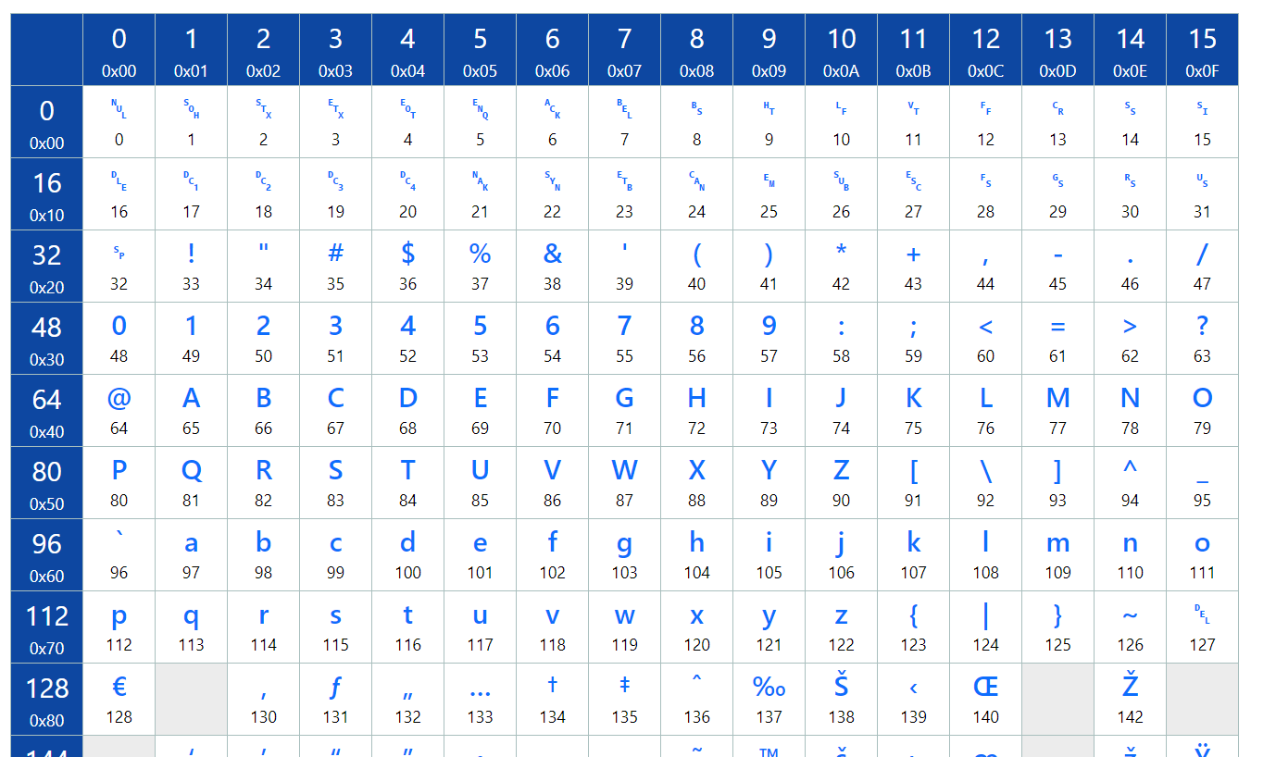

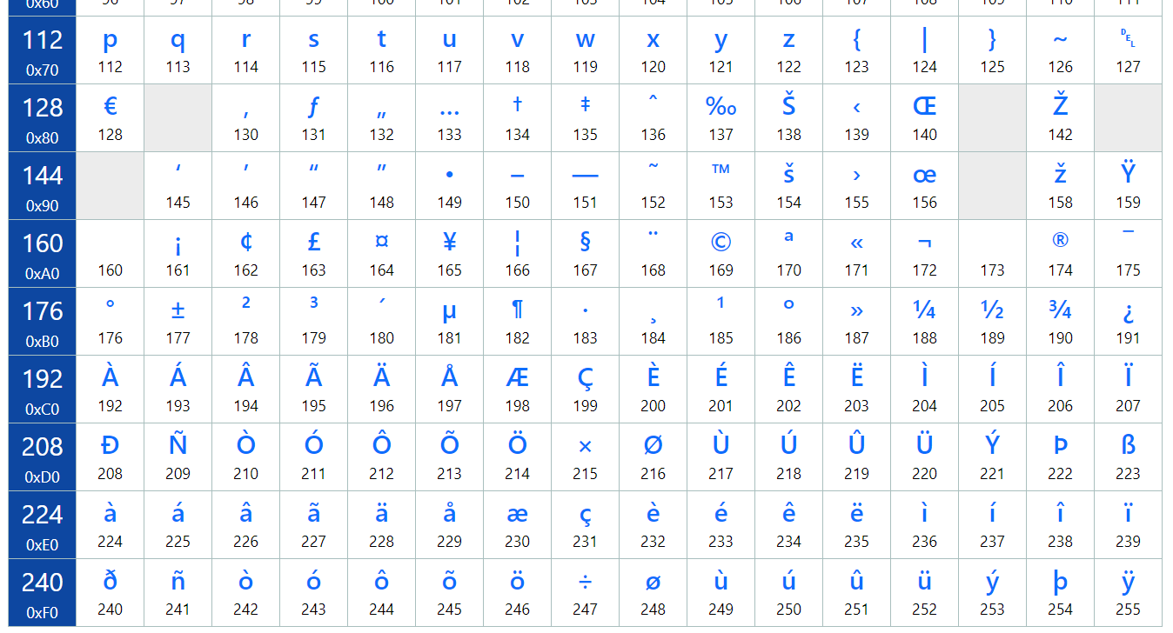

|  |  |  |  |  |  |  |  |  |  |  |
| --- | --- | --- | --- | --- | --- | --- | --- | --- | --- | --- |
| **7-Segment Hex Decoder** | | | | | | | | | | |
| **Input** | |  | **Outputs** | | | | | | | |
| **Decimal** | **Hex** | **segments** | | | | | | | **Value on**  **Display** |
| **g** | **f** | **e** | **d** | **c** | **b** | **a** |
| **0** | **0x00** | **1** | **0** | **0** | **0** | **0** | **0** | **0** | **0** |
| **1** | **0x01** | **0** | **0** | **0** | **0** | **1** | **1** | **0** | **1** |
| **2** | **0x02** | **1** | **0** | **1** | **1** | **0** | **1** | **1** | **2** |
| **3** | **0x03** | **1** | **0** | **0** | **1** | **1** | **1** | **1** | **3** |
| **4** | **0x04** | **1** | **1** | **0** | **0** | **1** | **1** | **0** | **4** |
| **5** | **0x05** | **1** | **1** | **0** | **1** | **1** | **0** | **1** | **5** |
| **6** | **0x06** | **1** | **1** | **1** | **1** | **1** | **0** | **1** | **6** |
| **7** | **0x07** | **0** | **0** | **0** | **0** | **1** | **1** | **1** | **7** |
| **8** | **0x08** | **1** | **1** | **1** | **1** | **1** | **1** | **1** | **8** |
| **9** | **0x09** | **1** | **1** | **0** | **0** | **1** | **1** | **1** | **9** |
| **10** | **0x0A** | **1** | **1** | **1** | **0** | **1** | **1** | **1** | **A** |
| **11** | **0x0B** | **1** | **1** | **1** | **1** | **1** | **0** | **0** | **b** |
| **12** | **0x0C** | **1** | **1** | **1** | **1** | **1** | **0** | **1** | **C** |
| **13** | **0x0D** | **1** | **0** | **1** | **1** | **1** | **1** | **0** | **d** |
| **14** | **0x0E** | **1** | **1** | **1** | **1** | **0** | **0** | **1** | **E** |
| **15** | **0x0F** | **1** | **1** | **1** | **0** | **0** | **0** | **1** | **F** |