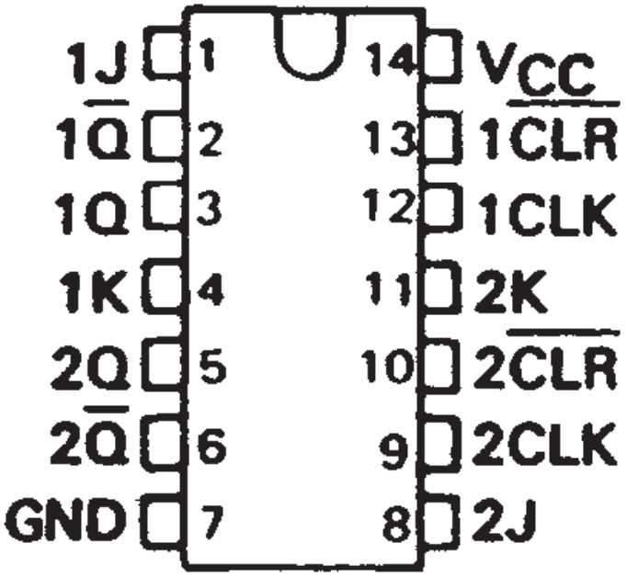
74LS107
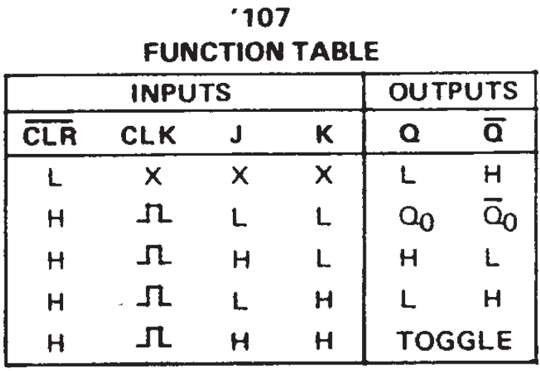

Function Table s(107/107a)
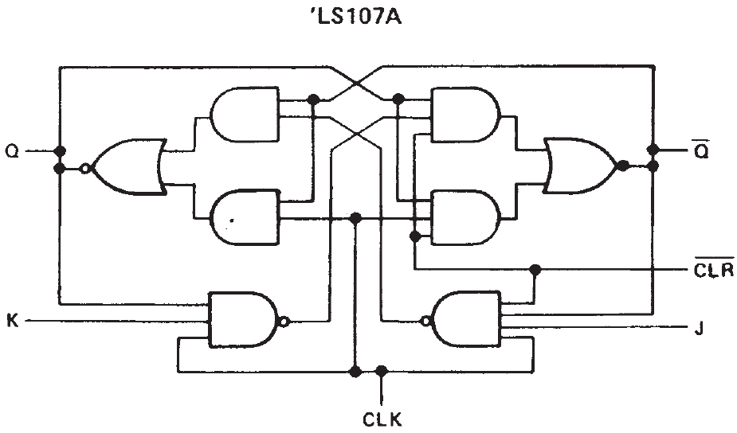
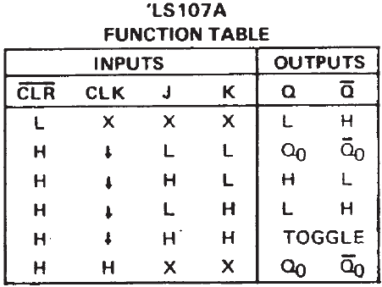

Logic Diagram (107a)

Description:
The ‘107 contain two independent J-K flip-flops with
individual J-K, clock, and direct clear inputs. The ‘107
is a positive pulse-triggered flip-flop. The J-K input data
is loaded into the master while the clock is high and
transferred to the slave and the outputs on the high-to-
low clock transition. For these devices the J and K inputs
must be stable while the clock is high.

The “LS107A contain two independent negative-edge-
triggered flip-flops. The J and K inputs must be stable
prior to the high-to-low clock transition for predictable
operation. When the clear is low, it overrides the clock
and data inputs forcing the Q output low and the !Q
output high.

Function Table (107a)
Inputs |  |  |  |  | Outputs
!CLR | CLK | J | K |  | Q | !Q
L | X | X | X |  | L | H
H | Rising Edge | L | L |  | Q₀ | !Q_{O}
H | Rising Edge | H | L |  | H | L
H | Rising Edge | L | H |  | L | H
H | Rising Edge | H | H |  | TOGGLE

Function Table (107)
Inputs |  |  |  |  | Outputs
!CLR | CLK | J | K |  | Q | !Q
L | X | X | X |  | L | H
H | Falling Edge | L | L |  | Q₀ | !Q_{O}
H | FallingEdge | H | L |  | H | L
H | Falling Edge | L | H |  | L | H
H | Falling Edge | H | H |  | TOGGLE

