Morse Code

S O S (repeated) S O S (once)

sound
Secret Message: wave form
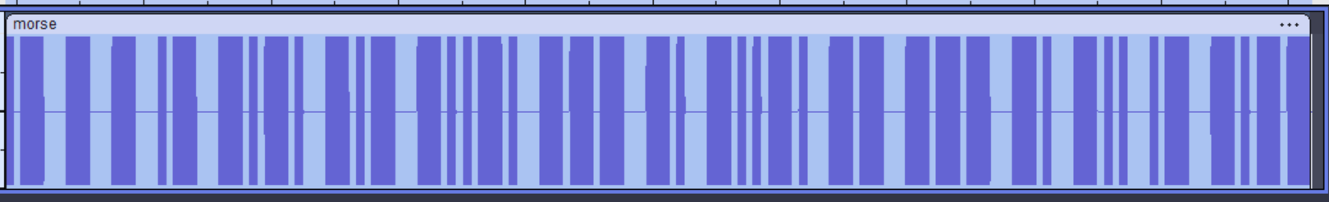
dot dash

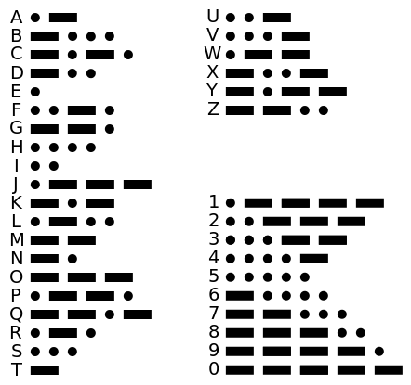
The Key

1-bit letters: E, T
2-bit letters: A, I, M, N
3-bit letters: D, G, K, O, R, S, U, W
4-bit Letters: B, C, F, H, J, L, P, Q, V, X, Y, Z

