I.) A Little History
In 1971 Texas Instruments (TI) introduced the 74LS__ series
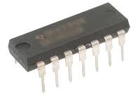
of Integrated Circuits(ICs).

In 1975 MOS Technology introduced the 6502 8-bit microprocessor.
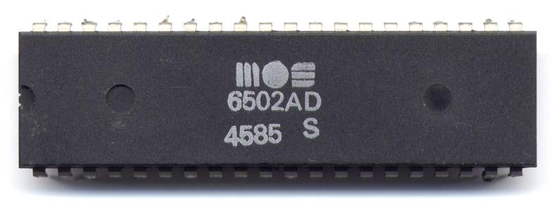

https://commons.wikimedia.))org/w/index.php?curid=91538
In 1977, based on these two technologies, Companies like Apple, Radio Shack, Commodore introduced the first Personal Computers. The magazine Byte introduced them as:
"1977 trinity": Commodore PET, Apple II, and TRS-80 Model I
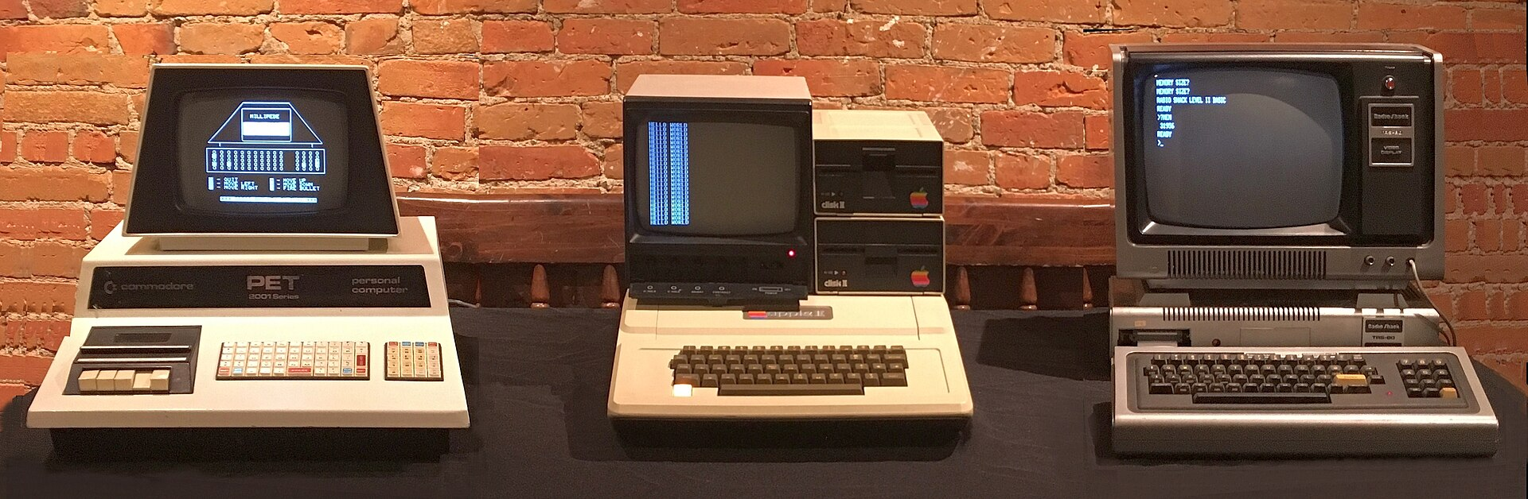
https://commons.wikimedia.))org/w/index.php?curid=144826526
II.) Proposal:
A.) Form a Company that will:
1.) Simulate Commodore, Apple and Radio Shack
2.) Design and Build an 8-bit Computer from the 74LS__ series of Integrated Circuits(ICs).
3.) NOTE: This predates 1975 so this 8-bit Computer will not have the capabilities of the Apple II, TRS-80, or PET; however, the fundamental operations of the computer will be very similar.
B.) Structure of the Company:
1.) CEO
2.) Departments:
a.) Engineering
b.) Drafting
c.) Technician
d.) Computer
e.) Education
f.) Media Arts
C.) Who:
1.) For Summer of 2025
a.) Four to Six Students from Chesterton Academy High School
b.) The CEO and/or Media Arts Department could be eliminated on the first year.
c.) The reasoning: Concentrate on the "Education Material" and "Equipment" for the four main Departments: Engineering, Drafting, Technician, Computer.
2.) Options for subsequent Summers:
a.) More than one company (6 persons per company)
b.) Invite Native Americans (eg "Native American Community Academy"(NACA here in Albuquerque)
c.) Repeat the above with Native Americans on the Cheyenne River Indian Reservation. For Chesterton students it would be a pilgrimage as well as a service opportunity!
d.) Possible follow up program for 2nd year students.
i.) Add to the 8-bit computer
1.) Add Input device (keypad, keyboard)
2.) Add Graphic Display for the Output
3.) Add “Logic Unit”
ii.) Expand on Ben Eater’s 6502 Microprocessor project.
D.) When:
1.) June 3 to Aug 1, 2025
2.) June-July, for following years!
E.) Where:
1.) For 2025: Queen of Heaven Parish, Albuquerque, NM
2.) For 2026: Albuquerque, Cheyenne River Youth Project, Eagle Butte, SD
F.) General Time Framework:
1.) Week 1 (June 1-7)
a.) Monday, Tuesday (June 2nd, 3rd)
i.) Orientation:
1.) Set up a daily time frame:
a.) What is the starting time?
b.) What is the Lunch schedule?
c.) What time does the work day end?
d.) Should each student be allowed a week off?
2.) Make Assignments:
a.) One Option: Choose the CEO
b.) Then: Let the CEO choose the other 5 Dept. Managers
3.) Review Managerial "Packets".
See Education Department Page: Packets
a.) Each Manager studies their specific Packet
b.) Time for Group Discussions
c.) NOTE: The contents of these Packets is a guideline.) Deletions/Additions/ Revisions of these contents over the whole summer should be expected!
d.) Be assured: Your understanding will surely increase over time.)
e.) Be Collaborative: Don't hesitate to ask your fellow employees for help.
b.) Wednesday - Friday (June 4th - June 6th) Begin the Education Phase: (see Education Dept: Training) Note: Again, this should be very collaborative in nature!
i.) Introduction:
1.) Codes:
2.) Truth Tables:
3.) Gates, Integrated Circuits(ICs):
4.) Design:
ii.) Architecture:
1.) Hardware:
a.) Everyone should know this like the back of their hand!
b.) Know the overall layout of the Architecture, the individual Modules and the relative positioning of each Module within the Architecture.)
2.) Software(Instruction Set Architecture-ISA):
a.) Computer Dept Manager: this is your bread and butter!
b.) Know it and know it well.
c.) Anyone assigned to work in the Computer Dept must be of the same mind.)
c.) Tech Software:
i.) "Digital"
1.) This is only software used in the "Design Stage".
2.) The Engineering Dept Manager must be very adapt with "Digital".
ii.)"Fritzing":
1.) This is the only software used in the "Drafting Stage".
2.) The Architect(Drafting) Dept Manager must be very adapt with "Fritzing".
iii.) "Visual Studio Code":
1.) This is what they call an "IDE"(Integrated Development Environment) software.)
2.) It is specifically used by Computer Programmers for various Computer Languages but only JavaScript for this Project!
3.) It will be used specifically when working on the Company's website.)
4.) Anyone interested in "Computer Programming" should learn the Ins and Outs of this software!
5.) Note: Programming the 8-bit Computer itself is done with pencil and paper and NOT with VS Code!
iv.) "GitHub":
1.) GitHub is a "Version Control System" and "Collaboration Tool" used by Software Developers.
2.) While this could be optional for this project, any future "Computer Programmer" should be able to use it.
3.) This project's website will be hosted on GitHub.
4.) When the MediaArts Manager wants to add images, videos or text to this website, it will be done in Visual Studio Code, which is setup to transfer data to and from their website on GitHub. They may only want to change the color of something, but even that must be done in a similar fashion.
v.) "Arduino IDE":
1.) This is only used in the Computer Programming Dept.
2.) It will be used for programming the three EEPROMs (one in the "Output Module" and two in the "Control Module").
3.) It will serve as an introduction to the "C/C++" programming language.)
4.) Ben Eater's videos on YouTube will serve as a guide.) No one will be expected to do this on their own.
5.) Note: This project is not well suited for learning any programming language, whether it be C/C++, JavaScript/HTML/CSS or any other language.) There is just too much to do outside that. It can, however, serve as a good introduction.
6.) It is possible that I could add some specific material on the "Training" dropdown on Education Dept Page.)
d.) Media Arts Software:
i.) GIMP:
1.) This is a free version of "Photoshop".
2.) Those working in the Media Arts Dept will be expected to take pictures through out this project as well as modifying them in GIMP.
3.) Many of these images should find their way to the various Depts on the website!
ii.) Kdenlive:
1.) Kdenlive is a video editing software.)
2.) Videos should be taken of all phases of this project and placed on the web site. Ben Eater's videos online should be used as examples.
iii.) Inkscape:
1.) Inkscape is a free version of Adobe's Illustrator.
2.) Like GIMP it works with images but creates vector images rather than pixel-based images.
3.) The images of the Logic Gates were created in Inkscape. Note the different file formats: .jpg, .png for GIMP images and .svg for Inkscape images!
4.) Learning both is highly recommended!
iv.) Audacity:
1.) Audacity is a free version of Adobe's Audition. Both are Audio Editing Programs
2.) It probably has limited use in this project but if any student wants to edit any audio then Audacity is available.
2.) Week 2 (June 8-14)
a.) Continuation from Week 1 or "Sample Project"!
b.) Sample Project: Design/Draft/Build "BCD to 7-Segment Display"
c.) Each student will work on this project independently.
3.) Week 3 (June 15-21): Start Designing the 8-bit computer
4.) Week 4 (June 22-28)
5.) Week 5 (June 29-July 5)
6.) Week 6 (July 6-12)
7.) Week 7 (July 13-19)
8.) Week 8 (July 20-26)
a.) Put the finishing touches on the Project.
b.) Invite the community(Queen of Heaven, Chesterton Academy) to a Presentation on Aug 3.
9.) Week 9 (July 27-Aug 2)
a.) Finish the Project
b.) Prepare for the presentation.
10.) Aug 3: Presentation
G.) Pay:
1.) "A worker deserves their wages" 1 Tim 5:18
2.) It is difficult to expect a person to appreciate a 'Good Work Ethic' when they are expected to work hard but NOT get payed!
3.) Salary: $300/person (eg $150/month/person)
4.) We would need to do a little fund raising!
5.) No monetary compensation is also an option!
III.) Some Personal Comments:
A.) This first year will be a trial and an opportunity to ascertain:
1.) Student's Interest
2.) Student's Capability
3.) The sufficiency of the Training Material
4.) The need for additional Equipment etc.
B.) I still have a significant amount of Training Material that needs to be added to the "Education Dept Page".
1.) Neemann Helmut's "Digital" design software has a very good learning tutorial but his target audience is a little too advanced. It needs to be expanded upon. "Digital" is at the heart of this project.
2.) The "Fritzing" software ("drafting") is the followup to "Digital". While tutorials are available online, they are not in any organized fashion.
3.) My goal is to have this "website" self sufficient. Hopefully in the next 3 months I will be able to complete the majority of the remaining material.
4.) On the other hand, it may be beneficial to have the students create some of this material themselves during the summer! They may learn something about "Teaching"!

