Initial Design

Given the (relatively) short timeline for this project, we are jumping right in with a complete, rough design. That doesn’t mean you can’t change direction over the next week, but time is limited and you need to make consistent forward progress.

You can work from the individual designs you already did or do something new. Everyone must contribute to the design.

**High level: Objectives & conflicts**

1. What is the player’s goal, and what do they need to do to achieve it?

* The player’s goal is to set up a base in which they can fight back the zombie horde for a set amount of time. Once the timer starts to get low, the player must make their way to the extraction point while fighting zombies. Once they reach the extraction point, they will enter a last stand until they are extracted. Failing to do so will result in enemies becoming stronger and having to wait for the next extraction.

1. What are the most significant obstacles/conflicts to the player succeeding?

* Terrain, traps, zombies, elements, resources, time, environment

**More specific: The central system dynamics**

1. What is the most important player action? The most common?

* The most important player action will be roaming to find resources and killing zombies.

1. List the possible ways that the environment can respond to those actions (outcomes).

* As time passes the difficulty starts to ramp up, the environment will react to this timer by summoning lightning, fires, etc.

**Commit to a specific idea**

1. List 2-3 player experiences that will make the game fun and interesting. Be specific and player-focused!

* Collecting randomized resources that could be traps depending on the run.
* Upgrading equipment to become stronger.
* Maximizing time usage

1. Draw out a sequence of screenshot sketches showing what a player would see during those critical gameplay experiences from question 5. Pay attention to what information is on screen (environment and UI elements). You must commit to a certain visual perspective here (2d/3d, fixed or rotating camera).

Use your phone or a webcam to scan those sketches and add them to the doc.

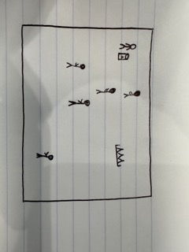

1. Write a 1-2 paragraph description that “sells” this concept to potential players. Try to capture what makes it uniquely interesting. Describe at least the premise, aesthetic, core gameplay and how you win or lose.’

* A new virus that turns people to undead monsters has just hit your city. Everyone is gone and you must survive by yourself. The city is up in flames and ruins; you are on the outsides of the city near a surrounding forest during a storm. You can wait for an extraction from the military, but the longer you wait the more zombies you attract. Your second option is to find all the missing pieces to create a jetpack and fly your way out of the city. With the help of guns and gadgets you can fight back some zombies but be wary of traps that will only make your life harder.

1. Working title

* Z-Virus Arcade