MeshCAD
User Manual and Practical Tutorials
2D block-structured mesh generator with integrated CAD
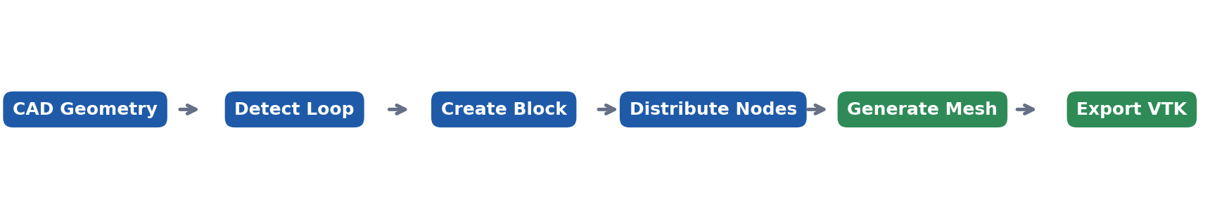
Manual version 1.0 | Application version 1.0

Contents
- 1. Introduction
- 2. Installation and startup
- 3. Interface overview
- 4. CAD drawing and editing
- 5. Block meshing workflow
- 6. Tutorial 1: rectangular block
- 7. Tutorial 2: curved two-block domain
- 8. Tutorial 3: biased distribution and mesh improvement
- 9. Saving and VTK export
- 10. Troubleshooting
- 11. Quick reference
Recommended path Read Sections 3 to 5 first. Complete the tutorials in order because each tutorial reuses concepts introduced in the previous one.

1. Introduction
MeshCAD is a desktop application for creating 2D CAD geometry, organizing closed contours into structured blocks, assigning edge-node distributions, generating meshes through transfinite interpolation, and exporting multiblock results to VTK.

1.1 Main capabilities
- Draw line segments, circular arcs, and Catmull-Rom splines with live previews and vertex snapping.
- Edit topological vertices and internal control points by dragging or by entering coordinates.
- Detect closed loops and split a selected loop into four logical block sides.
- Assign uniform or biased node distributions to one or more edges.
- Enforce near-boundary orthogonality and apply elliptic smoothing to interior nodes.
- Save complete projects as JSON and export one VTS file per block through a PVD collection.
Core idea Geometry, topology, and mesh data are separate. Create a closed contour first, create a block from that contour, assign node counts, and only then generate the mesh.

1.2 Visual conventions
Element | Appearance | Meaning
CAD edge | Blue curve | Geometric boundary
Vertex | Light red circle | Shared topological endpoint
Grip | Light blue circle | Arc center or internal spline point
Selected loop | Thick green path | Active closed contour
Selected edges | Orange path | Selection in the Distributions panel
Mesh | Thin dark grid | Generated structured mesh

2. Installation and startup

2.1 Requirements
- Windows, Linux, or macOS.
- Python 3.9 or newer.
- PyQt5 as the runtime GUI dependency.
- pytest and pytest-qt for development and verification.

2.2 Install from the repository
Open a terminal in the project root and run:
python -m venv .venv
.venv\Scripts\activate
pip install -e .
Linux and macOS Activate the environment with: source .venv/bin/activate

2.3 Start MeshCAD
python -m meshcad
A packaged build can be started from dist/MeshCAD when the PyInstaller build is available.

3. Interface overview

3.1 Main areas
Area | Purpose
File menu | Create, open, save, save as, export VTK, and exit.
Toolbar | CAD tools, grid controls, fit view, and live mesh-improvement settings.
Central canvas | Drawing, selection, editing, zoom, pan, and mesh display.
Loops panel | Detect closed loops and create blocks.
Distributions panel | Select edges, set node counts, and choose a distribution.
Blocks panel | Display blocks, dimensions, and opposite-side mismatches.
Status bar | Operational messages and current cursor coordinates.

3.2 Toolbar controls
Control | Operation
Select | Leave the active drawing tool and enable geometry editing.
Line | Two clicks: start and end.
Arc | Three clicks: center, start, and end; traversal is counterclockwise.
Spline | Add points with left-click and finish with right-click.
Insert Point | Create an isolated vertex from X and Y coordinates.
Generate Mesh | Generate or update all valid block meshes.
Clear Mesh | Hide the mesh without removing CAD geometry or block definitions.
Show Grid / Spacing | Show the reference grid and set its spacing.
Reset Zoom | Fit all geometry and remove accumulated panning.
Orthogonal / Layers / Strength | Improve near-boundary alignment.
Smoothing / Relaxation | Apply elliptic smoothing to interior nodes.

Tooltips Hold the pointer over any toolbar icon or control to display a concise explanation.

4. CAD drawing and editing

4.1 Canvas navigation
Action | Control
Zoom | Mouse wheel; zoom remains centered under the pointer.
Pan | Hold the middle mouse button and drag.
Fit complete model | Reset Zoom.
Cancel active tool | Esc.
Read coordinates | Status bar at the lower-right corner.

4.2 Create geometry
STEP 1 | Lines
Choose Line, click the first endpoint, and click the second endpoint. The dashed preview shows the candidate segment.
STEP 2 | Circular arcs
Choose Arc, click the center, click the start point to define the radius, and click the end point to define the terminal angle.
STEP 3 | Splines
Choose Spline, add control points with left-click, and finish with right-click. Internal points become editable grips.
Snapping When the cursor is close to an existing vertex, the new point snaps to it. Use snapping to guarantee topologically closed contours.

4.3 Edit geometry
- Drag a red vertex to move every connected edge.
- Drag a blue grip to move an arc center or an internal spline control point.
- Double-click a vertex or grip to enter exact X and Y coordinates.
- When an arc center is edited, the endpoints stay fixed and the center is projected onto the chord perpendicular bisector.
- If a mesh already exists, geometry changes trigger automatic regeneration.

5. Block meshing workflow

5.1 Detect a closed loop
Click Detect Loops. Select a listed loop to highlight it in green. If no loop appears, inspect endpoint connections and correct them through snapping or numerical editing.

5.2 Create a block
Select a loop, click Create Block from Loop, and select four distinct vertices. The selected vertices define the four logical corners. A block side may contain one or several CAD edges.

5.3 Node compatibility
Structured-grid condition Opposite sides 0/2 must have identical total node counts; sides 1/3 must also match. The Blocks panel reports OK or MISMATCH.

5.4 Edge distributions
Type | Effect | Typical use
Uniform | Equal parameter spacing. | Regular domains and initial meshes.
Biased | Intervals follow a geometric progression. | Concentrate nodes near the edge start.
Bias = 1 | Equivalent to uniform. | Neutral distribution.
Bias > 1 | Small intervals first, larger intervals later. | Local resolution near a feature or wall.

5.5 Mesh improvement
Parameter | Meaning | Suggested start
Orthogonal | Enable correction normal to boundaries. | On for curved walls.
Layers | Number of corrected inner layers. | 2 to 4.
Strength | Applied fraction of the correction. | 0.70 to 0.90.
Smoothing | Number of elliptic iterations. | 20 to 60.
Relaxation | Update fraction per iteration. | 0.30 to 0.50.

6. Tutorial 1: rectangular block
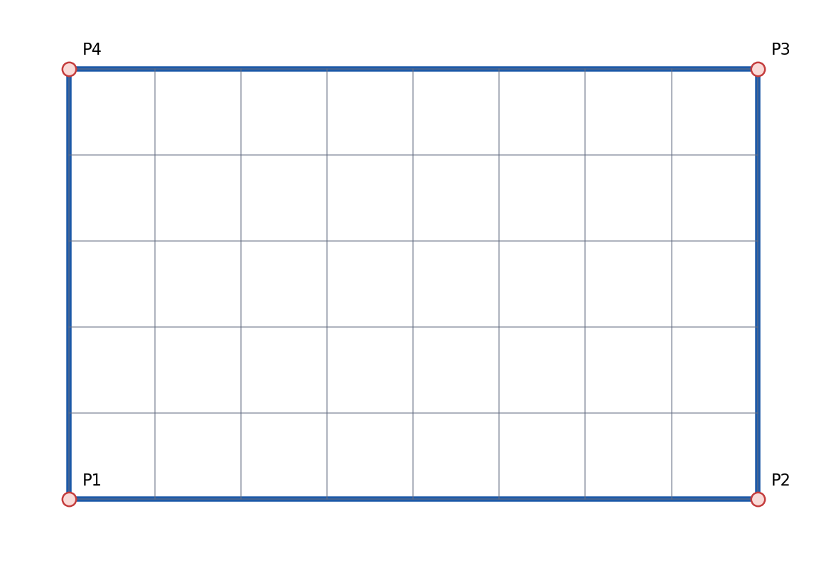

Objective
Create a simple Cartesian mesh and verify node and cell counts.
STEP 1 | Create the contour
Draw consecutive line segments through (0,0), (4,0), (4,2.5), (0,2.5), and back to (0,0).
STEP 2 | Detect and select the loop
Click Detect Loops and select the four-edge loop.
STEP 3 | Create the block
Click Create Block from Loop and select the four corners.
STEP 4 | Set horizontal nodes
Select the bottom and top edges, set 9 nodes and Uniform, then apply.
STEP 5 | Set vertical nodes
Select the left and right edges, set 6 nodes and Uniform, then apply.
STEP 6 | Generate
Click Generate Mesh. The result must contain 9 x 6 nodes and therefore 8 x 5 = 40 cells.
Verification The Blocks panel reports OK (nodes 9 x 6), interior lines are straight, and the status bar reports one block and 40 cells.

7. Tutorial 2: curved two-block domain
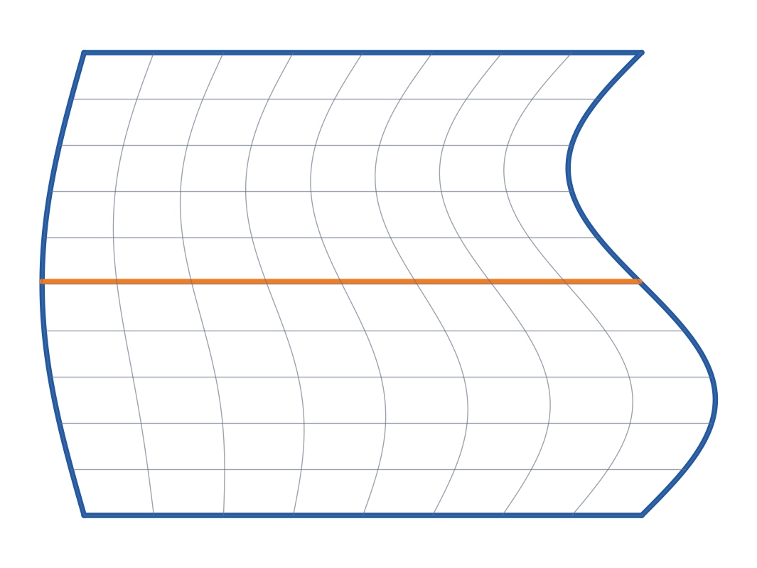

Objective
Build a curved domain, divide it into two conformal blocks, and verify a shared edge distribution.
STEP 1 | Outer contour
Draw the left and right boundaries with splines and close the top and bottom with lines.
STEP 2 | Internal division
Draw a transverse line between two existing boundary vertices. Snap both endpoints.
STEP 3 | Detect loops
Detect loops and identify the upper and lower subdomains.
STEP 4 | Create both blocks
Create one block from each subdomain and select four logical corners for each.
STEP 5 | Set distributions
Assign 15 uniform nodes to the principal edges. Confirm that both blocks report OK.
STEP 6 | Generate and edit
Generate the mesh, then drag a spline grip. Geometry and mesh update while the shared interface remains conformal.
Expected result Two blocks share exactly the same interface nodes. No gaps or duplicate interface lines should appear.

Using test.json
The supplied test.json project is a ready-made two-block example with seven edges and uniform node distributions. Open it, click Reset Zoom, and generate the mesh.

8. Tutorial 3: biased distribution and mesh improvement

Objective
Refine a region of interest and improve the orientation and smoothness of interior grid lines.
STEP 1 | Start from Tutorial 2
Open the curved domain or test.json and generate the uniform baseline mesh.
STEP 2 | Apply bias
Select an outer edge, choose Biased, set Bias to 1.5, and apply. Compare spacing at both ends.
STEP 3 | Increase resolution
Set 25 nodes in the direction requiring additional resolution. Confirm opposite-side compatibility.
STEP 4 | Enable orthogonality
Enable Orthogonal with 3 layers and Strength = 0.80.
STEP 5 | Smooth
Set Smoothing = 40 and Relaxation = 0.40. Live controls regenerate the mesh after a short debounce interval.
STEP 6 | Compare
Temporarily disable Orthogonal and set Smoothing to 0. Restore the combination that produces the cleanest grid.

Visual quality criteria
- No crossed or visibly inverted cells.
- Gradual transitions between small and large cells.
- Smooth interior grid lines without oscillations.
- Near-right angles along boundaries where orthogonality matters.
- Exact continuity across adjacent blocks.
Caution A large bias combined with too few cells can create abrupt size transitions. Increase Bias gradually and inspect every change.

9. Saving and VTK export

9.1 JSON projects
File > Save stores geometry, topology, edge distributions, blocks, and mesh-improvement settings. Save As creates a separate project copy. JSON is readable and version-control friendly, but editing through MeshCAD is recommended.

9.2 Export VTK
STEP 1 | Generate the mesh
Export is available only after a mesh has been generated.
STEP 2 | Export
Choose File > Export Mesh (VTK) and select a .pvd filename.
STEP 3 | Keep the output together
MeshCAD writes the PVD and a <name>_blocks folder containing one VTS file per block.
STEP 4 | Inspect
Open the PVD file in ParaView to load every block together.
Important Do not separate the PVD file from its _blocks folder because the PVD uses relative paths.

10. Troubleshooting
Symptom | Likely cause | Solution
No loops detected | Open contour or non-coincident endpoints. | Zoom in and edit the affected vertices numerically.
Block reports MISMATCH | Opposite sides have different totals. | Apply compatible node counts.
An edge cannot be deleted | The edge belongs to a block. | Delete the associated block first.
No mesh appears | No valid block or incompatible counts. | Review the Blocks panel and generate again.
Geometry is outside the view | Accumulated zoom or panning. | Click Reset Zoom.
Arc center differs from input | Center must remain equidistant from endpoints. | The center is projected onto the perpendicular bisector.
Mesh is strongly distorted | Excessive bias, strength, or relaxation. | Reduce parameters and increase them gradually.
VTK export unavailable | No generated mesh exists. | Generate the mesh first.

11. Quick reference

11.1 Mouse and keyboard
Input | Action
Left-click | Place points, select items, or begin dragging.
Double left-click | Edit vertex or grip coordinates.
Right-click | Finish a spline.
Middle drag | Pan the view.
Mouse wheel | Zoom under the pointer.
Esc | Cancel the active tool.

11.2 Minimal workflow
1. Draw a closed contour.
2. Detect and select its loop.
3. Create a block by selecting four corners.
4. Assign node counts and distributions.
5. Confirm that the block reports OK.
6. Generate the mesh.
7. Save the project and export VTK if required.

11.3 Recommended starting values
Case | Nodes | Orthogonal | Smoothing | Relaxation
Rectangle test | 9 x 6 | Off | 0 | -
Simple curved block | 15 x 15 | 2 layers, 0.80 | 30 | 0.40
Interactive adjustment | Low to medium | Optional | 10-20 | 0.30
Final mesh | As required | As required | 40-100 | 0.30-0.50

Final checklist Closed contours · blocks report OK · conformal interfaces · no crossed cells · project saved · export verified.

