

Practices for Secure Software Report

Table of Contents
Document Revision History 3
Client 3
Instructions 3
Developer 4
1. Algorithm Cipher 4
2. Certificate Generation 4
3. Deploy Cipher 4
4. Secure Communications 4
5. Secondary Testing 4
6. Functional Testing 4
7. Summary 4
8. Industry Standard Best Practices 4

Document Revision History

Version | Date | Author | Comments
1.0 | August 16, 2026 | Jesus Velasquez | Project Two secure software report

Client



Instructions

Submit this completed practices for secure software report. Replace the bracketed text with the relevant information. You must document your process for writing secure communications and refactoring code that complies with software security testing protocols.

- Respond to the steps outlined below and include your findings.
- Respond using your own words. You may also choose to include images or supporting materials. If you include them, make certain to insert them in all the relevant locations in the document.
- Refer to the Project Two Guidelines and Rubric for more detailed instructions about each section of the template.

Developer
Jesus Velasquez

Algorithm Cipher

For Artemis Financial, I recommend AES-256-GCM as the primary encryption cipher for protecting sensitive application data. AES is a symmetric encryption standard that uses the same secret key to encrypt and decrypt data. A 256-bit key provides a strong security margin, and Galois/Counter Mode (GCM) adds authenticated encryption so the application can detect unauthorized changes to encrypted data. AES-256-GCM is well suited for protecting financial information because it is efficient, widely supported, and designed for modern secure applications.
For integrity verification, I used SHA-256 for the checksum step. SHA-256 is a cryptographic hash function in the SHA-2 family. It accepts data of different lengths and produces a fixed 256-bit (32-byte) digest, normally displayed as 64 hexadecimal characters. A cryptographic hash is one-way and does not use an encryption key, so it is appropriate for verifying that data has not changed rather than for decrypting information. If the transferred data changes, its checksum also changes.
For secure communications, I generated a self-signed certificate with a 2,048-bit RSA key pair and configured the application to use HTTPS/TLS. RSA is asymmetric because it uses a public key and a private key rather than one shared secret. In a production TLS connection, public-key cryptography and certificates are used for authentication and secure session establishment, while efficient symmetric encryption such as AES protects the session data. Secure random values are also important when generating encryption keys, initialization vectors, and session secrets so that cryptographic material cannot be predicted.
Encryption practices have changed as older algorithms and weaker key sizes have become unsuitable. Modern secure software should avoid obsolete ciphers such as DES and weak hashes such as MD5 or SHA-1. For this project, my specific cipher recommendation is AES-256-GCM for data encryption, while SHA-256 provides integrity verification and RSA-2048 with TLS/HTTPS supports certificate-based secure communications.

Certificate Generation

I generated a self-signed certificate with Java Keytool for the Artemis Financial application. The certificate uses a 2,048-bit RSA public key and was stored in a PKCS12 keystore as keystore.p12 with the alias selfsigned. I also exported the certificate as server.cer. The certificate information below identifies Jesus Velasquez, Software Development, Global Rain, Miami, Florida, US, and confirms the RSA public key and certificate fingerprints.
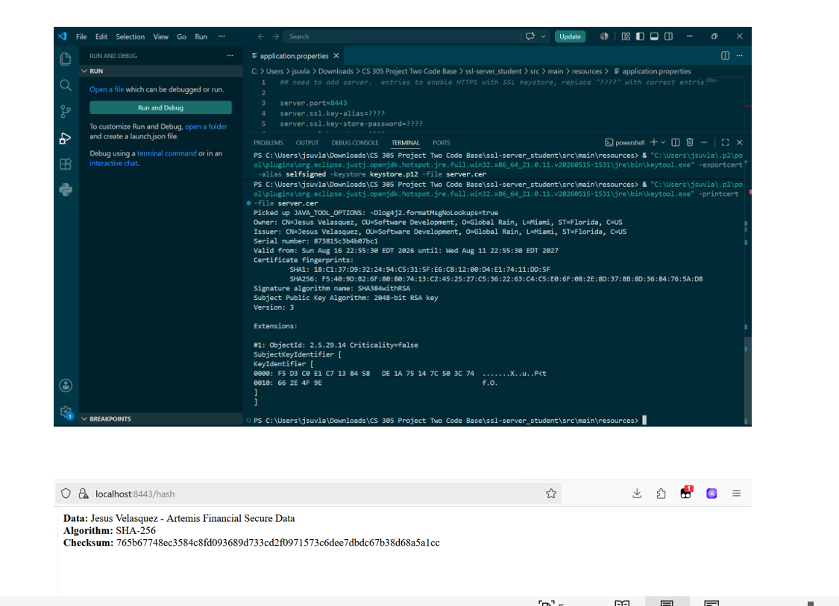
Figure 1. Exported self-signed certificate details and verification output.

Deploy Cipher

I refactored the application by adding a /hash route and using Java's MessageDigest implementation of SHA-256. The static data string is "Jesus Velasquez - Artemis Financial Secure Data." The application converts the data to UTF-8 bytes, calculates the SHA-256 digest, converts the result to hexadecimal, and returns the data, algorithm name, and checksum. This provides the requested verification mechanism without adding another third-party cryptographic library.
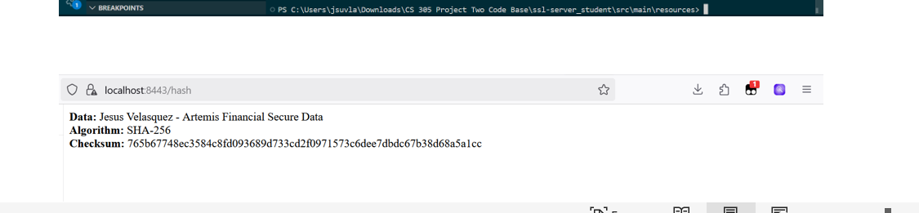
Figure 2. SHA-256 checksum verification for the Artemis Financial data string.

Secure Communications

I converted the application from HTTP to HTTPS by configuring Spring Boot to listen on port 8443 and by pointing the application to the PKCS12 keystore. The application properties specify the selfsigned key alias, keystore password, classpath location of keystore.p12, and PKCS12 keystore type. After starting the application, I verified the endpoint at https://localhost:8443/hash. Because the certificate is self-signed, a browser may show a local trust warning, but the server is using HTTPS as required.

Figure 3. HTTPS endpoint at localhost:8443/hash.

Secondary Testing

After refactoring, I ran OWASP Dependency-Check 12.2.2 as a secondary static test. The Maven build completed successfully and the generated report scanned 49 dependencies (28 unique). It reported 13 vulnerable dependencies and 213 known vulnerabilities, with 0 suppressed. The findings are associated with third-party components in the provided application's older Spring Boot dependency tree, including Spring, Jackson, SnakeYAML, Log4j, and related libraries. My SHA-256 implementation uses Java's standard MessageDigest API and the HTTPS configuration uses the existing Spring Boot/Tomcat stack, so the refactoring did not require adding a new third-party cryptographic dependency. The scan demonstrates why dependency patching and continued vulnerability monitoring are necessary.
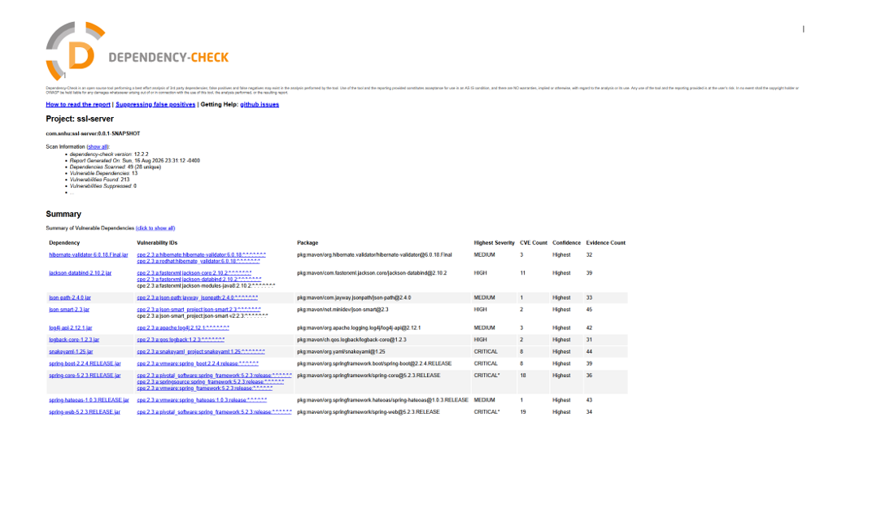
Figure 4. OWASP Dependency-Check 12.2.2 report generated after refactoring.

Functional Testing

I manually reviewed the refactored code for syntax, logic, and security issues and then executed the application. Spring Boot started successfully, Tomcat initialized on port 8443 using HTTPS, and the /hash endpoint returned the expected data, SHA-256 algorithm label, and checksum. I also verified the certificate and keystore were available to the application and that the Dependency-Check Maven goal completed with BUILD SUCCESS. These tests confirmed that the added security functionality worked without preventing the application from running.

Figure 5. Certificate verification and functioning HTTPS checksum endpoint.

Summary

The Artemis Financial application was refactored by adding a SHA-256 checksum verification endpoint, creating an RSA self-signed certificate, storing the certificate and private key in a PKCS12 keystore, and enabling HTTPS on port 8443. I then performed functional testing and an OWASP Dependency-Check scan. These changes add layers of security: SHA-256 supports data integrity, the certificate and TLS configuration support secure communications, and dependency scanning identifies known risks in third-party components.
Using the Vulnerability Assessment Process Flow Diagram, my refactoring most directly addressed Cryptography through SHA-256 and the RSA certificate; APIs through the /hash web endpoint; Client/Server security through HTTPS communication; Code Error and Code Quality through manual review and successful execution; and the API/code-review portions of the process through static dependency testing. The Dependency-Check findings also show that security maintenance must continue after implementation because known vulnerabilities can remain in framework dependencies.

Industry Standard Best Practices

I applied industry-standard secure-coding practices by using established cryptographic APIs instead of designing a custom algorithm, using SHA-256 for integrity verification, protecting network communication with HTTPS, using a certificate and PKCS12 keystore, and testing the refactored application both functionally and with OWASP Dependency-Check. I kept the security changes focused so that the application's existing behavior was preserved while the required controls were added.
These practices are valuable to Artemis Financial because the company handles sensitive financial and client information. Secure communication reduces the risk of data being exposed or altered in transit, checksum verification helps detect unintended changes, and dependency scanning gives developers visibility into known third-party risks that require maintenance. Consistent secure development and testing practices support customer trust, reduce security risk, and make future updates easier to evaluate and maintain.

