Lab 5 Option A Report

Data Structures

CS 2302

Jesus Maximino Hernandez

November 29, 2018

Introduction

I created a program that implements a min heap and sorts numbers using heapsort

Proposed solution

In order to implement a min heap I needed necessary functions such as insert and up heap. Insert would successfully insert a number into a heap array while still maintaining the heap functionality using up heap. In order to use heap sort however, I needed to create a function called heap down which would get the root of the heap replaced by the heapsort function and put it in its appropriate place.

Experimental results

The test cases were not very long and are simply using two different arrays, one of the arrays was very simple and had a few numbers while another arrat had double the number size. In both cases the heap and arrays were sorted and displayed correctly.

*SAMPLE #1: Test on three different arrays:*

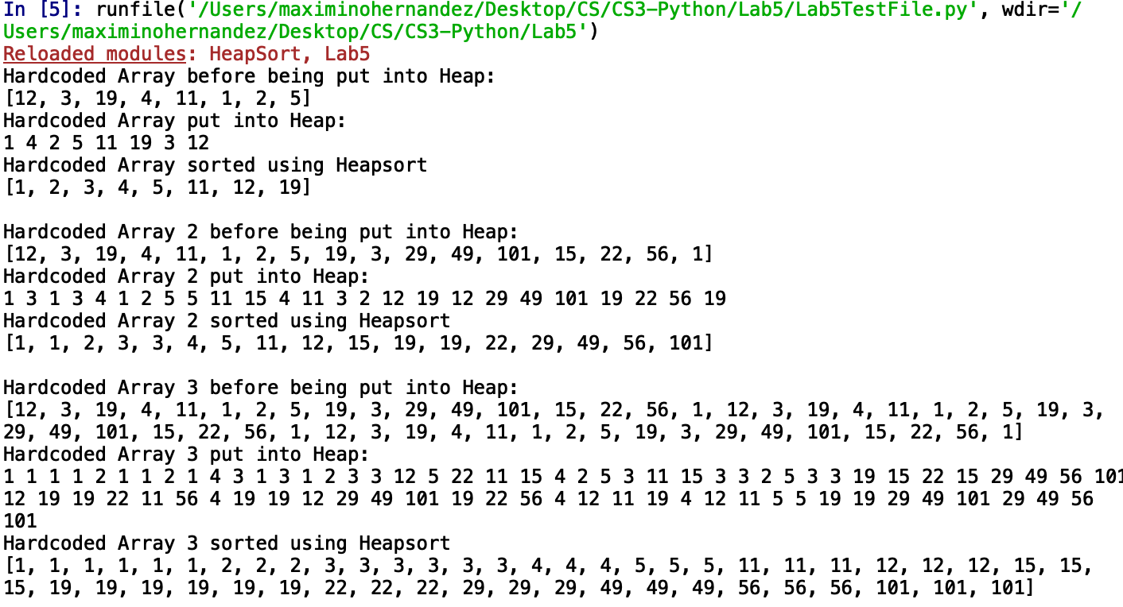

Time Complexity

The program is assumed to run in O(nlogn) time since the min heap is being made from scratch. Here is a table with the specific times.

|  |  |  |  |  |  |
| --- | --- | --- | --- | --- | --- |
| Size | 10 | 50 | 100 | 500 | 1000 |
| Time | 0.000216 | 0.000462 | 0.001505 | 0.012375 | 0.091234 |

Conclusion

As you can see from the table the methods can handle very high inputs in a very quick time. Although the down heap method was a little challenging for me since it was not working the way I wanted it too I was able to successfully implement it. The only thing from the appendix Diego provided that I was not able to use was the extract min function which did not play a key role in my program. In this lab I learned how to successfully implement a heap and heap sort in Python.

Appendix:

<https://github.com/Jesusmaxhernandez/Lab5CS2302>

“I certify that this project is entirely my own work. I wrote, debugged, and tested the code being presented, performed the experiments, and wrote the report. I also certify that I did not share my code or report or provided inappropriate assistance to any student in the class.”