Lab 6 Report

Data Structures

CS 2302

Jesus Maximino Hernandez

Dec 4, 2018

Introduction

I created a program that implements a topological sort and Kruskal’s algorithm on a graph

Proposed solution

In order to implement Kruskal’s algorithm I had to first make a function to sort the edges. From there, I was able to check if there was a cycle in the graph by using disjointed set forests. The topological sort was very similar to Diego’s implementation with almost nothing being changed. Both methods work on undirected and directed graphs.

Experimental results

For the test cases I made four different unique graphs, two for Kruskal and two to be implemented by topological sort. The test cases were successful as Kruskal’s algorithm returned the minimum edges needed for a min-tree while topological sort sorted the edges as expected.

*SAMPLE #1: Test on four different graphs*

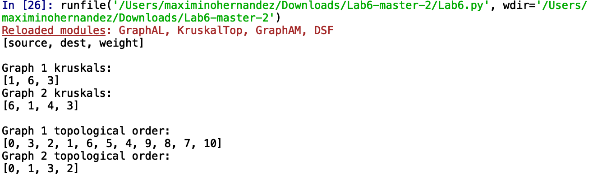

Time Complexity

Kruskal’s algorithm is assumed to run in O(ElogE) while topological sort is supposed to run in O(V+E) time

|  |  |  |  |  |
| --- | --- | --- | --- | --- |
| Graph | K | K | Top | Top |
| Size | 5 | 10 | 5 | 10 |
| Time | 0.000113 | 5.98346 | 5.889 | 7.8678 |

Conclusion

As you can see from the table the methods can handle very high inputs in a very quick time. Although Kruskal’s algorithm was a little challenging for me since it I had to sort the edges in order in the end, I was able to successfully implement it. The only thing is that Diego most of the topological sort algorithm which played a key role in my program. In this lab I learned how to successfully implement Kruskal’s algorithm and topological sort.

Appendix:

https://github.com/Jesusmaxhernandez/Lab6

“I certify that this project is entirely my own work. I wrote, debugged, and tested the code being presented, performed the experiments, and wrote the report. I also certify that I did not share my code or report or provided inappropriate assistance to any student in the class.”