Neo Balompié (NBP)

Diagrama de clases

Author: Author

Revision: 0.2

|  |  |
| --- | --- |
| No Magic |  |
| One Allen Center, 700 Central Expressway South, Suite 110 Allen, Texas 75013 USA | April 19, 2020 |

**Approval**

|  |
| --- |
| The original of this document is approved and signed by:  Name:  Ruben Bullones, Mari Carmen Lopez, Ruben Gonzalez, Lucia Montiel, Juan Manuel Pérez, Jesús Vicente y Adrián Cámara.  Title: Diagrama de clases de Neo Balompié (NBP)  Date: 19/04/2020  Signature: Introducción de Ingeniería de Software grupo 2ºC |

**Revision History**

|  |  |  |  |
| --- | --- | --- | --- |
| **Revision** | **Date** | **Description** | **Author** |
| 0.1 | <date 1> | <draft> | <Author name> |
| 0.2 | <date 2> | <release> | <Author name> |
|  |  |  |  |

| Table of Contents |
| --- |
| Introduction 1  **Purpose** 1  **Scope** 1  **Overview** 1  Package Controlador 2  **Interface Datos equipo** 2  **Attribute Detail** 3  **Relation Detail** 3  Association 3  **Interface Datos partido** 3  **Attribute Detail** 4  **Relation Detail** 4  Association 4  **Interface Datos pista** 5  **Attribute Detail** 5  **Relation Detail** 5  Association 5  **Interface Datos Usuario** 6  **Attribute Detail** 6  **Relation Detail** 6  Association 6  **Interface Notificaciones** 6  **Attribute Detail** 7  **Relation Detail** 7  Association 7  **Interface Valoraciones** 7  **Attribute Detail** 7  **Relation Detail** 8  Association 8  Package Modelo 8  **Class Administrador** 9  **Attribute Detail** 10  Gestiona 10  **Operation Detail** 10  añadirpista 10  eliminarpista 10  **Relation Detail** 10  Association 10  Generalization 10  **Class Date** 10  **Class Equipo** 11  **Attribute Detail** 11  Compuesto 11  Creador 11  Juega 11  Nombre 12  Tamaño 12  **Operation Detail** 12  getCompuesto 12  getCreador 12  getJuega 12  getNombre 12  getTamaño 12  setCompuesto 12  setCreador 12  setJuega 13  setNombre 13  setTamaño 13  unirpartido 13  **Relation Detail** 13  Association 13  **Class Jugador** 13  **Attribute Detail** 14  Apellidos 14  Fecha de nacimiento 14  Juega 14  Nick 15  Nombre 15  Pertenece 15  Posición fav. 15  Recibe 15  Tiene 15  Valorar 15  **Operation Detail** 15  aceptarjugador 15  crearpartido 15  eliminarequipo 16  getApellidos 16  getFecha de nacimiento 16  getJuega 16  getNick 16  getNombre 16  getPertenece 16  getPosición fav. 16  getRecibe 16  getTiene 17  getValorar 17  salirsedeunpartido 17  setApellidos 17  setFecha de nacimiento 17  setJuega 17  setNick 17  setNombre 17  setPertenece 17  setPosición fav. 18  setRecibe 18  setTiene 18  setValorar 18  uniranoregistrado 18  unirpartido 18  valorarjugador 18  valorarpista 18  **Relation Detail** 18  Association 18  Generalization 19  **Class Notificacion** 19  **Attribute Detail** 19  Enviada a 19  Mensaje 19  **Operation Detail** 19  getEnviada a 20  getMensaje 20  setEnviada a 20  setMensaje 20  **Relation Detail** 20  Association 20  **Class Partido** 20  **Attribute Detail** 21  Equipo 21  Fecha 21  Hora 21  Jugador 21  **Operation Detail** 21  get 21  getEquipo 21  getFecha 21  getHora 21  getJugador 22  set 22  setEquipo 22  setFecha 22  setHora 22  setJugador 22  **Relation Detail** 22  Association 22  **Class Pista** 23  **Attribute Detail** 23  Es gestionada 23  Hora fin 23  Hora inicio 23  Nombre 24  Tiene 24  Ubicación 24  **Operation Detail** 24  get 24  getEs gestionada 24  getHora fin 24  getHora inicio 24  getNombre 24  getTiene 24  getUbicación 25  set 25  setEs gestionada 25  setHora fin 25  setHora inicio 25  setNombre 25  setTiene 25  setUbicación 25  **Relation Detail** 25  Association 25  **Class Usuario** 26  **Attribute Detail** 26  Contraseña 26  Correo electrónico 26  **Operation Detail** 26  getContraseña 26  getCorreo electrónico 26  setContraseña 27  setCorreo electrónico 27  **Relation Detail** 27  Generalization 27  **Class Valoración** 27  **Attribute Detail** 27  Valoracion 27  Valorada por 28  **Operation Detail** 28  getValoracion 28  getValorada por 28  setValoracion 28  setValorada por 28  **Relation Detail** 28  Association 28  Generalization 28  **Class Valoración Jugador** 28  **Attribute Detail** 29  Asociada 29  **Relation Detail** 29  Association 29  Generalization 29  **Class Valoración Pista** 29  **Attribute Detail** 29  Asociada 29  **Relation Detail** 29  Association 30  Generalization 30  **Interface Equipo** 30  **Attribute Detail** 30  **Relation Detail** 30  Association 30  **Interface Notificación** 30  **Attribute Detail** 30  **Relation Detail** 31  Association 31  **Interface Partido** 31  **Attribute Detail** 31  **Relation Detail** 31  Association 31  **Interface Pista** 31  **Attribute Detail** 31  **Relation Detail** 32  Association 32  **Interface Usuario** 32  **Attribute Detail** 32  **Relation Detail** 32  Association 32  **Interface Valoraciones** 32  **Attribute Detail** 33  **Relation Detail** 33  Association 33  Package Vista 33  **Interface Añadir Pista** 34  **Attribute Detail** 35  **Relation Detail** 35  Association 35  **Interface Crear Equipo** 35  **Attribute Detail** 35  **Relation Detail** 35  Association 35  **Interface Crear Partido** 35  **Attribute Detail** 36  **Relation Detail** 36  Association 36  **Interface Eliminar Equipo** 36  **Attribute Detail** 36  **Relation Detail** 36  Association 36  **Interface Eliminar Partido** 36  **Attribute Detail** 37  **Relation Detail** 37  Association 37  **Interface Eliminar Pista** 37  **Attribute Detail** 37  **Relation Detail** 37  Association 37  **Interface Iniciar Sesion** 37  **Attribute Detail** 38  **Relation Detail** 38  Association 38  **Interface Mandar Notificaciones** 38  **Attribute Detail** 38  **Relation Detail** 38  Association 38  **Interface Modificar Equipo** 38  **Attribute Detail** 39  **Relation Detail** 39  Association 39  **Interface Registrarse** 39  **Attribute Detail** 39  **Relation Detail** 39  Association 39  **Interface Salirse de Partido** 39  **Attribute Detail** 40  **Relation Detail** 40  Association 40  **Interface Unir a un no Registrado** 40  **Attribute Detail** 40  **Relation Detail** 40  Association 40  **Interface Unirse a Partido** 40  **Attribute Detail** 41  **Relation Detail** 41  Association 41  **Interface Unirse con Equipo** 41  **Attribute Detail** 41  **Relation Detail** 41  Association 41  **Interface Valorar Pistas** 41  **Attribute Detail** 42  **Relation Detail** 42  Association 42  **Interface Valorar Usuario** 42  **Attribute Detail** 42  **Relation Detail** 42  Association 42  Appendix A: Diagram 43  **Model** 43  **Model** 43 |

| Table of Figures |
| --- |
| Figure 1. Controlador 2  Figure 2. Datos equipo 3  Figure 3. Datos partido 4  Figure 4. Datos pista 5  Figure 5. Datos Usuario 6  Figure 6. Notificaciones 7  Figure 7. Valoraciones 7  Figure 8. Modelo 9  Figure 9. Administrador 10  Figure 10. Equipo 11  Figure 11. Jugador 14  Figure 12. Notificacion 19  Figure 13. Partido 20  Figure 14. Pista 23  Figure 15. Usuario 26  Figure 16. Valoración 27  Figure 17. Valoración Jugador 28  Figure 18. Valoración Pista 29  Figure 19. Equipo 30  Figure 20. Notificación 30  Figure 21. Partido 31  Figure 22. Pista 31  Figure 23. Usuario 32  Figure 24. Valoraciones 32  Figure 25. Vista 34  Figure 26. Añadir Pista 35  Figure 27. Crear Equipo 35  Figure 28. Crear Partido 36  Figure 29. Eliminar Equipo 36  Figure 30. Eliminar Partido 37  Figure 31. Eliminar Pista 37  Figure 32. Iniciar Sesion 38  Figure 33. Modificar Equipo 38  Figure 34. Registrarse 39  Figure 35. Salirse de Partido 39  Figure 36. Unir a un no Registrado 40  Figure 37. Unirse a Partido 40  Figure 38. Unirse con Equipo 41  Figure 39. Valorar Pistas 41  Figure 40. Valorar Usuario 42  Figure 41. Model 43  Figure 42. Model 44 |

# **Introduction**

## **Purpose**

This document provides class, interface, and enumeration specification. The specification provides the details of the types being modeled within the system

## **Scope**

This document is intended to define class specification for the {System Name}.

## **Overview**

This document provides a list of all packages with a summary for each. Each package has a section that contains a list of its classes, interfaces and enumeration type, with a summary for each. Class and Interface contains description, summary tables, detailed member descriptions, and relation table.

# **Package Controlador**

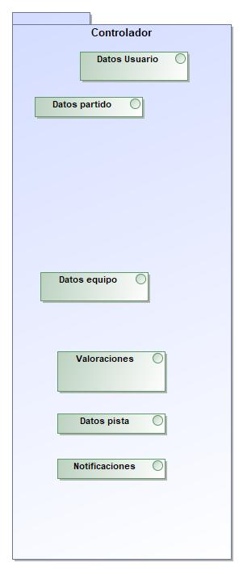

1. Controlador

|  |  |
| --- | --- |
| **Name** | Controlador |
| **Qualified Name** | Controlador |

## **Interface** **Datos equipo**

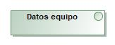

1. Datos equipo

|  |  |
| --- | --- |
| **Name** | Datos equipo |
| **Qualified Name** | Controlador::Datos equipo |
| **Visibility** | public |
| **Base Classifier** |  |

### **Attribute Detail**

|  |  |
| --- | --- |
| **Type** | Crear Equipo |
| **Default Value** |  |
| **Visibility** | public |
| **Multiplicity** |  |

|  |  |
| --- | --- |
| **Type** | Eliminar Equipo |
| **Default Value** |  |
| **Visibility** | public |
| **Multiplicity** |  |

|  |  |
| --- | --- |
| **Type** | Modificar Equipo |
| **Default Value** |  |
| **Visibility** | public |
| **Multiplicity** |  |

|  |  |
| --- | --- |
| **Type** | Equipo |
| **Default Value** |  |
| **Visibility** | public |
| **Multiplicity** |  |

### **Relation Detail**

#### Association

|  |  |
| --- | --- |
| **Name** |  |
| **Related Element** | * Crear Equipo |

|  |  |
| --- | --- |
| **Name** |  |
| **Related Element** | * Modificar Equipo |

|  |  |
| --- | --- |
| **Name** |  |
| **Related Element** | * Equipo |

|  |  |
| --- | --- |
| **Name** |  |
| **Related Element** | * Eliminar Equipo |

## **Interface** **Datos partido**

1235818509.jpg

1. Datos partido

|  |  |
| --- | --- |
| **Name** | Datos partido |
| **Qualified Name** | Controlador::Datos partido |
| **Visibility** | public |
| **Base Classifier** |  |

### **Attribute Detail**

|  |  |
| --- | --- |
| **Type** | Crear Partido |
| **Default Value** |  |
| **Visibility** | public |
| **Multiplicity** |  |

|  |  |
| --- | --- |
| **Type** | Unirse a Partido |
| **Default Value** |  |
| **Visibility** | public |
| **Multiplicity** |  |

|  |  |
| --- | --- |
| **Type** | Unir a un no Registrado |
| **Default Value** |  |
| **Visibility** | public |
| **Multiplicity** |  |

|  |  |
| --- | --- |
| **Type** | Unirse con Equipo |
| **Default Value** |  |
| **Visibility** | public |
| **Multiplicity** |  |

|  |  |
| --- | --- |
| **Type** | Salirse de Partido |
| **Default Value** |  |
| **Visibility** | public |
| **Multiplicity** |  |

|  |  |
| --- | --- |
| **Type** | Eliminar Partido |
| **Default Value** |  |
| **Visibility** | public |
| **Multiplicity** |  |

|  |  |
| --- | --- |
| **Type** | Partido |
| **Default Value** |  |
| **Visibility** | public |
| **Multiplicity** |  |

### **Relation Detail**

#### Association

|  |  |
| --- | --- |
| **Name** |  |
| **Related Element** | * Unir a un no Registrado |

|  |  |
| --- | --- |
| **Name** |  |
| **Related Element** | * Salirse de Partido |

|  |  |
| --- | --- |
| **Name** |  |
| **Related Element** | * Eliminar Partido |

|  |  |
| --- | --- |
| **Name** |  |
| **Related Element** | * Unirse con Equipo |

|  |  |
| --- | --- |
| **Name** |  |
| **Related Element** | * Unirse a Partido |

|  |  |
| --- | --- |
| **Name** |  |
| **Related Element** | * Crear Partido |

|  |  |
| --- | --- |
| **Name** |  |
| **Related Element** | * Partido |

## **Interface** **Datos pista**

177221073.jpg

1. Datos pista

|  |  |
| --- | --- |
| **Name** | Datos pista |
| **Qualified Name** | Controlador::Datos pista |
| **Visibility** | public |
| **Base Classifier** |  |

### **Attribute Detail**

|  |  |
| --- | --- |
| **Type** | Añadir Pista |
| **Default Value** |  |
| **Visibility** | public |
| **Multiplicity** |  |

|  |  |
| --- | --- |
| **Type** | Eliminar Pista |
| **Default Value** |  |
| **Visibility** | public |
| **Multiplicity** |  |

|  |  |
| --- | --- |
| **Type** | Pista |
| **Default Value** |  |
| **Visibility** | public |
| **Multiplicity** |  |

### **Relation Detail**

#### Association

|  |  |
| --- | --- |
| **Name** |  |
| **Related Element** | * Pista |

|  |  |
| --- | --- |
| **Name** |  |
| **Related Element** | * Añadir Pista |

|  |  |
| --- | --- |
| **Name** |  |
| **Related Element** | * Eliminar Pista |

## **Interface** **Datos Usuario**

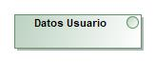

1. Datos Usuario

|  |  |
| --- | --- |
| **Name** | Datos Usuario |
| **Qualified Name** | Controlador::Datos Usuario |
| **Visibility** | public |
| **Base Classifier** |  |

### **Attribute Detail**

|  |  |
| --- | --- |
| **Type** | Registrarse |
| **Default Value** |  |
| **Visibility** | public |
| **Multiplicity** |  |

|  |  |
| --- | --- |
| **Type** | Iniciar Sesion |
| **Default Value** |  |
| **Visibility** | public |
| **Multiplicity** |  |

|  |  |
| --- | --- |
| **Type** | Usuario |
| **Default Value** |  |
| **Visibility** | public |
| **Multiplicity** |  |

### **Relation Detail**

#### Association

|  |  |
| --- | --- |
| **Name** |  |
| **Related Element** | * Iniciar Sesion |

|  |  |
| --- | --- |
| **Name** |  |
| **Related Element** | * Usuario |

|  |  |
| --- | --- |
| **Name** |  |
| **Related Element** | * Registrarse |

## **Interface** **Notificaciones**

-69774903.jpg

1. Notificaciones

|  |  |
| --- | --- |
| **Name** | Notificaciones |
| **Qualified Name** | Controlador::Notificaciones |
| **Visibility** | public |
| **Base Classifier** |  |

### **Attribute Detail**

|  |  |
| --- | --- |
| **Type** | Mandar Notificaciones |
| **Default Value** |  |
| **Visibility** | public |
| **Multiplicity** |  |

|  |  |
| --- | --- |
| **Type** | Notificación |
| **Default Value** |  |
| **Visibility** | public |
| **Multiplicity** |  |

### **Relation Detail**

#### Association

|  |  |
| --- | --- |
| **Name** |  |
| **Related Element** | * Mandar Notificaciones |

|  |  |
| --- | --- |
| **Name** |  |
| **Related Element** | * Notificación |

## **Interface** **Valoraciones**

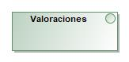

1. Valoraciones

|  |  |
| --- | --- |
| **Name** | Valoraciones |
| **Qualified Name** | Controlador::Valoraciones |
| **Visibility** | public |
| **Base Classifier** |  |

### **Attribute Detail**

|  |  |
| --- | --- |
| **Type** | Valorar Usuario |
| **Default Value** |  |
| **Visibility** | public |
| **Multiplicity** |  |

|  |  |
| --- | --- |
| **Type** | Valorar Pistas |
| **Default Value** |  |
| **Visibility** | public |
| **Multiplicity** |  |

|  |  |
| --- | --- |
| **Type** | Valoraciones |
| **Default Value** |  |
| **Visibility** | public |
| **Multiplicity** |  |

### **Relation Detail**

#### Association

|  |  |
| --- | --- |
| **Name** |  |
| **Related Element** | * Valorar Usuario |

|  |  |
| --- | --- |
| **Name** |  |
| **Related Element** | * Valorar Pistas |

|  |  |
| --- | --- |
| **Name** |  |
| **Related Element** | * Valoraciones |

# **Package Modelo**

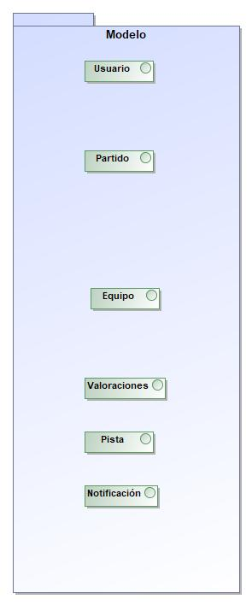

1. Modelo

|  |  |
| --- | --- |
| **Name** | Modelo |
| **Qualified Name** | Modelo |

## **Class** **Administrador**

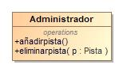

1. Administrador

|  |  |
| --- | --- |
| **Name** | Administrador |
| **Qualified Name** | Modelo::Administrador |
| **Visibility** | public |
| **Abstract** | false |
| **Base Classifier** | * Usuario |
| **Realized Interface** |  |

### **Attribute Detail**

#### Gestiona

|  |  |
| --- | --- |
| **Type** | Pista |
| **Default Value** |  |
| **Visibility** | private |
| **Multiplicity** | * |

### **Operation Detail**

#### añadirpista

|  |  |
| --- | --- |
| **Type** |  |
| **Visibility** | public |
| **Is Abstract** | false |
| **Parameter** |  |

#### eliminarpista

|  |  |
| --- | --- |
| **Type** |  |
| **Visibility** | public |
| **Is Abstract** | false |
| **Parameter** | * in p : Pista |

### **Relation Detail**

#### Association

|  |  |
| --- | --- |
| **Name** | Gestiona |
| **Related Element** | * Pista |

#### Generalization

|  |  |
| --- | --- |
| **Name** |  |
| **Related Element** | * Usuario |

## **Class** **Date**

|  |  |
| --- | --- |
| **Name** | Date |
| **Qualified Name** | Modelo::Date |
| **Visibility** | public |
| **Abstract** | false |
| **Base Classifier** |  |
| **Realized Interface** |  |

## **Class** **Equipo**

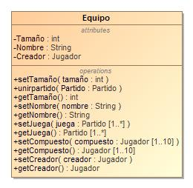

1. Equipo

|  |  |
| --- | --- |
| **Name** | Equipo |
| **Qualified Name** | Modelo::Equipo |
| **Visibility** | public |
| **Abstract** | false |
| **Base Classifier** |  |
| **Realized Interface** |  |

### **Attribute Detail**

#### Compuesto

|  |  |
| --- | --- |
| **Type** | Jugador |
| **Default Value** |  |
| **Visibility** | private |
| **Multiplicity** | 1..10 |

#### Creador

|  |  |
| --- | --- |
| **Type** | Jugador |
| **Default Value** |  |
| **Visibility** | private |
| **Multiplicity** |  |

#### Juega

|  |  |
| --- | --- |
| **Type** | Partido |
| **Default Value** |  |
| **Visibility** | private |
| **Multiplicity** | 1..* |

#### Nombre

|  |  |
| --- | --- |
| **Type** | String |
| **Default Value** |  |
| **Visibility** | private |
| **Multiplicity** |  |

#### Tamaño

|  |  |
| --- | --- |
| **Type** | int |
| **Default Value** |  |
| **Visibility** | private |
| **Multiplicity** |  |

### **Operation Detail**

#### getCompuesto

|  |  |
| --- | --- |
| **Type** | Jugador |
| **Visibility** | public |
| **Is Abstract** | false |
| **Parameter** |  |

#### getCreador

|  |  |
| --- | --- |
| **Type** | Jugador |
| **Visibility** | public |
| **Is Abstract** | false |
| **Parameter** |  |

#### getJuega

|  |  |
| --- | --- |
| **Type** | Partido |
| **Visibility** | public |
| **Is Abstract** | false |
| **Parameter** |  |

#### getNombre

|  |  |
| --- | --- |
| **Type** | String |
| **Visibility** | public |
| **Is Abstract** | false |
| **Parameter** |  |

#### getTamaño

|  |  |
| --- | --- |
| **Type** | int |
| **Visibility** | public |
| **Is Abstract** | false |
| **Parameter** |  |

#### setCompuesto

|  |  |
| --- | --- |
| **Type** |  |
| **Visibility** | public |
| **Is Abstract** | false |
| **Parameter** | * in compuesto : Jugador [1..10] |

#### setCreador

|  |  |
| --- | --- |
| **Type** |  |
| **Visibility** | public |
| **Is Abstract** | false |
| **Parameter** | * in creador : Jugador |

#### setJuega

|  |  |
| --- | --- |
| **Type** |  |
| **Visibility** | public |
| **Is Abstract** | false |
| **Parameter** | * in juega : Partido [1..*] |

#### setNombre

|  |  |
| --- | --- |
| **Type** |  |
| **Visibility** | public |
| **Is Abstract** | false |
| **Parameter** | * in nombre : String |

#### setTamaño

|  |  |
| --- | --- |
| **Type** |  |
| **Visibility** | public |
| **Is Abstract** | false |
| **Parameter** | * in tamaño : int |

#### unirpartido

|  |  |
| --- | --- |
| **Type** |  |
| **Visibility** | public |
| **Is Abstract** | false |
| **Parameter** | * in Partido : Partido |

### **Relation Detail**

#### Association

|  |  |
| --- | --- |
| **Name** |  |
| **Related Element** | * Jugador |

|  |  |
| --- | --- |
| **Name** | Partido |
| **Related Element** | * Partido |

## **Class** **Jugador**

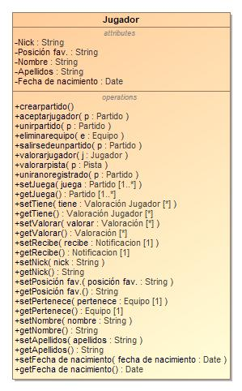

1. Jugador

|  |  |
| --- | --- |
| **Name** | Jugador |
| **Qualified Name** | Modelo::Jugador |
| **Visibility** | public |
| **Abstract** | false |
| **Base Classifier** | * Usuario |
| **Realized Interface** |  |

### **Attribute Detail**

#### Apellidos

|  |  |
| --- | --- |
| **Type** | String |
| **Default Value** |  |
| **Visibility** | private |
| **Multiplicity** |  |

#### Fecha de nacimiento

|  |  |
| --- | --- |
| **Type** | Date |
| **Default Value** |  |
| **Visibility** | private |
| **Multiplicity** |  |

#### Juega

|  |  |
| --- | --- |
| **Type** | Partido |
| **Default Value** |  |
| **Visibility** | private |
| **Multiplicity** | 1..* |

#### Nick

|  |  |
| --- | --- |
| **Type** | String |
| **Default Value** |  |
| **Visibility** | private |
| **Multiplicity** |  |

#### Nombre

|  |  |
| --- | --- |
| **Type** | String |
| **Default Value** |  |
| **Visibility** | private |
| **Multiplicity** |  |

#### Pertenece

|  |  |
| --- | --- |
| **Type** | Equipo |
| **Default Value** |  |
| **Visibility** | private |
| **Multiplicity** | 1 |

#### Posición fav.

|  |  |
| --- | --- |
| **Type** | String |
| **Default Value** |  |
| **Visibility** | private |
| **Multiplicity** |  |

#### Recibe

|  |  |
| --- | --- |
| **Type** | Notificacion |
| **Default Value** |  |
| **Visibility** | private |
| **Multiplicity** | 1 |

#### Tiene

|  |  |
| --- | --- |
| **Type** | Valoración Jugador |
| **Default Value** |  |
| **Visibility** | private |
| **Multiplicity** | * |

#### Valorar

|  |  |
| --- | --- |
| **Type** | Valoración |
| **Default Value** |  |
| **Visibility** | private |
| **Multiplicity** | * |

### **Operation Detail**

#### aceptarjugador

|  |  |
| --- | --- |
| **Type** |  |
| **Visibility** | public |
| **Is Abstract** | false |
| **Parameter** | * in p : Partido |

#### crearpartido

|  |  |
| --- | --- |
| **Type** |  |
| **Visibility** | public |
| **Is Abstract** | false |
| **Parameter** |  |

#### eliminarequipo

|  |  |
| --- | --- |
| **Type** |  |
| **Visibility** | public |
| **Is Abstract** | false |
| **Parameter** | * in e : Equipo |

#### getApellidos

|  |  |
| --- | --- |
| **Type** | String |
| **Visibility** | public |
| **Is Abstract** | false |
| **Parameter** |  |

#### getFecha de nacimiento

|  |  |
| --- | --- |
| **Type** | Date |
| **Visibility** | public |
| **Is Abstract** | false |
| **Parameter** |  |

#### getJuega

|  |  |
| --- | --- |
| **Type** | Partido |
| **Visibility** | public |
| **Is Abstract** | false |
| **Parameter** |  |

#### getNick

|  |  |
| --- | --- |
| **Type** | String |
| **Visibility** | public |
| **Is Abstract** | false |
| **Parameter** |  |

#### getNombre

|  |  |
| --- | --- |
| **Type** | String |
| **Visibility** | public |
| **Is Abstract** | false |
| **Parameter** |  |

#### getPertenece

|  |  |
| --- | --- |
| **Type** | Equipo |
| **Visibility** | public |
| **Is Abstract** | false |
| **Parameter** |  |

#### getPosición fav.

|  |  |
| --- | --- |
| **Type** | String |
| **Visibility** | public |
| **Is Abstract** | false |
| **Parameter** |  |

#### getRecibe

|  |  |
| --- | --- |
| **Type** | Notificacion |
| **Visibility** | public |
| **Is Abstract** | false |
| **Parameter** |  |

#### getTiene

|  |  |
| --- | --- |
| **Type** | Valoración Jugador |
| **Visibility** | public |
| **Is Abstract** | false |
| **Parameter** |  |

#### getValorar

|  |  |
| --- | --- |
| **Type** | Valoración |
| **Visibility** | public |
| **Is Abstract** | false |
| **Parameter** |  |

#### salirsedeunpartido

|  |  |
| --- | --- |
| **Type** |  |
| **Visibility** | public |
| **Is Abstract** | false |
| **Parameter** | * in p : Partido |

#### setApellidos

|  |  |
| --- | --- |
| **Type** |  |
| **Visibility** | public |
| **Is Abstract** | false |
| **Parameter** | * in apellidos : String |

#### setFecha de nacimiento

|  |  |
| --- | --- |
| **Type** |  |
| **Visibility** | public |
| **Is Abstract** | false |
| **Parameter** | * in fecha de nacimiento : Date |

#### setJuega

|  |  |
| --- | --- |
| **Type** |  |
| **Visibility** | public |
| **Is Abstract** | false |
| **Parameter** | * in juega : Partido [1..*] |

#### setNick

|  |  |
| --- | --- |
| **Type** |  |
| **Visibility** | public |
| **Is Abstract** | false |
| **Parameter** | * in nick : String |

#### setNombre

|  |  |
| --- | --- |
| **Type** |  |
| **Visibility** | public |
| **Is Abstract** | false |
| **Parameter** | * in nombre : String |

#### setPertenece

|  |  |
| --- | --- |
| **Type** |  |
| **Visibility** | public |
| **Is Abstract** | false |
| **Parameter** | * in pertenece : Equipo [1] |

#### setPosición fav.

|  |  |
| --- | --- |
| **Type** |  |
| **Visibility** | public |
| **Is Abstract** | false |
| **Parameter** | * in posición fav. : String |

#### setRecibe

|  |  |
| --- | --- |
| **Type** |  |
| **Visibility** | public |
| **Is Abstract** | false |
| **Parameter** | * in recibe : Notificacion [1] |

#### setTiene

|  |  |
| --- | --- |
| **Type** |  |
| **Visibility** | public |
| **Is Abstract** | false |
| **Parameter** | * in tiene : Valoración Jugador [*] |

#### setValorar

|  |  |
| --- | --- |
| **Type** |  |
| **Visibility** | public |
| **Is Abstract** | false |
| **Parameter** | * in valorar : Valoración [*] |

#### uniranoregistrado

|  |  |
| --- | --- |
| **Type** |  |
| **Visibility** | public |
| **Is Abstract** | false |
| **Parameter** | * in p : Partido |

#### unirpartido

|  |  |
| --- | --- |
| **Type** |  |
| **Visibility** | public |
| **Is Abstract** | false |
| **Parameter** | * in p : Partido |

#### valorarjugador

|  |  |
| --- | --- |
| **Type** |  |
| **Visibility** | public |
| **Is Abstract** | false |
| **Parameter** | * in j : Jugador |

#### valorarpista

|  |  |
| --- | --- |
| **Type** |  |
| **Visibility** | public |
| **Is Abstract** | false |
| **Parameter** | * in p : Pista |

### **Relation Detail**

#### Association

|  |  |
| --- | --- |
| **Name** |  |
| **Related Element** | * Valoración Jugador |

|  |  |
| --- | --- |
| **Name** |  |
| **Related Element** | * Valoración |

|  |  |
| --- | --- |
| **Name** |  |
| **Related Element** | * Notificacion |

|  |  |
| --- | --- |
| **Name** |  |
| **Related Element** | * Equipo |

|  |  |
| --- | --- |
| **Name** | Partido1 |
| **Related Element** | * Partido |

#### Generalization

|  |  |
| --- | --- |
| **Name** |  |
| **Related Element** | * Usuario |

## **Class** **Notificacion**

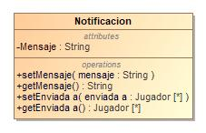

1. Notificacion

|  |  |
| --- | --- |
| **Name** | Notificacion |
| **Qualified Name** | Modelo::Notificacion |
| **Visibility** | public |
| **Abstract** | false |
| **Base Classifier** |  |
| **Realized Interface** |  |

### **Attribute Detail**

#### Enviada a

|  |  |
| --- | --- |
| **Type** | Jugador |
| **Default Value** |  |
| **Visibility** | private |
| **Multiplicity** | * |

#### Mensaje

|  |  |
| --- | --- |
| **Type** | String |
| **Default Value** |  |
| **Visibility** | private |
| **Multiplicity** |  |

### **Operation Detail**

#### getEnviada a

|  |  |
| --- | --- |
| **Type** | Jugador |
| **Visibility** | public |
| **Is Abstract** | false |
| **Parameter** |  |

#### getMensaje

|  |  |
| --- | --- |
| **Type** | String |
| **Visibility** | public |
| **Is Abstract** | false |
| **Parameter** |  |

#### setEnviada a

|  |  |
| --- | --- |
| **Type** |  |
| **Visibility** | public |
| **Is Abstract** | false |
| **Parameter** | * in enviada a : Jugador [*] |

#### setMensaje

|  |  |
| --- | --- |
| **Type** |  |
| **Visibility** | public |
| **Is Abstract** | false |
| **Parameter** | * in mensaje : String |

### **Relation Detail**

#### Association

|  |  |
| --- | --- |
| **Name** |  |
| **Related Element** | * Jugador |

## **Class** **Partido**

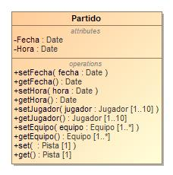

1. Partido

|  |  |
| --- | --- |
| **Name** | Partido |
| **Qualified Name** | Modelo::Partido |
| **Visibility** | public |
| **Abstract** | false |
| **Base Classifier** |  |
| **Realized Interface** |  |

### **Attribute Detail**

|  |  |
| --- | --- |
| **Type** | Pista |
| **Default Value** |  |
| **Visibility** | private |
| **Multiplicity** | 1 |

#### Equipo

|  |  |
| --- | --- |
| **Type** | Equipo |
| **Default Value** |  |
| **Visibility** | private |
| **Multiplicity** | 1..* |

#### Fecha

|  |  |
| --- | --- |
| **Type** | Date |
| **Default Value** |  |
| **Visibility** | private |
| **Multiplicity** |  |

#### Hora

|  |  |
| --- | --- |
| **Type** | Date |
| **Default Value** |  |
| **Visibility** | private |
| **Multiplicity** |  |

#### Jugador

|  |  |
| --- | --- |
| **Type** | Jugador |
| **Default Value** |  |
| **Visibility** | private |
| **Multiplicity** | 1..10 |

### **Operation Detail**

#### get

|  |  |
| --- | --- |
| **Type** | Pista |
| **Visibility** | public |
| **Is Abstract** | false |
| **Parameter** |  |

#### getEquipo

|  |  |
| --- | --- |
| **Type** | Equipo |
| **Visibility** | public |
| **Is Abstract** | false |
| **Parameter** |  |

#### getFecha

|  |  |
| --- | --- |
| **Type** | Date |
| **Visibility** | public |
| **Is Abstract** | false |
| **Parameter** |  |

#### getHora

|  |  |
| --- | --- |
| **Type** | Date |
| **Visibility** | public |
| **Is Abstract** | false |
| **Parameter** |  |

#### getJugador

|  |  |
| --- | --- |
| **Type** | Jugador |
| **Visibility** | public |
| **Is Abstract** | false |
| **Parameter** |  |

#### set

|  |  |
| --- | --- |
| **Type** |  |
| **Visibility** | public |
| **Is Abstract** | false |
| **Parameter** | * in : Pista [1] |

#### setEquipo

|  |  |
| --- | --- |
| **Type** |  |
| **Visibility** | public |
| **Is Abstract** | false |
| **Parameter** | * in equipo : Equipo [1..*] |

#### setFecha

|  |  |
| --- | --- |
| **Type** |  |
| **Visibility** | public |
| **Is Abstract** | false |
| **Parameter** | * in fecha : Date |

#### setHora

|  |  |
| --- | --- |
| **Type** |  |
| **Visibility** | public |
| **Is Abstract** | false |
| **Parameter** | * in hora : Date |

#### setJugador

|  |  |
| --- | --- |
| **Type** |  |
| **Visibility** | public |
| **Is Abstract** | false |
| **Parameter** | * in jugador : Jugador [1..10] |

### **Relation Detail**

#### Association

|  |  |
| --- | --- |
| **Name** |  |
| **Related Element** | * Pista |

|  |  |
| --- | --- |
| **Name** | Partido |
| **Related Element** | * Equipo |

|  |  |
| --- | --- |
| **Name** | Partido1 |
| **Related Element** | * Jugador |

## **Class** **Pista**

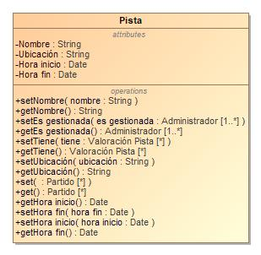

1. Pista

|  |  |
| --- | --- |
| **Name** | Pista |
| **Qualified Name** | Modelo::Pista |
| **Visibility** | public |
| **Abstract** | false |
| **Base Classifier** |  |
| **Realized Interface** |  |

### **Attribute Detail**

|  |  |
| --- | --- |
| **Type** | Partido |
| **Default Value** |  |
| **Visibility** | private |
| **Multiplicity** | * |

#### Es gestionada

|  |  |
| --- | --- |
| **Type** | Administrador |
| **Default Value** |  |
| **Visibility** | private |
| **Multiplicity** | 1..* |

#### Hora fin

|  |  |
| --- | --- |
| **Type** | Date |
| **Default Value** |  |
| **Visibility** | private |
| **Multiplicity** |  |

#### Hora inicio

|  |  |
| --- | --- |
| **Type** | Date |
| **Default Value** |  |
| **Visibility** | private |
| **Multiplicity** |  |

#### Nombre

|  |  |
| --- | --- |
| **Type** | String |
| **Default Value** |  |
| **Visibility** | private |
| **Multiplicity** |  |

#### Tiene

|  |  |
| --- | --- |
| **Type** | Valoración Pista |
| **Default Value** |  |
| **Visibility** | private |
| **Multiplicity** | * |

#### Ubicación

|  |  |
| --- | --- |
| **Type** | String |
| **Default Value** |  |
| **Visibility** | private |
| **Multiplicity** |  |

### **Operation Detail**

#### get

|  |  |
| --- | --- |
| **Type** | Partido |
| **Visibility** | public |
| **Is Abstract** | false |
| **Parameter** |  |

#### getEs gestionada

|  |  |
| --- | --- |
| **Type** | Administrador |
| **Visibility** | public |
| **Is Abstract** | false |
| **Parameter** |  |

#### getHora fin

|  |  |
| --- | --- |
| **Type** | Date |
| **Visibility** | public |
| **Is Abstract** | false |
| **Parameter** |  |

#### getHora inicio

|  |  |
| --- | --- |
| **Type** | Date |
| **Visibility** | public |
| **Is Abstract** | false |
| **Parameter** |  |

#### getNombre

|  |  |
| --- | --- |
| **Type** | String |
| **Visibility** | public |
| **Is Abstract** | false |
| **Parameter** |  |

#### getTiene

|  |  |
| --- | --- |
| **Type** | Valoración Pista |
| **Visibility** | public |
| **Is Abstract** | false |
| **Parameter** |  |

#### getUbicación

|  |  |
| --- | --- |
| **Type** | String |
| **Visibility** | public |
| **Is Abstract** | false |
| **Parameter** |  |

#### set

|  |  |
| --- | --- |
| **Type** |  |
| **Visibility** | public |
| **Is Abstract** | false |
| **Parameter** | * in : Partido [*] |

#### setEs gestionada

|  |  |
| --- | --- |
| **Type** |  |
| **Visibility** | public |
| **Is Abstract** | false |
| **Parameter** | * in es gestionada : Administrador [1..*] |

#### setHora fin

|  |  |
| --- | --- |
| **Type** |  |
| **Visibility** | public |
| **Is Abstract** | false |
| **Parameter** | * in hora fin : Date |

#### setHora inicio

|  |  |
| --- | --- |
| **Type** |  |
| **Visibility** | public |
| **Is Abstract** | false |
| **Parameter** | * in hora inicio : Date |

#### setNombre

|  |  |
| --- | --- |
| **Type** |  |
| **Visibility** | public |
| **Is Abstract** | false |
| **Parameter** | * in nombre : String |

#### setTiene

|  |  |
| --- | --- |
| **Type** |  |
| **Visibility** | public |
| **Is Abstract** | false |
| **Parameter** | * in tiene : Valoración Pista [*] |

#### setUbicación

|  |  |
| --- | --- |
| **Type** |  |
| **Visibility** | public |
| **Is Abstract** | false |
| **Parameter** | * in ubicación : String |

### **Relation Detail**

#### Association

|  |  |
| --- | --- |
| **Name** |  |
| **Related Element** | * Valoración Pista |

|  |  |
| --- | --- |
| **Name** |  |
| **Related Element** | * Partido |

|  |  |
| --- | --- |
| **Name** | Gestiona |
| **Related Element** | * Administrador |

## **Class** **Usuario**

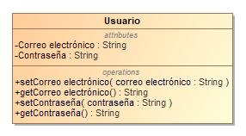

1. Usuario

|  |  |
| --- | --- |
| **Name** | Usuario |
| **Qualified Name** | Modelo::Usuario |
| **Visibility** | public |
| **Abstract** | false |
| **Base Classifier** |  |
| **Realized Interface** |  |

### **Attribute Detail**

#### Contraseña

|  |  |
| --- | --- |
| **Type** | String |
| **Default Value** |  |
| **Visibility** | private |
| **Multiplicity** |  |

#### Correo electrónico

|  |  |
| --- | --- |
| **Type** | String |
| **Default Value** |  |
| **Visibility** | private |
| **Multiplicity** |  |

### **Operation Detail**

#### getContraseña

|  |  |
| --- | --- |
| **Type** | String |
| **Visibility** | public |
| **Is Abstract** | false |
| **Parameter** |  |

#### getCorreo electrónico

|  |  |
| --- | --- |
| **Type** | String |
| **Visibility** | public |
| **Is Abstract** | false |
| **Parameter** |  |

#### setContraseña

|  |  |
| --- | --- |
| **Type** |  |
| **Visibility** | public |
| **Is Abstract** | false |
| **Parameter** | * in contraseña : String |

#### setCorreo electrónico

|  |  |
| --- | --- |
| **Type** |  |
| **Visibility** | public |
| **Is Abstract** | false |
| **Parameter** | * in correo electrónico : String |

### **Relation Detail**

#### Generalization

|  |  |
| --- | --- |
| **Name** |  |
| **Related Element** | * Jugador |

|  |  |
| --- | --- |
| **Name** |  |
| **Related Element** | * Administrador |

## **Class** **Valoración**

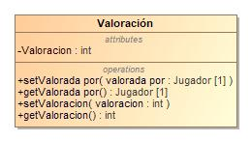

1. Valoración

|  |  |
| --- | --- |
| **Name** | Valoración |
| **Qualified Name** | Modelo::Valoración |
| **Visibility** | public |
| **Abstract** | false |
| **Base Classifier** |  |
| **Realized Interface** |  |

### **Attribute Detail**

#### Valoracion

|  |  |
| --- | --- |
| **Type** | int |
| **Default Value** |  |
| **Visibility** | private |
| **Multiplicity** |  |

#### Valorada por

|  |  |
| --- | --- |
| **Type** | Jugador |
| **Default Value** |  |
| **Visibility** | private |
| **Multiplicity** | 1 |

### **Operation Detail**

#### getValoracion

|  |  |
| --- | --- |
| **Type** | int |
| **Visibility** | public |
| **Is Abstract** | false |
| **Parameter** |  |

#### getValorada por

|  |  |
| --- | --- |
| **Type** | Jugador |
| **Visibility** | public |
| **Is Abstract** | false |
| **Parameter** |  |

#### setValoracion

|  |  |
| --- | --- |
| **Type** |  |
| **Visibility** | public |
| **Is Abstract** | false |
| **Parameter** | * in valoracion : int |

#### setValorada por

|  |  |
| --- | --- |
| **Type** |  |
| **Visibility** | public |
| **Is Abstract** | false |
| **Parameter** | * in valorada por : Jugador [1] |

### **Relation Detail**

#### Association

|  |  |
| --- | --- |
| **Name** |  |
| **Related Element** | * Jugador |

#### Generalization

|  |  |
| --- | --- |
| **Name** |  |
| **Related Element** | * Valoración Pista |

|  |  |
| --- | --- |
| **Name** |  |
| **Related Element** | * Valoración Jugador |

## **Class** **Valoración Jugador**

-2050261044.jpg

1. Valoración Jugador

|  |  |
| --- | --- |
| **Name** | Valoración Jugador |
| **Qualified Name** | Modelo::Valoración Jugador |
| **Visibility** | public |
| **Abstract** | false |
| **Base Classifier** | * Valoración |
| **Realized Interface** |  |

### **Attribute Detail**

#### Asociada

|  |  |
| --- | --- |
| **Type** | Jugador |
| **Default Value** |  |
| **Visibility** | private |
| **Multiplicity** | 1 |

### **Relation Detail**

#### Association

|  |  |
| --- | --- |
| **Name** |  |
| **Related Element** | * Jugador |

#### Generalization

|  |  |
| --- | --- |
| **Name** |  |
| **Related Element** | * Valoración |

## **Class** **Valoración Pista**

659964937.jpg

1. Valoración Pista

|  |  |
| --- | --- |
| **Name** | Valoración Pista |
| **Qualified Name** | Modelo::Valoración Pista |
| **Visibility** | public |
| **Abstract** | false |
| **Base Classifier** | * Valoración |
| **Realized Interface** |  |

### **Attribute Detail**

#### Asociada

|  |  |
| --- | --- |
| **Type** | Pista |
| **Default Value** |  |
| **Visibility** | private |
| **Multiplicity** | 1 |

### **Relation Detail**

#### Association

|  |  |
| --- | --- |
| **Name** |  |
| **Related Element** | * Pista |

#### Generalization

|  |  |
| --- | --- |
| **Name** |  |
| **Related Element** | * Valoración |

## **Interface** **Equipo**

2103253351.jpg

1. Equipo

|  |  |
| --- | --- |
| **Name** | Equipo |
| **Qualified Name** | Modelo::Equipo |
| **Visibility** | public |
| **Base Classifier** |  |

### **Attribute Detail**

|  |  |
| --- | --- |
| **Type** | Datos equipo |
| **Default Value** |  |
| **Visibility** | public |
| **Multiplicity** |  |

### **Relation Detail**

#### Association

|  |  |
| --- | --- |
| **Name** |  |
| **Related Element** | * Datos equipo |

## **Interface** **Notificación**

-322622476.jpg

1. Notificación

|  |  |
| --- | --- |
| **Name** | Notificación |
| **Qualified Name** | Modelo::Notificación |
| **Visibility** | public |
| **Base Classifier** |  |

### **Attribute Detail**

|  |  |
| --- | --- |
| **Type** | Notificaciones |
| **Default Value** |  |
| **Visibility** | public |
| **Multiplicity** |  |

### **Relation Detail**

#### Association

|  |  |
| --- | --- |
| **Name** |  |
| **Related Element** | * Notificaciones |

## **Interface** **Partido**

-877734611.jpg

1. Partido

|  |  |
| --- | --- |
| **Name** | Partido |
| **Qualified Name** | Modelo::Partido |
| **Visibility** | public |
| **Base Classifier** |  |

### **Attribute Detail**

|  |  |
| --- | --- |
| **Type** | Datos partido |
| **Default Value** |  |
| **Visibility** | public |
| **Multiplicity** |  |

### **Relation Detail**

#### Association

|  |  |
| --- | --- |
| **Name** |  |
| **Related Element** | * Datos partido |

## **Interface** **Pista**

1380281545.jpg

1. Pista

|  |  |
| --- | --- |
| **Name** | Pista |
| **Qualified Name** | Modelo::Pista |
| **Visibility** | public |
| **Base Classifier** |  |

### **Attribute Detail**

|  |  |
| --- | --- |
| **Type** | Datos pista |
| **Default Value** |  |
| **Visibility** | public |
| **Multiplicity** |  |

### **Relation Detail**

#### Association

|  |  |
| --- | --- |
| **Name** |  |
| **Related Element** | * Datos pista |

## **Interface** **Usuario**

-1987266729.jpg

1. Usuario

|  |  |
| --- | --- |
| **Name** | Usuario |
| **Qualified Name** | Modelo::Usuario |
| **Visibility** | public |
| **Base Classifier** |  |

### **Attribute Detail**

|  |  |
| --- | --- |
| **Type** | Datos Usuario |
| **Default Value** |  |
| **Visibility** | public |
| **Multiplicity** |  |

### **Relation Detail**

#### Association

|  |  |
| --- | --- |
| **Name** |  |
| **Related Element** | * Datos Usuario |

## **Interface** **Valoraciones**

-1481351569.jpg

1. Valoraciones

|  |  |
| --- | --- |
| **Name** | Valoraciones |
| **Qualified Name** | Modelo::Valoraciones |
| **Visibility** | public |
| **Base Classifier** |  |

### **Attribute Detail**

|  |  |
| --- | --- |
| **Type** | Valoraciones |
| **Default Value** |  |
| **Visibility** | public |
| **Multiplicity** |  |

### **Relation Detail**

#### Association

|  |  |
| --- | --- |
| **Name** |  |
| **Related Element** | * Valoraciones |

# **Package Vista**

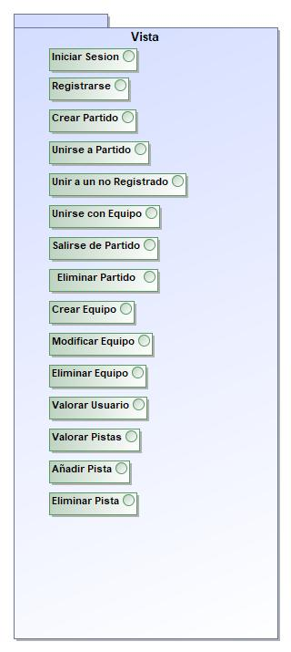

1. Vista

|  |  |
| --- | --- |
| **Name** | Vista |
| **Qualified Name** | Vista |

## **Interface** **Añadir Pista**

-1067780203.jpg

1. Añadir Pista

|  |  |
| --- | --- |
| **Name** | Añadir Pista |
| **Qualified Name** | Vista::Añadir Pista |
| **Visibility** | public |
| **Base Classifier** |  |

### **Attribute Detail**

|  |  |
| --- | --- |
| **Type** | Datos pista |
| **Default Value** |  |
| **Visibility** | public |
| **Multiplicity** |  |

### **Relation Detail**

#### Association

|  |  |
| --- | --- |
| **Name** |  |
| **Related Element** | * Datos pista |

## **Interface** **Crear Equipo**

-1122057698.jpg

1. Crear Equipo

|  |  |
| --- | --- |
| **Name** | Crear Equipo |
| **Qualified Name** | Vista::Crear Equipo |
| **Visibility** | public |
| **Base Classifier** |  |

### **Attribute Detail**

|  |  |
| --- | --- |
| **Type** | Datos equipo |
| **Default Value** |  |
| **Visibility** | public |
| **Multiplicity** |  |

### **Relation Detail**

#### Association

|  |  |
| --- | --- |
| **Name** |  |
| **Related Element** | * Datos equipo |

## **Interface** **Crear Partido**

-629730672.jpg

1. Crear Partido

|  |  |
| --- | --- |
| **Name** | Crear Partido |
| **Qualified Name** | Vista::Crear Partido |
| **Visibility** | public |
| **Base Classifier** |  |

### **Attribute Detail**

|  |  |
| --- | --- |
| **Type** | Datos partido |
| **Default Value** |  |
| **Visibility** | public |
| **Multiplicity** |  |

### **Relation Detail**

#### Association

|  |  |
| --- | --- |
| **Name** |  |
| **Related Element** | * Datos partido |

## **Interface** **Eliminar Equipo**

952412162.jpg

1. Eliminar Equipo

|  |  |
| --- | --- |
| **Name** | Eliminar Equipo |
| **Qualified Name** | Vista::Eliminar Equipo |
| **Visibility** | public |
| **Base Classifier** |  |

### **Attribute Detail**

|  |  |
| --- | --- |
| **Type** | Datos equipo |
| **Default Value** |  |
| **Visibility** | public |
| **Multiplicity** |  |

### **Relation Detail**

#### Association

|  |  |
| --- | --- |
| **Name** |  |
| **Related Element** | * Datos equipo |

## **Interface** **Eliminar Partido**

1323263239.jpg

1. Eliminar Partido

|  |  |
| --- | --- |
| **Name** | Eliminar Partido |
| **Qualified Name** | Vista::Eliminar Partido |
| **Visibility** | public |
| **Base Classifier** |  |

### **Attribute Detail**

|  |  |
| --- | --- |
| **Type** | Datos partido |
| **Default Value** |  |
| **Visibility** | public |
| **Multiplicity** |  |

### **Relation Detail**

#### Association

|  |  |
| --- | --- |
| **Name** |  |
| **Related Element** | * Datos partido |

## **Interface** **Eliminar Pista**

331817926.jpg

1. Eliminar Pista

|  |  |
| --- | --- |
| **Name** | Eliminar Pista |
| **Qualified Name** | Vista::Eliminar Pista |
| **Visibility** | public |
| **Base Classifier** |  |

### **Attribute Detail**

|  |  |
| --- | --- |
| **Type** | Datos pista |
| **Default Value** |  |
| **Visibility** | public |
| **Multiplicity** |  |

### **Relation Detail**

#### Association

|  |  |
| --- | --- |
| **Name** |  |
| **Related Element** | * Datos pista |

## **Interface** **Iniciar Sesion**

-1551127276.jpg

1. Iniciar Sesion

|  |  |
| --- | --- |
| **Name** | Iniciar Sesion |
| **Qualified Name** | Vista::Iniciar Sesion |
| **Visibility** | public |
| **Base Classifier** |  |

### **Attribute Detail**

|  |  |
| --- | --- |
| **Type** | Datos Usuario |
| **Default Value** |  |
| **Visibility** | public |
| **Multiplicity** |  |

### **Relation Detail**

#### Association

|  |  |
| --- | --- |
| **Name** |  |
| **Related Element** | * Datos Usuario |

## **Interface** **Mandar Notificaciones**

|  |  |
| --- | --- |
| **Name** | Mandar Notificaciones |
| **Qualified Name** | Vista::Mandar Notificaciones |
| **Visibility** | public |
| **Base Classifier** |  |

### **Attribute Detail**

|  |  |
| --- | --- |
| **Type** | Notificaciones |
| **Default Value** |  |
| **Visibility** | public |
| **Multiplicity** |  |

### **Relation Detail**

#### Association

|  |  |
| --- | --- |
| **Name** |  |
| **Related Element** | * Notificaciones |

## **Interface** **Modificar Equipo**

1373566052.jpg

1. Modificar Equipo

|  |  |
| --- | --- |
| **Name** | Modificar Equipo |
| **Qualified Name** | Vista::Modificar Equipo |
| **Visibility** | public |
| **Base Classifier** |  |

### **Attribute Detail**

|  |  |
| --- | --- |
| **Type** | Datos equipo |
| **Default Value** |  |
| **Visibility** | public |
| **Multiplicity** |  |

### **Relation Detail**

#### Association

|  |  |
| --- | --- |
| **Name** |  |
| **Related Element** | * Datos equipo |

## **Interface** **Registrarse**

-1438177862.jpg

1. Registrarse

|  |  |
| --- | --- |
| **Name** | Registrarse |
| **Qualified Name** | Vista::Registrarse |
| **Visibility** | public |
| **Base Classifier** |  |

### **Attribute Detail**

|  |  |
| --- | --- |
| **Type** | Datos Usuario |
| **Default Value** |  |
| **Visibility** | public |
| **Multiplicity** |  |

### **Relation Detail**

#### Association

|  |  |
| --- | --- |
| **Name** |  |
| **Related Element** | * Datos Usuario |

## **Interface** **Salirse de Partido**

2083933971.jpg

1. Salirse de Partido

|  |  |
| --- | --- |
| **Name** | Salirse de Partido |
| **Qualified Name** | Vista::Salirse de Partido |
| **Visibility** | public |
| **Base Classifier** |  |

### **Attribute Detail**

|  |  |
| --- | --- |
| **Type** | Datos partido |
| **Default Value** |  |
| **Visibility** | public |
| **Multiplicity** |  |

### **Relation Detail**

#### Association

|  |  |
| --- | --- |
| **Name** |  |
| **Related Element** | * Datos partido |

## **Interface** **Unir a un no Registrado**

-1953297277.jpg

1. Unir a un no Registrado

|  |  |
| --- | --- |
| **Name** | Unir a un no Registrado |
| **Qualified Name** | Vista::Unir a un no Registrado |
| **Visibility** | public |
| **Base Classifier** |  |

### **Attribute Detail**

|  |  |
| --- | --- |
| **Type** | Datos partido |
| **Default Value** |  |
| **Visibility** | public |
| **Multiplicity** |  |

### **Relation Detail**

#### Association

|  |  |
| --- | --- |
| **Name** |  |
| **Related Element** | * Datos partido |

## **Interface** **Unirse a Partido**

-1004366707.jpg

1. Unirse a Partido

|  |  |
| --- | --- |
| **Name** | Unirse a Partido |
| **Qualified Name** | Vista::Unirse a Partido |
| **Visibility** | public |
| **Base Classifier** |  |

### **Attribute Detail**

|  |  |
| --- | --- |
| **Type** | Datos partido |
| **Default Value** |  |
| **Visibility** | public |
| **Multiplicity** |  |

### **Relation Detail**

#### Association

|  |  |
| --- | --- |
| **Name** |  |
| **Related Element** | * Datos partido |

## **Interface** **Unirse con Equipo**

1189435873.jpg

1. Unirse con Equipo

|  |  |
| --- | --- |
| **Name** | Unirse con Equipo |
| **Qualified Name** | Vista::Unirse con Equipo |
| **Visibility** | public |
| **Base Classifier** |  |

### **Attribute Detail**

|  |  |
| --- | --- |
| **Type** | Datos partido |
| **Default Value** |  |
| **Visibility** | public |
| **Multiplicity** |  |

### **Relation Detail**

#### Association

|  |  |
| --- | --- |
| **Name** |  |
| **Related Element** | * Datos partido |

## **Interface** **Valorar Pistas**

1243520658.jpg

1. Valorar Pistas

|  |  |
| --- | --- |
| **Name** | Valorar Pistas |
| **Qualified Name** | Vista::Valorar Pistas |
| **Visibility** | public |
| **Base Classifier** |  |

### **Attribute Detail**

|  |  |
| --- | --- |
| **Type** | Valoraciones |
| **Default Value** |  |
| **Visibility** | public |
| **Multiplicity** |  |

### **Relation Detail**

#### Association

|  |  |
| --- | --- |
| **Name** |  |
| **Related Element** | * Valoraciones |

## **Interface** **Valorar Usuario**

-786674423.jpg

1. Valorar Usuario

|  |  |
| --- | --- |
| **Name** | Valorar Usuario |
| **Qualified Name** | Vista::Valorar Usuario |
| **Visibility** | public |
| **Base Classifier** |  |

### **Attribute Detail**

|  |  |
| --- | --- |
| **Type** | Valoraciones |
| **Default Value** |  |
| **Visibility** | public |
| **Multiplicity** |  |

### **Relation Detail**

#### Association

|  |  |
| --- | --- |
| **Name** |  |
| **Related Element** | * Valoraciones |

# **Appendix A: Diagram**

## **Model**

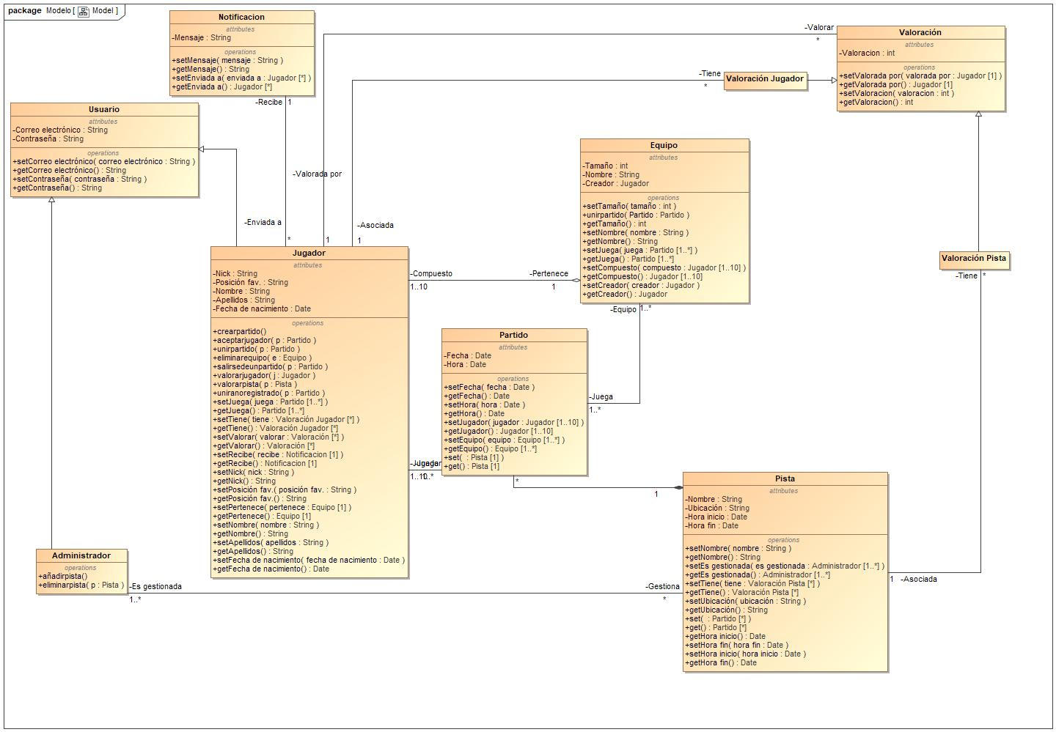

1. Model

## **Model**

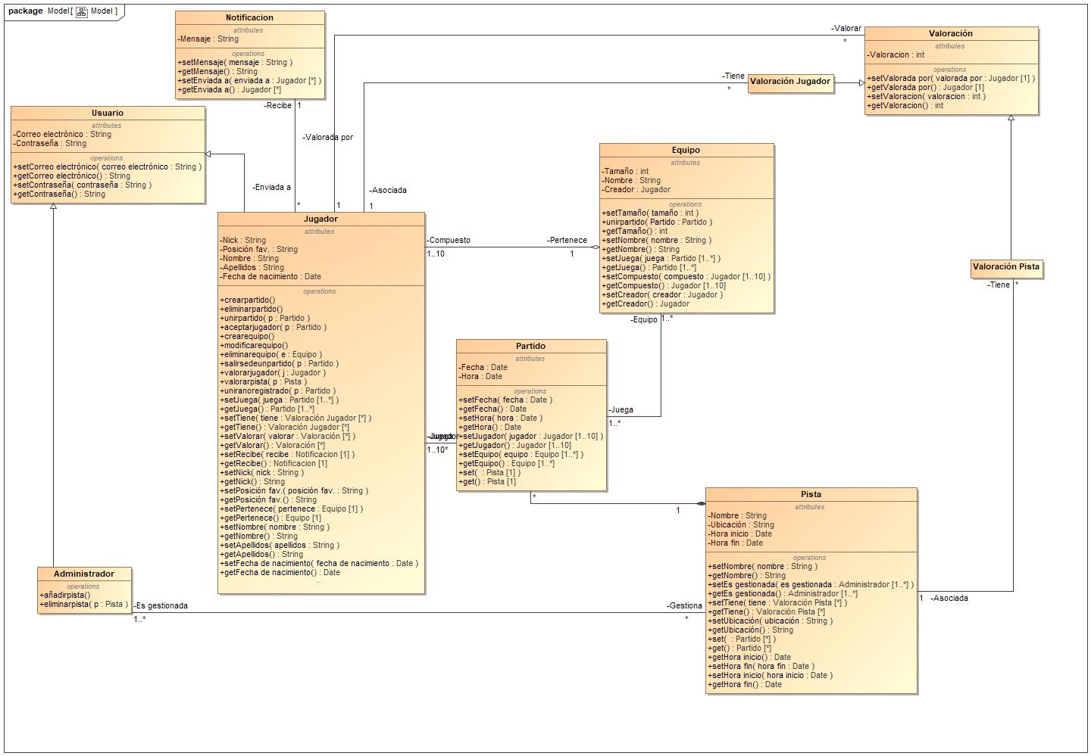

1. Model

**Clase Usuario**

La clase Usuario contiene información sobre un determinado usuario: su nick, su correo electrónico y su contraseña.

**Clase Jugador**

La clase Jugador hereda de la clase Usuario, por lo que contiene información sobre un determinado usuario, además de su nombre, apellidos y fecha de nacimiento. También posee información sobre su posición favorita.

Este jugador puede tanto crear partidos y modificarlos como unirse a aquellos que ya estén creados. Además, podrá crear equipos con los cuales podrá unirse a un partido. Otra opción será la de unirse al partido con gente que no esté registrada.

Asimismo tendrá la opción de salirse del partido o eliminarlo (si es anfitrión) y de modificar y eliminar sus equipos. Este anfitrión podrá aceptar o rechazar a todo aquel que quiera unirse al partido.

Otra opción será la de valorar pistas y jugadores con los que ya haya jugado.

**Clase Equipo**

La clase Equipo contiene información de un determinado equipo como el tamaño del equipo, el nombre del mismo y el nombre del capitán de equipo(creador).

El equipo se podrá unir a un partido con alguno o todos sus miembros.

**Clase Partido**

La clase partido proporciona la fecha y hora en la que se realizará un partido en específico, se puede jugar un partido con equipo, solo o con jugadores no registrados, partido está relacionado con pista ya que estará asignado a una.

**Clase Administrador**

La clase Administrador hereda de la clase Usuario, por lo que contiene información sobre un determinado usuario, el administrador es el que gestiona las pistas.

**Clase Pista**

La clase Pista contiene información sobre una determinada pista, tal como su nombre, su ubicación y la hora de inicio y fin en la que se pueden realizar los partidos. Las pistas son modificadas por el administrador ya sea para eliminarlas, añadirlas o cambiar su información, también cuenta con valoraciones dadas por los usuarios.

**Clase Valoración**

Esta clase engloba todas las valoraciones, ya sean de usuario o de pista.

Como atributos tiene un entero Valoración que es la calificación entre 1 y 5 de una pista o usuario.

Relacionada con las clases Pista y Jugador.

**Clase Valoración Usuario**

Esta clase hereda de Valoración y contiene todas las valoraciones que los jugadores hacen de otros usuarios, también jugadores.

No contiene atributos propios, solo los que hereda de su superclase.

**Clase Valoración Pista**

Hereda de Valoración y contiene todas las calificaciones que los usuarios realizan a las pistas en las que han jugado algún partido.

No contiene atributos propios, solo Valoración, heredada de su superclase.

**Clase Notificación**

Esta clase representa las notificaciones que recibe el usuario por parte del sistema.

Tiene como atributos Mensaje, un String, que sería el cuerpo de la notificación.

Está relacionada con Jugador.