Task Submission Document - Iris Classification
Task No: ____ | Student Name: Jeswanth Reddy Reddem | Date: __________________
Important: Before final submission, replace all placeholder links below with your actual GitHub, Google Drive, and notebook links. Ensure Google Drive sharing is set to "Anyone with the link can view".

1-Page Executive Summary
Project Goal: Build a supervised machine learning classification model to predict iris flower species using sepal length, sepal width, petal length, and petal width.
Dataset: Classic Iris dataset containing three species: Iris-setosa, Iris-versicolor, and Iris-virginica. The dataset was split into training and testing sets using stratification to preserve class distribution.
EDA and Visualization: Exploratory data analysis was performed using class distribution charts and feature scatter plots. Petal length and petal width showed strong class separability, especially for Iris-setosa.
Models Trained: k-Nearest Neighbors, Logistic Regression, and Decision Tree classifiers were trained and compared.
Evaluation Metrics: Models were evaluated using accuracy, precision, recall, F1-score, and confusion matrix. The best model was selected based on test accuracy and macro/weighted performance.
Best Model: Logistic Regression was selected as the best model in this run, achieving 93.33% test accuracy. The trained model was saved using both joblib and pickle formats.
Deliverables: The submission contains a well-structured notebook, source code, saved model files, generated plots/screenshots, README, requirements file, and inference example.

Submission Links
Artifact | Required Link | Status
GitHub Repository | Paste GitHub repo link here | To be added
Notebook Link | Paste GitHub/Colab notebook link here | To be added
Saved Model File | Paste Drive/GitHub model file link here | To be added
Screenshots/Plots Folder | Paste Drive/GitHub screenshots folder link here | To be added
Final Project ZIP | Paste Google Drive ZIP link here, if required | Optional

Artifacts Included
- Notebook: notebooks/Iris_Classification.ipynb
- Training script: train_model.py
- Inference script: inference.py
- Saved models: models/best_iris_model.joblib and models/best_iris_model.pkl
- Plots/screenshots: plots/class_distribution.png, plots/petal_scatter.png, plots/sepal_scatter.png, plots/metrics_comparison.png, plots/confusion_matrix_best_model.png
- README: README.md
- Requirements: requirements.txt
- Metrics summary: metrics_comparison.csv

Screenshots / Plots
Class Distribution
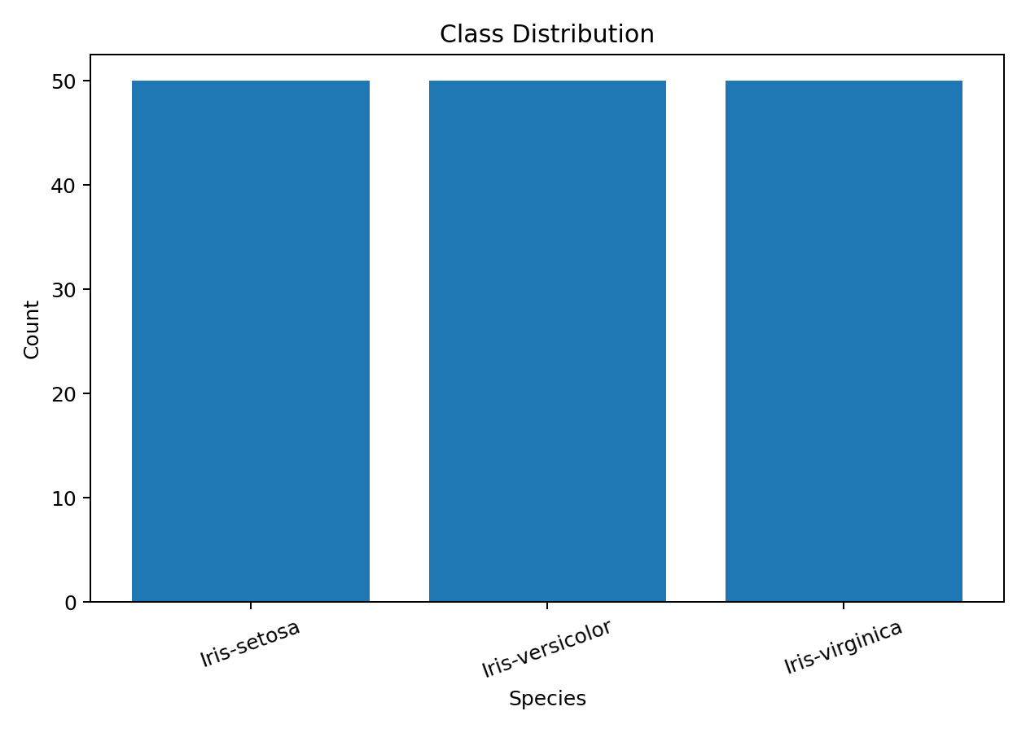
Petal Feature Separability
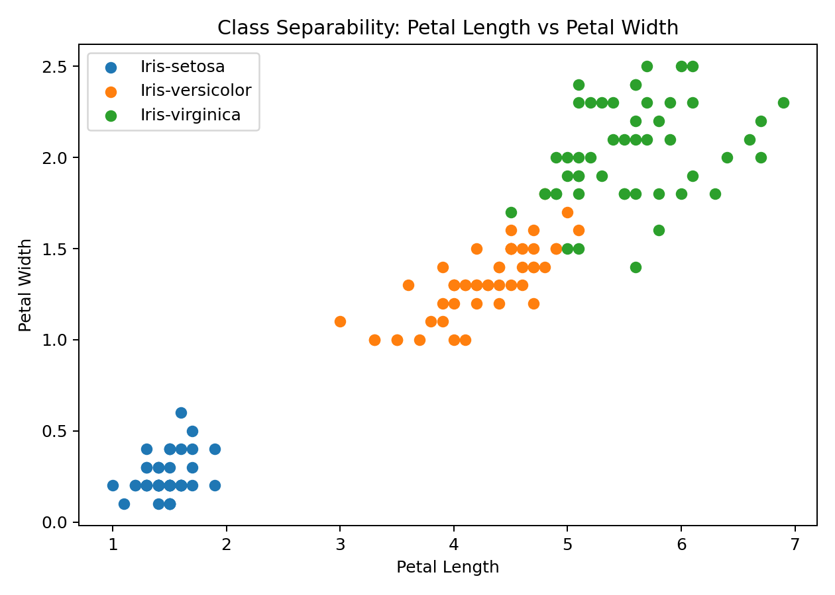
Metrics Comparison
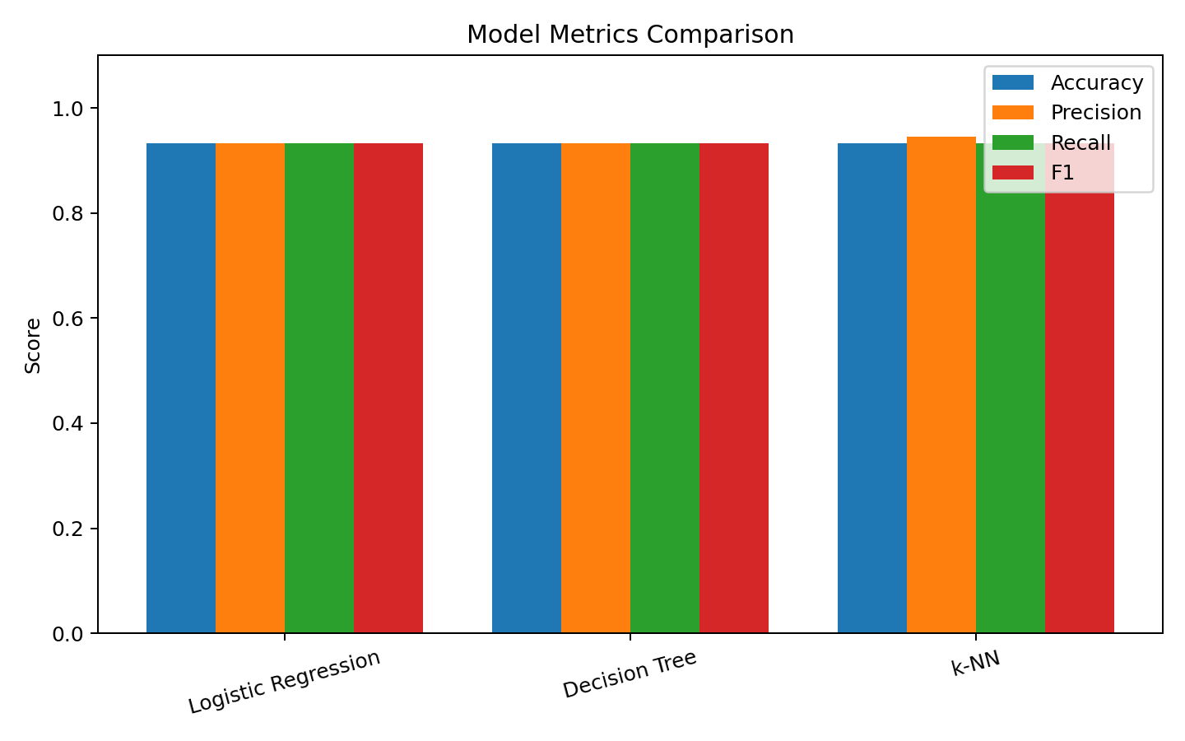
Confusion Matrix - Best Model
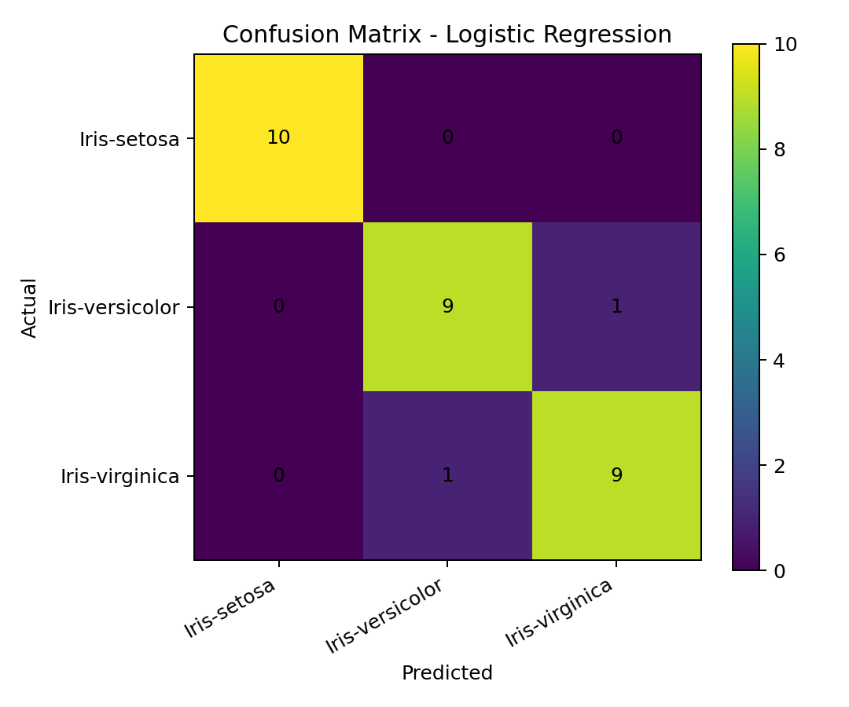

Reproducibility Commands
# 1. Install dependencies
pip install -r requirements.txt
# 2. Train and evaluate models
python train_model.py
# 3. Run example inference
python inference.py
# 4. Open the notebook
jupyter notebook notebooks/Iris_Classification.ipynb

Package Versions
- Python 3.x
- pandas
- numpy
- matplotlib
- seaborn
- scikit-learn
- joblib
- jupyter

Final Submission Checklist
☐ Push notebooks and code to GitHub.
☐ Upload large files or final ZIP to Google Drive if required.
☐ Set Google Drive sharing permission to anyone with the link can view.
☐ Paste links clearly on the Task Submission page with task number.
☐ Attach or upload this DOC/PDF submission document as required.
☐ Verify that README includes package versions and exact commands.

