URBAN BUS TRACKING SYSTEM

REPORT

Submitted by

DAYA ANAND C H (19IT019)
ENIYAN M S (19IT027)
MANOJ A (19IT055)
TARUN KISHORE G T (19IT112)

in partial fulfillment for the completion of course Engineering Design Project
of
BACHELOR OF TECHNOLOGY
IN
INFORMATION TECHNOLOGY

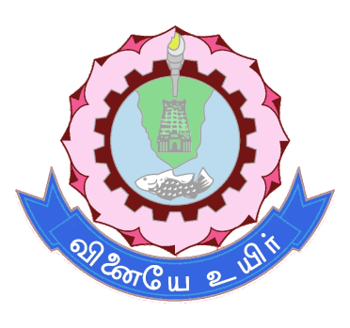

THIAGARAJAR COLLEGE OF ENGINEERING, MADURAI–15
(A Govt. Aided, Autonomous Institution, Affiliated to Anna University)

JUNE 2022

THIAGARAJAR COLLEGE OF ENGINEERING, MADURAI-15
(A Govt. Aided, Autonomous Institution, Affiliated to Anna University)

BONAFIDECERTIFICATE

Certified that this project report “URBAN BUS TRACKING SYSTEM” is the bonafide work of “DAYA ANAND C H (19IT019)” who carried out the project work under my supervision during the Academic Year 2021 -2022.

SIGNATURE
Mrs.R.Parkavi,
ASSISTANT PROFESSOR,
INFORMATION TECHNOLOGY
THIAGARAJAR COLLEGE OF
ENGINEERING,
MADURAI-15

THIAGARAJAR COLLEGE OF ENGINEERING, MADURAI-15
(A Govt. Aided, Autonomous Institution, Affiliated to Anna University)

BONAFIDECERTIFICATE

Certified that this project report “URBAN BUS TRACKING SYSTEM” is the bonafide work of “ENIYAN M S (19IT027)” who carried out the project work under my supervision during the Academic Year 2021 -2022.

SIGNATURE
Mrs.R.Parkavi,
ASSISTANT PROFESSOR,
INFORMATION TECHNOLOGY
THIAGARAJAR COLLEGE OF
ENGINEERING,
MADURAI-15

THIAGARAJAR COLLEGE OF ENGINEERING, MADURAI-15
(A Govt. Aided, Autonomous Institution, Affiliated to Anna University)

BONAFIDECERTIFICATE

Certified that this project report “URBAN BUS TRACKING SYSTEM” is the bonafide work of “MANOJ A (19IT055)” who carried out the project work under my supervision during the Academic Year 2021 -2022.

SIGNATURE
Mrs.R.Parkavi,
ASSISTANT PROFESSOR,
INFORMATION TECHNOLOGY
THIAGARAJAR COLLEGE OF
ENGINEERING,
MADURAI-15

THIAGARAJAR COLLEGE OF ENGINEERING, MADURAI-15
(A Govt. Aided, Autonomous Institution, Affiliated to Anna University)

BONAFIDECERTIFICATE

Certified that this project report “URBAN BUS TRACKING SYSTEM” is the bonafide work of “TARUN KISHORE G T (19IT112)” who carried out the project work under my supervision during the Academic Year 2021 -2022.

SIGNATURE
Mrs.R.Parkavi,
ASSISTANT PROFESSOR,
INFORMATION TECHNOLOGY
THIAGARAJAR COLLEGE OF
ENGINEERING,
MADURAI-15

TABLE OF CONTENTS

SL. NO. | DETAILS | PAGE NO.
1 | ABSTRACT | 1
2 | PROBLEM DESCRIPTION | 2
3 | BACKGROUND | 4
4 | DESIGN REQUIREMENTS | 9
5 | PROPOSED METHODOLOGY | 13
6 | DESIGN | 15
7 | DESIGN VERIFICATION MATRIX | 18
8 | BUSINESS ASPECTS | 19
9 | FINAL IMPLEMENTATION | 20
10 | TESTING & VALIDATION | 26
11 | DELIVERABLES | 28
12 | PERFORMANCE TEST RESULTS | 29
13 | FINANCIAL CONSIDERATION | 30
14 | DEPLOYMENT | 30

ABSTRACT

Madurai city faces severe problems of road congestion and associated issues of commuters, which include delays in the arrival of buses at bus stops, lack of information about different bus routes and stops and time. College students/staffs will miss their bus by a fraction of second. This will lead to many problems like being late for the classes and sometimes late for the exams also. To overcome this, we have implemented an Urban Bus Tracking System.

The proposed system uses a Smartphone application. Buses carry Global Positioning System (GPS) devices to track their positions and Google Maps API is used to display the vehicle on the map in the Smartphone application. It shows where exactly the bus is there on the map and provides updated information to the user at different time intervals. This also displays the estimated arrival time, which helps the user to know when exactly the bus is going to reach his/her stop.

The user can get flexibility of planning travel using the app, to decide when to catch the bus. The proposed system is user friendly and ensures safety and surveillance at low maintenance cost.

PROBLEM DESCRIPTION

Vehicle tracking systems were first implemented for the shipping industry because people wanted to know where each vehicle was at any given time. These days, however, with technology growing at a fast pace, automated vehicle tracking system is being used in a variety of ways to track and display vehicle locations in real-time.

However, bus transportation service has very poor transportation information system nowadays. Bus users do not know the exact arrival time for a bus, but only know the scheduled approximate arrival time. Bus transportation service does not have a proper system to track all buses position and the actual arrival time in every bus stop. These problems occur because current bus service system did not apply real time tracking technology to track on each bus on the road and also lack of a platform to update latest bus traffic information to bus users.

In order to solve these problems and enhance current bus service system, real time bus tracking system has to develop and implement. With real time bus tracking system, bus position data is connected real time and transmitted to a central server for processing and extracting transit information. The main technology used to develop this system is Global Positioning System (GPS). GPS technology able to receives the position of an object from space-based satellite navigation system through a GPS receiver.

For wireless data transmission, GSM and SMS technology are commonly used. The SMS technology through GSM network and GSM modem provide a user with vehicle location information. Instead of using SMS, the bus tracking system uses the smart phone application to track and monitor a bus location obtained from the in-vehicle tracking device.

The bus location is automatically placed on Google maps, which makes it easier for tracking a vehicle and provides users with more accurate vehicle location information.

The developed bus tracking system will be able to provide bus users a real time platform to check on updated bus traffic information, for example bus arrival or departure time.

BACKGROUND

- LITERATURE SURVEY

S. No. | Title of the Paper | Author | Dataset/Methodology | Observations
1 | The Smart Bus for a Smart City - A real-time implementation, 2016 IEEE International Conference on Advanced Networks and Telecommunications Systems (ANTS). | Shared S, Bagavathi Sivakumar P, Anantha Narayanan V | Artificial Neural Networks (ANN) is used to give an accurate estimate of the arrival time (ETA) to the commuter by means of an application. ETA to the next stop is communicated to the commuter using the MQTT (Message Queuing Telemetry Transport) protocol, by the hardware mounted on the bus. The proposed solution also adds a fleet management console to the administrators, making them manage and monitor the fleet of buses in real time. | The prototype thus developed makes sure that commuting in cities is pleasant and hassle-free. The Intelligent Transport System (ITS)s-based solutions can be studied to overcome this pitfall, which would help the commuter to effectively utilize the public transport which includes lower waiting time.
2 | GPS Supported City Bus Tracking & Smart Ticketing System, 2015 International Conference on Green Computing and Internet of Things (ICGCIoT). | Ajay Shingare, Ankita Pendole, Nikita Chaudhari and Parikshit Deshpande, Prof. Samadhan Sonavane | The location of the bus can be observed continuously using GPS system. The GPS satellites transmit signals to a GPS receiver. These receivers statically receive signals. GPS satellite transmits data that indicates the location and current time of the vehicle. The Smart Card provides, identification, application processing along with data storage. Every passenger will carry the smart card. The Smart Card holds information of the user such as available balance, identification number, user’s information. | These smart cards are capable of recharge. By integrating both GPS technology and smart cards we are going to design a whole bus ticketing system. Whenever the passengers will enter in the bus, he/she will be asked by the conductor whether he/she wants to buy ticket by using smart card or money. If smart card is used, then the conductor will swipe smart card. Then validity and of smart card will be checked with server and then the ticket will be issued. According to Source and destination the distance covered by passenger is get calculated and according to that bus fare amount will be reduced from smart card. The smart cards will also useful for conductor for fast issuing the tickets to the passengers.
3 | Smart assistance for public transport system, 2016 International Conference on Inventive Computation Technologies (ICICT), Volume: 3. | ReshmaRathod | The project is to be implemented for public bus (for ex: PMTs in Pune). It has the entire smart assistance system required for public security and safety. The smart system includes safety for women as well. It has accident detection and monitoring facility. It also has user friendly application for user to track bus on smart their phones. The smart system can be designed for both online (GPS) and offline (GSM) for user friendly service. Here, GPS system is used to get real-time co-ordinates for offline (GSM) system. It allows user to save its time by acknowledging no. of persons present in the bus as well as no. of seats available in the bus along with the current and next stop acknowledgement with its arrival timings. It also has ramp for handicap people to provide them ease to use the bus service. It also has driver authentication system using RFID tag. | The system also has many additions feature to make public transport system an intelligent and easy to use system, so that public can take smart advantage of it. The system is specially designed for Smart Cities as it is trending now-a-days. The basic idea of producing smart public transport system is to be developed on ARM system using GPS/GSM technology. The basic need to develop this system is to minimize public time issues related to the public transport system. Features to be implemented in the system are vehicle tracking(online/offline), availability of no. of seats in the vehicle (bus), engine heat monitoring in the bus, women safety, accident detection, and various other features.
4 | Smart bus: a tracking system for school buses, 2017 Sensors Networks Smart and Emerging Technologies (SENSET). | Majd Ghareeb, Athar Ghamlous, Hawraa Hamdan, Ali Bazzi,Samih Abdul-Nabi | The objective of this project is to facilitate this task on parents and save their time by automatically notifying them few minutes before the arrival of their kid, so they can go out to receive him from the bus. This is also applied in the morning tour of the bus to inform parents that the bus is approaching and their kid should go out to take the bus to school. This system can be used by any Lebanese school to increase the safety measures for its students and to relieve parents from the responsibility of waiting school buses each day. | The system has been efficiently and dynamically designed and implemented so it can be hosted and used by any school administration without the need to any major modifications.
5 | IoT-based school bus tracking and arrival time prediction, 2017 International Conference on Advances in Computing, Communications and Informatics (ICACCI). | R.C.Jisha, Aiswarya Jyothindranath, L Sajitha Kumary | This system is providing a real-time vehicle tracking via Global-Positioning System (GPS) technology to detect the location of the bus and to use internet by a generalpacket-radio service (GPRS) technology to display live images on the Google Map or website app for tracking location of buses anytime. We are using the GPS and GPRS modules, the GPS module will locate the buses via the satellite, and the GPRS module will collect all data and send it to the website. | The buses will be monitored live using coordinates with this system. Also, by implementing geofence, user get notify once bus entered in his/her predefined area. We are developing an Android-application which will give the real-time schedule of buses. Also, it provides quick and real-time replay for inquiry, via the server. Also, in case of any unexpected activities or breakdown, the alert will be sent to the system, with Bus location.

- SCOPE OF THE PROBLEM/OBJECTIVE

Many cities have found that GPS tracking system not only improve the efficiency of city bus operation, but also encourage commuters to take the advantage of city bus system. Many city bus systems have discovered that GPS tracking system allows monitoring the location and arrival time of their bus actually increase the number of people using city buses for routine communing. The application is a user friendly one that anyone can access for free of cost.

The basic idea for this project was to guide the bus travelers with the routes, all the possible stops that come on their way to the destination and moreover, display maps and track their locations and show the estimate remaining time required to reach. The aim is to overcome all the drawbacks faced in all the previous applications and generate fast and accurate results.

- CONSTRAINTS AND LIMITATIONS

1.GPS Accuracy
- Environmental Condition is a major factor.
2.Power Source
- Only needed when the bus is operating in a city.
- GPS trackers work on high battery charge.
3.GSM Connectivity
- GSM utilizes a cellular network.
- Coverage of GSM service must cover even corners of a city.

DESIGN REQUIREMENTS OR PROJECT SPECIFICATION

- SCHEDULE / TIMELINE CHART

SL.NO. | MILESTONES TO BE ACHIEVED | ESTIMATED DATE | REMARKS
1 | Exploratory Analysis | 15.04.2022 - 21.04.2022 | Completed
2. | Gathering IoT modules | 22.04.2022 - 29.04.2022 | Completed
3. | Confusion Matrix and initiation of App Development | 30.04.2022 - 05.05.2022 | Completed
4. | Testing and Deployment with CI/CD | 06.05.2022 - 21.05.2022 | Completed
5. | Classification Report | 22.05.2022 - 29.05.2022 | Completed
6. | Final App | 30.05.2022 | Completed

- BUDGET
The budget for this project costs around 2000-3000 rupees per unit and the android app can be downloaded for free from the play store.

- RISK FACTORS
The major risk factor for this app is GPS accuracy. Sometimes it can share wrong the location data with the wrong time stamps and it can lead the user to plan his travel in the wrong manner. Also, a sufficient amount of power source needs to be provided to the tracker for its flawless execution. Another risk factor, is the GSM connectivity and it is completely dependent on the telecomm provider and their signal coverage area. These are the risk factors of our project.

- TEAM MEMBERS ROLES AND RESPONSIBILITIES

Team members | Roles | Responsibility
Daya Anand C H | Team leader and backend developer | Lead the team and assign tasks to the other members and did the backend for the Android App
Eniyan M S | Frontend and IoT Developer | UI/UX for the Android App and assembling of the IoT components
Manoj A | Frontend/Backend Developer | Integrated the Application’s two ends and took care of the project workflow using GitHub.
Tarun Kishore G T | Frontend/Backend Developer | Took care of the map’s frontend & API and Google firebase cloud management.
MAIN REQUIREMENTS:

- SOFTWARE REQUIREMENTS:
- Technology used: Android 4.1 or higher
- IDE: Android studio
- Emulator: Android Emulator
- Plug-in – Android ADT plugin
- Backend – Firebase
- Front end – Android SDK

- HARDWARE REQUIREMENTS:
- System Processor: Microcontroller
- Mobile Processor: 1GHZ or higher
- Other Requirements: 12v power supply, GPS Receiver, GSM Module

- FUNCTIONAL REQUIREMENTS:
- There are functions such as
- Store the user credentials
- Store bus information to the database
- Update location in the database
- Retrieve the results from the database

This system generates continuous update of location, where the students can see the location before starting and reach their stop on time with no delay.

- NON-FUNCTIONAL REQUIREMENTS:
- Usability:
Any end user familiar with android application can use this application since it has user friendly interface

- Reliability:
Since we are using GPS Tracker combined with Node MCU to get the location so, the location we are getting is correct and accurate and location details are controlled by the admin

- Performance:
The app seems to perform well as it doesn’t handle any complex calculation. It gets the latitude and longitude of the bus’s location and identifies the distance from the user and the bus. This can simply provide notification based on the distance of the bus and the user.

- Operation:
The location of the bus is being uploaded to the firebase database periodically and the app fetches the location and plots it into the map. The app will push a notification automatically.

- Supportability:
As it is an android application it can be installed it only android OS and developer maintains this application.

PROPOSED METHODOLOGY

To track the bus locations in real-time and to get that live update on the mobile application, we have three phases. The first phase is to implement tracker implementation. For that, we use the GPS and GSM IoT modules, which will help us get its current location. This location data is transmitted in the terms of latitude & longitude coordinates. This location data is updated in real-time, which means every second or two.

The second phase is the cloud part. We’ve used Google Firebase for our implementation. Because Firebase has real-time database functionality, which we can utilize for the live location updates. Also, firebase gives us a free tier for 1000 requests per second. It means we can host our application on the cloud, for as long as we like.

The third and the most important phase of the project is the android app implementation. It has authentication facilities from google and it can pinpoint the bus’s live location from the data fetched from the firebase cloud. Just like the Firebase, the app itself hot reloads the data every second or two. So, the exact data on the cloud at any given moment is reflected right on the app, instantaneously. This is our proposed methodology.

EXISTING VS PROPOSED METHODOLOGY:

EXISTING SYSTEM:
- Location if the bus is not known, thus we need to ask the bus information to respective persons
- Long time waiting for the bus
- Chances of missing bus

PROPOSED SYSTEM:
- Users will be able to spot the buses that or currently running around the city.
- Users now can prepare the journey well in advance and leave from their place to bus stop in the right time.

DESIGN
- USE CASE DIAGRAM
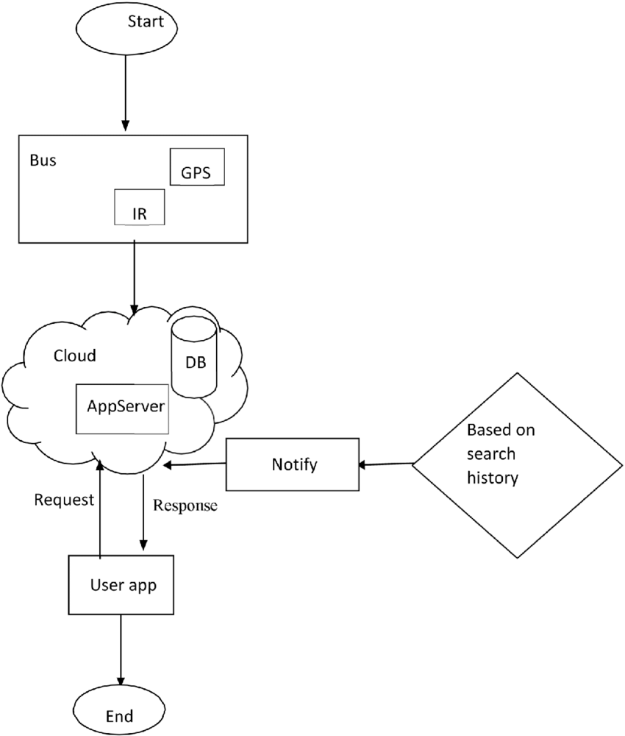

- CLASS DIAGRAM
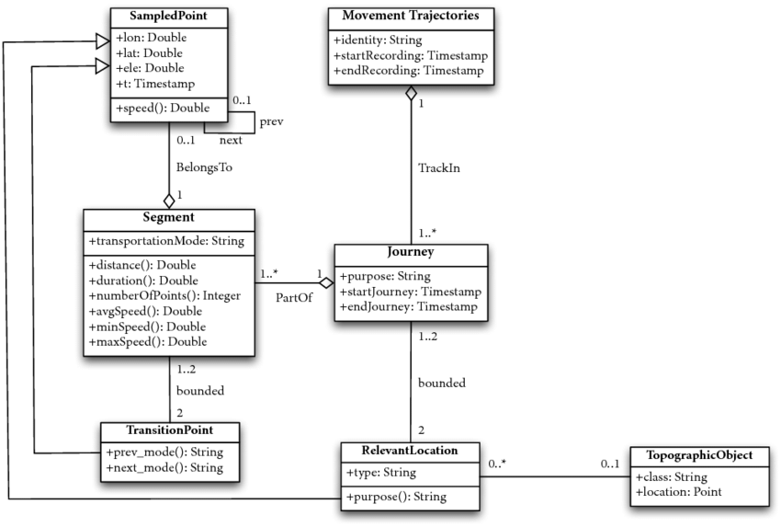

- SEQUENCE DIAGRAM
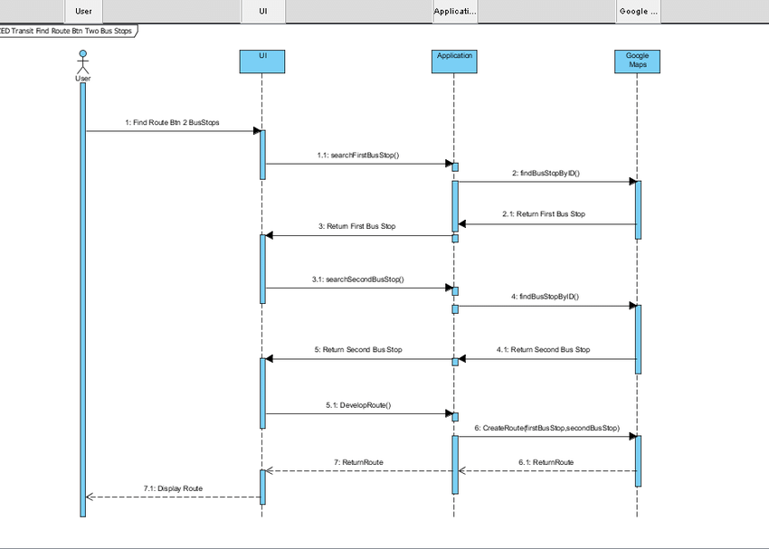
- STATE CHART DIAGRAM
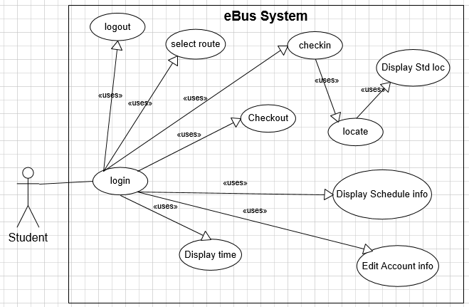
Urban Bus Tracking System
User

- ACTIVITY DIAGRAM

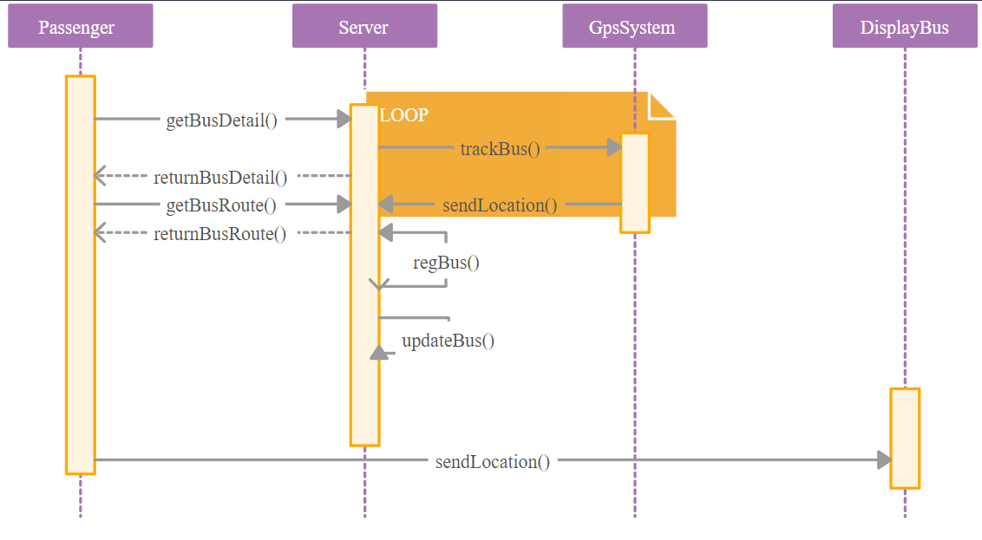

DESIGN VERIFICATION MATRIX

S.NO | DESIGN DESCRIPTION | SCORE
1 | Ease of Use | 90
2 | Flexibility | 85
3 | Colors and Icons | 80
4 | Usability | 85
5 | Elegance | 90
6 | Acceptability | 95

BUSINESS ASPECTS

- MARKET:

Even though vehicle tracking has been around for a long time, this will mark the first real-time, domain-specific, accurate urban bus tracking implementation. Also, on the budget lines, this is very easy to work with, so the government can easily adapt this method pretty quickly.

- MAINTAINABILITY:

This project, although we had some technical hurdles at first, was very easy to implement. All the team members contributed to the project to their maximum extent and it can be easily maintained with minimal human interaction, in the future.

- CUSTOMER AND CLIENT:

The stakeholders for this project are the daily urban bus commuters and the government bus sectors. They have a lot of gains from this one and the market estimate for this project is quite high in demand.

- STARTUP CAPITAL

We need IoT components for this project and each unit costs around 2000-3000 rupees for the finished product. Once equipped, it can work without any hiccups for almost 5-6 years, if maintained properly. The app is completely free for the use and the cloud service too.

- ADAPTABILITY AND DETERMINATION:

The Urban bus tracking system adapts the more features and also the feedback provided by the user and improves the project based on the feedback given by the user so that the users of our projects have confidence in the team so that business increases and demand increase for our project.
FINAL IMPLEMENTATION

TECHNOLOGY STACK USED
i. Front end – Android Application (Java, XML)
ii. DB – Google Fire store Realtime Database
iii. Backend - Google Firebase

IOT (INTERNET OF THINGS) IMPLEMENTATION:

Components:
- Arduino UNO
- GSM Module (SIM 900A)
- GPS Module (Neo 6M)

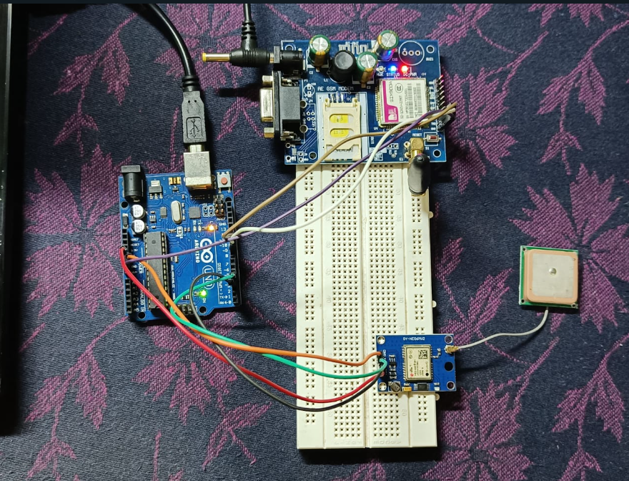

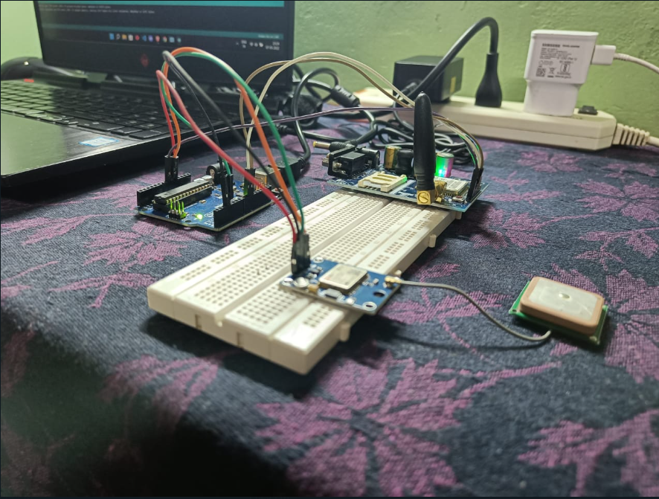

The code for the IOT component is attached in the Deployment section of this report. We have used Real Time Database from firebase to send our location information dynamically.

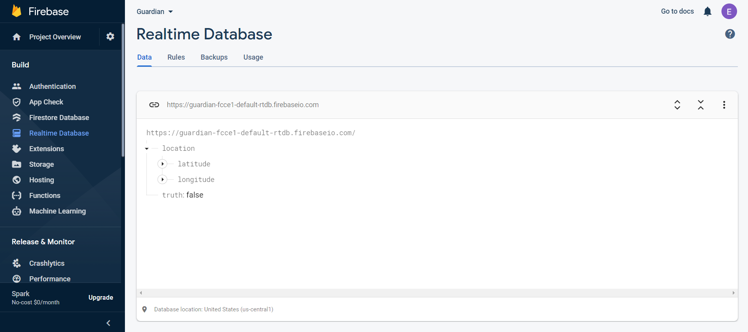
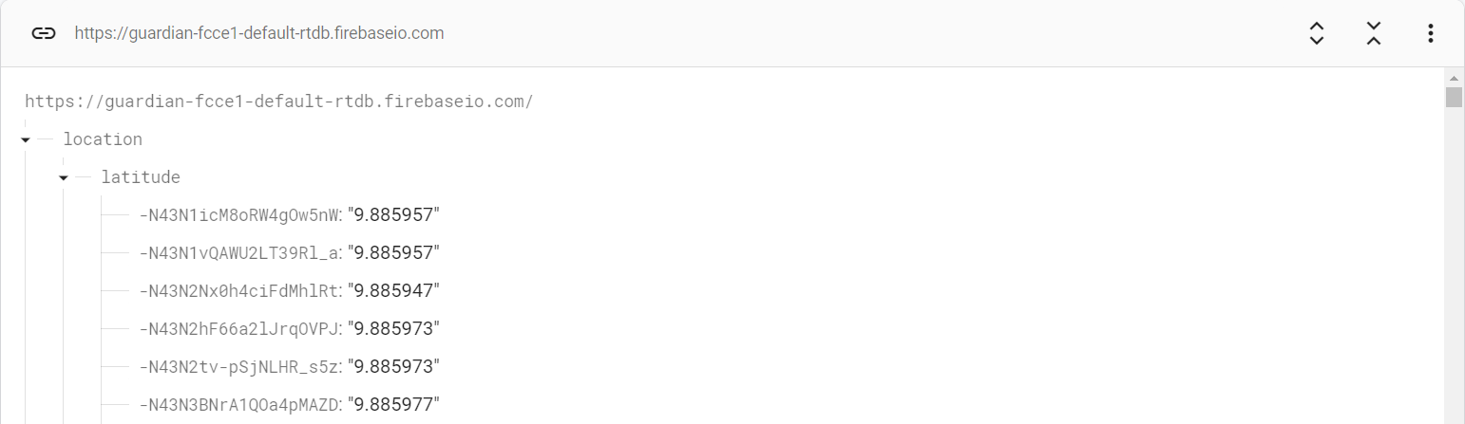
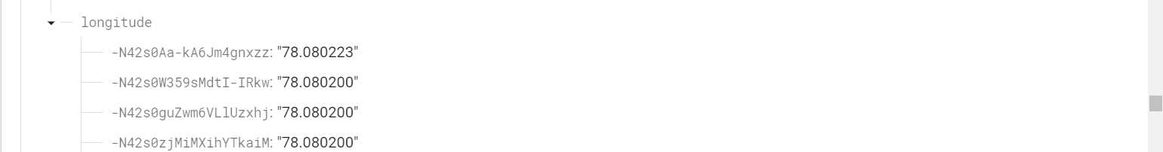

ANDROID APP IMPLEMENTATION:
User login and Authentication:

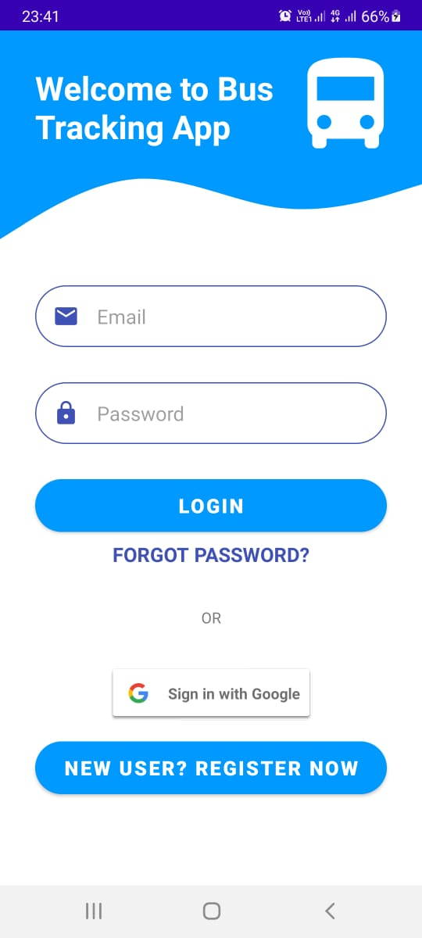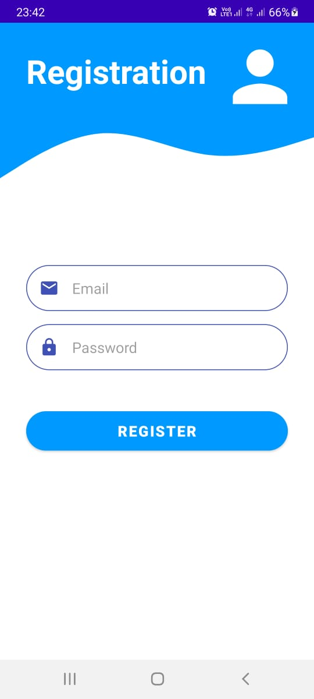
The above images show the login page and the registration app for our app. Our app also supports google API for login which is shown below.

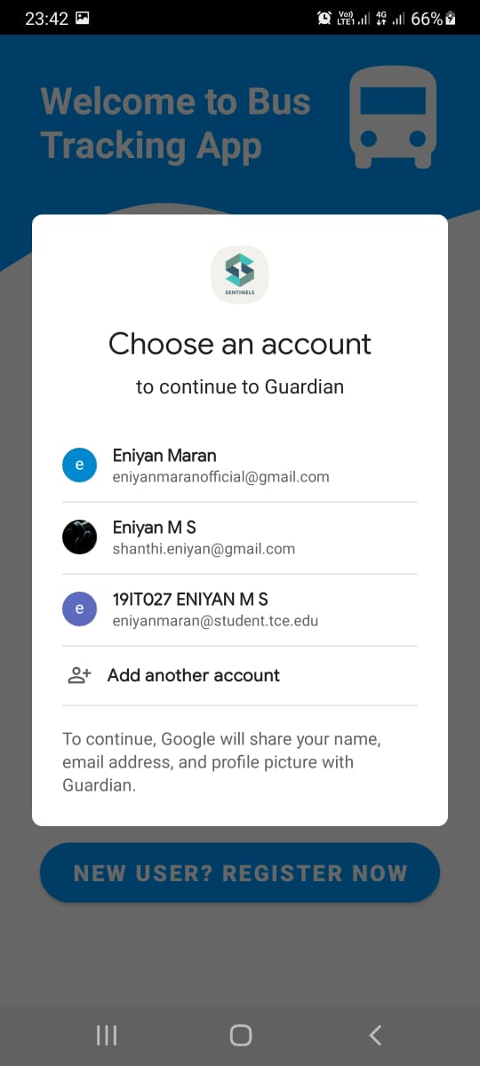

The backend for our mobile application is Firebase. It validates the user authentication and verifies them upon login to our app.

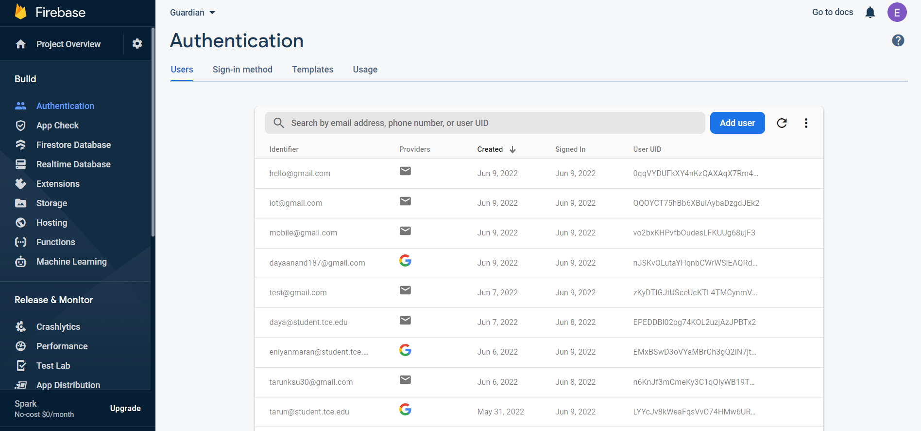
Upon Login, A home page will appear along with a Navigation Drawer. We have included 4 main pages alongside the login and registration pages in our application. We have also included Log out service for our user.

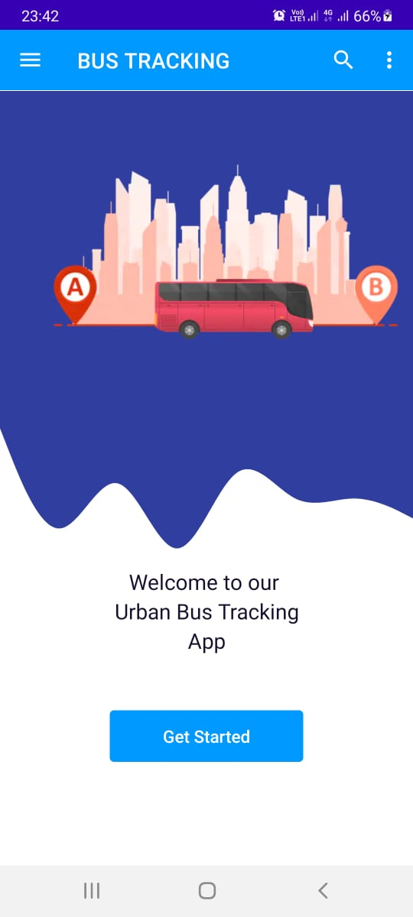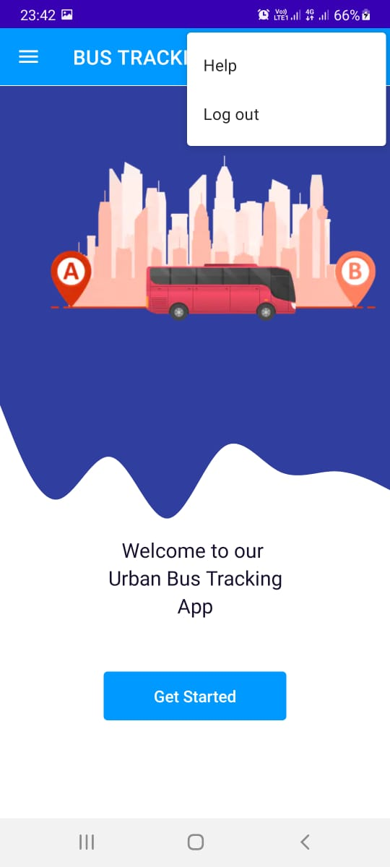

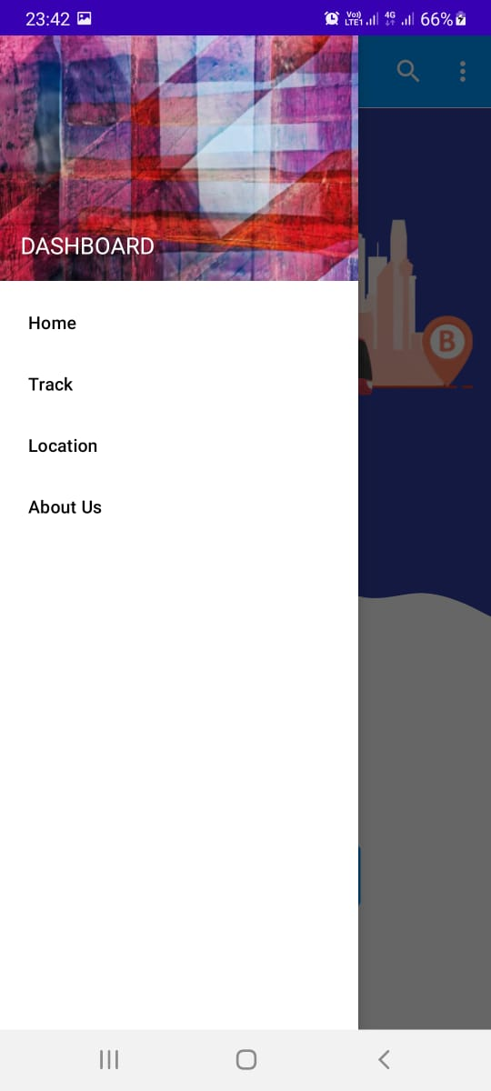
The Bus tracking page tracks the current location of our application user and uses the location permission. When the bus comes within a close distance to the user’s location, a status notification is sent to alert them that the bus is close (as you can see below).

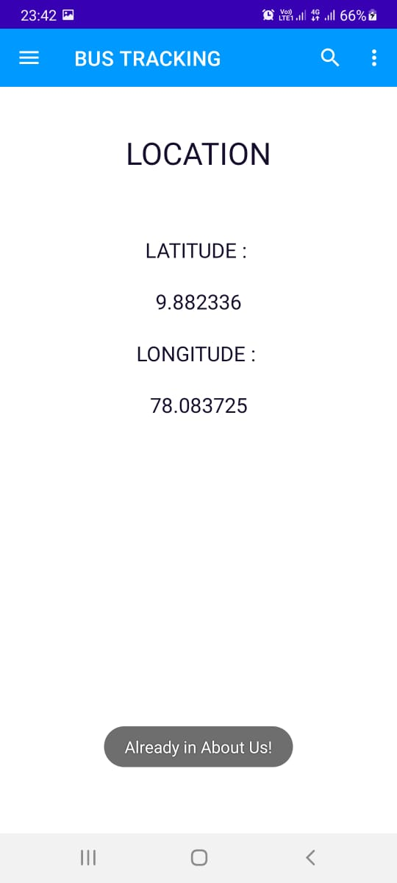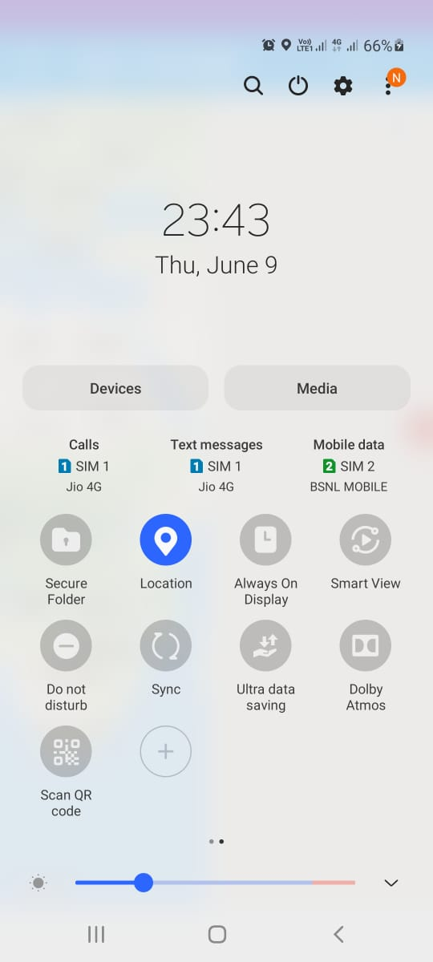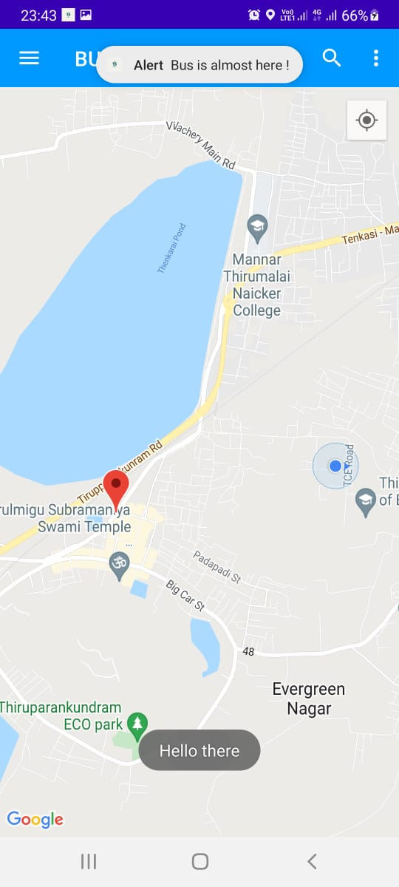

The above latitude and longitude are fetched from firebase’s Realtime database which is uploaded by the IOT module. We have also added an About Us page to our application.
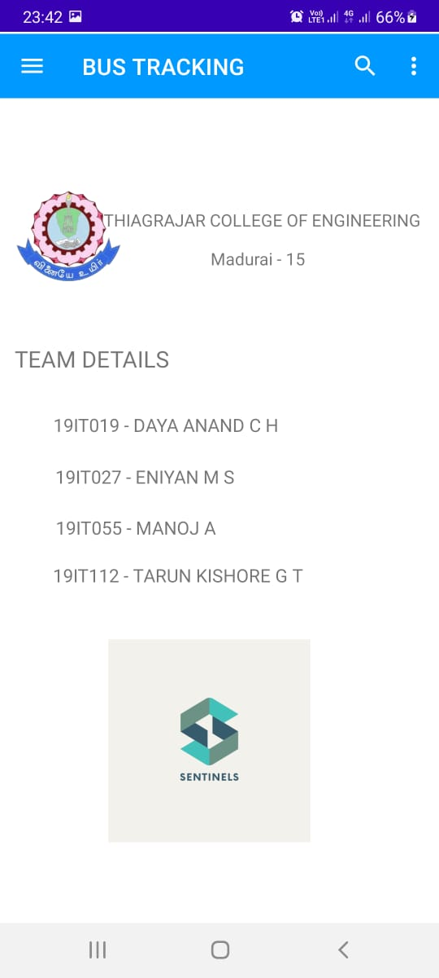
TESTING & VALIDATION

  - Unit testing:
We had certain checkpoints in which we checked on our app at regular basis. We worked on GitHub which also had support for CI/CD which really helped us a lot.

B. Integration testing:
After successfully building each module separately, we then started integration them and tested them after integrating each module. We also used the help of GitHub Actions.

C. Usability testing:
We also had our friends who gave us a lot of reviews so that we could build a clean app. They used our app at regular intervals and reported all the bugs to us and we tried our level best to solve it.
UI
  - Visibility
  - Readability
UX
  - Smooth navigation
  - Self-explanatory
Response time
- Reasonable response time
- Data visualization

D. Acceptance testing:
- Some people accepted our solution while others did not and we consolidated all the reviews and build out product.
- Location should be enabled as always.
- Battery Constraint
- Works only in android platform

Black box and white box testing:
- Black box testing: This tests the inputs and the corresponding outputs.
- White box testing: The code where exactly the fault occurs can be identified by this means of testing.

DELIVERABLES

S. NO | DELIVERABLE NAME | PRIORITY | STATUS
1. | Requirements gathering. | HIGH | Completed
2. | Design | MEDIUM | Completed
3. | Database Design | MEDIUM | Completed
4. | Team formation module | MEDIUM | Completed
5. | File submission and Review module | HIGH | Completed
6. | Testing the originality of component | HIGH | Completed
7. | Building an IoT module | HIGH | Completed
8. | Searching for App UI | MEDIUM | Completed
9. | Building the App | HIGH | Completed
10. | Testing the App | HIGH | Completed
11. | Integration of IoT Module with the App | HIGH | Completed
12. | Testing the whole set-up | HIGH | Completed

PERFORMANCE TEST RESULTS

 | ms
App Switch | 120
Splash Screen | 100
Permission Request | 160
Detect GPS | 180
Receive Data from IoT Modules | 215
Data from Firebase | 200
Sign In | 190
Register | 180
Error | 150
Miscellaneous | 220

FINANCIAL CONSIDERATION

The IoT Module costs around Rs.4000/- which can also be integrated with the existing speed governor of the bus. It’s worth the price than to waste time.

DEPLOYMENT

A. User Manual Report

Admin:
The admin has all the privileges as he is the person maintaining the app. He has a database which holds all the data of the buses with the year limit.

Customer:
Once the customer is registered, he can view the buses around him with the help of GPS in his mobile. He will get a notification when a bus is closely approaching.

B. Code Report
We have used Firebase as the Database. We have used Google Authentication from firebase for Google sign-in. We have also used real-time database of firebase to store the latitude and longitude of the bus sent from the IoT module. We have used material.io to develop a pleasant UI for our app. We have used Arduino library to push data from Node MCU to firebase.

IOT IMPLEMENTATION:
Arduino Code:

#include <TinyGPS++.h>
#include <SoftwareSerial.h>
#include <ESP8266WiFi.h>
#include <FirebaseArduino.h>
#include <ArduinoJson.h>

static const int RXPin = 4, TXPin = 5;
static const uint32_t GPSBaud = 9600;
float latitude , longitude;
String lat_str , lng_str;

const char* ssid = "Deathblade";
const char* password = "abcdefgg";

#define FIREBASE_HOST "guardian-fcce1-default-rtdb.firebaseio.com"
#define FIREBASE_AUTH "MFrW8cVI8g6qPiBPS9Tz1b9vBmf620u9cQBZfzzq"

TinyGPSPlus gps;
WiFiClient client;

SoftwareSerial ss(RXPin, TXPin);
void setup()
{
Serial.begin(115200);
ss.begin(GPSBaud);
Serial.print("Connecting to ");
Serial.println(ssid);
WiFi.begin(ssid, password);
while (WiFi.status() != WL_CONNECTED) {
delay(500);
Serial.print(".");
}
Serial.println("");
Serial.println("WiFi connected");
Serial.println("IP address: ");
Serial.println(WiFi.localIP());
Serial.print("Netmask: ");
Serial.println(WiFi.subnetMask());
Serial.print("Gateway: ");
Serial.println(WiFi.gatewayIP());
Firebase.begin(FIREBASE_HOST, FIREBASE_AUTH);
Firebase.setBool("truth", false);
// handle error
if (Firebase.failed()) {
Serial.print("setting /truth failed:");
Serial.println(Firebase.error());
return;
}
delay(1000);
}
void loop()
{
while (ss.available() > 0){
if (gps.encode(ss.read()))
{
if (gps.location.isValid())
{
latitude = gps.location.lat();
lat_str = String(latitude , 6);
longitude = gps.location.lng();
lng_str = String(longitude , 6);
Serial.print("Latitude = ");
Serial.println(lat_str);
Serial.print("Longitude = ");
Serial.println(lng_str);
Serial.println();
Firebase.pushString("/location/latitude", lat_str);
Firebase.pushString("/location/longitude", lng_str);
if (Firebase.failed())
{
Serial.println(Firebase.error());
return;
}
}
delay(5000);
Serial.println();
}
}
}

This Arduino code is used for sending the latitude and longitude data to the Firebase Realtime Database, which then can be invoked by the android application for further experimentation.

ANDROID APP IMPLEMENTATION:

The whole code is being hosted on GitHub to work collaboratively as we are working remotely. Each person in the team is assigned design a specific functionality and the code is merged by the GitHub. We have also made use of GitHub actions to ensure that every build of the app passes certain constraints.
Application Link: https://github.com/Eniyan27/BusTrack

Outcome:
Thus, our built will be very helpful in this busy world. Everybody has got their own schedules and no one wants to waste time. Taking this into consideration, our app will precisely give the end users with the most required data they need. With the data, the end users can make decision which will save time as a whole. They will also get a notification if they are not that engaged with the app. The cost is only for the IoT products and never for the app. If this project scales up to a greater extent, then the cost of the product will reduce considerably.

