MICROSERVICES-BASED E-COMMERCE SYSTEM

1. Introduction
Modern applications require scalability, flexibility, and fault tolerance. Traditional monolithic architectures struggle to meet these demands. This project implements a microservices-based e-commerce backend system that demonstrates real-world architectural practices including service isolation, asynchronous communication, caching, monitoring, and centralized logging.
The system is designed to simulate a production-grade backend using industry-standard tools and technologies.

2. Objectives
- To design and implement a microservices architecture
- To enable independent service deployment and scaling
- To implement asynchronous communication using message queues
- To improve performance using caching mechanisms
- To integrate monitoring and logging systems
- To implement distributed request tracing
- To simulate a production-ready backend system

3. System Architecture
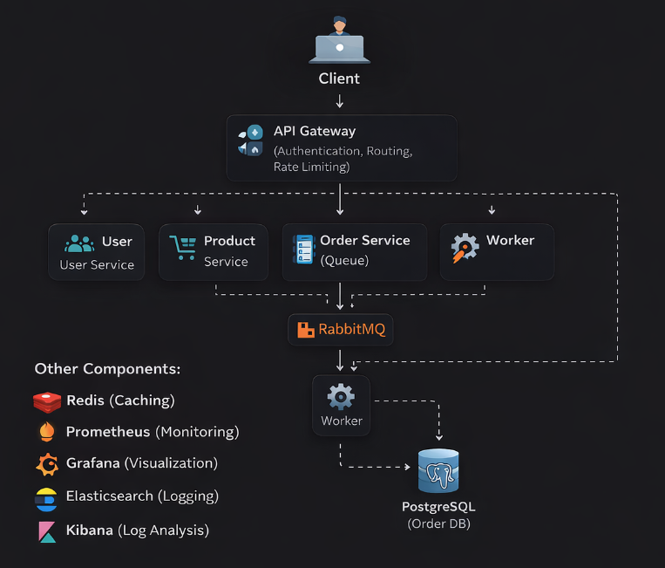
4. Technologies Used
Category | Technology
Backend Framework | FastAPI
Database | PostgreSQL
Cache | Redis
Message Queue | RabbitMQ
Monitoring | Prometheus
Visualization | Grafana
Logging | Elasticsearch
Log UI | Kibana
Containerization | Docker

5. System Components

5.1 API Gateway
- Central entry point for all requests
- Handles:
  - Authentication (JWT)
  - Routing
  - Rate limiting
  - Load balancing
- Adds request_id for distributed tracing

5.2 User Service
- Handles user registration and login
- Generates JWT tokens
- Stateless authentication system

5.3 Product Service
- Manages product data
- Uses:
  - PostgreSQL (persistent storage)
  - Redis (caching layer)
- Implements:
  - Cache-first strategy (read-through + write-through)

5.4 Order Service
- Receives order requests
- Sends order data to queue instead of direct DB write
- Ensures non-blocking processing

5.5 Worker Service
- Consumes messages from RabbitMQ
- Processes orders asynchronously
- Stores data in PostgreSQL

6. Key Features

6.1 Microservices Architecture
- Services are independently deployable
- Each service has its own database
- Loose coupling between components

6.2 Asynchronous Processing
- Implemented using RabbitMQ
- Improves system responsiveness
- Prevents blocking operations

6.3 Caching (Redis)
- Reduces database load
- Improves response time
- Cache strategy:
  - Write-through
  - Read-through

6.4 Monitoring
- Prometheus collects metrics
- Metrics include:
  - Request count
  - Request latency
- Grafana visualizes system performance

6.5 Centralized Logging
- Logs are sent to Elasticsearch
- Kibana provides log visualization
- Structured logging (JSON format)

6.6 Distributed Tracing
- Each request has a unique request_id
- Helps track request across services
- Useful for debugging and observability

6.7 Rate Limiting
- Prevents API abuse
- Limits requests per user per time window

7. System Workflow
🔹 Product Flow
Client → Gateway → Product Service
→ Redis (check)
→ DB (if miss)
→ Cache update
🔹 Order Flow
Client → Gateway → Order Service
→ RabbitMQ
→ Worker
→ PostgreSQL

8. Observability

🔹 Monitoring
- Metrics endpoint: /metrics
- Prometheus scrapes data
- Grafana dashboards visualize trends

🔹 Logging
- Logs stored in Elasticsearch
- Kibana used for searching logs

🔹 Tracing
- Request ID passed via headers
- Enables full request lifecycle tracking

9. Advantages
- Scalable architecture
- Fault isolation
- High performance via caching
- Better debugging using logs and tracing
- Real-world production practices

10. Limitations
- Increased complexity compared to monolith
- Requires proper orchestration
- Logging pipeline not fully decoupled (no Logstash yet)
- Services not fully containerized (optional improvement)

11. Future Enhancements
- Replace RabbitMQ with Kafka
- Add Logstash or Fluent Bit
- Implement Kubernetes deployment
- Add CI/CD pipeline
- Implement service discovery (Consul)
- Add API rate limiting using Redis

12. Conclusion
This project demonstrates a complete microservices-based backend system with real-world features such as asynchronous processing, caching, monitoring, logging, and distributed tracing. It reflects industry practices and provides a strong foundation for scalable and maintainable backend development.

