Financial Document Intelligence Chatbot using Retrieval-Augmented Generation (RAG)

1. Abstract
Financial reports such as annual reports and regulatory filings contain critical insights but are often lengthy and difficult to analyze efficiently. This project presents a Financial Document Intelligence Chatbot that enables users to query complex financial documents conversationally.
The system leverages Retrieval-Augmented Generation (RAG) to ensure responses are accurate, explainable, and grounded strictly in the source documents. By combining semantic search with a locally hosted large language model, the chatbot can answer factual questions, perform year-wise comparisons, and support follow-up queries through an interactive web interface.

2. Problem Statement
Traditional financial document analysis requires:
- Manual reading of hundreds of pages
- Domain expertise
- Significant time and effort to extract specific metrics such as revenue, net sales, or operating income
Existing AI chatbots often hallucinate answers or rely on external knowledge, which is unacceptable for financial analysis.
Problem:
How can we build a system that:
- Understands real financial documents
- Retrieves only relevant information
- Answers questions accurately without hallucination
- Supports conversational and comparative analysis

3. Objectives
The key objectives of this project are:
- Build a document-grounded chatbot for financial analysis
- Implement semantic search using vector embeddings
- Ensure responses are generated only from retrieved document context
- Support follow-up and comparison questions
- Provide a clean, user-friendly web interface
- Avoid dependency on paid APIs

4. Scope
Included
- PDF-based financial documents (annual reports, filings)
- Factual and analytical queries
- Year-wise and region-wise comparisons
- Conversational interface
Not Included
- Financial forecasting
- External market data integration
- Real-time stock analysis

5. Technology Stack
Programming & Environment
- Python
- Google Colab (GPU-enabled environment)
LLM & NLP
- Hugging Face Transformers
- Mistral-7B-Instruct (4-bit quantized)
RAG Framework
- LlamaIndex
Embeddings & Retrieval
- Sentence Embeddings: all-MiniLM-L6-v2
- Vector Index: LlamaIndex VectorStoreIndex
- Similarity Metric: Cosine similarity
User Interface
- Gradio (web-based chatbot UI)

6. System Architecture
6.1 High-Level Flow
- Document Upload
  - Financial PDFs are uploaded by the user
- Document Processing
  - Documents are chunked into smaller semantic units
- Embedding Generation
  - Each chunk is converted into a vector representation
- Vector Indexing
  - Vectors are stored in a vector index for fast similarity search
- Query Handling
  - User query is embedded and matched against the index
  - Top-K relevant chunks are retrieved
- Response Generation
  - Retrieved context is passed to the LLM
  - Answer is generated strictly from retrieved data
- Conversation Memory
  - Previous answers are used only for comparison when required
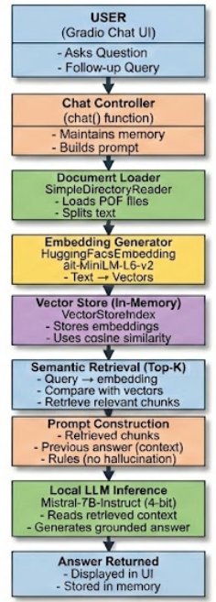

7. Key Features
- Document-grounded answers (no hallucinations)
- Semantic search using cosine similarity
- Multi-turn conversational support
- Financial comparisons across years
- Real financial PDF support
- Interactive chatbot UI
- Fully free and open-source stack

- Sample Queries (based on Apple Annual Report pdf)
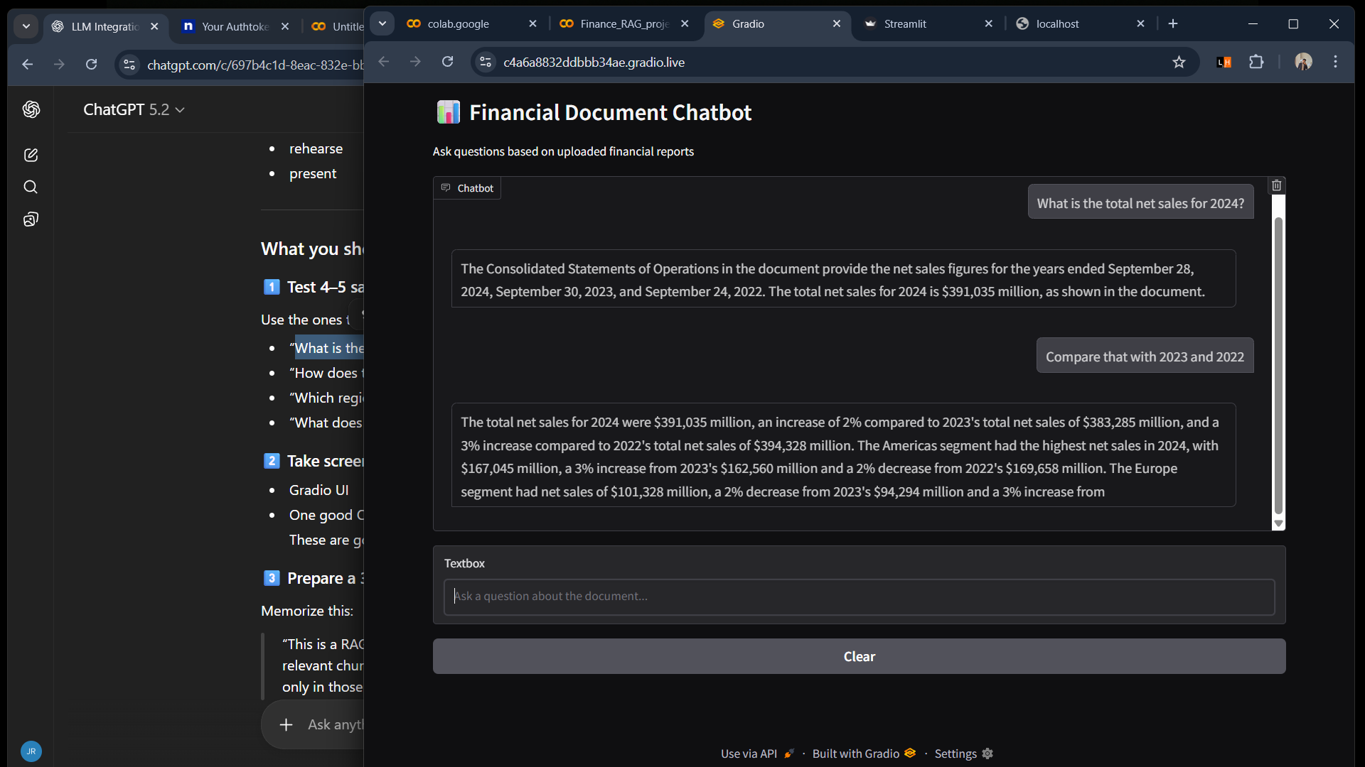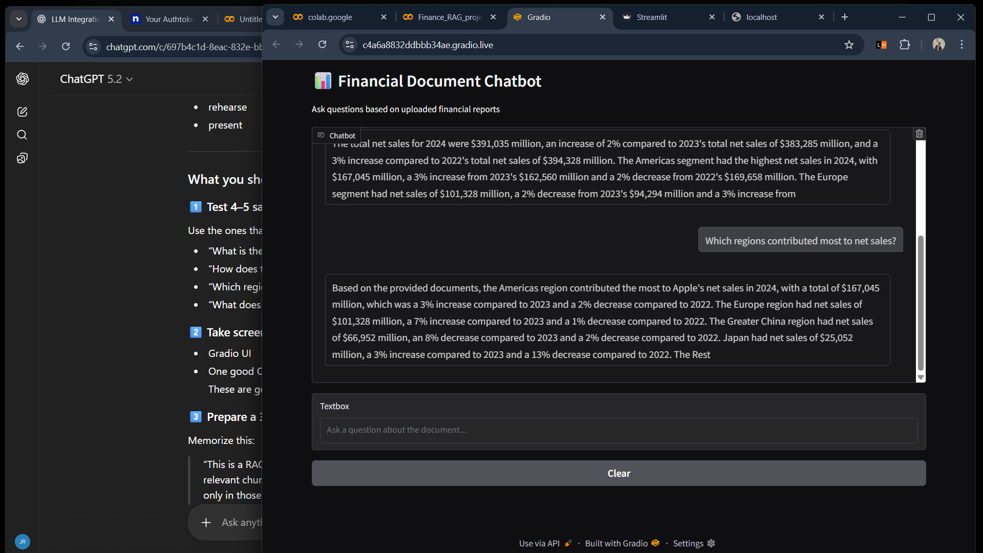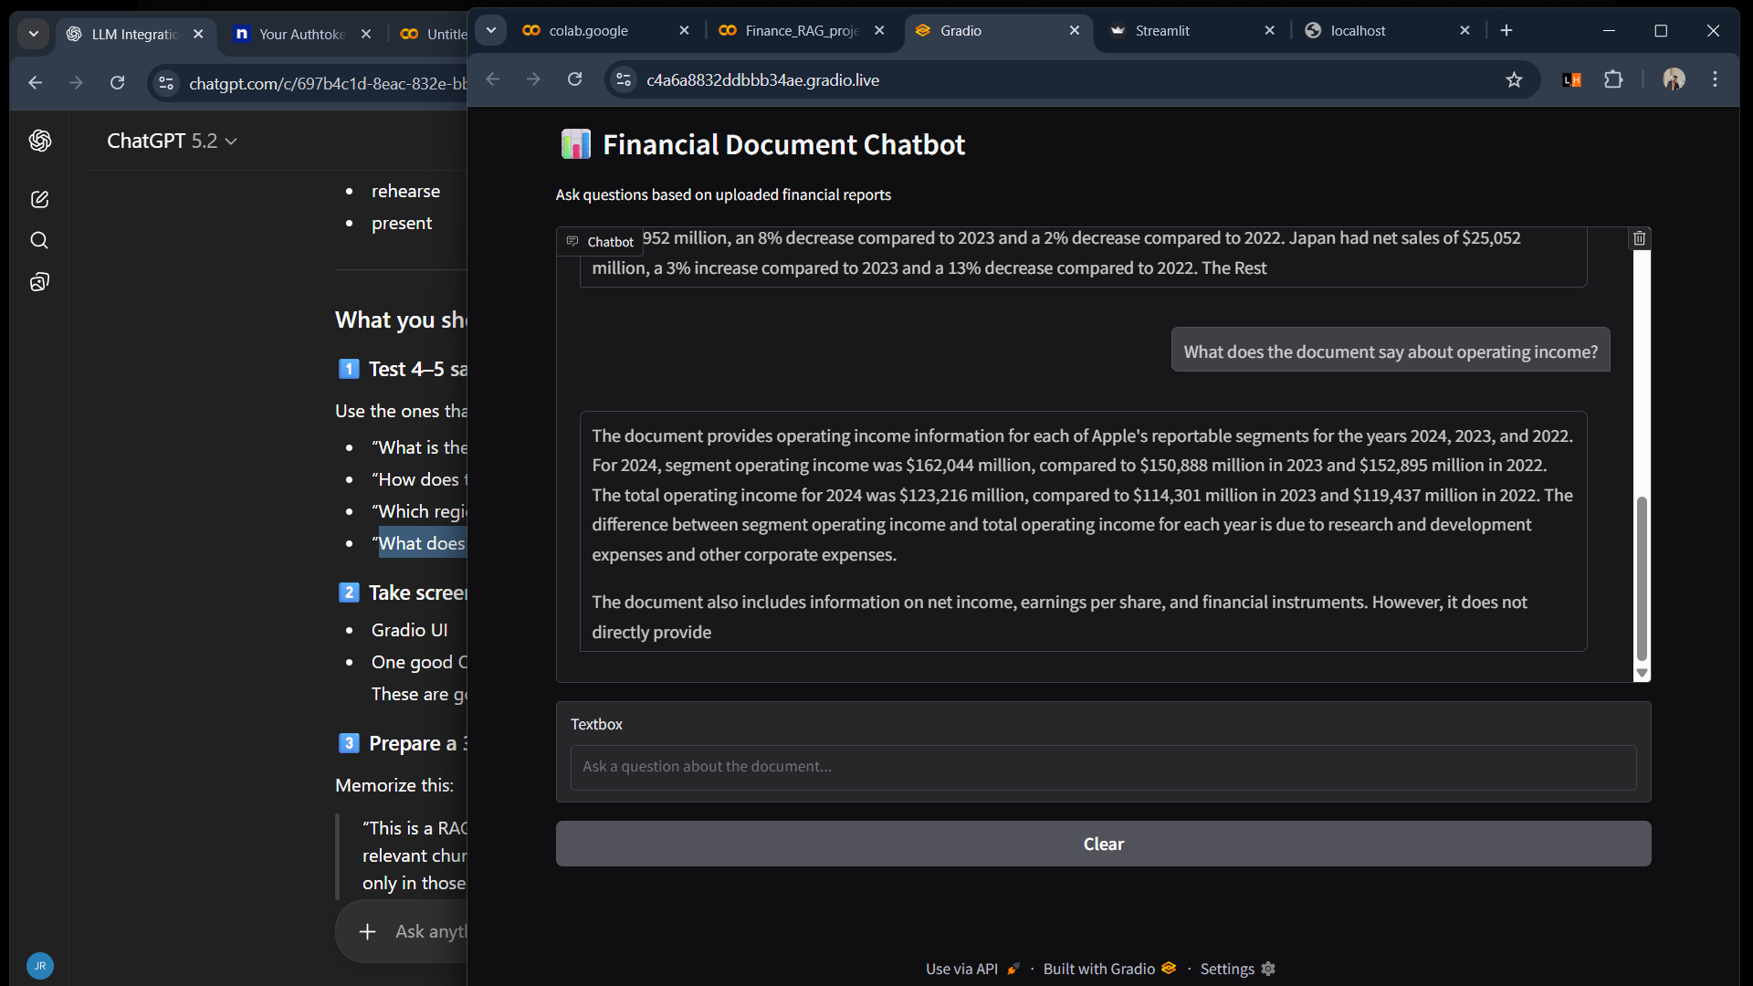
9. Results and Observations
- The chatbot successfully retrieves precise financial figures
- Comparison queries work without re-asking full context
- Answers are explainable and traceable to source documents
- UI enables smooth demonstration and interaction
- System avoids hallucinated responses when data is missing

10. Performance Considerations
- Response latency is higher due to local LLM inference
- Quantization (4-bit) significantly reduces memory usage
- Retrieval accuracy improves relevance and reduces prompt size

11. Limitations
- Large models require GPU support
- Performance depends on document clarity
- Long documents increase indexing time
- Not suitable for real-time data updates

12. Future Enhancements
- API integration (Gemini / OpenAI) for faster inference
- Multi-document cross-analysis
- Persistent vector database (FAISS / Chroma)
- Authentication and user-specific document storage
- Cloud deployment (AWS / GCP / Hugging Face Spaces)

13. Conclusion
This project demonstrates a practical, industry-ready application of Retrieval-Augmented Generation for financial document analysis. By grounding responses in retrieved document context, the chatbot ensures accuracy, reliability, and explainability — essential requirements in financial and enterprise environments.
The system is extensible, open-source friendly, and suitable for real-world deployment with further optimization.

14. Author
Jeswin K Reji
Aspiring Data Scientist
February 2026
jeswinkr7@gmail.com
LinkedIn GitHub

